How to generate a report

In eRA, if you would like to generate a report for your records you may follow the steps below to download and print a PDF report.

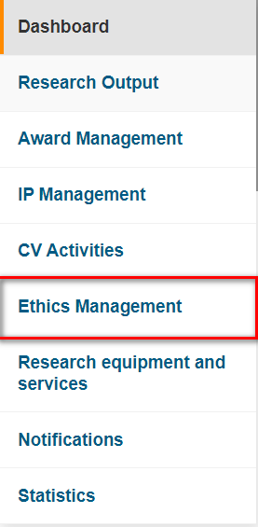

On the navigation menu click on **Ethics Management**

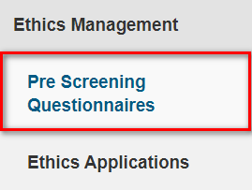

Select **Pre Screening Questionnaires *or* Ethics Applications**

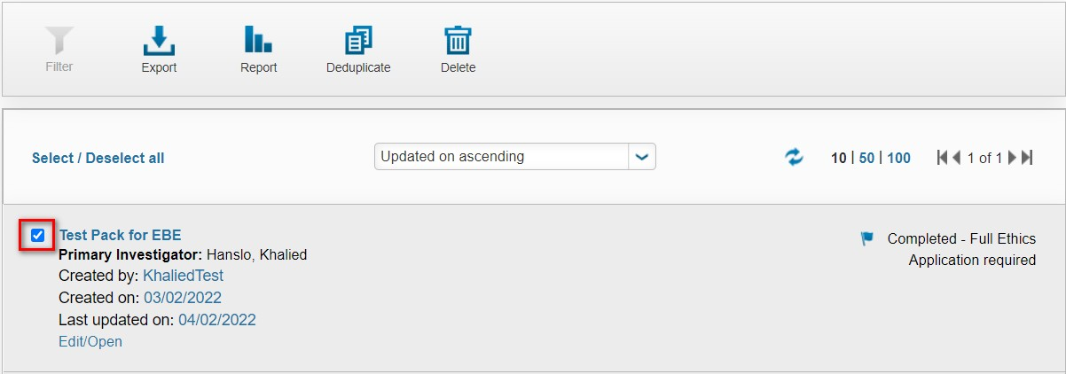

From the list that appears place a tick in the checkbox of the record you want downloaded.

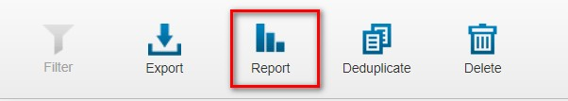

Select **Report**

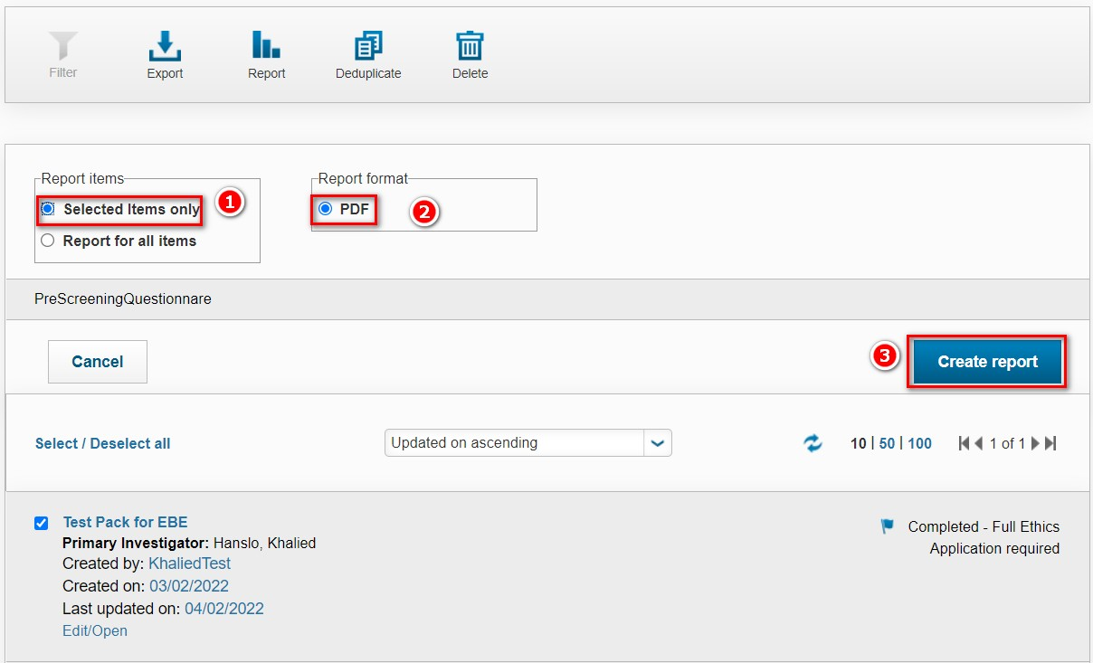

1. Ensure the **selected items only** radio button is selected
2. The radio button is selected for **PDF**
3. Click **Create report**

You may only create 1 report at a time, so ensure you only click 1 checkbox.

This is an example of the PDF report that will be downloaded to your local computer.

