Factors influencing the relationship between β and p at a constant value of leftward shift
by
OLSPS Marine
Silvermine House
Steenberg Office Park
Tokai 7945

20 November 2018

Summary
This document reports some initial results of an investigation into the possible reasons for the dependence of β (‘the main control parameter in the OMPs under consideration’) on p (‘the proportion of the South Coast spawning biomass that contributes to the effective West Coast spawning biomass’) for a class of operating models typified by Interim OMP-18 (the description of the OMP is given in FISHERIES/2018/AUG/SWG-PEL/24). As an example, FISHERIES/2018/AUG/SWG-PEL/19 reports that although the 20%-tile of the total biomass under catches determined by an OMP with β=0.174 is 68% of the ‘no catch’ situation when using an OM with p=0.08 (the “leftward shift”), the value of β must be increased to 0.208 to achieve 68% when p=0.60.
In order to investigate the reason for this, this document reports the leftward shift of total sardine biomass at the 20%-tile across a sequence of operating models of increasing levels of complexity. The actual operating model used in the development of OMPs for the resource in, for example, FISHERIES/2018/AUG/SWG-PEL/19 involves the simulation of results across Bayesian replicates of the stock assessment model parameters. The operating models used for the investigations reported here do not use these Bayesian replicates but instead an approximation to this. A number of other aspects included in the ongoing OMP development process are not utilised in the models underlying the results shown here – this is documented here. A progression of models of increasing levels of complexity is used to try to isolate the reason that in FISHERIES/2018/AUG/SWG-PEL/19, β (in a particular class of operating models, for which interim-OMP-18 is a particular case) is an increasing function of p, when constrained to a leftward shift of 68% (at the 20%-tile).
In the most advanced of the investigative steps referred to above, instead of a Bayesian sampling approach, the covariance matrix of stock assessment model parameters (from the Hessian) provided by the ADMB software package is used to generate realizations of stock assessment model parameters. This simulation procedure assumes that the joint distribution of the model parameters is multivariate normal. A series of logarithmic and logit transformation were applied to the stock assessment model parameters in an attempt to enhance the multivariate nature of the distribution in the model parameter transformed domain.
Initial results from a progression of 8 models presented to a PWG task team show a very slightly increasing trend in β as a function of p, constrained to a leftward shift of 68%. Although this is qualitatively consistent with the direction of the results in FISHERIES/2018/AUG/SWG-PEL/19, the dependence of β on p reported in FISHERIES/2018/AUG/SWG-PEL/19 is much stronger than shown here by the 8 models. It is possible that the full scale of the effect in FISHERIES/2018/AUG/SWG-PEL/19 is due to the use of Bayesian replicates to reflect stock assessment uncertainty, something not included in the initial set of 8 models.
This document reports the results of “Step 12”, one further step of complexity in calculations. This is to model stock assessment uncertainty under the assumption of multivariate normality of model parameters. Although preliminary, these results show a strongly increasing trend in β as a function of p, broadly both qualitatively and quantitively consistent with FISHERIES/2018/AUG/SWG-PEL/19.
This document is a contribution to ongoing attempts to better understand the relationship between β, leftward shift, and Risk_{S} for different operating models, to provide a better understood basis for the finalisation of OMP-18 underpinned by OMs with different values of p. A by-product of this work is the testing of a possible alternative to the Bayesian sampling approach for reflecting uncertainty in stock assessment model parameter uncertainty which is less time consuming and makes it possible to explore additional robustness tests in the OMP development process.

Background
FISHERIES/2018/AUG/SWG-PEL/19 estimates that β in a particular class of operating models (of which Interim-OMP-18 is a particular case) is an increasing function of p, when constrained to a leftward shift of 68% (at the 20%-tile) – “the result. For example, FISHERIES/2018/AUG/SWG-PEL/19 reports that although the 20%-tile of the total biomass under catches determined by an OMP with β=0.174 is 68% of the ‘no catch’ situation when using an OM with p=0.08 (the “leftward shift”), the value of β must be increased to 0.208 to achieve 68% when p=0.60.
The behaviour shown by FISHERIES/2018/AUG/SWG-PEL/19 is not a feature of deterministic models in which there is perfect knowledge of resource biomass (e.g. OLSPS Marine 2017, 2018, not shown here). It seem therefore that some of the stochastic complexity of the models used in FISHERIES/2018/AUG/SWG-PEL/19 results in a strong positive relationship between β on p, when the leftward shift is 68%. Finalising an OMP for the pelagic resource on multiple OMs is being hampered by lack of clarity about the reasons for this relationship, and by other poorly understood interrelationships which involve, inter alia, Risk_{S}, the probability of spawning biomass dropping below its lowest historical level. Risk_{S} is not considered here - this document focusses initially only on the relationship between leftward shift and β and p.

Methods
The methods used here are to gradually transition a model which starts as purely deterministic, where there is perfect knowledge upon which to base harvesting decisions, and where the harvest is based on a simple constant proportion of biomass rule, to a model which incorporates the kind of stochastic features and observations errors, and the complexities of the harvesting rules used in FISHERIES/2018/AUG/SWG-PEL/19. This is done by means of 8 initial steps, “Steps 1 to 8” and one last step “Step 12”.
The stock assessment methods which underpin these steps are described in Appendix C.
The stock assessment method for Steps 1 to 8 are based on model parameters derived from an “internal” fit of the HS function during the sardine assessment, and an “internal” fit of the BH function during the anchovy assessment. Internal means that the S/R HR and BH function parameters are fitted at the same time that the stock assessment is run. Steps 1 to 8 trace a progression of model complexity from a purely deterministic version to one that incorporates recruitment stochasticity and observation error. The harvesting rules also increase in complexity across the eight steps, being in the last steps close to Interim OMP-18 but with β = 0.144. Step 8 does not incorporate uncertainty in the stock assessment model parameters, but hold their values fixed at the MLE from the stock assessment.
For Step 12 the S/R HS function was fitted “external” to the stock assessment model. This external stock assessment model is described in Appendix A. In “Step 12” the main additional feature is the incorporation of stock assessment model parameter uncertainty based on the covariance matrix of the stock assessment model parameters. An attempt was made to enhance the multivariate nature of the distribution in the model parameter transformed domain by using logarithmic transformations for all model parameters bounded below by zero, and logit transformations for all model parameters which were bounded below by 0 and above by 1.
The following sections provide additional details about the methods. The intention was to follow the stock assessment methodology, the harvesting rules and the simulation approaches described in the following documents:
- The sardine stock assessment methods outlined in MARAM/IWS/DEC16/Sardine/P2,
- The anchovy stock assessment methods outlined in MARAM/IWS/DEC16/Sardine/BG7
- The sardine/anchovy OMP formulae described in FISHERIES/2018/AUG/SWG-PEL/24, and
- The sardine/anchovy forward simulation procedure given in FISHERIES/2018/DEP/SWG-PEL/27,
in the interest of brevity, the description presented here focusses on deviations from those documents, rather than on a re-description of all model assumptions and equations.

Steps 1 to 8
Table 2 summarises the 8 steps referred to in this subsection. A brief summary is as follows:
Step 1: This is a model which reflects deterministic dynamic anchovy and sardine recruitment, a fixed level of West Coast to South Coast migration, perfect knowledge about biomass levels, a total harvest level of 14.4% of the total biomass, 75% of the catch taken on the West Coast, a constant anchovy catch of 250 000 MT and all other model parameters set at the MLE values obtained from the stock assessments.
Step 2: Introduction of stochastic recruitment for Sardine on the West and South Coasts, and for anchovy.
Step 3: Introduction of observation error for total sardine biomass.
Step 4: Random selection of the West Coast to South Coast movement parameter for each year from a pool made up of the last 10 years of estimates from the stock assessment MLE.
Step 5: Introduction of a stochastic model for setting the percentage of sardine catch on the West Coast.
Step 6: Introduction of all sardine bycatch amounts. Introduction of the anchovy catch as a proportion (0.914) of the true total biomass estimate.
Step 7: Introduction of the anchovy catch as a proportion (0.914) of the observed total biomass estimate. Introduction of all other observation errors required at this step.
Step 8: Introduction of Interim OMP-18 harvesting control rules for sardine and anchovy.
Appendix A provides more details about the models used to produce these results, and Appendix C provides detail on the stock assessments which underpin the results.

Step 12
Table 2 summarises Step 12 as referred to in this subsection. The main complexity that is added to Step 8 to reach Step 12 is to include uncertainty in the stock assessment model parameters. Appendix B summarises details about the simulation methods used and Appendix C is a summary of the associated stock assessment methods. Appendix D is a summary of the multivariate normal based simulation approach taken to reflect stock assessment uncertainty.

Results

Checking the natural variability of the simulation results for 1000 ‘simulates’
ADMB case R1 was run with different sets of random numbers and 50 repetitions to estimate the standard error of a single value of the leftward shift. The results are that the CV for the leftward shift calculated as the ratio of the 20%-tiles of the distributions for sardine biomass with catch versus sardine biomass with no catch was 1.24% (ratio of the percentiles). The CV for the leftward shift calculated as the 20%-tile of the distribution of the ratio of B with catch vs B with no catch is 0.42% (percentile of the ratios). Table 1 shows the differences between leftward shifts for p=0.60 and p=0.08 expressed as a % of the p=0.60 case.

Results for Steps 1 to 8
In Table 1 the largest difference between the leftward shift for p=0.60 compared to p=0.08, by either calculation method (ratio of percentiles or percentile of the ratios) is 0.71%. Although this lies within the 95% confidence limits (based on the CV) of the leftward shift estimate, the difference is noteworthy across both the ADMB and Excel results because both make use of a common set of random numbers. Note that the difference increases with increasing complexity in the model – this trend is more apparent for ‘the percentile of the ratios” than for the “ratio of the percentiles” methods.
Table 1. Differences between leftward shifts for p=0.60 and p=0.08 expressed as a % of the p=0.60 case.
Additional results are presented in Table 3 and Figure 1. Table 4 and Figure 2 are results obtained when the percentage of catch on the West Coast is constrained to be 40% or larger.

Results for Step 12
The most significant result in Table 4 is the leftward shift obtained in Step 12 with p = 0.60 and p = 0.08, and β = 0.144, which shows that:
- the “ratio of the 20%-iles” declines from 0.702 at p=0.60 to 0.653 at p = 0.08.
- the “20%-ile of the ratios” declines from 0.684 at p=0.60 to 0.661 at p = 0.08.
A further run at p = 0.08 was carried out with β = 0.110, and a linear interpolation/extrapolation was carried out for p = 0.08 to estimate the value of β at which the same leftward shift is achieved as at p = 0.60 with β = 0.144. The results suggest the following (where leftward shift is the depletion exhibited by the total biomass)
- The β value necessary to achieve the same leftward shift for p=0.08 as for p=0.60 using β = 0.144, viz. 0.702, for the “ratio of the 20%-iles” method of defining leftward shift is 0.103.
- The β value necessary to achieve the same leftward shift for p=0.08 as for p=0.60 using β = 0.144, viz. 0.684, for the “20%-iles of the ratio” method of defining leftward shift is 0.121.
These results show therefore that for the same leftward shift, the value of β is larger for a value of p=0.60 than for a value of p= 0.08.

Discussion
This document reports some initial results of an investigation into the possible reasons for dependence of β on p for a class of operating models typified by Interim OMP-18. The main results are the leftward shift of total sardine biomass at the 20%-tile for a value of β = 0.144, and for p=0.60 or 0.08, across a sequence of operating models and simulation approaches of increasing levels of complexity. Here the leftward shift is relevant to the state of the projected (via simulation methods) resource total biomass in year 2048, chosen as a point in time at which transient effects due to the state of the resource in 2018 have negligible effect.
The actual operating model used in the development of OMPs for the resource involves the simulation of results across Bayesian replicates of the stock assessment model parameters. The operating models used here do not include these Bayesian replicates, nor a number of other aspects included in the ongoing OMP development process (and as documented here). A progression of models of increasing levels of complexity is used to try to isolate the reason that in FISHERIES/2018/AUG/SWG-PEL/19, β in a particular class of operating models (of which Interim-OMP-18 is a particular case) is an increasing function of p, when constrained to a leftward shift of 68% (at the 20%-tile). In the most advanced of these model steps, we use the covariance matrix of the stock assessment model parameters derived from the Hessian matrix, and as provided by the ADMB software package, to set up a procedure to create realizations of the stock assessment model parameters.
Results from a progression of 8 models presented to a PWG task team earlier in 2018 shows some slight increasing trend in β as a function of p, subject to a leftward shift of 68%, qualitatively consistent with the results in FISHERIES/2018/AUG/SWG-PEL/19. The dependence of β on p reported in FISHERIES/2018/AUG/SWG-PEL/19 was however much stronger than these initial results showed. It was speculated at the time that perhaps the full scale of the effect in FISHERIES/2018/AUG/SWG-PEL/19 was due to the use of Bayesian replicates of stock assessment model parameters which was not included in the analyses made available by this author at that time.
This document reports the results of one further step of complexity in the forward simulation process used to calculate the leftward shift for year 2048. This is, as previously described, the inclusion of the realizations of stock assessment model parameters under the assumption of multivariate normality. Although these results are preliminary, in their present form they show that there is a strongly increasing trend in β as a function of p, subject to a leftward shift of 68%. This is (broadly) both qualitatively and quantitively consistent with the nature and scale of the results in FISHERIES/2018/AUG/SWG-PEL/19.
Suggested future work relevant to the development of pelagic OMPs from this document is:
- To compare the Bayesian replicates and the multivariate normal realizations to see whether the latter is an adequate reflection of stock assessment uncertainty. If not, to do further work to improve the comparison to the point that the latter can be used for management procedure evaluations.
- To further interrogate the results to get a better understanding of the reasons relationship between β, p and leftward shift.
- To include Risk_{S} in the analyses and to get an understanding of its relationship to β, p and leftward shift. To explore the use of different biomasses for Risk_{S} and leftward shift (total biomass, spawning biomass, effective spawning biomass) and different biomass thresholds for Risk_{S}.

Acknowledgements
The work reported here was carried out in close collaboration with the PWG task team comprising Carryn de Moor, Doug Butterworth, Carl van der Lingen, Fannie Shabangu and Janet Coetzee, and benefitted substantially from input from the task team.

References
de Moor, C.L. and D.S. Butterworth. 2016. Assessment of the South African sardine resource using data from 1984-2015: Results at the joint posterior mode for the two mixing-stock hypothesis. MARAM/IWS/DEC16/Sardine/P2.
de Moor, C.L. 2016. Assessment of the South African anchovy resource using data from 1984 – 2015: results at the posterior mode. MARAM/IWS/DEC16/Sardine/BG7.
de Moor, C.L. 2018. Interim OMP-18. FISHERIES/2018/AUG/SWG-PEL/24.
de Moor, C.L. 2018. Simulation testing framework used during OMP-18 development. FISHERIES/2018/SEP/SWG-PEL/27.
de Moor, C.L. 2018. Multiple sardine Operating Models and associated risk. FISHERIES/2018/AUG/SWG-PEL/19.

Table 2. A progression of levels of complexity introduced into the model intended to highlight which feature of the model causes the value of $β$ for p=0.60 to be larger than $β$ for p=0.08, when the constraint of a leftward shift of 68% is active.

Table 3. Results obtained for Steps 1-8. The values shown are, unless indicated otherwise, the leftward shift at the 20%-tile level.

Table 4. Results obtained for Steps 1-8, but now imposing a constraint that the % catch on the WC must be 40% or larger. The values shown are, unless indicated otherwise, the leftward shift at the 20%-tile level and the value of beta.
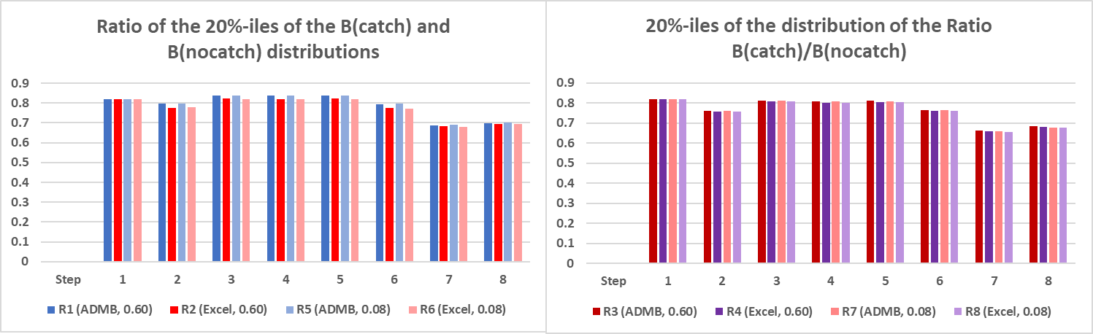
Figure 1. Results obtained for Steps 1-8. The LH panel gives the leftward shift calculated as the ratio of the 20%-iles of the distributions for B with catch and B with no catch. The RH panel gives the leftward shift calculated as the 20%-ile of the distribution of the ratio of B with catch vs B with no catch. The values shown are, unless indicated otherwise, the leftward shift at the 20%-tile level.
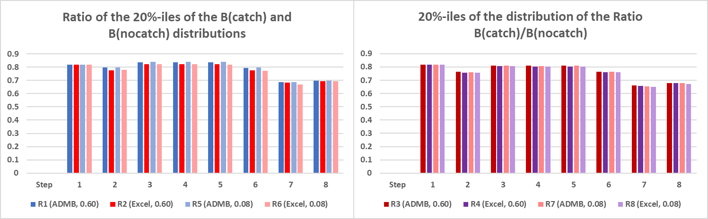
Figure 2. Results obtained for Steps 1-8, but now imposing a constraint that the % catch on the WC must be 40% or larger. The LH panel gives the leftward shift calculated as the ratio of the 20%-iles of the distributions for B with catch and B with no catch. The RH panel gives the leftward shift calculated as the 20%-ile of the distribution of the ratio of B with catch vs B with no catch. The values shown are, unless indicated otherwise, the leftward shift at the 20%-tile level.
Table 5. Input values (at age) for Sardine West Coast for both 60% and 8%. As used for the results for Steps 1 to 8.
age | 0 | 1 | 2 | 3 | 4 | 5
weight begin | 1.056 | 35.66 | 74.00 | 86.00 | 88.87 | 89.52
weight middle | 17.99 | 58.56 | 87.48 | 95.04 | 96.60 | 96.85
mortality | 1.00 | 0.80 | 0.80 | 0.80 | 0.80 | 0.80
exp(-m/2) | 0.6065 | 0.6703 | 0.6703 | 0.6703 | 0.6703 | 0.6703
selectivity | 0.05454 | 0.6251 | 0.9504 | 0.9910 | 0.9984 | 1.0000
fecundity | 0.0000 | 0.08107 | 0.5031 | 0.6631 | 0.6962 | 0.7034

Table 6. Input values (at age) for Sardine South Coast for both 60% and 8%. As used for the results for Steps 1 to 8.
age | 0 | 1 | 2 | 3 | 4 | 5
weight begin | 1.065 | 34.09 | 74.18 | 88.07 | 91.72 | 92.62
weight middle | 16.01 | 53.11 | 81.37 | 90.14 | 92.28 | 92.69
mortality | 1.00 | 0.80 | 0.80 | 0.80 | 0.80 | 0.80
exp(-m/2) | 0.6065 | 0.6703 | 0.6703 | 0.6703 | 0.6703 | 0.6703
selectivity | 0.02140 | 0.5014 | 0.9370 | 0.9886 | 0.9979 | 1.0000
fecundity | 0.0000 | 0.06386 | 0.5174 | 0.7178 | 0.7595 | 0.7690

Table 7. Numbers at age for 2018 for Sardine West Coast for p= 8% and p= 60%. As used for the results for Steps 1 to 8.
p | year | age | 0 | 1 | 2 | 3 | 4 | 5
0.60 | 2018 | Numbers | 26614 | 8906 | 2357 | 173.5 | 18.73 | 1.675
0.08 | 2018 | Numbers | 26141 | 8743 | 2307 | 172.4 | 18.59 | 1.663

Table 8. Numbers at age for 2018 for Sardine South Coast for p= 8% and p= 60%. As used for the results for Steps 1 to 8.
p | year | age | 0 | 1 | 2 | 3 | 4 | 5
0.60 | 2018 | Numbers | 4215 | 1505 | 1926 | 436.0 | 472.7 | 294.0
0.08 | 2018 | Numbers | 4215 | 1505 | 1903 | 435.8 | 472.6 | 293.9

Table 9. Left hand panel: Recruitment parameter values aR, bR and sigmaR values for Sardine West Coast for p= 8% and p= 60%. As used for the results for Steps 1 to 8. Right hand panel: Recruitment parameter values for Sardine South Coast, using a two part rectangular distribution function in the log-recruitment domain. As used for the results for Steps 1 to 8.
  p | aR | bR | sigmaR
  0.60 | 16923.3 | 30674.7 | 0.952
  0.08 | 16489.3 | 14915.7 | 0.960
  γ | 0.41
  min | -10.0
  mid | -0.65
  max | 3.20

Table 10. Set of movement values. As used for the results for Steps 1 to 8.
2006 | 0.26591
2007 | 0.59368
2008 | 0.28110
2009 | 0.00338
2010 | 0.09682
2011 | 0.48642
2012 | 0.00152
2013 | 0.07208
2014 | 0.61019
2015 | 0.72102

Table 11. Values of g1 and g2 in the equation calculating the annual proportion of sardine catch taken west of Cape Agulhas. As used for the results for Steps 1 to 8.
g₁ | 0.9376
g₂ | 0.4647

Table 12. Input values (at age) for Anchovy. As used for the results for Steps 1 to 8.
age | 0 | 1 | 2 | 3 | 4
weight begin | 0.06776 | 10.33 | 13.25 | 13.50 | 13.52
weight middle | 5.484 | 12.70 | 12.7 | 12.7 | 12.7
mortality | 1.2 | 1.2 | 1.2 | 1.2 | 1.2
fecundity | 2.165E-06 | 0.3552 | 0.5787 | 0.5963 | 0.5976

Table 13. 2018 numbers at age for anchovy. As used for the results for Steps 1 to 8.
year | age | 0 | 1 | 2 | 3 | 4
2018 | Numbers | 551122 | 149103 | 46259 | 13525 | 7933

Table 14. BH recruitment parameter values used for anchovy. As used for the results for Steps 1 to 8.
alphaR | betaR | sigmaR
1317430 | 1494930 | 0.83

Appendix A. Methods for Steps 1 to 8
Steps 1 to 8 are a sequence of models of increasing levels of complexity, designed to ascertain which additional ‘complicating’ feature of the model gives rise to dependence of β on p when subject to a constraint on the leftward shift.
The dynamic model used for the simulations carried out here uses initial values on 1 November 2016 as starting values (these were obtained from a joint sardine-anchovy stock assessment carried out using the methods that are described in MARAM/IWS/DEC16/Sardine/P2 in which the S/R function parameter are fitted internal to the assessment), the values $N_{j,2016,a}^{S}$ for j=1,2 and a=0,1,2,3,4,5+ and $N_{j,2018,a}^{A}$ for a=0,1,2,3,4+, and then implements the dynamic equations A.1, A.2, A.4 and section headed ‘Assumptions made for 2016, 2017 and 2018’ of FISHERIES/2018/DEP/SWG-PEL/27, implementing MoveR by randomly selecting from the set of movement parameters given in Table 10. The values $N_{j,2018,a}^{S}$ and $N_{j,2018,a}^{A}$ obtained in this way are shown in Table 7, Table 8 and Table 13. The movement values in Table 10 were derived using a joint sardine-anchovy stock assessment carried out using the methods that are described in MARAM/IWS/DEC16/Sardine/P2.
Unless indicated as “Deterministic” or “As per TT agreements” in Table 2, implementation of stochastic recruitment uses an approach that deviates from A.5, A.6 and A.7 of FISHERIES/2018/DEP/SWG-PEL/27, and for West Coast sardine recruitment, using instead the following formulae:
$N_{j=1,y,0}^{S,pred}=HS\left({effSSB}_{j=1,y}^{S,pred}\right)e^{ε_{j=1,y}σ_{j=1,r}}$
where HS means Hockey Stick function, $ε_{j=1,y}$ is drawn from N(0,1), and the HS parameter values and the value of $σ_{j=1,r}$ used are simulation replicate invariant but depend on the value of p (see Table 9) – the replicate index has been omitted from this equation but is implicit. Similarly, for anchovy, simulated recruitment values are given as follows:
$N_{y,0}^{A,pred}=BH\left({SSB}_{y}^{A,pred}\right)e^{ε_{A,y}σ_{A,r}}$
where BH means a Beverton Holt function, $ε_{A,y}$ is drawn from N(0,1), and the BH parameter values and the value of $σ_{A,r}$ are given in Table 14. The replicate index has been omitted from the equation above but is implicit.
Unless indicated as “Deterministic” or “As per TT agreements” in Table 2, sardine recruitment values on the South Coast are simulated using a different approach to that outlined in FISHERIES/2018/DEP/SWG-PEL/27. This is also somewhat different to the approach that was agreed to by the PWG’s task team. Here a two part rectangular distribution R, comprising two continuous rectangles governed by four parameters {γ, min, mid, max} is used to generate realization of the logarithm of South Coast recruitment, $ln\left(N_{j=1,y,0}^{S,pred}\right)$. There is a lefthand and a righthand rectangle. The lefthand rectangle is defined on the x-axis for
‘min’ < $ln\left(N_{j=1,y,0}^{S,pred}\right)$ < ‘mid’
and the righthand rectangle is defined on the x-axis over the interval
‘mid’ < $ln\left(N_{j=1,y,0}^{S,pred}\right)$ < ‘max’
When the distribution is normalised, the rectangle heights are such that the proportion of the area under the left-hand rectangle is γ and under the right-hand rectangle it is 1- γ. The parameter values of the distribution R are given in Table 14 and were based on an approximation to the historic recruitment values on the South Coast.
For deterministic recruitment (as per Table 2, Step 1), the following equations are applicable:
West Coast sardine recruitment:
$$N_{j=1,y,0}^{S,pred}=HS\left({effSSB}_{j=1,y}^{S,pred}\right)e^{σ_{j=1,r}^{2}/2}$$
Anchovy recruitment is switched to an HS function for the deterministic case, as follows:
$N_{y,0}^{A,pred}=HS\left({SSB}_{y}^{A,pred}\right)e^{σ_{A}^{2}/2}$,
with a recruitment maximum value of 1028.3 billion and hinge point in terms of spawning biomass of 1115.6 thousand tons.
South Coast sardine recruitment is simply a fixed value:
$N_{j=1,y,0}^{S,pred}=4.215$ billion.
The simulations implement ‘Interim OMP-18’ described in FISHERIES/2018/AUG/SWG-PEL/24, equations OMP.1 – OMP.22, in order to provide annual catch estimates. Equations A.8a and A.8b are the basis for modelling the percentage of catch taken on the West Coast, except that a modified version of A.8b was used:
$τ_{y}^{i}=$ ${\dot{τ}}_{y}^{i}+{2ε}_{y}^{i}\sqrt{{{\dot{τ}}_{y}^{i}(1-{\dot{τ}}_{y}^{i})}/{20}}$ ,
(here ‘i’ is the replicate index which was not shown in previous equations given here) where the factor 2 was included as an ad hoc approach to increase the spread of the %’s to reflect the Bayesian replicate to replicate variance which is not catered for by the approach taken here for all Steps < 9. The values of $g_{1}^{i}$ and $g_{2}^{i}$ were replicate invariant and are as given in Table 11.
Equations A.9 to A.54 of FISHERIES/2018/DEP/SWG-PEL/27 were implemented as given. The models which are considered here are summarised in Table 1.
As mentioned above, in general terms the simulation approach used here follows FISHERIES/2018/SEP/SWG-PEL/27 and FISHERIES/2018/AUG/SWG-PEL /24 closely but there are some important departures which are described as follows:
- The same set of movement values are used throughout, regardless of whether p=0.08 or p=0.60. These values are given in Table 10.
- The same set of initial population numbers are used for 2018. These values are given in Table 7, Table 8 and Table 13.
- The same set of weights-at-age values are used for 2018 and onwards, regardless of whether p=0.08 or p=0.60. These values are given in Table 5, Table 6 and Table 12.
- The same selectivities, mortality and fecundity values are used for 2018 and onwards, regardless of whether p=0.08 or p=0.60. These values are also given in Table 5, Table 6 and Table 12.
- The % of the catch on the WC is modelled by the function given by equations (A.8a) in FISHERIES/2018/SEP/SWG-PEL/27 and (A.8b) in FISHERIES/2018/SEP/SWG-PEL/27, but with the value of the square root part in (A.8b) in FISHERIES/2018/SEP/SWG-PEL/27 doubled (in a sense to reflect the additional variance that arises from the Bayesian replication of this relationship). The values of g₁ and g₂ are given in Table 11.
- When there is no observation error (as and when defined in Table 2), then the relevant normal error values are simply set to zero.
- Two sets of results are produced, one in which the % of catch on the WC is not constrained to lie above 40%, and another where it is so constrained.
- The value of biomass which is used to determine leftward shift is the total true biomass $B_{WC+SC,y=2048}^{S,pred}$ in 2048, i.e. a 30-year time horizon is run to remove the effect of transient effects. This is the value ${B_{WC+SC,y=2048}^{S,pred}=B}_{j=WC,y=2048}^{S,pred}+B_{j=SC,y=2048}^{S,pred}$where the terms on the righthand side are defined in equation A.1 of FISHERIES/2018/SEP/SWG-PEL/27. Both a ‘no catch’ and a ‘catch’ scenario is considered, and associated with each are the values $B_{WC+SC,y=2048}^{S,pred}(no catch)$, $B_{WC+SC,y=2048}^{S,pred}(catch)$ and $B_{WC+SC,y=2048}^{S,pred}(catch)/B_{WC+SC,y=2048}^{S,pred}(no catch)$. By ‘No catch’ is meant a situation where there is no catch of sardine by any means, whether from the directed fishery or as a bycatch from fishing on other pelagic species. Let L(no catch) be the 20%-tile value for the distribution of $B_{WC+SC,y=2048}^{S,pred}(no catch)$, let L(catch) be the 20%-tile value for the distribution of $B_{WC+SC,y=2048}^{S,pred}(catch)$, and let L(ratio) be the 20% value of the distribution of the ratio $B_{WC+SC,y=2048}^{S,pred}(catch)/B_{WC+SC,y=2048}^{S,pred}(no catch)$. Here the value L(catch)/L(no catch) is referred to loosely as the ‘ratio of the percentiles’ and the value L(ratio) is referred to as the ‘percentile of the ratios’.
- ADMB and EXCEL results were checked for a single case and for the same set of random numbers and were found to agree to 11 significant figures. The interim OMP-18 calculations were also run using a separate VBA implementation in addition to the ADMB and Excel implementations and was found to agree to ~ 12 significant figures with output from the ADMB and Excel implementations, for the same set of random numbers.
- In the final results shown here, the same set of random numbers are used for all ADMB results. All Excel results use the same set of random numbers, but this set differs from the set used by ADMB.

Appendix B. Methods for Step 12
The main aspect of Step 12 is the incorporation of stock assessment uncertainty in the simulations. Some of the features of simulations for Step 12 which are not consistent with FISHERIES/2018/DEP/SWG-PEL/27 and/or agreements reached by the PWG and its task team are:
- MoveR is implemented, and not MoveD. Move R as implemented here uses a ’realization specific’ set of movement parameters from which a random draw is carried out. The pool of values and the specific random draw for each simulation realization is the same for p=0.08 and p=0.60.
- The set of initial population numbers used for 2018 are “realization” specific but the same for p=0.08 and p=0.60.
- Realization specific values of weights-at-age are used for 2018 onwards, regardless of whether p=0.08 or p=0.60.
- Realization specific values of selectivity and growth equations parameter values are used for 2018 and onwards, regardless of whether p=0.08 or p=0.60.
- The % of the catch on the WC is modelled by the function given by equations (A.8a) in FISHERIES/2018/SEP/SWG-PEL/27 and (A.8b) in FISHERIES/2018/SEP/SWG-PEL/27, but with the value of the square root part in (A.8b) in FISHERIES/2018/SEP/SWG-PEL/27 doubled (in a sense to reflect the additional variance that arises from the Bayesian replication of this relationship). The values of g₁ and g₂ are given in Table 11. The PWG’s task team had agreed to carry out Bayesian replicate specific model fits for this function – this has not been implemented here.
- Step 12 has only been run with a 40% lower bound on the % of catch on the WC, but not the maximum 90% agreed to by the PWG’s task team.
Simulated recruitment values for sardine on the West Coast use the following approach:
$N_{j=1,y,0}^{S,pred}=HS\left({effSSB}_{j=1,y}^{S,pred}\right)e^{ε_{j=1,y}σ_{j=1,r}}$
where ${effSSB}_{j=1,y}^{S,pred}$is the effective spawning biomass and the two parameters of the HS function are fitted external to the stock assessments. The simulated value of $ε_{j=1,y}$ uses an AR1 process, viz.
$ε_{j=1,y}=ρε_{j=1,y-1}+η_{y}\sqrt{1-ρ^{2}}$ where $η_{y}\sim ℵ(0, 0.81)$
and where $ρ$ is estimated separately for each simulation realization.
For sardine on the South Coast and for anchovy, the same approach as used for Steps 1 – 8 is used.

Appendix C. Stock assessments methods used to obtain the Hessian for Step 12
The inclusion of this material on the stock assessments is not central to the main subject of this document and need not be read to appreciate the thrust of the main document.
The stock assessment method closely follows equations (A1) to (A39), and the specification of Table A1 in MARAM/IWS/DEC16/Sardine/P2, as well as equations (A1) to (A27) and the specification Table A1 of MARAM/IWS/DEC16/Sardine/BG7. The following deviations from the equations and specifications in MARAM/IWS/DEC16/Sardine/P2 and MARAM/IWS/DEC16/Sardine/BG7 are noted:
- Equation (A8) of MARAM/IWS/DEC16/Sardine/P2: A fixed value of $ρ^{t}=0.5$ is used in this document.
- Sardine
- Equation (A23) of MARAM/IWS/DEC16/Sardine/P2: The stock-recruitment function model for sardine when fitting of the HS S/R function is internal to the stock assessments for Steps 1 to 8, and uses the following equations:
For West Coast for peak years (viz. $2000≤y≤2004$):
$$N_{j,p,y,0}^{S}= \left\{\begin{aligned}c_{j}^{S}e^{ε_{j,y}^{S}} if p=NI \\ 0 if p=I\end{aligned}\right.$$
where $ε_{j,y}^{S}∼N\left(0,{\left(σ_{peak,r}^{S}\right)}^{2}\right)$.
For West Coast for non-peak years (viz. $2000>y;y>2004)$ and South Coast:
$N_{j,p,y,0}^{S}=\left\{\begin{aligned}{a_{j}^{S}e}^{ε_{j,y}^{S}} if p=NI;{SSB}_{j,y}^{S}≥b_{j}^{S} \\ {\frac{a_{j}^{S}}{b_{j}^{S}}{SSB}_{j,y}^{S}e}^{ε_{j,y}^{S}} if p=NI;{SSB}_{j,y}^{S}<b_{j}^{S} \\ 0 if p=I\end{aligned}\right.$
where $ε_{j,y}^{S}∼N\left(0,{\left(σ_{j,r}^{S}\right)}^{2}\right)$.
- Equation (A23) of MARAM/IWS/DEC16/Sardine/P2. The stock-recruitment function model for sardine when fitting of the HS S/R function was external to the stock assessments for Step 12 and uses the following equations:
For West Coast for peak years (viz. $2000≤y≤2004$):
$$N_{j,p,y,0}^{S}= \left\{\begin{aligned}c_{j}^{S}e^{ε_{j,y}^{S}} if p=NI \\ 0 if p=I\end{aligned}\right.$$
where $ε_{j,y}^{S}∼N\left(0,{\left(σ_{peak,r}^{S}\right)}^{2}\right)$.
For West Coast for non-peak years (viz. $2000>y;y>2004)$ and South Coast:
$$N_{j,p,y,0}^{S}=\left\{\begin{aligned}{a_{j}^{S}e}^{ε_{j,y}^{S}} if p=NI \\ 0 if p=I\end{aligned}\right.$$
where $ε_{j,y}^{S}∼N\left(0,0.8\right)$.
- Anchovy
- Equation (A14) of MARAM/IWS/DEC16/Sardine/BG7. The stock-recruitment function model for anchovy was internal to the stock assessments for Steps 1 to 12 and used the following equations:
$$N_{y,0}^{A}= \frac{α^{A}{SSB}^{A}}{β^{A}+{SSB}^{A}}e^{ε_{y}^{A}}$$
where $ε_{y}^{A}∼N\left(0,{\left(σ_{r,2000+}^{A}\right)}^{2}\right)$ for $y≥2000$, and where $ε_{y}^{A}∼N\left(0,{\left(σ_{r}^{A}\right)}^{2}\right)$ for $y≤1999$.
In the stock assessment 6 model parameters for sardine were kept at fixed values, because their standard errors were either very small or very big. These parameters and their fixed values were:
- $N_{j=SC,NI,1983,a=0}^{S}$ = 3.89855e-007 (MARAM/IWS/DEC16/Sardine/P2 page 30)
- $N_{j=SC,NI,1983,a=1}^{S}$ = 0.0133428 (MARAM/IWS/DEC16/Sardine/P2 page 30)
- ${(σ_{j=WC,r}^{S})}^{2}$= 0.80 (MARAM/IWS/DEC16/Sardine/P2 equation (A23))
- ${(σ_{j=SC,r}^{S})}^{2}$= 0.80 (MARAM/IWS/DEC16/Sardine/P2 equation (A23))
- ${\overline{l}}_{2,j=SC,y=84-86,q=1-4}$ = 11.799 (MARAM/IWS/DEC16/Sardine/P2 equation (A15))
- $Φ$= 0.90 (MARAM/IWS/DEC16/Sardine/P2 page 24 relating move(age 2+) to move(age=1)
Table 15 and Figure 3 to Figure 19 provide diagnostic information about the stock assessment model fits:
  - Table 15 tabulates component level contributions to the overall log-likelihood for both the sardine and the anchovy assessments.
  - Figure 3 gives West and South Coast acoustic survey estimated and model predicted November sardine total biomass for 1984 to 2015.
  - Figure 4 gives West and South Coast acoustic survey estimated and model predicted recruitments for 1984 to 2015.
  - Figure 5 is a scatter plot of estimated recruitment versus estimated sardine spawning biomass for the West and South Coasts.
  - Figure 6 shows the annual von Bertalanffy growth curves for sardine estimated by allowing for auto-correlated residuals for the variation about the age at which length is zero.
  - Figure 7 shows the year specific sardine migration estimates and the annual infection rates.
  - Figure 8 is a plot of the model estimated November survey selectivity at length for sardine for the West and South Coasts respectively.
  - Figure 9 shows the average (over all years) model predicted and observed proportion-at-length in the November survey for sardine.
  - Figure 10 gives plots of the model estimated commercial selectivity at length for sardine, which differs between four pre-specified time periods (the four rows) and quarters.
  - Figure 11 shows the model predicted and observed proportion-at-length for sardine in the commercial catch.
  - Figure 12 shows the model estimated proportions-at-length of west and south stock sardine infected.
  - Figure 13 shows a scatter plot of the anchovy recruitment and spawning biomass estimates, as well as a time trend of anchovy recruitment deviations.
  - Figure 14 is a plot of acoustic survey results and model estimates for November anchovy total biomass, and egg survey results and model estimates for November anchovy spawner biomass.
  - Figure 15 plots the acoustic survey results and model estimates for anchovy recruitment by year.
  - Figure 16 shows the model estimated trawl survey selectivity at length for anchovy, as well as the average model predicted and observed proportions-at-length in the November survey trawls.
  - Figure 17 is a plot of the model estimated quarterly commercial selectivity at length for anchovy.
  - Figure 18 gives the average model predicted and observed proportions-at-length in the quarterly commercial catch for anchovy.
  - Figure 19 is a plot of the model estimated growth curve for anchovy.

Table 15. The contributions to the objective function at the posterior mode for the sardine (left hand panel) and anchovy (right hand panel) stock assessments.

  NLLF | 692.14
  NLLFSnov | 40.62
  NLLFSrec | 39.24
  NLLFSsurpropl | -352.52
  NLLFScompropl | -395.66
  NLLFSprev | 1276.43
  Prior(rec) | 72.41
  Prior(growth) | 40.98
  Prior(b/K)
  Prior(kSac) | -1.28
  Prior(move) | -27.26
  NLLF | -631.61
  NLLFAnov | -14.44
  NLLFAegg | 5.82
  NLLFArec | 14.65
  NLLFAsurpropl | -403.39
  NLLFAcompropl | -272.81
  Prior(rec) | 30.75
  Prior(growth) | -3.22
  Prior(delta) | 0.00
  Prior(Ninit) | 11.03

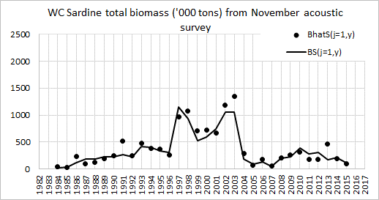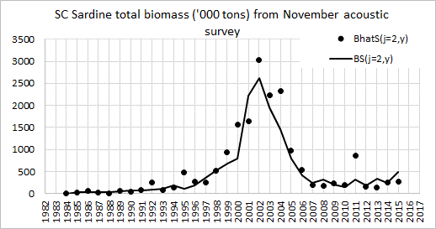
Figure 3. Acoustic survey estimated and model predicted November sardine total biomass from 1984 to 2015 – circles are point estimates from the surveys, line plots model fitted values.

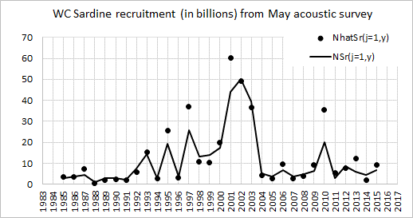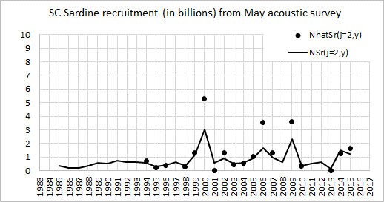
Figure 4. Acoustic survey estimated and model predicted sardine recruitment numbers from May 1985 to May 2015.

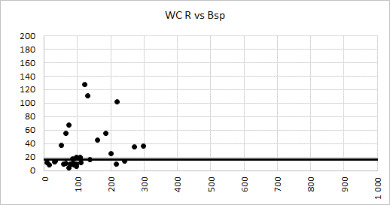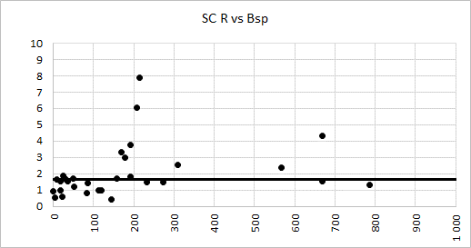
Figure 5. Model predicted November sardine recruitment plotted against spawner biomass from November 1984 to November 2014. Line shows median value.

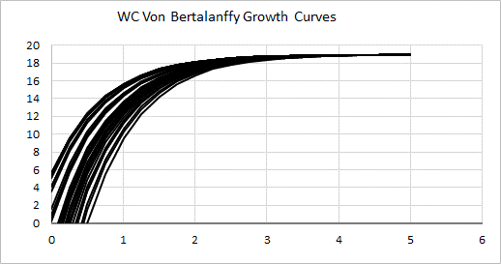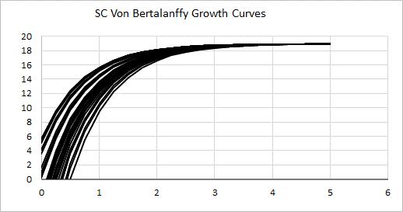
Figure 6. The annual von Bertalanffy growth curves for sardine estimated by allowing for auto-correlated residuals for the variation about the age at which length is zero.

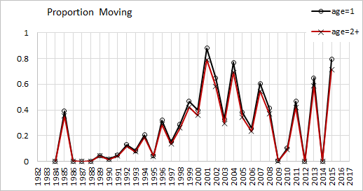 | 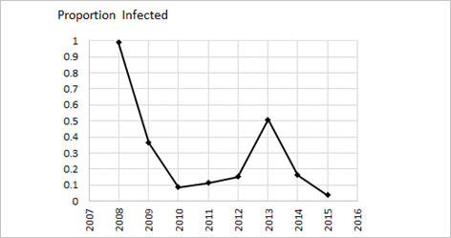

Figure 7. Left hand panel: Model estimated proportion of sardine 1-year-olds and 2+-year-olds which move from the “west” stock to the “south” stock in November. Right hand panel: The model estimated proportion of west stock sardine infected with the parasite between 2008 and 2015.

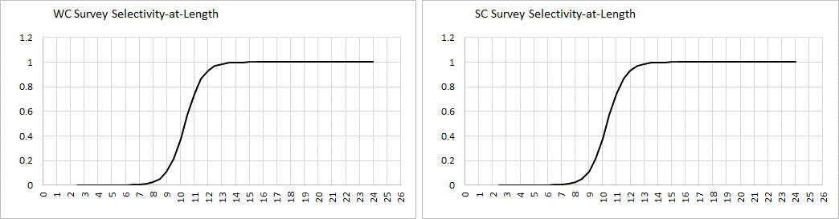
Figure 8. The model estimated November survey selectivity at length for sardine.

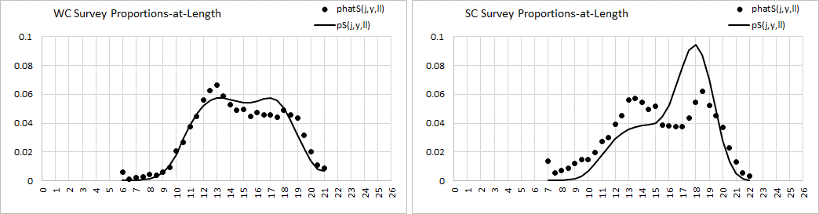
Figure 9. Average (over all years) model predicted and observed proportion-at-length in the November survey for sardine.

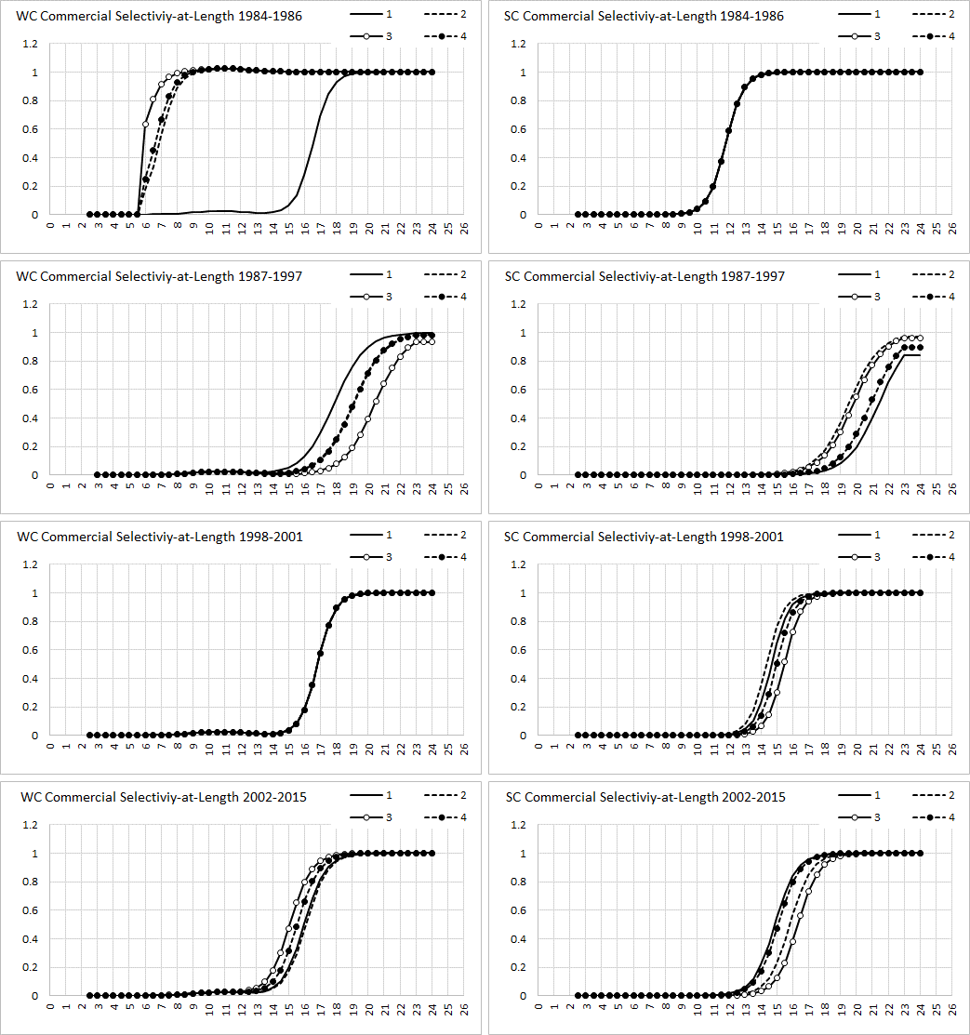
Figure 10. The model estimated commercial selectivity at length for sardine, which differs between four pre-specified time periods (the four rows) and quarters.

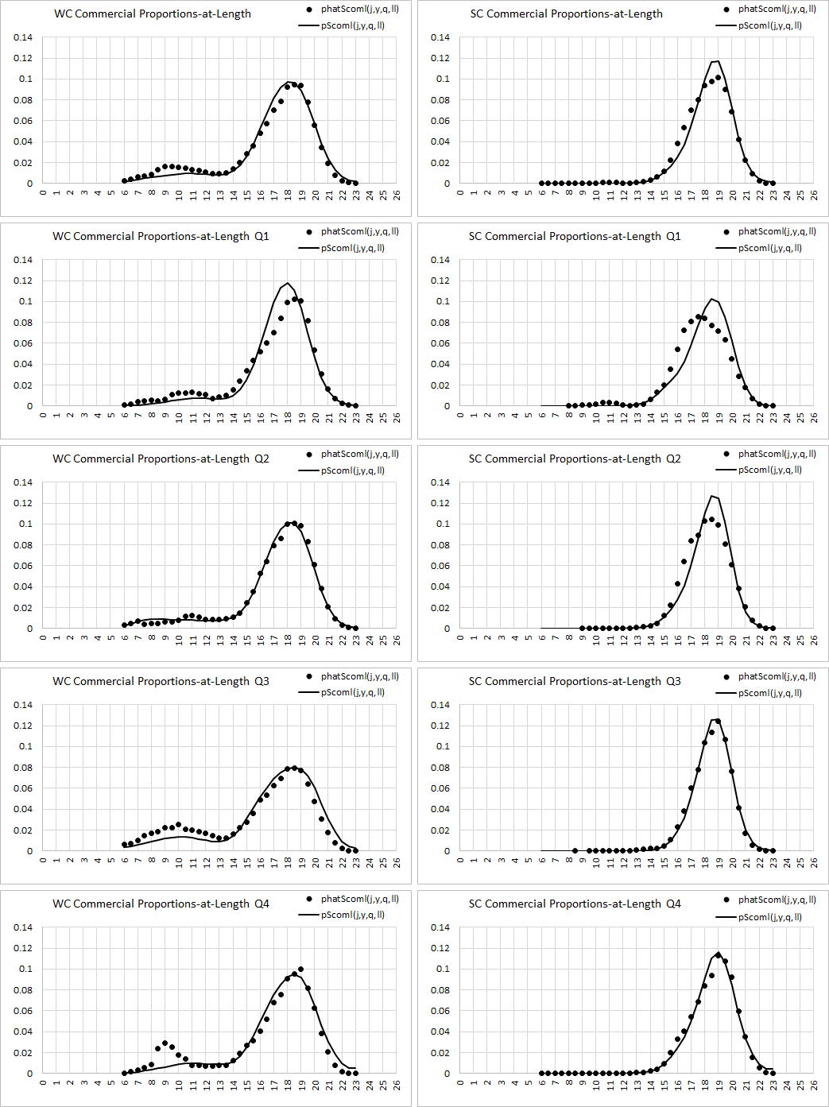
Figure 11. Average (over all quarters and years) model predicted and observed proportion-at-length for sardine in the commercial catch (top row), and average (over all years) quarterly model predicted and observed proportions-at-length in the commercial catch (subsequent rows).

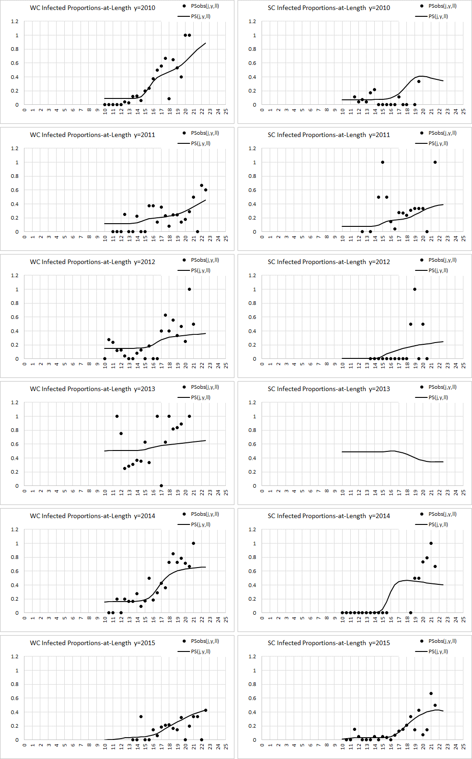
Figure 12. The model estimated proportions-at-length of west and south stock sardine infected with the parasite (i.e. parasite prevalence-by-length) between 2010 and 2015 together with the observed proportions-at-length.

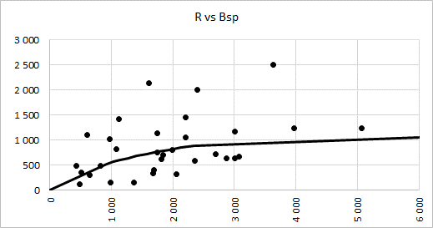 | 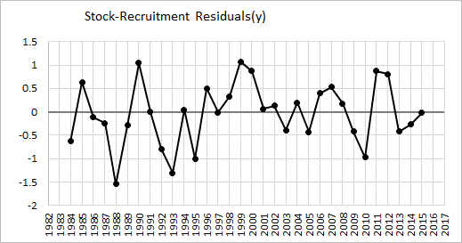

Figure 13. The anchovy stock-recruit relationship at the critical point of the objective function (left hand panel) and the anchovy unstandardized stock-recruitment residuals (right hand panel).

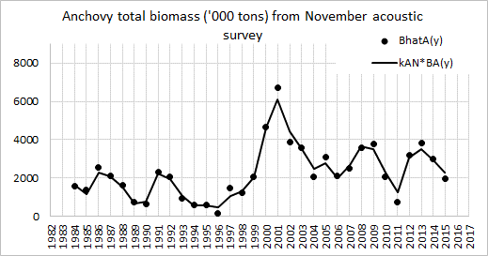 | 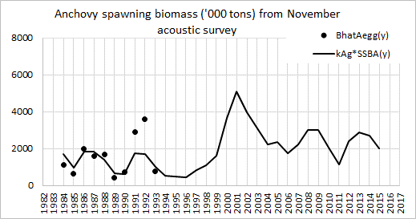

Figure 14. Acoustic survey results and model estimates for November anchovy total biomass from 1984 to 2015 (left hand panel) and egg survey results and model estimates for November anchovy spawner biomass from 1984 to 1993 (right hand panel).
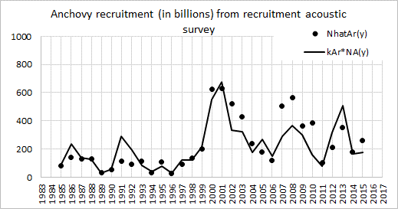
Figure 15. Acoustic survey results and model estimates for anchovy recruitment numbers from May 1985 to May 2015.

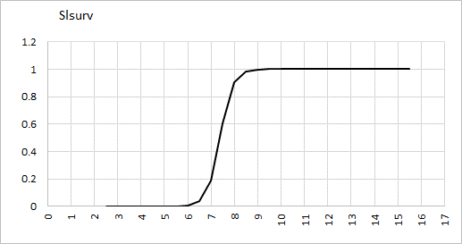 | 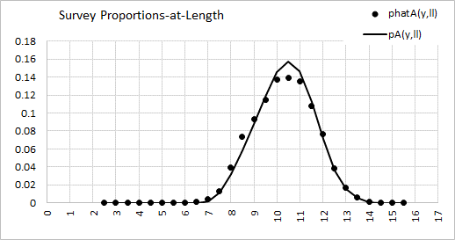

Figure 16. Model estimated trawl survey selectivity at length for anchovy (left hand panel). Average (over all years) model predicted and observed proportions-at-length in the November survey trawls for anchovy (right hand panel).

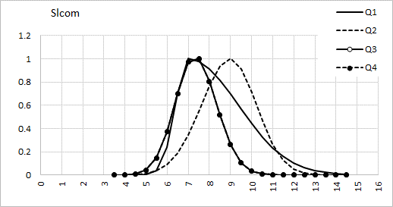
Figure 17. Model estimated quarterly commercial selectivity at length for anchovy.

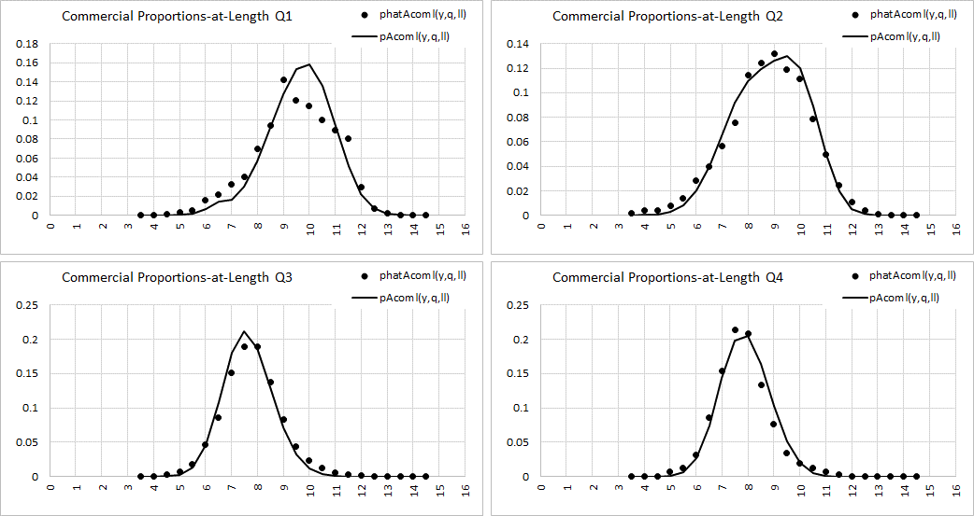
Figure 18. Average (over all years) model predicted and observed proportions-at-length in the quarterly commercial catch for anchovy.

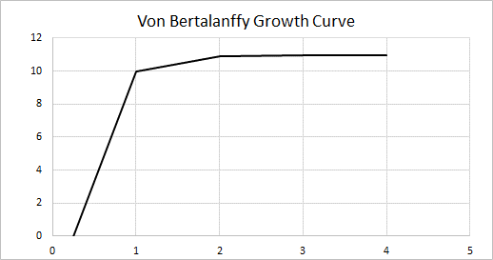
Figure 19. The model estimated von Bertalanffy growth curve for anchovy, where integer ages are taken to correspond to November each year.

Appendix D. Methods used to generate realizations of stock assessment model parameters.
The minimisation software ADMB provides point estimates for the model parameters, as well as standard errors and a correlation matrix. Separate runs in ADMB were used to produce these outputs for the sardine and the anchovy assessments since there is no dependence between these two models in the stock assessment model calculations. Both of these assessment model runs reported a positive definite Hessian. The correlation matrix and the standard errors were used to calculate the covariance matrix. A check was run in R to verify that all the eigenvalues of the covariance matrix were real and positive. The R function “mvrnorm” was used to produce 1000 realizations of the model parameters.
In the process 6 model parameters for sardine were kept at fixed values, because their standard errors were either very small or very big. These parameters and their fixed values were:
- $N_{j=SC,NI,1983,a=0}^{S}$ = 3.89855e-007 (MARAM/IWS/DEC16/Sardine/P2 page 30)
- $N_{j=SC,NI,1983,a=1}^{S}$ = 0.0133428 (MARAM/IWS/DEC16/Sardine/P2 page 30)
- ${(σ_{j=WC,r}^{S})}^{2}$= 0.80 (MARAM/IWS/DEC16/Sardine/P2 equation (A23))
- ${(σ_{j=SC,r}^{S})}^{2}$= 0.80 (MARAM/IWS/DEC16/Sardine/P2 equation (A23))
- ${\overline{l}}_{2,j=SC,y=84-86,q=1-4}$ = 11.799 (MARAM/IWS/DEC16/Sardine/P2 equation (A15))
- $Φ$= 0.90 (MARAM/IWS/DEC16/Sardine/P2 page 24 relating move(age 2+) to move(age=1)

Interim OMP-18 was adopted in mid-2018 to finalise the sardine and anchovy TAC’s for 2018 but will be replaced by a new and revised OMP by December 2018 for the determination of the 2019 TACs. The final revised OMP will include red flags, which are provisions added to the OMP to address implicit spatial management aspects for sardine.
The OMP allows for a harvest proportional (by constant β) to the observed biomass above a threshold biomass, a harvest that declines quadratically below a lower threshold biomass, a stable catch level between these two threshold biomasses, an absolute minimum TAC, and a series of constraints on the extent of change in TAC from year to year, coupled with linear smoothing to ensure that there are no discontinuities in the TAC viewed as a function of the observed biomass.
The “leftward shift” is the ratio of the 20%-tile of the total sardine biomass under fishing, divided by the 20%-tile of the total sardine biomass under a ‘no-catch’ situation.
Risk_{S} is the probability of the sardine west component effective spawner biomass being below the 2007 level over the projection period.
BH refers to a Beverton-Holt recruitment function
HS refers to a Hockey-Stick recruitment function

