A simulation schema for projections of West Coast sardine recruitment
by
Mike Bergh
OLSPS Marine
Silvermine House
Steenberg Office Park
Tokai 7945

23 November 2018
Summary
This document summarises work that a technical task team of the PWG carried out to establish a reliable method for simulating future values of recruitment for the West Coast component of the sardine stock, for use in the simulation studies exploring the performance of possible management procedures. This issue arose after a technical task team (TT) of the Pelagic Working Group noticed that the simulations at that time were producing future recruitment values for sardine that were, on average, substantially smaller than the historical values for the same spawning biomass. As a result the TT pursued a series of technical analyses to establish the best simulation approach for obtaining future recruitment values, guided by the goal of achieving a recruitment distribution which best matched the historical distribution for the same spawning biomass level. There were two notable milestones in this process (amongst a multitude of other diversions), viz.
- A simulation approach that generated lognormally distributed recruitment values based on the variance of the historical recruitment as produced by stock assessments for which the S/R HS function, and associated recruitment variances, were fitted “internally”, and which attempted to ‘recover’ this distribution by using a Bayesian replicate invariant value of the variance of deviations of the logarithm of recruitment to simulate recruitment, using replicate specific fits to the Hockey Stick (HS) stock and recruitment function. This step did not use serial correlations in recruitment as part of the simulations.
- A simulation approach which was based on stock assessments for which the S/R HS function, and the associated recruitment variances and serial correlation levels, were fitted “externally”, and which attempted to ‘recover’ this distribution in the simulated recruitments. This method initially used Bayesian replicate specific estimates of the variance of deviations of the logarithm of recruitment to simulate recruitment. Options were run with or without the inclusion of Bayesian replicate specific serial correlations. Options also explored the use of a Bayesian replicate invariant value of the variance of deviations of the logarithm of recruitment to simulate recruitment, but including the Bayesian replicate specific serial correlations.
The benchmark used to evaluate the reliability of different options was how well the distribution of future recruitment values matched the historic distribution based on 1000 Bayesian replicates.

Background
In April 2018 the TT (Technical Task team of the Pelagic Working Group) noted that simulations of the performance candidate management procedures for the resource at the time were being based on simulated ‘future’ West Coast recruitment values which showed a different distribution to the historical distribution. For example, for the same spawning biomass, the mean of the historical recruitment values was in the order of 30% -40% larger than that of the ‘future’ simulated recruitment values. There were other distributional differences (see de Moor, 2018 this workshop - MARAM/IWS/2018/Sardine/P2). At the time the reason for this bias was unclear. The equation for recruitment in the relevant assessment document MARAM/IWS/DEC16/Sardine/BG7 is equation (A.14):
In terms of the notation used here this equation is:
$R_{y,r}^{hist}=\left(\frac{{α_{r}SSB}_{y,r}}{β_{r}+{SSB}_{y,r}}\right)e^{ε_{y,r}-σ_{r}^{2}/2}$ (8)
The setup in the assessments is thus to include the bias correction factor $e^{σ_{r}^{2}/2}$ in the S/R equation when this is fitted “internal” to the stock assessments. At first glance this suggests that
$E\left[R_{y,r}^{hist}\right]=\left(\frac{{α_{r}SSB}_{y,r}}{β_{r}+{SSB}_{y,r}}\right)$, (9)
so that, provided that the bias correction factor $e^{σ_{r}^{2}/2}$ is included in the same way in the simulation equations, the simulated recruitments should have the same expectation as the historical values. The equation for the simulation process suggests that this is the case (see FISHERIES/2018/SEP/SWG-PEL/27) since the relevant simulation equation is:
,
where the notation used here for this equation is:
$R_{y,r}^{sim}=\left(\frac{{α_{r}SSB}_{y,r}}{β_{r}+{SSB}_{y,r}}\right)e^{ε_{y,r}-σ_{r}^{2}/2}$. (10)
Amongst other possibilities for why $E\left[R_{y,r}^{hist}\right]>E\left[R_{y,r}^{sim}\right]$ are a number concerning the value of $σ_{r}$. In equations (8) and (10), the symbol $σ_{r}$ is really a conflation of five different concepts, viz.
$σ_{r}^{emp}$ the empirical estimate obtained from the sequence of historical estimates $ε_{y,r}$,
$σ_{r}^{pen}$ the value which is usually included in the log-likelihood term which penalises estimates of $ε_{y,r}$ which do not conform to a normal distribution with variance ${\left(σ_{r}^{pen}\right)}^{2}$,
$σ_{r}^{bias, hist}$ the value used in the bias correction equation (8) above which is now better cast as $R_{y,r}^{hist}=\left(\frac{{α_{r}SSB}_{y,r}}{β_{r}+{SSB}_{y,r}}\right)e^{ε_{y,r}-{\left(σ_{r}^{bias, hist}\right)}^{2}/2}$,
$σ_{r}^{bias, sim}$ the value used in the bias correction equation (10) above which is now better cast as $R_{y,r}^{sim}=\left(\frac{{α_{r}SSB}_{y,r}}{β_{r}+{SSB}_{y,r}}\right)e^{ε_{y,r}-{\left(σ_{r}^{bias, sim,}\right)}^{2}/2}$.
$σ_{r}^{sim}$ the value used to generate the $ε_{y,r}$ values in $R_{y,r}^{sim}=\left(\frac{{α_{r}SSB}_{y,r}}{β_{r}+{SSB}_{y,r}}\right)e^{ε_{y,r}-{\left(σ_{r}^{bias, sim,}\right)}^{2}/2}$.
One assumes that there can be no bias introduced due to the bias correction term when $σ_{r}^{bias, hist}=σ_{r}^{bias, sim}$. A poor choice for $σ_{r}^{pen}$ may result in a biased estimate of $σ_{r}^{emp}$, but this cannot on its own cause $E\left[R_{y,r}^{hist}\right]>E\left[R_{y,r}^{sim}\right]$. A more substantial bias would be imparted if, for example, $σ_{r}^{sim}$ were to be set equal to $σ_{r}^{pen}$ or $σ_{r}^{bias, hist}$in circumstances where $σ_{r}^{emp}>σ_{r}^{pen},σ_{r}^{bias, hist}$. For example, if $σ_{r}^{pen},σ_{r}^{bias, hist}=0.5$ and $σ_{r}^{emp}=0.95$, then setting $σ_{r}^{sim}=σ_{r}^{pen},σ_{r}^{bias, hist}=0.5$ would cause the simulated recruitment values to be too small on average by a factor of $e^{{\left(0.50\right)}^{2}/2-{\left(0.95\right)}^{2}/2}$. This is 0.72 which has an inverse of 1.38, within range of the 30% - 40% difference actually observed. This illustrates the potential for bias concerning the value of $σ_{r}$ in different contexts. However, the TT never investigated whether something like this was the cause of the bias observed. Rather it embarked on a fresh approach to try to achieve a more acceptable outcome, i.e. a better match between historical and simulated recruitment distributions.
A significant complicating factor that arose in early 2018 was the transition from a stock assessment approach in which the S/R function was fitted internally to when it was fitted externally. This transition was made because, had the S/R fits remained internal, it would not have been feasible to explore robustness test w.r.t. different S/R functions, since the assessments are being run using a Bayesian approach which takes many weeks to run. However, the variance of recruitment residuals in the “external” assessments was substantially larger than in the “internal” assessment, $σ_{r}$~0.95 compared to $σ_{r}$~ 0.70. The TT was initially reluctant to insert such a large value of $σ_{r}$(0.95) into the operating models given knock-on effects on the consistent interpretation of the meaning of biological risk calculated under different values of $σ_{r}$. Initially a typical consideration by the TT was ‘Can we get a distributional match without increasing $σ_{r}$ to 0.95?’. The answer to this question was eventually found to be ‘No’. This meant that the realities of inconsistencies in the measures of biological risk had to be confronted. Also, partly because of this, the investigations initially focussed on trying to achieve agreement between simulated recruitment values and the historical values from the ‘internal’ assessments, and only later switched to matching with the ‘external’ assessment based values of recruitment.
Figure 1 provides a comparison between the distributions of recruitment for the ‘internal’ stock assessments and the ‘external’ stock assessments. The low value of R² illustrates how different these two distributions are.
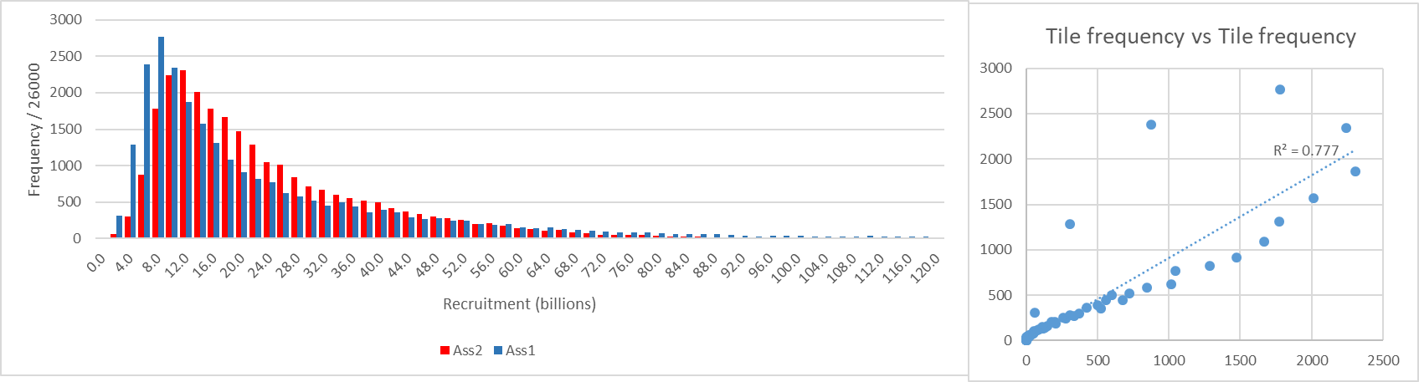
Figure 1. LHS: Histogram of the historic recruitment for off-peak years, for the HS function fitted internal to the stock assessment (RED: Ass2), or external (BLUE: Ass1), across all 26000 values given by the 26 off-peak years and 1000 Bayesian replicates. RHS: A plot of the tile frequencies from the LHS plotted against each other – the R-squared is shown on the RHS for a linear regression forced to pass through the origin. The value of $σ_{r}$ for the ‘internal’ stock assessments is close to 0.70, and for the ‘external’ stock assessments it is close to 0.95.

Methods
The Appendices (A,B, C, D and E) provide some technical and notational background to the methods that were used to explore different simulation approaches for sardine recruitment. Appendix A outlines how the S/R HS function parameters are fitted and how the value of ρ is obtained from these. Appendix B outlines a class of simulation procedures from which the final option was selected. Appendix C defines measures of goodness of ‘match’ between historical and simulated recruitment distributions and Appendix D clarifies how the simulation procedure is applied in practice. Appendix E provides some explanation of notation used.
The main variables that were dimensions of investigation by the TT were:
- Whether to match simulated recruitments to historical recruitments derived from the ‘internal’ or the ‘external’ stock assessments.
- Whether to use Bayesian replicate specific or invariant values for $σ_{r}$ and the serial correlation of recruitment ρ, and whether or not to include the serial correlation.
- Whether to allow for an additional bias factor over and above that which arises naturally from the log-transform and the value of $σ_{r}$.
- How precisely to assess the goodness of ‘match’ between historical and simulated recruitments. Just on mean, median and 5% and 95% percentiles, or on a visual impression or quantified measure of the agreement between frequency distributions such as those shown in Figure 1. Within the TT there were different opinions about this.
It is noted here that the simulations that were run to carry out these evaluations did not have access to nor make use of the actual operating models used for management strategy evaluations. Thus, the simulated recruitment values are not based on future simulated spawning biomass values according to resource dynamics. Rather they were based on the historical spawning biomass values estimated from the assessments, but excluding the values for the peak years 2000 to 2004. Also, note that as part of the work discussed here, substantial developmental work had to be done to improve the fitting procedure for the HS function parameters, details not reported here.

Results
The first result reported here is for a simulation approach that generated lognormally distributed recruitment values based on the variance of the historical recruitment as produced by stock assessments for which the S/R HS function, and associated recruitment variances, were fitted “internally”, and which attempted to ‘recover’ this distribution by using a Bayesian replicate invariant value of the variance of deviations of the logarithm of recruitment to simulate recruitment, but using replicate specific fits to the Hockey Stick (HS) stock and recruitment function. The value of $σ_{r}$ used was 0.698. The method did not involve the use of any serial correlation in recruitment as part of the simulations. The graphical results are shown in Figure 2. The match that was achieved between the simulated recruitment values and the historical value, distributionally, was very good. The means agreed at 23.0 billion, the medians agreed at 18.0 billion and the 5% and 95% values were very close: 6.1 vs 5.7 billion and 56.5 and 56.9 billion. At this stage however the TT was trying to achieve agreement with the recruitment values from the ‘internal’ assessment.
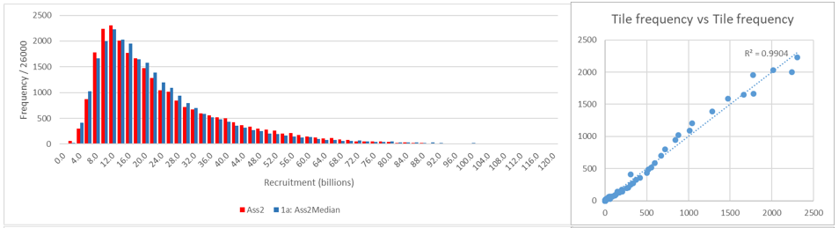
Figure 2. Testing to see whether a simulation approach (1a: Ass2Median) which uses a lognormal distribution with $σ_{r}=0.697$ reproduces the distribution of recruitments from the ‘internal’ stock assessments (Ass2). The match is very good and the means agree at 23.0 billion, the medians agree at 18.0 billion and 5% and 95% values are 6.1 vs 5.7 billion and 56.5 and 56.9 billion. At this stage of developments the TT was trying to achieve agreement with the recruitment values from the ‘internal’ assessment.
Shortly after Figure 2 was produced, attempts switched to trying to achieve agreement with the recruitment values from the ‘external’ assessments. There followed a series of investigations using various combinations of Bayesian replicate invariant values of $σ_{r}$ , inclusion of serial correlations, matching to the distribution of recruitment values produced by stock assessments for which the S/R HS function, and associated recruitment variances, were fitted “externally”. This schema was Bayesian replicate specific w.r.t. the recruitment parameters and the serial correlations. An additional bias correction factor was allowed for (termed ‘RAT”). The TT explored a number of different combinations of parameters $RAT$ and $σ_{R,fixed}$. The results shown here are the culmination of that process – this paper does not document all possibilities that were considered. Although the class of simulations schemes was explored for a range of different values of RAT and $σ_{R,fixed}$, at a certain point in the process the TT realized that the value of RAT could be held fixed at 1.00, and that it was only necessary to explore values of $σ_{R,fixed}$.
The results show the comparisons that are achieved at different values of p, and for the preferred approach which is described in Appendix D and which involves the use of serial correlation in recruitment with a Bayesian replicate invariant value of $σ_{r}$ = 0.90. These can be found as follows:
- Table 1 and Figure 3 for p=0.60
- Figure 4 for p=0.08
- Figure 5 for p=0.00
It is notable that the final value of $σ_{R,fixed}$ chosen, 0.90 – Bayesian replicate invariant, is less than the value estimated external to the stock assessments.

Acknowledgements
The work reported here was carried out in close collaboration with the PWG task team comprising Carryn de Moor, Doug Butterworth, Carl van der Lingen, Fannie Shabangu and Janet Coetzee, and benefitted substantially from input from the task team.

Table 1. New results, p=0.6.

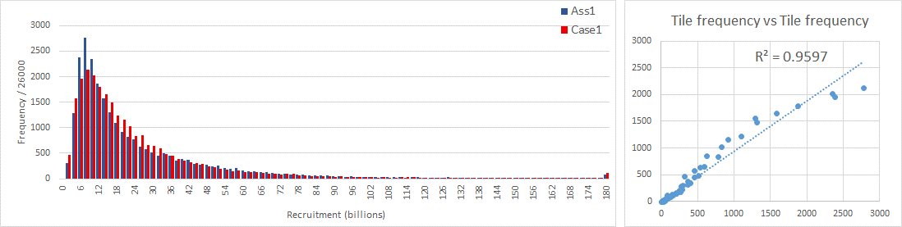

Figure 3. Results for p=0.6 corresponding to Table 1, $σ_{R,fixed}$=0.90.

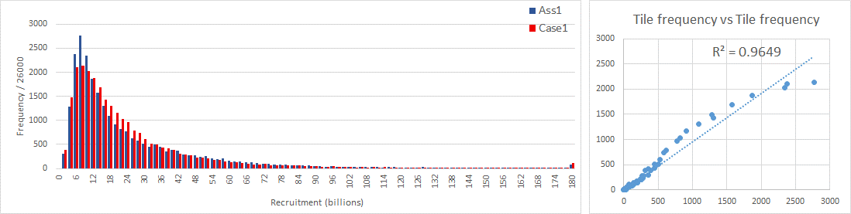

Figure 4. Results for p=0.08, $σ_{R,fixed}$=0.90.
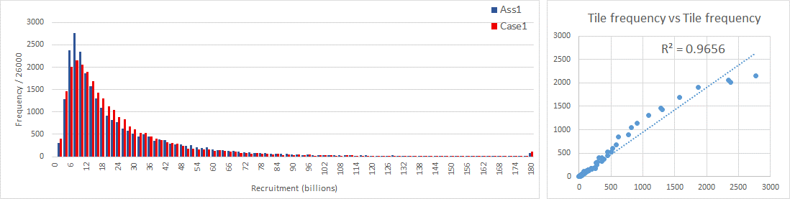

Figure 5. Results for p=0, $σ_{R,fixed}$=0.90.

Appendix A: Estimating relevant S/R parameters
The available data comprise the Ass1 Bayesian replicates of recruitment and spawning biomass on the West Coast, where index y refers to year and r to replicate. The years considered here exclude the peak recruitment years of 2000, 2001, 2002, 2003 and 2004, and thus run from 1984 – 1999 and 2005 – 2014 inclusive.
A hockey-stick (HS) model is fitted to the historic data for each replicate r, $(\left[\hat{R_{y,r}}\right],\hat{{SSB}_{y,r}), }$ by maximising the LF:
$LF=\prod_{y=1984}^{y=2014}{\left\{\frac{1}{\sqrt{2πσ_{R,r}^{2}}}e^{-{{\left(ln\left[\hat{R_{y,r}}\right]-ln\left[R_{y,r}^{pred}\right]\right)}^{2}}/{2σ_{R,r}^{2}}}\right\}} ∀ y<2000, y>2004$, [1]
w.r.t. the parameters a_{r} and b_{r} (i.e. different for each replicate) where
$R_{y,r}^{pred}=a_{r} for \hat{{SSB}_{y,r}}≥b_{r}$ [2]
$R_{y,r}^{pred}=\frac{a_{r}}{b_{r}}*\hat{{SSB}_{y}} for \hat{{SSB}_{y,r}}<b_{r}$, [3]
and where
$σ_{R,r}^{2}=\frac{\sum_{y=1984}^{y=2014}{{\left(ln\left[\hat{R_{y,r}}\right]-ln\left[R_{y,r}^{pred}\right]\right)}^{2}}}{\left(\sum_{y=1984}^{y=2014}{1}\right)-2} y<2000, y>2004$. [4]
Two serial correlation estimates are derived for the values $ln\left[\hat{R_{y,r}}\right]-ln\left[R_{y,r}^{pred}\right]$, one $ρ_{1,r}$ for the period 1984 – 1999, and another $ρ_{2,r}$ for the period 2001 – 2014. These are simply the correlations of values 1984 to 1998 against values 1985 to 1999, and of values 2005 to 2013 against 2006 to 2014. An overall correlation value $ρ_{r}$is then calculated as a weighted average
$ρ_{r}=\frac{15ρ_{1,r}+9ρ_{2,r}}{24}$ , [5]
being a “sample size-1” weighting of the correlations from each portion of the recruitment time series.

Appendix B: A class of simulation procedures
This section defines a class of prospective simulation schemes for future recruitment characterised by the parameters $RAT$ and $σ_{R,fixed}^{2}$. The selection of this class of simulations schemes is inspired by the properties of the log-normal distribution.
For the purpose of validating a prospective simulation scheme, for each replicate comprising 26 years of recruitment and spawning biomass values and fitted HS function, a corresponding set of 26 replicate specific recruitment values are generated by simulation, corresponding to the years 1984 – 1999 and 2005 – 2014. The simulated values are denoted $R_{y}^{sim}$ and are given by the formula:
$R_{y,r}^{sim}={RAT ×R}_{y,r}^{pred}e^{ε_{y,r}}$, [6]
where the values $ε_{y,r}$ are generated using two serially correlated time series, as follows:
$ε_{1984,r}\sim N(0, σ_{R,fixed}^{2})$ [7]
$ε_{y,r}=ρ_{r}ε_{y-1,r}+η_{y,r}\sqrt{1-ρ_{r}^{2}}$ where $η_{y,r}\sim N(0, σ_{R,fixed}^{2})$and 1985 $≤y≤1999$ [8]
$ε_{2005,r}\sim N(0, σ_{R,fixed}^{2})$ [9]
$ε_{y,r}=ρ_{r}ε_{y-1,r}+η_{y,r}\sqrt{1-ρ_{r}^{2}}$ where $η_{y,r}\sim N(0, σ_{R,fixed}^{2})$and 2006 $≤y≤2014$. [10]
The values RAT and $σ_{R,fixed}$ typify different cases of the simulation schema. These are real valued replicate invariant numbers, most likely lying on the interval (0.5,1.2). The actual values used were the subject of an iterative exploration process which was guided by the Task Team, eventually fixing on the finally recommended values for use in CMP performance evaluation studies.
Use of equation [6] means that the spawning biomass values implicit in the simulations [for purposes of validating the simulation schema only] are the historic spawning biomass estimates, in order, for the simulations for 1984 – 1999 and 2005 – 2014. Amongst other advantages of such an approach, it upholds the validity of the serial correlations based on the given values and order of $\hat{{SSB}_{y,r}}$.

Appendix C: Validation of simulation procedures
The TT’s choice of an appropriate simulation scheme was guided by comparing the degree of agreement between the distribution of recruitments generated by the simulation scheme and the distribution of the historic ASS1 recruitment values, with respect to the following values:
- $σ_{R,out}^{2}=\frac{\sum_{r=1}^{r=1000}{\sum_{y=1984}^{y=2014}{{\left(ln\left[\hat{R_{y,r}}\right]-ln\left[R_{y,r}^{sim}\right]\right)}^{2}}}}{\sum_{r=1}^{r=1000}{\sum_{y=1984}^{y=2014}{1^{}}}} y<2000, y>2004$ [16]
- Median of the distribution of recruitments (historic versus simulated).
- Mean of the distribution of recruitments (historic versus simulated).
- 5%-tile value of the distribution of recruitments (historic versus simulated).
- 95%-tile value of the distribution of recruitments (historic versus simulated).
- R-squared for a regression forced through the origin of the frequencies of fine-scale quantiles for the historic and simulated recruitment.
- $ρ^{2}$ for a regression forced through the origin of the frequencies of fine-scale quantiles for the historic and simulated recruitment.
[Note that for (1) there is no adjustment for the number of parameters in the estimation since (a) this estimation process does not happen in the simulations, and (b) the purpose of (1) is simply to verify that the input value of $σ_{R,fixed}^{2}$ is being achieved].
The definition of the last two of these measures is based on the frequencies of recruitment values (total count = 26000), $f_{i,case}$, that lie within the i-th recruitment bin, for bins that run from values 0-2 billion (i=1) up to 176-178 billion (i=89), and include as a final value the frequency if all recruitment values larger than 178 (i=90). “case” in $f_{i,case}$ refers to different versions of the simulation scheme, i.e. different combinations of the values $RAT$ and $σ_{R,fixed}^{2}$. $f_{i,Ass1}$ are the frequencies for the historic recruitment values obtained from stock assessments for which the recruitment function fit takes place external to the stock assessment fits. “R-squared” is the R-squared value of a linear regression of $f_{i,case}∀i$ against $f_{i,Ass1}∀i$ forced through the origin, and $ρ^{2}$ is the squared sample correlation between $f_{i,case}∀i$ and $f_{i,Ass1}∀i$.

Appendix D: Application of the simulation schema in CMP evaluation studies
The previous section used a particular approach of simulating recruitment values for given historic spawning biomass values so as to be able to validate the simulation schema, i.e. by checking how well the simulated recruitment values correspond to the historic Ass1 recruitment distribution. In forward simulations designed to test the performance of CMPs, different spawning biomass values will arise and therefore the simulation schema will be different.
The approach will be that for some y > 2014, and for a particular replicate r, population dynamics simulations will give rise to a value $\hat{{SSB}_{y,r}}$ for which there is an associated value of $R_{y,r}^{pred}$where
$R_{y,r}^{pred}=a_{r} if \hat{{SSB}_{y,r}}≥b_{r}$ [11]
$R_{y,r}^{pred}=\frac{a_{r}}{b_{r}}*\hat{{SSB}_{y}} if \hat{{SSB}_{y,r}}<b_{r}$. [12]
A simulated value of recruitment $R_{y,r}^{sim}$is now generated
$R_{y,r}^{sim}={RAT ×R}_{y,r}^{pred}e^{ε_{y,r}}$, [13]
where the values $ε_{y,r}$ are generated as a serially correlated time series:
$ε_{y,r}=ρ_{r}ε_{y-1,r}+η_{y,r}\sqrt{1-ρ_{r}^{2}}$ where $η_{y,r}\sim ℵ(0, σ_{R,fixed}^{2})$and $y≥2015$ [14]
and where
$ε_{2014,r}=ln\left[\hat{R_{2014,r}}\right]-ln\left[R_{2014,r}^{pred}\right]$. [15]

Appendix E: Notation
sim – a superscript sometimes used to denote simulated values
hist – a superscript sometimes used to denote historical values
pred – a superscript sometimes used to denote values derived from a deterministic equation without any stochasticity or observation errors.
fixed – a subscript used at times to indicate that the value referred to is Bayesian replicate invariant
$a_{r}$, $b_{r}$– Hockey Stick model parameters
r – an index denoting Bayesian replicate.
$ε_{y,r}$– logarithm of deviations of recruitment from model predicted values, for year y and Bayesian replicate r, either in historical estimates or future simulations.
$ρ_{r}$ – Bayesian replicate specific values of serial correlations in the $ε_{y,r}$
$η_{y,r}$– a random shock specific to year y and Bayesian replicate r, part of the equation for $ε_{y,r}$
$RAT$ – a bias correction factor explored in candidate simulation procedures, over above the bias factor that arises naturally from the log normal transformation for the normal distribution.
$R_{y,r}^{pred}$ – the recruitment value generated by the HS recruitment function, without any stochastic deviations.
$\hat{{SSB}_{y,r}}-$spawning biomass in year y and Bayesian replicate r
$\hat{R_{y,r}}$ – recruitment in year y and Bayesian replicate r
$σ_{R,fixed}^{2}$– a value representing the variance of the deviation of the logarithm of recruitment from the logarithm of the recruitment predicted by the HS S/R function, where the subscript ‘fixed’ denotes that it
$σ_{r}^{2}$– often used interchangeably with $σ_{R,fixed}^{2}$, or in square rooted form $σ_{r}$
$σ_{R,out}^{2}$ – the value of $σ_{r}^{2}$ that can be calculated from the simulated values of recruitment
$σ_{R,r}^{2}$ the value of $σ_{r}^{2}$ in a particular context as defined
ρ – the serial correlation in the values of $ε_{y,r}$.
$ρ_{r}$ – a replicate specific value for the serial correlation in the value of $ε_{y,r}$
$ρ_{1,r}$ – a replicate specific value for the serial correlation in the value of $ε_{y,r}$ for 1984 to 1999.
$ρ_{2,r}$ – a replicate specific value for the serial correlation in the value of $ε_{y,r}$ for 2005 to 2014.
$f_{i,case}$– the frequencies for the historic recruitment values obtained from stock assessments for which the recruitment function fit takes place external to the stock assessment fits.
$σ_{r}^{emp}$ – a version of $σ_{r}$, the empirical estimate obtained from the sequence of historical estimates $ε_{y,r}$
$σ_{r}^{pen}$ – a version of $σ_{r}$, the value which is usually included in the log-likelihood term which penalises estimates of $ε_{y,r}$ which do not conform to a normal distribution with variance ${\left(σ_{r}^{pen}\right)}^{2}$
$σ_{r}^{bias, hist}$ – a version of $σ_{r}$, the value used in the bias correction equation (8) which has been recast as $R_{y,r}^{hist}=\left(\frac{{α_{r}SSB}_{y,r}}{β_{r}+{SSB}_{y,r}}\right)e^{ε_{y,r}-{\left(σ_{r}^{bias, hist}\right)}^{2}/2}$
$σ_{r}^{bias, sim}$ – a version of $σ_{r}$, the value used in the bias correction equation (10) which has been recast as $R_{y,r}^{sim}=\left(\frac{{α_{r}SSB}_{y,r}}{β_{r}+{SSB}_{y,r}}\right)e^{ε_{y,r}-{\left(σ_{r}^{bias, sim,}\right)}^{2}/2}$
$σ_{r}^{sim}$ – a version of $σ_{r}$, the value used to generate the $ε_{y,r}$ values in $R_{y,r}^{sim}=\left(\frac{{α_{r}SSB}_{y,r}}{β_{r}+{SSB}_{y,r}}\right)e^{ε_{y,r}-{\left(σ_{r}^{bias, sim,}\right)}^{2}/2}$

PWG – Pelagic Working Group
The stock recruitment function parameters are fitted at the same time as all other stock assessment parameters are fitted.
The stock recruitment function parameters are fitted after and in a completely differed calculations to the one used to estimate all other stock assessment parameters.
Ass1 refers to the stock assessments that were run with the S/R function fitting being ”external” to the stock assessment fits, as described elsewhere in this document.

