**An Overview of the South African Linefish fishery**

Denham Parker1, Henning Winker1, Sven Kerwath1,2 & Colin Attwood2

*1DAFF - Department of Agriculture, Forestry and Fisheries, Private Bag X2, Rogge Bay 8012, South Africa.*

*2Department of Biological Sciences, University of Cape Town, Cape Town, South Africa*

**Overview**

Linefishing in South Africa is defined as the capture of fish with hook and line, but excludes the use of longlines. Together, the three sectors of the linefishery (commercial, recreational and small-scale/subsistence) target between 95 and 200 of South Africa’s 2,200 marine fish species. Target species include temperate, reef-associated seabreams (e.g. roman, hottentot seabream, santer and slinger), coastal migrants (e.g. geelbek and dusky kob) and nomads (e.g. snoek and yellowtail). More than 90% of the current linefish catch is derived from the aforementioned eight species.

The commercial linefishing sector is exclusively boat-based. The total number of registered vessels operating in this sector was estimated at 700 in the late 1990s, which accounted for 37% of all commercial fishing boats operating in marine fisheries in South Africa. From 2006 a maximum allocation of 455 boats has been maintained, however the number of boats allocated per zone has varied. Line-fishing is a low-earning, labour-intensive industry, important from a human livelihood point of view. Employing an estimated 27% of all fishers, it has the lowest average employment income of all South African fisheries. Although the commercial linefishery has the largest fleet, it contributes only 6% of the total estimated value all South African marine fisheries.

After the introduction of the towable ski-boat in the late 1940s, the recreational boat-based sector expanded rapidly, with an estimated minimum number of 4,000 vessels. Landings from this open-access recreational fishery are not reported throughout the region, and for some areas and species, the total catch from this sector could be equivalent to that reported by the commercial sector. The recreational linefishery has by far the largest number of participants (>450 000) of all fishery sectors in South Africa and consequently has great economic value.

Recently, the small-scale/subsistence sector was legally created to recognize those fishers who depend on marine living resources for direct food security – usually very poor coastal communities or those using simple traditional methods. There are an estimated 30,000 small-scale fishers active along the South African coastline and 85% of them harvest linefish.

**History and Management**

The origins of linefishing in South Africa can be traced back to the fishing activities of indigenous Khoi people and European seafarers in the 1500s. Despite an abundance of fish, the fishery was slow to develop in the 1700s due to various restrictions implemented by the Dutch administration. These fishing restrictions were removed when the British captured the Cape Colony in 1795, and during the 1800s boat-based linefishing developed into a thriving industry.

Despite its long history, the first comprehensive management framework for the linefishery was only introduced in 1985 when this fishery was formally recognised. However, successive research surveys indicated continuing declines in linefish resources. In December 2000, the Minister of Environmental Affairs and Tourism, taking cognisance of the critical status of many linefish stocks, declared linefish resources to be in a State of Emergency, as provided for in the Marine Living Resources Act (MLRA, Act 18 of 1998). Effort was reduced and fixed at 450 vessels and the hake and tuna components were developed into separate sectors. To rebuild collapsed stocks and to achieve a sustainable level of utilisation, a Linefish Management Protocol was developed in 1999 in order to base regulations in the linefishery on quantifiable reference points. This remains the basis of linefish management.

A number of regulations were put in place to manage fishing pressure on linefish resources. Due to the large number of users, launch sites and species targeted, and to flexibility of the operational range, the commercial linefishery is currently managed through a Total Allowable Effort (TAE) allocation, based on boat and crew numbers. The recreational fishery is managed by a number of output restrictions, such as size and bag limits, closed areas and seasons. The small-scale fishery will also be managed through a combination of size and bag limits, closed areas and seasons. However, this sector differs in that community-based management is the core principle on which the small-scale sector is based and local communities are encouraged and empowered to promote sustainability.

**Research and Monitoring**

Monitoring of the boat-based linefishery in the Cape was introduced by Dr JDF Gilchrist in 1897, in the form of a shore-based observer programme that aimed to record statistics on catch and effort at all the fishing centres. Comprehensive per-species catch-and-effort data from the boat-based commercial fishery have been collected since 1985 and stored in the National Marine Linefish System (NMLS). A national observer programme was implemented from 2008 until 2010, in which scientific observers recorded catch-and-effort data and collected size frequencies per species from the boat-based fishery at access points around the country.

The biology of the fish caught in the linefishery has been remarkably well studied considering the large variety of target species in comparison with other fisheries, as evident from the published linefish species profiles that contains information on life-history, ecology and population status of 139 linefish species.

Assessing the status of linefish stocks has been a priority in recent years. Drawing on the enormous body of data contained in the NMLS, the largest spatially-referenced marine dataset in the world, a novel method to standardize Catch Per Unit Effort (CPUE) data that accounts for targeting in the multi-species linefish sector has been developed. Following on, a comprehensive Bayesian State-Space Surplus Production Model framework (JABBA: Just Another Bayesian Biomass Assessment) was developed and applied to the eight most important species, namely slinger (*Chrysoblephus puniceus*), carpenter (*Argyrozona argyrozona*), hottentot seabream (*Pachymetopon blochi*), snoek (*Thyrsites atun*), yellowtail (*Seriola lalandi*), santer (*Cheimerius nufar*) and silver kob (*Argyrosomus inodorus*).

In situations whereby traditional stock assessment methods are not applicable, alternative methods have been applied. For rare linefish species, such as red steenbras and dageraad that are caught infrequently and are subject to stringent bag and size limits, a novel approach based on encounter probabilities in the catch has been applied. Application of this fairly robust method confirms the continuous decline of these once abundant species to critically low levels. These two species are now of serious conservation concern and have been included on the IUCN threatened species list as endangered. Furthermore, a unique spatio-temporally disaggregated model has been successfully applied to geelbek (*Atractoscion aequidens*) as this species undertakes a complex, size-dependent migration. Sector-specific assessments, such as that of white stumpnose (*Rhabdosargus globiceps*) which quantifies the relative contribution of the commercial and recreational fishing sectors to the species’ decline in Saldanha bay, seek to address equality issues that arise in a multi-sector fishery.

**Current Status**

The results of stock assessments performed in 2017 indicate that the drastic reduction of fishing effort from 2003 resulted in the partial recovery of some species, such as the slinger, santer, hottentot seabream and carpenter. However, other important stocks such as silver kob are still being overfished, due to the cumulative impact of the linefishery and inshore-trawl fishery on this species. The yellowtail assessment suggests the stock is optimally exploited, while snoek remains underexploited. The annual catch of the nomadic yellowtail and snoek is dependent on their availability to the nearshore linefishers and is, therefore, highly variable. Moreover, the inconsistent quality of yellowtail and snoek landed by the linefishery detracts from the optimal use of these important stocks. There is also considerable inter-fishery conflict around these species which are also caught by other fisheries (i.e. trawl and hake handline fishery in the case of snoek and tuna-pole and beach seine net fisheries in the case of yellowtail).

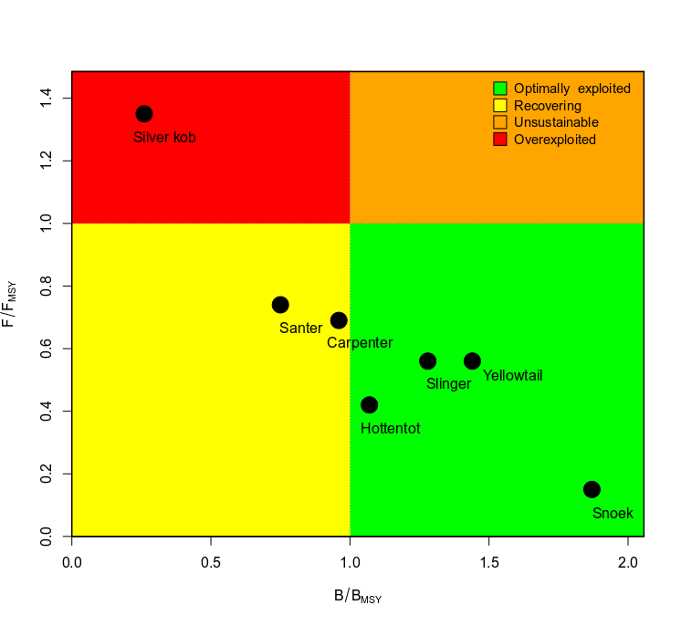

**Figure 1:** Kobe phase plot summarizing the stock status estimates of fishing mortality relative to FMSY and biomass relative to BMSY for linefish species. Only results from stock assessments conducted by the Linefish Scientific Working Group (LSWG) in 2017 are included.

**Table 1:** Reported annual catch (t) of the eight most important linefish species for the period 1985 to 2017.

|  |  |  |  |  |  |  |  |  |
| --- | --- | --- | --- | --- | --- | --- | --- | --- |
| **Year** | **Snoek** | **Yellowtail** | **Kob** | **Carpenter** | **Slinger** | **Hottentot seabream** | **Geelbek** | **Santer** |
| 1985 | 1063 | 324 | 1504 | 588 | 312 | 399 | 152 | 73 |
| 1986 | 3143 | 817 | 2016 | 768 | 268 | 811 | 262 | 99 |
| 1987 | 5642 | 809 | 1902 | 831 | 246 | 915 | 436 | 99 |
| 1988 | 4919 | 722 | 1822 | 877 | 132 | 953 | 482 | 57 |
| 1989 | 4039 | 868 | 2097 | 775 | 199 | 739 | 810 | 60 |
| 1990 | 7892 | 585 | 2540 | 1228 | 262 | 542 | 513 | 86 |
| 1991 | 6556 | 542 | 2082 | 1210 | 249 | 522 | 457 | 89 |
| 1992 | 5692 | 591 | 1799 | 873 | 305 | 496 | 530 | 114 |
| 1993 | 2948 | 888 | 1867 | 695 | 298 | 614 | 610 | 124 |
| 1994 | 7759 | 868 | 1348 | 638 | 217 | 815 | 468 | 82 |
| 1995 | 9618 | 801 | 1422 | 758 | 235 | 252 | 396 | 85 |
| 1996 | 7063 | 497 | 1415 | 879 | 179 | 276 | 384 | 80 |
| 1997 | 6623 | 488 | 1471 | 841 | 128 | 322 | 524 | 68 |
| 1998 | 7872 | 565 | 1331 | 518 | 114 | 408 | 684 | 64 |
| 1999 | 8348 | 339 | 1026 | 574 | 160 | 270 | 467 | 60 |
| 2000 | 6543 | 320 | 1093 | 441 | 186 | 234 | 894 | 75 |
| 2001 | 6839 | 327 | 831 | 285 | 139 | 109 | 395 | 69 |
| 2002 | 3837 | 242 | 784 | 231 | 101 | 79 | 315 | 48 |
| 2003 | 4532 | 329 | 544 | 177 | 88 | 106 | 513 | 48 |
| 2004 | 7278 | 883 | 720 | 228 | 184 | 254 | 672 | 87 |
| 2005 | 4787 | 739 | 647 | 184 | 169 | 168 | 580 | 84 |
| 2006 | 3529 | 310 | 800 | 159 | 192 | 87 | 419 | 79 |
| 2007 | 2765 | 478 | 841 | 265 | 157 | 128 | 448 | 84 |
| 2008 | 5223 | 313 | 715 | 226 | 194 | 120 | 403 | 82 |
| 2009 | 6322 | 330 | 884 | 282 | 186 | 184 | 495 | 66 |
| 2010 | 6360 | 171 | 838 | 263 | 180 | 144 | 408 | 69 |
| 2011 | 6205 | 204 | 625 | 363 | 214 | 216 | 286 | 62 |
| 2012 | 6809 | 382 | 441 | 300 | 240 | 160 | 337 | 82 |
| 2013 | 6690 | 712 | 313 | 481 | 200 | 173 | 263 | 84 |
| 2014 | 3863 | 987 | 289 | 522 | 201 | 192 | 212 | 74 |
| 2015 | 2104 | 609 | 246 | 522 | 186 | 143 | 244 | 69 |
| 2016 | 1681 | 475 | 277 | 713 | 211 | 211 | 250 | 66 |
| 2017 | 1888 | 361 | 199 | 820 | 215 | 188 | 148 | 72 |

**Further Reading**

Attwood CJ, Booth T, Kerwath S, Mann B, Marr S, Bonthuys J, Duncan J, Potts W (eds). 2013. A decade after the emergency. WWF South Africa Report Series - 2013/Marine/001. Cape Town: WWF. 288 pp

Kerwath SE, Winker H, Götz A, Attwood CG. 2013. Marine protected area improves yield without disadvantaging fishers. *Nature Communications* 4: 2347.

Mann BQ (ed). 2013 South African Marine Linefish Species Profiles, Oceanographic Research Institute, Special Publication No 9. Published by South African Association of Marine Biological Research, Durban, 357 pp.

Parker D, Kerwath S, Næsje T, Arendse C, Keulder-Stenevik F, Hutchings K, Clark B, Winker H, Cowley PDP, Attwood CG. 2017. When plenty is not enough: an assessment of the white stumpnose (*Rhabdosargus globiceps*) fishery of Saldanha Bay, South Africa. *African Journal of Marine Science* 39: 153–166.

Parker D, Winker H, Attwood CG, Kerwath SE. 2016. Dark times for dageraad *Chrysoblephus cristiceps*: evidence for stock collapse. *African Journal of Marine Science* 38: 341–349.

Winker H, Attwood CG, Kerwath SE. Assessment of stock abundance of inshore fish resources included in the basket of species to be allocated under the small-scale fisheries policy. Linefish Scientific Working Group Report. LSWG Jan 2015/1. 69 pp.