Investigation into the process error in biomass dynamics of fishes

Henning Winker¹

¹ DAFF - Department of Agriculture, Forestry and Fisheries, Private Bag X2, Rogge Bay 8012, South Africa.

Summary
Simultaneous estimation of both process and observation variance in biomass surplus production models has received notable attention within the field of quantitative fisheries science. Yet, the expectation about the likely magnitude of the process error for the natural variations in the biomass dynamics is often vague. In this paper, I conduct two simulation experiments to (1) explore the implications of the alternative formulations for the multiplicative lognormal process error term in the process equation of surplus productions models and (2) explore the expected ranges of process errors based on stochastic age-structured biomass dynamics of seven selected species from seven families that cover a broad range of life history strategies. From the first experiment I found that including the action of process error after catches produces an almost exact match between the process error recovered from simulated biomass trajectories and the ‘true’ input value, whereas including the action of process error before catches resulted in positive bias relative to the input value. The results from my second experiment suggest that increases in fishing pressure are likely to increase the process error, which I attribute to truncation of the age-structure and weaker density dependence at low biomass levels. The here developed age-structured approach to biomass-dynamic process errors could become of use for the developing informative priors for process errors for data limited situations, as well as diagnostic tools that can aid in identifying potential model misspecifications.

Keywords: Process error, biomass dynamics, state-space surplus production models, age-structured simulation

1. Introduction
Surplus productions models (SPMs) are typically formulated in the form of a discrete process equation to model the unobservable biomass B_{y} in year y:

$B_{y+1}=\left\{\begin{matrix}{(B}_{y}+g\left(B_{y}\right)-C_{y})e^{η_{y}} & if catches occur before the action of process errors \\ {(B}_{y}+g\left(B_{y}\right))e^{η_{y}}-C_{y} & if catches occur after the action of process errors\end{matrix}\right.$ (1)

and an observation equation that scales the observed relative abundance index $I_{y}$to B_{y} via a catchability coefficient q:

$I_{y}=qBe^{ε_{y}}$ (2)

where $g\left(B_{y}\right)$ is the surplus production function that can take various forms (Fox, 1970; Pella and Tomlinson, 1969; Schaefer, 1957). The term $η_{y}$ denotes the process error residuals and $ε_{y}$ the observation error term, which are both conventionally treated as multiplicative lognormal random variables with:

$η_{y}\text{\sim }Normal\left(0,σ_{η}^{2}\right)$ and $ε_{y}\text{\sim }Normal\left(0,σ_{ε}^{2}\right)$ (3)

where $σ_{η}^{2}$ and $σ_{ε}^{2}$ are the process variance and observation variance, respectively. I note for later reference that placing the process error outside the process equation has become common practice for SPM state-space formulations (Brodziak and Ishimura, 2012; Meyer and Millar, 1999; Ono et al., 2012; Punt, 2003; Winker et al., 2018a), although this may appear somewhat counter-intuitive as it includes catch term. Mechanistically, these two formulations correspond to different assumptions about the timing of density dependence relative to catches.

The process error can account for model structural uncertainty (Thorson et al., 2014b) as well as natural variability of stock biomass due to stochasticity in recruitment, natural mortality, growth, and maturation (Meyer and Millar, 1999; Punt, 2003), whereas the observation error determines the uncertainty in the observed abundance index due to measurement error, reporting error and other unaccounted variations in catchability (Francis, 2011; Francis et al., 2003). Ignoring the observation error easily leads to overfitting and loss of predictive power, whereas ignoring the process error can results in biased stock status estimates and typically poorly estimated precision (Ono et al., 2012; Punt, 2003; Thorson and Minto, 2015).

Over the past two decades, there has been considerable progress in optimizing the fitting procedures to estimate both observation and process errors. These approaches can be broadly summarized into (1) applying mixed-effects model techniques (Punt, 2003; Thorson and Minto, 2015) and (2) Bayesian state-space formulations (McAllister et al., 2000; Meyer and Millar, 1999; Winker et al., 2018a). A frequent challenge for both approaches is that simultaneous estimation of observation and process errors often requires constraining the process error to achieve model convergence. Available mixed-effect model applications typically revert to constraining the process error by imposing a fixed process to observation error ratio of $\frac{σ_{η}}{σ_{ε}}=c$, where $c$ is often prespecified at $1.0$ (Pedersen and Berg, 2016; Punt, 2003; Thorson and Minto, 2015). In Bayesian state-space frameworks, the choice of using inverse-gamma priors on the process error variance appears to have established since the early work by Meyer and Miller (1999). Specifications of non-informative inverse-gamma priors typically have the form $p\left(x\right)\sim 1/gamma(0.001,0.001)$ (Chaloupka and Balazs, 2007; Zhou et al., 2011), which is practically equivalent to the Jeffrey’s prior $p\left(x\right)\sim 1/x$ for precision estimates (Meyer and Millar, 1999). However, the efficient use of non-informative priors on the process variance usually requires unbiased and sufficiently informative data, which is probably rather the exception (Winker et al., 2018b) than the norm (Brodziak and Ishimura, 2012; Meyer and Millar, 1999; Mourato et al., 2018; Parker et al., 2018). As a result, it is common place to use informative priors (Meyer and Millar, 1999; Winker et al., 2018a) or even fixing the process error (McAllister, 2014, 2000). However, the underlying assumptions about the expected magnitude of the process error often remain opaque. The existing ambiguity of process error assumptions among analysts highlights the need for research to improve the predictability of the process error. I envision that improved information regarding the magnitude of process errors can aid in developing informative process error priors for data limited situations as well as diagnostic tools to identify potential model misspecifications (Thorson et al., 2014b).

In this paper, I use simulations to further investigate the process error of the biomass dynamics of fishes. This work was specifically motivated by the two following recommendations that were made by International Panel of Fisheries Stock Assessment Workshop that took place in 2017 in Cape Town (http://www.maram.uct.ac.za/ maram/workshops/2017):
- Sensitivity should be explored to the catch term not being affected [by the timing of process error].
- Ideally, the posterior for the process error variance [on the biomass] should be comparable to the variation in spawning biomass obtained by projecting the age-structured model forward for many years without catches, but with process error.

To address (1), I considered three alternative stochastic formulations that place the process error: (i) after catches, (ii) before catches and (iii) directly on r (or effectively on the production function). I then proceed by with a generic simulation experiment to compare the process errors derived from simulated biomass dynamics with the ‘true’ value used in the simulation model.

To address (2), I developed a generalized age-structured simulation tool that is designed to simulate spawning biomass trajectories and then extract the process error distributions for practically all fishes under varying fishing pressures. For my simulation experiment, I formulate the hypothesis that process error of the annual variation in log-biomass will increase under increasing fishing pressure as a result of truncation of the age-structure and weaker density dependence. To test is hypothesis for a wide range of life history strategies of marine fishes I select seven species from seven families. These were (1) very short-lived, small pelagic South African anchovy (Egraulis capensis; Egraulidea); (2) the larger and longer-lived small pelagic pilchard (Sardinops sagax; Clupeidae), (3) the highly-migratory albacore tuna (Thunnus alalunga; Scombridae); (4) demersal deep-water cape hake (Merluccius paradoxus; Gadidae); (5) the moderately long-lived; rockfish Bocaccio (Sebastes paucispinis; Sebastidae); (6) the early maturing but fairly long-lived South African silver kob (Argyrosomus inodorus; Scienidae) and (7) the slow-growing, long-lived South African carpenter seabream (Argyrozona argyrozona; Sparidae).

2. Material and Methods

2.1 Evaluating sensitivity to the location of the process error
For the first experiment, I formulated three alterative the Schaefer process equations by changing the position of the process error residuals $η_{y}$:

$B_{y+1}=\left\{\begin{matrix}{(B}_{y}+rB_{y}\left(1- \frac{1}{K}\right)-F_{y}B_{y})e^{η_{y}} & after catch \\ \left(B_{y}+rB_{y}\left(1- \frac{1}{K}\right)\right)e^{η_{y}} -F_{y}B_{y}) & before catch \\ B_{y}+re^{η_{y}}B_{y}\left(1- \frac{1}{K}\right)-F_{y}B_{y}) & on productivity per biomass\end{matrix}\right.$ (5)

where r is the intrinsic rate of population increase, K the carrying capacity and catch is given by $C_{y}{=F}_{y}B_{y}$ where $F_{y}$ is the fishing mortality in year y. For convenience I will refer to the three formulations as AC (after Catch), BC (before Catch) and PB (productivity per biomass).

For the simulation experiment, I randomly generated 1000 replicates k of biomass trajectories over a 200 years for BC, BO and PO under a constant value of $F=1.5F_{MSY}$, where $F_{MSY}=r/2$. The time frame was divided into a 100 year “burn-in” period and a 100 year evaluation period. The reasoning for choosing a constant F design was that under deterministic biomass trajectory would eventually attain become stationary, given a sufficiently long burn-in period, so that the year-to-year variation in biomass can be directly attributed to process error in the biomass dynamics. The models was initiated by setting B₁ = K. For illustration, the parameters for Schaefer models were initially fixed at r = 0.3, K = 1000 and $σ_{η}$= 0.1, but I also explore the effects of varying r, $σ_{η}$ and the multiplier of $F=xF_{MSY}$, by sampling from uniform distributions of $r\sim U\left(0.05,0.5\right)$ $σ_{η}\sim U(0.05,0.15$) and $x\sim U(0,3$) and increasing the number of replicates to 5000 per treatment. During each run, a new, process error vector was randomly generated:

$η_{y,k}\sim Normal\left(0,σ_{η}^{2}\right)-0.5σ_{η}^{2}$ (7)

and passed on to each of the three Schaefer model process equations.

To recover the underlying process errors ${\tilde{σ}}_{η,k}$ from the simulated biomass trajectories, I first calculate the annual process error residual from the annual changes in log(B_{y}) over the 100 years long evaluation period, such that:

${\tilde{η}}_{y,k}=\log\left(B_{y,k}\right)-\log\left(B_{y-1,k}\right)$ (8)

I then took the standard deviation of ${\tilde{η}}_{y,k}$ to obtain the simulation-derived values of ${\tilde{σ}}_{η,k}$ for comparison with the ‘true’ input value $σ_{η}$= 0.1.

2.2 Predicting process error from age-structured simulations
With my second simulation experiment, I seek to explore the expected ranges of process errors using simulated age-structured biomass dynamics of fishes. To do this, I developed an age-structured simulator to generate spawning biomass trajectories (SB_{y}) under varying levels of constant fishing morality F (see Section 2.1). Varying fishing pressure is considered here to test my hypothesis that natural variation in in biomass increases (on log-scale) under increasing fishing pressure due truncation the age-structure and increasing contribution of incoming recruits to biomass. To limit complexity, I made the simplified assumption that the natural stochasticity in biomass dynamics is mostly driven by the interplay between life history traits and variations (steepness, variance and auto-correlation) in recruitment strength (Thorson et al., in press), while ignoring additional effects, such as time-varying age-dependent natural mortality (Millar and Meyer, 2000).

To objectively generate the required age-structured input parameters for the age-structured simulator, I linked the random data generation process to the novel “Data-Integrated Life History” (DILH) model, which is implemented in the R package FishLife 2.0 (Thorson, in press). This model extends the multivariate hierarchical life history model from FishLife1.0 (Thorson et al., 2017; https://github.com/James-Thorson/FishLife) by way of integrated analysis of all life history parameters from FishBase (www.fishbase.org) and spawning-recruitment data series from the RAM Legacy Database (Ricard et al., 2012) to predict the recruitment compensation and variability (variance and autocorrelation) in recruitment for all fishes (Thorson et al., in press b). I then sampled the stock parameters, describing growth, maturation, mortality, longevity and recruitment, from the predicted multivariate distributions via the FishLife 2.0 package, with the aim to propagate parameter uncertainty and correlation structure into the simulated spawning biomass dynamics permutations.

2.2.1 Age-structured dynamics
The basic population dynamics are governed by the numbers-at-age a and year y, N_{a,y}:

$N_{a,y}=\left\{\begin{aligned}R_{y} \\ N_{a-1,y-1}e^{-s_{a,S}F_{y-1}M}\end{aligned}\right.$ (9)

where R_{y} is recruitment in year y, s_{a,s} is fishery selectivity at age under selectivity regime s, M is the instantaneous rate of natural mortality, and F_{y} in year y.
Spawning biomass SB_{y} is expressed as:

${SB}_{y}=\sum_{a}{w_{a}ψ_{a}N_{a,y}}$ (10)

where $w_{a}$ is the weight at age, $ψ_{a}$ is the proportion of mature fish in the populations. I assume for simplicity that growth can be adequately described by the von Bertalanffy growth function (VBGF) parameters $L_{∞}$, $κ$ and $a_{0}$ for the ages 0 to $a_{max}$, maturity-at-age and weight-at-age are known without error and that selectivity for the fishery and maturity for the population can be approximated as being knife-edged at a known age-at-maturity $a_{mat}$.

I assume that stochastic recruitment follows the Beverton and Holt spawner-recruitment function, which I formulate as a function of the steepness parameter h, SB_{y} and average spawning biomass SB₀ and recruitment R₀ of the unfished stock:

$R_{y}=\frac{4hR_{0}SB_{y}}{{SB}_{0}\left(1-h\right)+SB_{y}(5h-1)}e^{ε_{y}}$ (11)

where $ε_{y}$ describes the variations about the spawning-recruitment relationship that follow a first-order auto-regression model (Corrigendum: Thorson et al., 2014a). The first-order auto-regression (AR1) equation has the form:

$ε_{y}=\left\{\begin{aligned}δ_{y}-0.5σ_{R}^{2} for y=1 \\ ρε_{t-1}+δ_{y}\sqrt{1-ρ^{2}}-0.5σ_{R}^{2} for y>1\end{aligned}\right.$ (12)

where $ρ$ is the auto-correlation coefficient and $δ_{y}$ is a normally distributed variable:

$δ_{y}\sim Normal\left(0,σ_{R}^{2}\right)$ (13)
2.2.3 Generation of input parameters
I randomly sampled 1000 random sets of the life history input parameters ${\tilde{L}}_{∞_{i,k}}$, ${\tilde{κ}}_{i,k}$, ${\tilde{M}}_{i,k}$, ${\tilde{a}}_{{mat}_{i,k}}$ , ${\tilde{a}}_{\max_{i,k}}$and the recruitment parameters ${\tilde{h}}_{i,k}$,${\tilde{ρ}}_{i,k}$ and ${\tilde{σ}}_{R_{i,k}}$ for species i and permutation k from multivariate normal (MVN) distributions that were predicted with the “data-integrated life history” model from the R package FishLife2.0 (Thorson, in press). On species level, the multivariate prediction model can then be used to produce the expected mean values ${\hat{y}}_{{spec}_{i,j},}$ and covariance matrix${Cov}_{{spec}_{i,j}}$ for species i and the life history and recruitment parameters j. The expected values and covariance are typical predicted on log-scale, except that $ρ$ is normally distributed $ρ$ and h is transformed by a logit function that constrains the range of untransformed values to h = 0.21-0.99. I then applied a multivariate random generator in R to generate 1000 random sets of input parameters, such that:

${\tilde{y}}_{{spec}_{i,j,k}}\sim MVN({\hat{y}}_{{spec}_{i,j},}{Cov}_{{spec}_{i,j}})$ (14)

The parameters describing the weight-length relationship and theoretical age at zero length a₀ are by default fixed to $w_{a}=0.01{L_{a}}^{3}$ and a₀ = -0.1, unless they are provided as use-defined value. In addition, I developed a generic routine to provide a user option for including one or more user defined stock parameters. This routine first separates ${\hat{y}}_{{spec}_{i,j}}$ into user-defined parameters and undefined parameters. The user-defined parameters are then used and linear predictor variables related to the undefined parameters via a simple linear MVN regression. The MVN regression is then used to predict the update the undefined parameters of the new vector ${\hat{y}}_{{stock}_{i,j}}$. For example, if a user-defined estimate of the length-at-maturity were to be larger than the predicted mean from FishLife, age-at-maturity would be adjusted upward given this new information. I only applied this routine to adjust the predicted growth and maturity for carpenter and silver kob to the stock-specific estimates presented in (MARAM-IWS2018-Linefish P2 & P3).

2.2.4 Simulation experiment
Similar to the simulation design under 2.1, I divided the simulation time frame was into a 200 year “burn-in” period and a 100 year evaluation period. I explored three alternative constant fishing pressures scenarios as: (i) unfished with F = 0, (ii) sustainably fished with F = M and (iii) overfished with F = 2M.

To extract the process errors ${\tilde{σ}}_{η,k}$ from 1000 simulated spawning biomass trajectories for species i and replicate k, I calculated the annual process error residual from the stationary variation in biomass given constant F over the 100 years long evaluation period:

${\tilde{η}}_{yi,,k}=\log\left(SB_{i,y,k}\right)-\log\left(SB_{i,y-1,k}\right)$ (15)

and then obtained the process error ${\tilde{σ}}_{i,η,k}$ of the biomass dynamics as the standard deviation of ${\tilde{η}}_{i,y,k}$.
The resulting simulation posterior distribution of ${\tilde{σ}}_{i,η,k}$ were then summarized by species i in terms the geometric and standard deviation of log(${\tilde{σ}}_{i,η,k}$) by making the assuming that ${\tilde{σ}}_{η,k}$ is approximately lognormal distributed.

3. Results
3.1 Sensitivity to the location of the process error
The simulation results indicated that the burn-in period was sufficient long for the biomass to vary around a stationary mean biomass over the evaluation period (Fig. 1). I find that, for the reference case (r = 0.3, F = 1.5F_{MSY}, $σ_{η}$= 0.1), the ‘true’ process error of $σ_{η}$= 0.1 could be almost exactly recovered from the annual variation in log(B_{y}) when catch occurred before the process error action (Fig. 1). If catch occurred after the process error action, the simulated process was inflated by more than 25% relative to the “true” input value $σ_{η}$= 0.1. Placing the process error as a multiplicative lognormal error on r resulted decreased the variation in log(B_{y}) by almost one order of magnitude compared to the other two formulations (Fig. 1). Next, I explored of the effects of varying on of the input parameters r, $σ_{η}$, $F/F_{FMSY}$ at the time and then plotting those against the ratios of the simulation estimate ${\tilde{σ}}_{η,k}$ to the ‘true’, now randomized, input values $σ_{η,k}$ (${\tilde{σ}}_{η,k}/σ_{η,k})$. The results for AC showed stationary behaviour around ${\tilde{σ}}_{η,k}/σ_{η,k}\sim 1$ when plotted against r and $σ_{η}$. Varying $F/F_{FMSY}$, however, showed a slight positive bias on ${\tilde{σ}}_{η,k}/σ_{η,k}$ (≤ +10%) towards $F/F_{FMSY}$ = 0, which disappeared at higher exploitation levels at around $F/F_{FMSY}$> 1.5 (Fig. 2). For BC and PB, the ratio ${\tilde{σ}}_{η,k}/σ_{η,k}$ showed strong positive correlation with r and $F/F_{FMSY}$, but no correlations with $σ_{η}$ (Fig. 2).

3.2. Predicting process error from age-structured simulations
The age-structured Monte-Carlo simulation results showed general support for out hypothesis that the process error increase for stocks at low biomass levels (Table 1). For most species this increase in the process error exceed a factor of three between the unfished (F = 0) and heavily exploited state (F = 0) (Table 1). Not unsurprisingly, the simulated biomass dynamics for the two small pelagic species, South African anchovy and pilchard, were associated with the highest process error. The biomass trajectories show major variations in biomass levels, even in the absence of fishing (Figs. 3-4), which may be explained by a combination of a short reproductive life span, high natural mortality and large recruitment variation ($σ_{R}>0.6)$ (Fig. A1). Pilchards are considerable longer lived than anchovies but were still predicted to exhibit relatively variations large variations in recruitment (Fig. A2). Interestingly, the process error for pilchards appear increase relatively faster in response to fishing pressure (Fig. 4), which may have to do with the stronger age-truncation effect on pilchard, a species that can attain maximum ages of up to 11 years (Fig. 2A). Next in line, are albacore tuna (Fig. 5) and shallow-water hake (Fig. 6), which both are broadly perceived as fairly resilient to fishing. Another common trait is the relatively low predicted recruitment variability ($σ_{R}$~ 0.4), together with similar age-at-maturity and longevity estimates (Figs. 3A-4A). For both species, the process error estimates were found to double at approximately sustainable fishing levels (F = M) and triple for the over-exploitation scenario (F = 2M) (Table 1). The lower spectrum of the process error predictions is occupied by the three longer-lived species Bocaccio, silver kob and carpenter (Table 1; Figs A5-7). The simulated biomass trajectories for the three species show little annual fluctuations under unfished conditions (Figs 7-9), with process error means estimated at less than 0.04. However, in particular carpenter and Bocaccio are associated with relatively high auto-correlations coefficients $ρ$ (Figs 5-7), which suggests that these species can experience larger fluctuations biomass over extended time-periods. The uncertainty estimates (CV) for the process error can be seen as reflective for the available number records for a species as well as the variation across studies, which also explains the relatively high process error precision for deep-water hake and albacore tuna.

Discussion
I have presented two simulation experiments to explore influence of the process error on modelled biomass dynamics for marine fishes. From the first experiment I found that placing the process error after catch (AC) in the surplus production model (SPM) function enables approximating the process error from the simulated biomass trajectories under a constant F prescription, albeit with a slight positive bias (≤10%) towards F = 0. However, if the process error action is applied before the catch subtraction biomass (BC), I detect a positive bias in the variation of the simulated biomass. I interpret this bias as a “mechanistic” measurement of the simulations experiment considering that the process error deviates, measured as log(B_{y})- log(B_{y-1}), also include the positive expectation about the surplus production and the associated variance. This is also reflected in the positive correlation between r and the bias of the simulated process errors in the case of BC (and PB). In general, these findings indicate that AC formulation conveniently allows isolating the natural variation in the biomass under constant fishing mortality and given a sufficiently long burn-in period to achieve stationary biomass variation.

Imposing the action of process error on r (PB) resulted in almost less than an order of magnitude of biomass variation when compared to the AC and BC models. The PB formulation may therefore not be the most suitable to deduct the process variance component that is attributable to recruitment variation. Instead, the PB formulation maybe when the aim is to estimate systematic changes in average stock’s productivity, such as changes in somatic growth, maturation or predation pressure. As alternative to treating variations about r as ‘white noise’ (e.g. Chang et al., 2014), the analyst could also explore random walk or AR1 formulations to potentially improve the ability of isolate the though after trends from the recruitment signal.

The simulation results from my second experiment appear to provide generally support for the hypothesised increase in process error in response higher fishing pressure. Apart from the variation around the expected recruitment standard deviation ($σ_{R})$, the complex interplay between age-at-maturity, longevity and natural mortality appears to be an important driver of the biomass variation. I therefore propose metrics that could summarize these traits, such as the average reproductive life span (Myers et al., 1999) or generation time, as potential candidate predictors for further inference about the process error. An important aspect that was not addressed [yet] here is the likely strong autocorrelation in biomass. I would expect that autocorrelation in biomass is typically higher than in recruitment because a strong recruitment year class, for example, would elevate the biomass above average over consecutive years. Recent research has made notable advances estimating autocorrelation in recruitment (Johnson et al., 2016; Thorson et al., 2014a) and similar estimation frameworks could be considered for SPMs.

I suggest that the here developed age-structured simulation approach represents a promising first step to relate common assumptions about the stochasticity in age-structured population models to the process error in SPMs. I envision that the age-structured process simulator will find useful applications for developing informative process priors and as diagnostic tool to assess the estimated process error against a plausible range of simulated values. Either application will require careful considerations of the likely increase in process errors at low biomass levels. Higher process error at low biomass levels implies less predictive power for assessing future projections against biomass based reference points. This comes with an increased probability of a “stochastic” collapse, even under strict rebuilding plans (Thorson et al., 2015).

Acknowledgements
I wish to thank the 2017 IWS Review Panel for their helpful recommendations on the way forward on the interpretation of process error estimates in surplus production models. James Thorson is thanked for very helpful edits on the introduction and methods sections and his critical comments that have helped to contextualize the initial findings of this paper in light of remaining caveats. I also want to thank Kim Prochazka for enabling a second linefish session to review this work.

References
Brodziak, J., Ishimura, G., 2012. Development of Bayesian production models for assessing the North Pacific swordfish population. Fish. Sci. 77, 23–34. doi:10.1007/s12562-010-0300-0
Chaloupka, M., Balazs, G., 2007. Using Bayesian state-space modelling to assess the recovery and harvest potential of the Hawaiian green sea turtle stock. Ecol. Modell. 205, 93–109. doi:10.1016/j.ecolmodel.2007.02.010
Chang, Y.-J., Brodziak, J., O’Malley, J., Lee, H.-H., DiNardo, G., Sun, C.-L., 2014. Model selection and multi-model inference for Bayesian surplus production models: A case study for Pacific blue and striped marlin. Fish. Res. doi:10.1016/j.fishres.2014.08.023
Fox, W.W., 1970. An Exponential Surplus-Yield Model for Optimizing Exploited Fish Populations. Trans. Am. Fish. Soc. 99, 80–88. doi:10.1577/1548-8659(1970)99<80:AESMFO>2.0.CO;2
Francis, R.I.C.C., 2011. Data weighting in statistical fisheries stock assessment models. Can. J. Fish. Aquat. Sci. 68, 1124–1138. doi:10.1139/f2011-025
Francis, R.I.C.C., Hurst, R.J., Renwick, J.A., 2003. Quantifying annual variation in catchability for commercial and research fishing. Fish. Bull. 101, 293–304.
Johnson, K.F., Councill, E., Thorson, J.T., Brooks, E., Methot, R.D., Punt, A.E., 2016. Can autocorrelated recruitment be estimated using integrated assessment models and how does it affect population forecasts ? Fish. Res. 183, 222–232. doi:10.1016/j.fishres.2016.06.004
McAllister, M.K., 2014. A generalized Bayesian surplus production stock assessment software (BSP2). Collect. Vol. Sci. Pap. -ICCAT 70, 1725–1757.
McAllister, M.K., 2000. Application of a non-equilibrium generalized production model 51, 1523–1550.
McAllister, M.K., Babcock, E.A., Pikitch, E.K., Prager, M.H., 2000. Application of a non-equilibrium generalized production model to South and North Atlantic swordfish: combining Bayesian and demographic methods for parameter estimation. Collect. Vol. Sci. Pap. ICCAT 51, 1523–1550.
Meyer, R., Millar, R.B., 1999. BUGS in Bayesian stock assessments. Can. J. Fish. Aquat. Sci. 56, 1078–1086. doi:10.1139/cjfas-56-6-1078
Millar, R.B., Meyer, R., 2000. Bayesian state-space modeling of age-structured data: fitting a model is just the beginning. Can. J. Fish. Aquat. Sci. 57, 43–50. doi:10.1139/cjfas-57-1-43
Mourato, B.L., Winker, H., Carvalho, F., Ortiz, M., 2018. Stock Assessment of blue marlin (Makaira nigricans) using a Bayesian State-Space Surplus Production Model JABBA. ICCAT-SCRS/2018/091 1–25.
Myers, R. a, Bowen, K.G., Barrowman, N.J., 1999. Maximum reproductive rate of fish at low population sizes. Can. J. Fish. Aquat. Sci. 56, 2404–2419. doi:10.1139/f99-201
Ono, K., Punt, A.E., Hilborn, R., Rivot, E., 2012. Model performance analysis for Bayesian biomass dynamics models using bias, precision and reliability metrics. Fish. Res. 125, 173–183. doi:10.1016/j.fishres.2012.02.022
Parker, D., Winker, H., Silva, C. da, Kerwath, S.E., 2018. Bayesian State-Space Surplus Production Model JABBA assessment of Indian Ocean Striped marlin (Tetrapturus audax). IOTC-2018-WPB16-16 1–20.
Pedersen, M.W., Berg, C.W., 2016. A stochastic surplus production model in continuous time. Fish Fish. doi:10.1111/faf.12174
Pella, J.J., Tomlinson, P.K., 1969. A generalized stock production model. Inter-American Trop. Tuna Comm. Bull. 13, 421–458.
Punt, A.E., 2003. Extending production models to include process error in the population dynamics. Can. J. Fish. Aquat. Sci. 60, 1217–1228. doi:10.1139/f03-105
Ricard, D., Minto, C., Jensen, O.P., Baum, J.K., 2012. Examining the knowledge base and status of commercially exploited marine species with the RAM Legacy Stock Assessment Database. Fish Fish. 13, 380–398. doi:10.1111/j.1467-2979.2011.00435.x
Schaefer, M.B., 1957. A study of the dynamics of the fishery for yellowfin tuna in the eastern tropical Pacific Ocean.No Title. Inter-American Trop. Tuna Comm. Bulliten 2, 247–285.
Thorson, J.T., n.d. Predicting recruitment density dependence and intrinsic growth rate for all fishes worldwide using a data-integrated life-history model. Fish Fish. in press.
Thorson, J.T., Jensen, O.P., Hilborn, R., 2015. Probability of stochastic depletion: an easily interpreted diagnostic for assessment modelling and fisheries management. ICES J. Mar. Sci. 72, 428–435.
Thorson, J.T., Jensen, O.P., Zipkin, E.F., 2014a. How variable is recruitment for exploited marine fishes ? A hierarchical model for testing life history theory. Can. J. Fish. Aquat. Sci. 71, 973–983.
Thorson, J.T., Minto, C., 2015. Mixed effects: a unifying framework for statistical modelling in fisheries biology. ICES J. Mar. Sci. 72, doi:10.1093/icesjms/fsu213. doi:10.1093/icesjms/fst048
Thorson, J.T., Munch, S.B., Cope, J.M., Gao, J., 2017. Predicting life history parameters for all fishes worldwide. Ecol. Appl. 27, 2262–2276. doi:10.1002/eap.1606
Thorson, J.T., Ono, K., Munch, S.B., 2014b. A Bayesian approach to identifying and compensating for model misspecification in population models. Ecology 95, 329–341.
Thorson, J.T., Rudd, M.B., Winker, H., n.d. The case for estimating recruitment variation in data-moderate and data-poor age-structured models (in press). Fish. Res. https://doi.org/10.1016/j.fishres.2018.07.007.
Winker, H., Carvalho, F., Kapur, M., 2018a. JABBA: Just Another Bayesian Biomass Assessment. Fish. Res. 204, 275–288.
Winker, H., Kerwath, S.E., Merino, G., Ortiz, M., 2018b. Bayesian State-Space Surplus Production Model JABBA of Atlantic bigeye tuna (Thunnus obesus) stock. ICCAT/SCRS/110 SCRS/2018/, 1–45.
Zhou, S., Punt, A.E., Deng, R., Kienzle, M., Rochester, W., Rose, K., 2011. Bayesian fishable biomass dynamics models incorporating fished area and relative fish density. Can. J. Fish. Aquat. Sci. 68, 1603–1614. doi:10.1139/f2011-083

Table 1. Age-structured simulation results summarizing the derived process errors means and associated CVs under different fishing mortality (F) for seven species of seven families of marine fishes.
 |  |  |  | F = 0 |  | F = M |  | F = 2M
Common name | Family | Genus | Species | $${\overline{σ}}_{η}$$ | CV | $${\overline{σ}}_{η}$$ | CV | $${\overline{σ}}_{η}$$ | CV
Cape Anchovy | Egraulidae | Engraulis | capensis | 0.327 | 0.340 | 0.543 | 0.281 | 0.651 | 0.242
Pilchard | Clupeidae | Sardinops | sagax | 0.158 | 0.119 | 0.298 | 0.106 | 0.424 | 0.099
Albacore tuna | Scombridae | Thunnus | alalunga | 0.056 | 0.130 | 0.110 | 0.127 | 0.174 | 0.133
Deep-water hake | Gadidae | Merluccius | paradoxus | 0.041 | 0.219 | 0.093 | 0.211 | 0.153 | 0.197
Bocaccio | Sebastidae | Sebastes | paucispinis | 0.035 | 0.346 | 0.076 | 0.325 | 0.121 | 0.313
Silver Kob | Sciaenidae | Argyrosomus | inodorus | 0.019 | 0.361 | 0.051 | 0.363 | 0.092 | 0.339
Carpenter | Sparidae | Argyrozona | argyrozona | 0.014 | 0.368 | 0.039 | 0.339 | 0.064 | 0.317

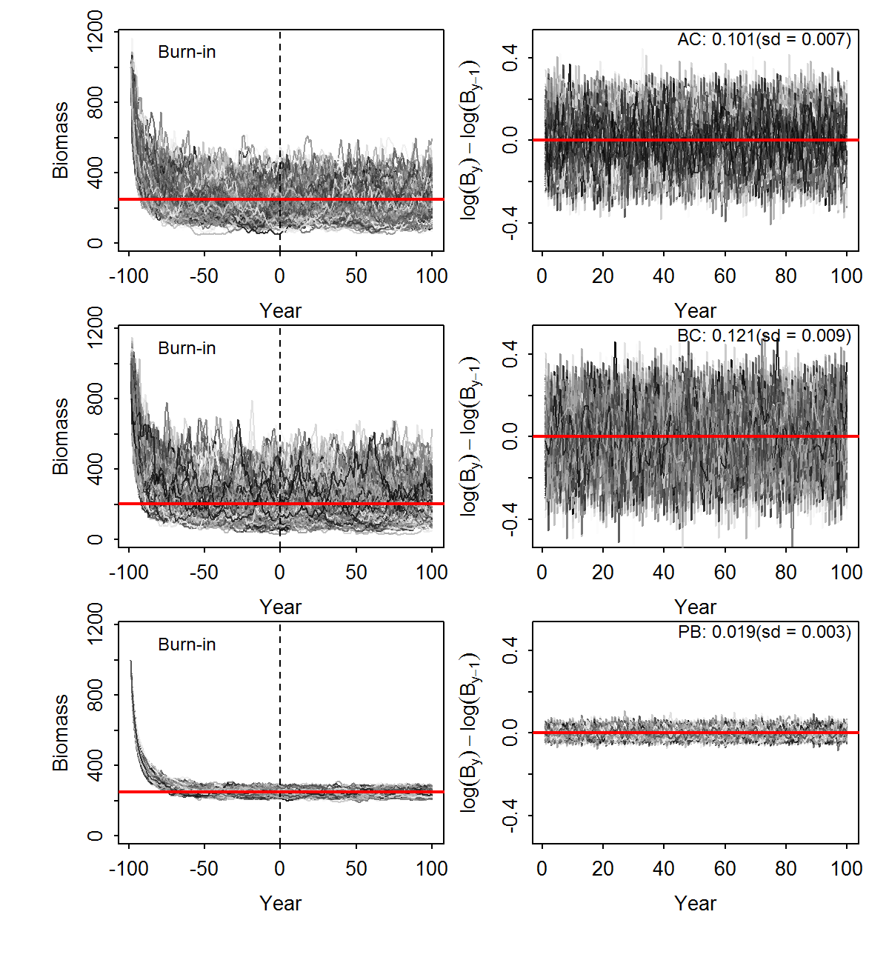
Fig. 1. Simulated stochastic biomass trajectories (left panel) and the annual process error deviations in biomass (right panel) showing the sensitivity to three alternative formulations for applying the process error action in the process equation in generic Schaefer Surplus Model. The mean and standard deviation (sd) of the process errors from 1000 replicates is presented in the top-right corner of the plots in the left panel. The end of the burn-in period is denoted by dashed vertical lines (left panels). AC: process error action after catch; BC: process error action before catch; PB: process error action on the productivity per unit biomass.

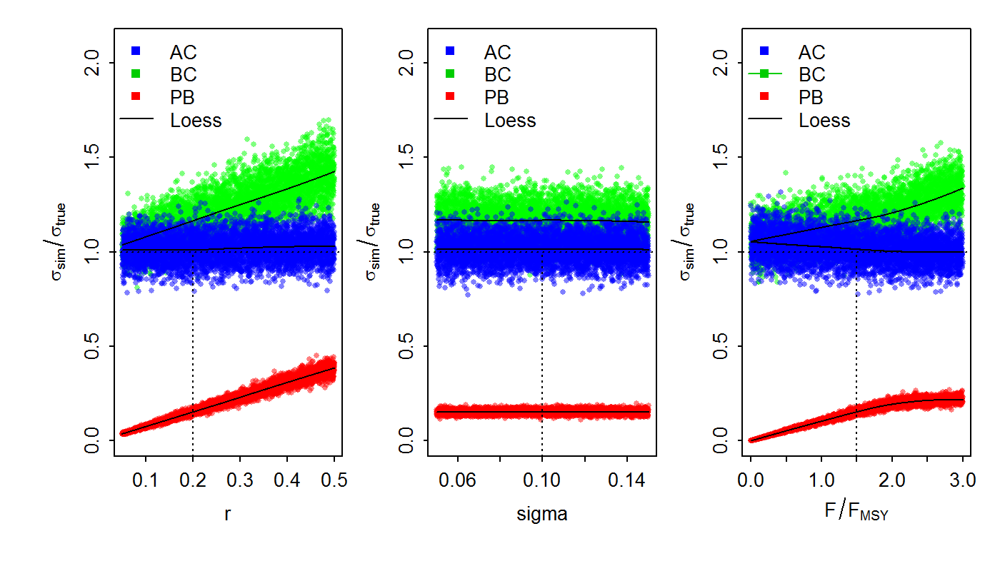
Fig. 2. Effects of individually varying the stochastic Schaefer model input parameters r, $σ_{η}$ $xF_{FMSY}$ on the ratio of process error simulation estimates ${\tilde{σ}}_{η,k}$ to the ‘true’ input value $σ_{η,k}$ (in the plots conveniently noted as $σ_{sim}/σ_{true})$. Solid lines represent loess smoother fitted to the 5000 replicates. Dashed, horizontal 1:1 lines provide reference the input $σ_{true}$, whereas dashed vertical lines provides reference to controlled parameter values, while varying one at a time.

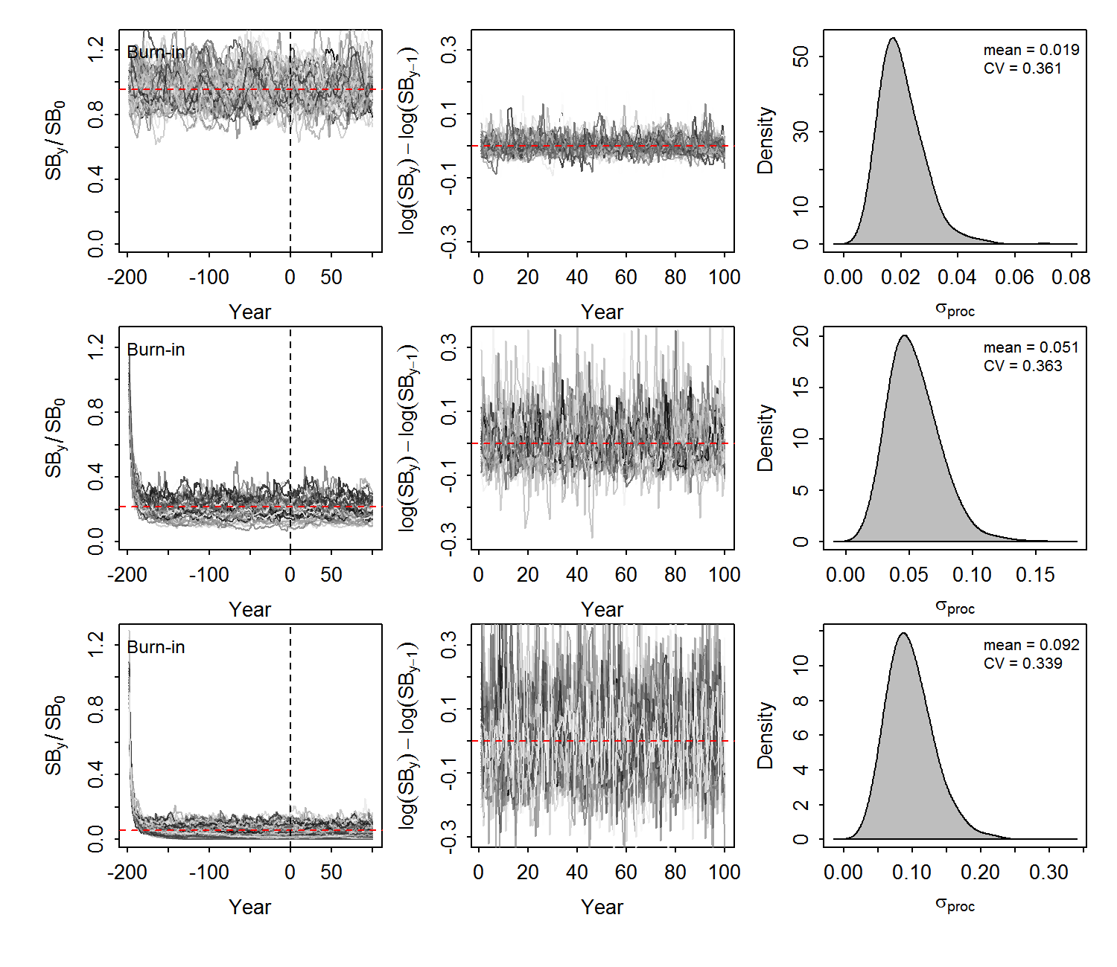
Fig. 3. Showing the age-structured simulation results for South African anchovy (Engraulis capensis) in the form of simulated biomass trajectories (left panel), the corresponding annual process error deviations in biomass (middle panel) and kernel density distributions simulated process error values under three constant fishing mortality scenarios: F = 0 (top), F = M (middle) and F = 2M. (bottom)
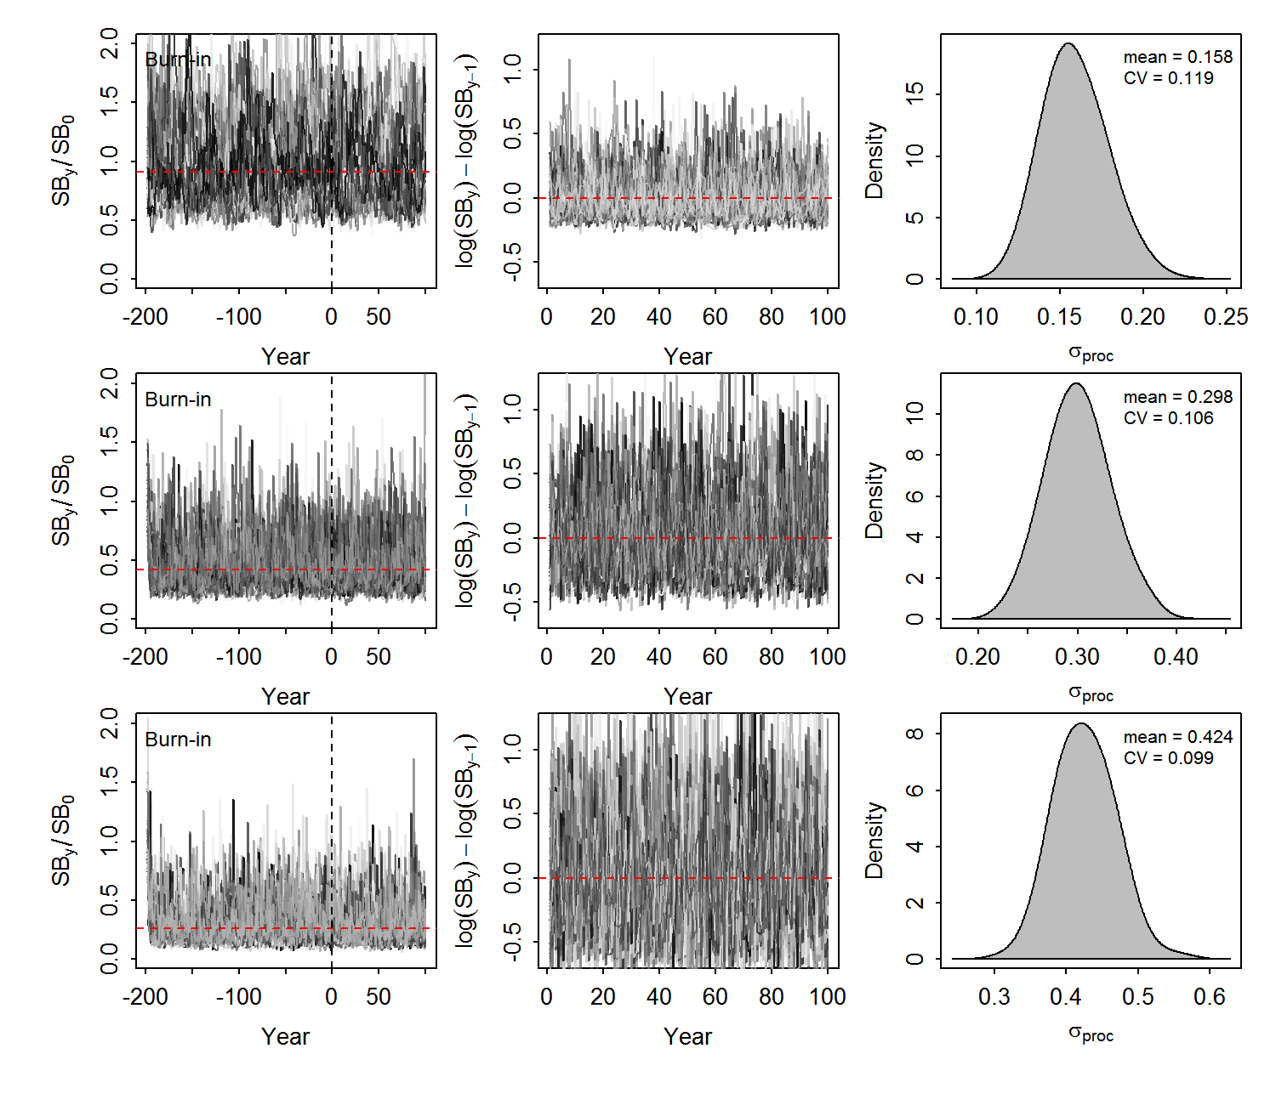
Fig. 4. Showing the age-structured simulation results for pilchard (Sardinops sagax) in the form of simulated biomass trajectories (left panel), the corresponding annual process error deviations in biomass (middle panel) and kernel density distributions simulated process error values under three constant fishing mortality scenarios: F = 0 (top), F = M (middle) and F = 2M. (bottom)
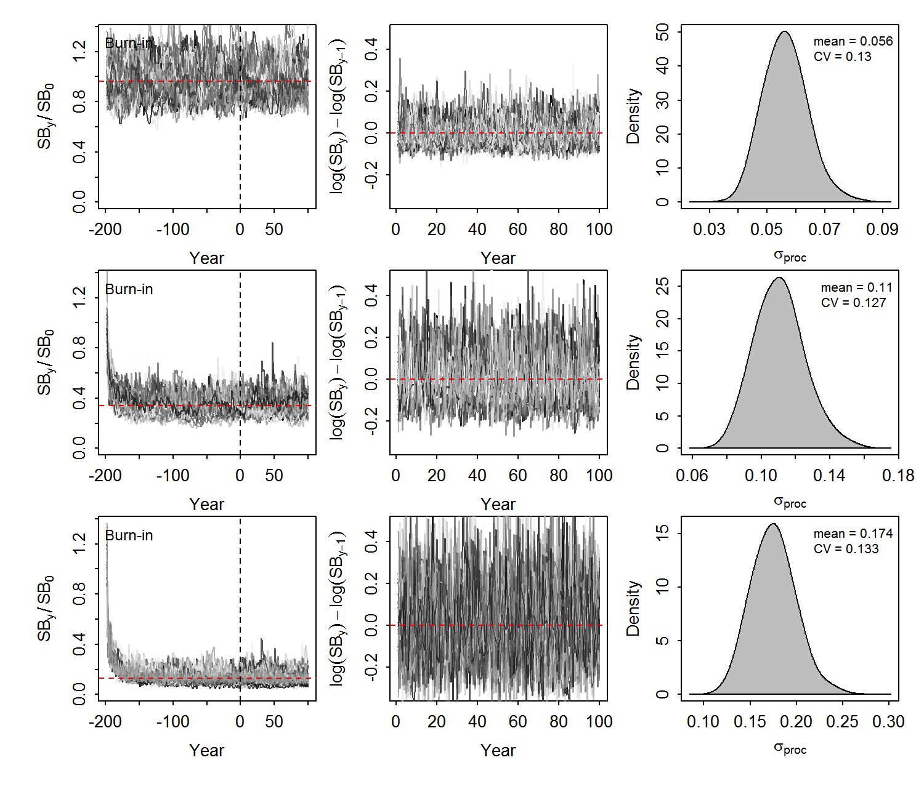
Fig. 5. Showing the age-structured simulation results for albacore tuna (Thunnus alalunga) in the form of simulated biomass trajectories (left panel), the corresponding annual process error deviations in biomass (middle panel) and kernel density distributions simulated process error values under three constant fishing mortality scenarios: F = 0 (top), F = M (middle) and F = 2M. (bottom)

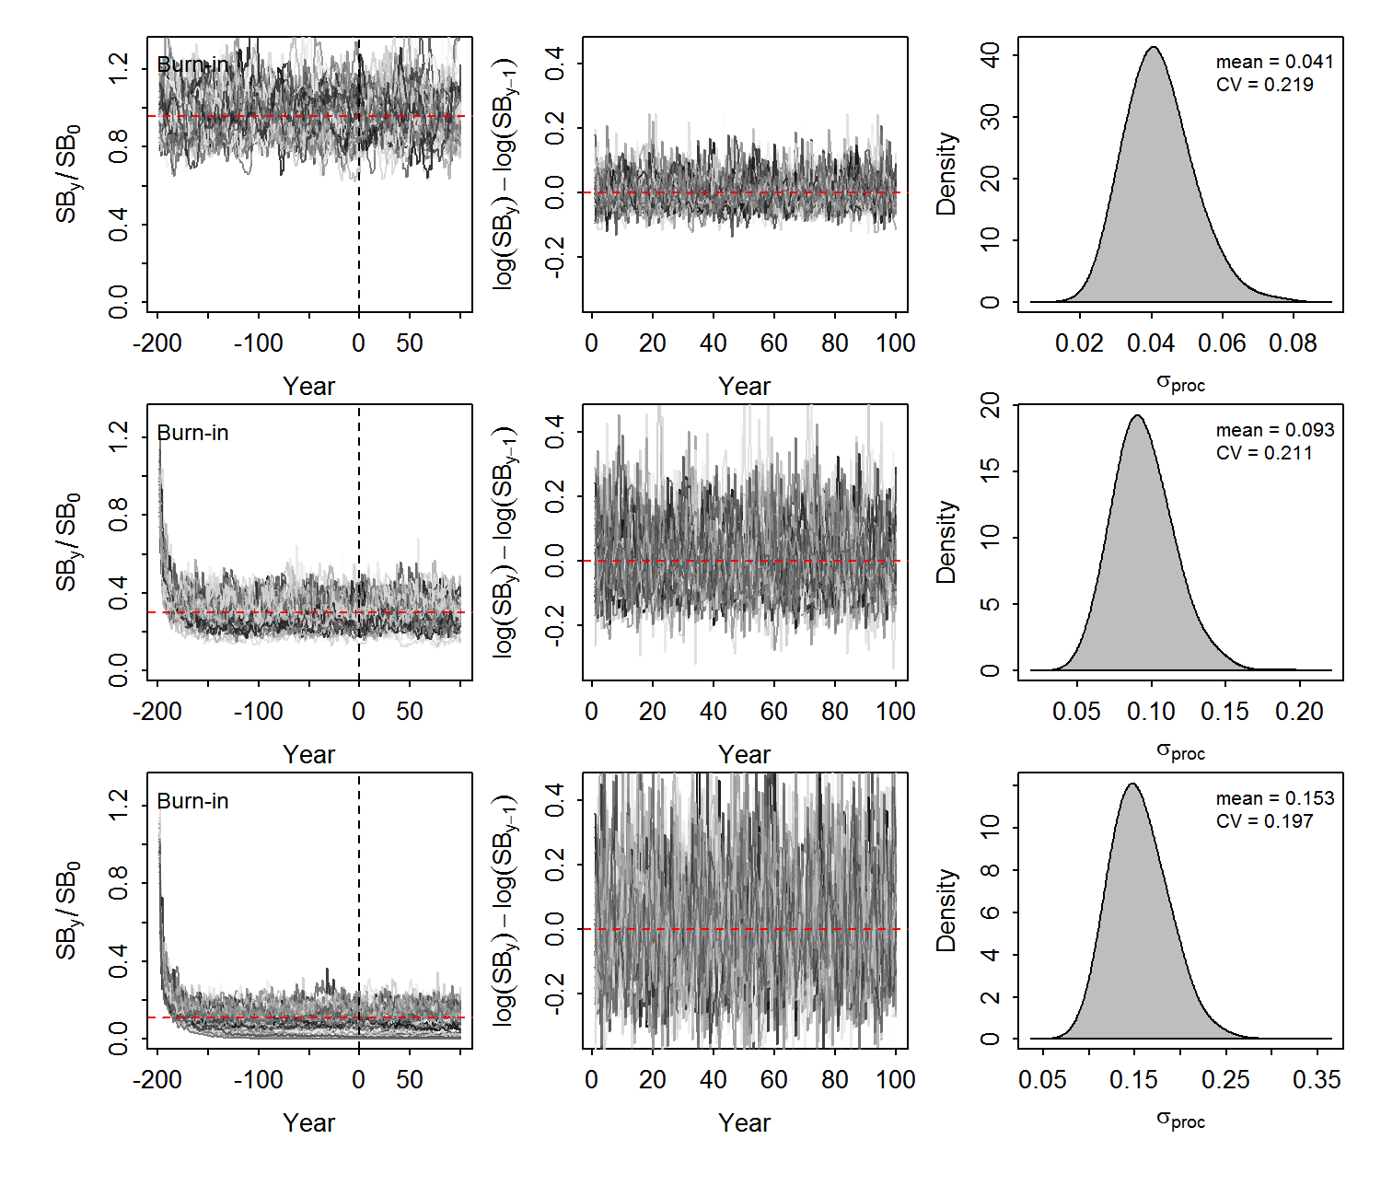
Fig. 6. Showing the age-structured simulation results for deep-water cape hake (Merluccius paradoxus) in the form of simulated biomass trajectories (left panel), the corresponding annual process error deviations in biomass (middle panel) and kernel density distributions simulated process error values under three constant fishing mortality scenarios: F = 0 (top), F = M (middle) and F = 2M. (bottom)

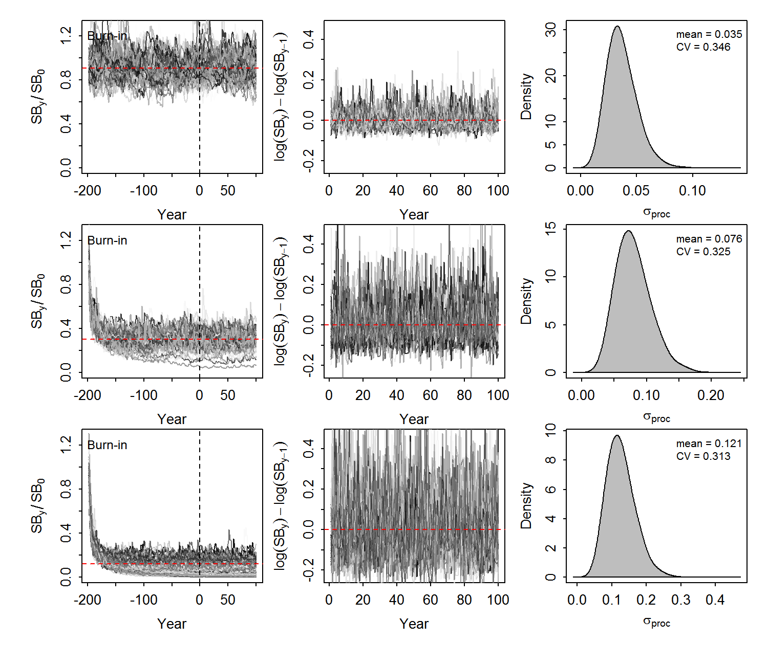
Fig. 7. Showing the age-structured simulation results for the rockfish Bocaccio (Sebastes paucipinis) in the form of simulated biomass trajectories (left panel), the corresponding annual process error deviations in biomass (middle panel) and kernel density distributions simulated process error values under three constant fishing mortality scenarios: F = 0 (top), F = M (middle) and F = 2M. (bottom)

Fig. 8. Showing the age-structured simulation results for the silver kob (Argyrosomus inodorus) in the form of simulated biomass trajectories (left panel), the corresponding annual process error deviations in biomass (middle panel) and kernel density distributions simulated process error values under three constant fishing mortality scenarios: F = 0 (top), F = M (middle) and F = 2M. (bottom)

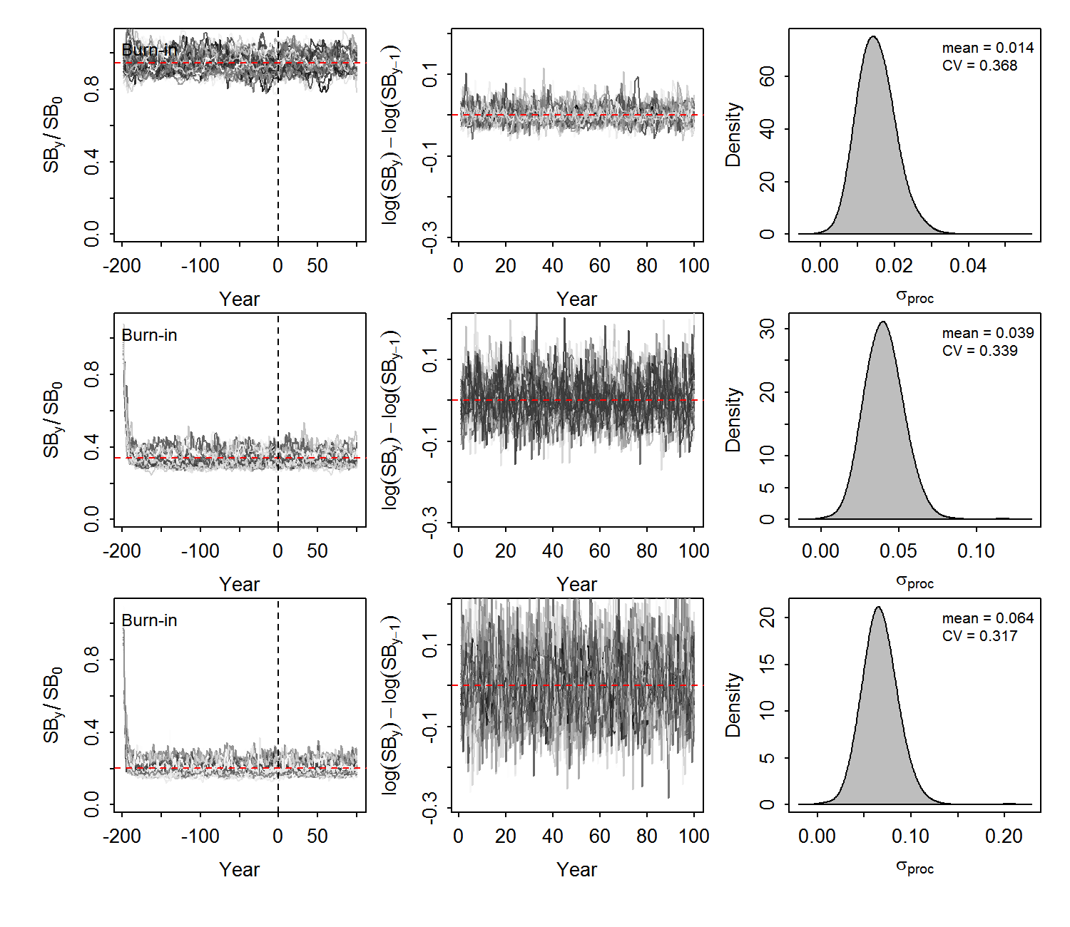
Fig. 9. Showing the age-structured simulation results for the carpenter seabream (Argyrozona argyrozona) in the form of simulated biomass trajectories (left panel), the corresponding annual process error deviations in biomass (middle panel) and kernel density distributions simulated process error values under three constant fishing mortality scenarios: F = 0 (top), F = M (middle) and F = 2M. (bottom)

Appendix A
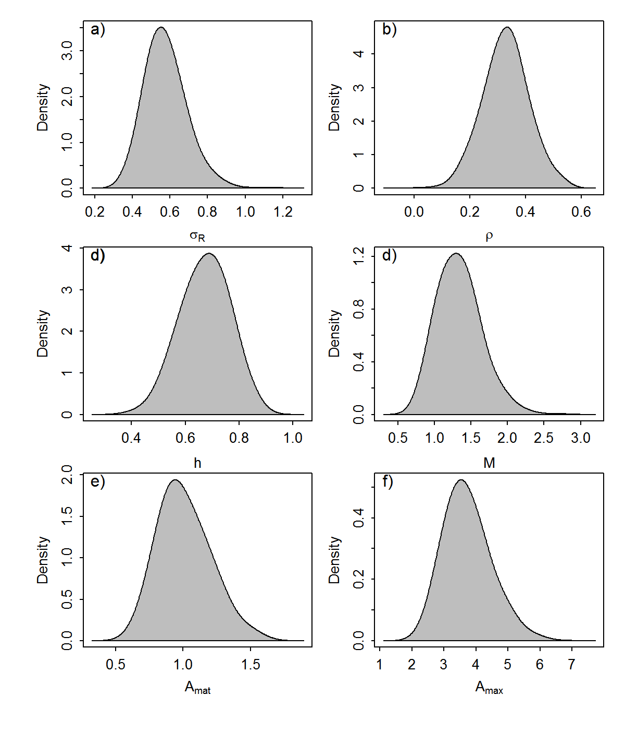
Fig. A1. Predicted distributions of six stock parameters for South African anchovy (Egraulis capensis) from FishLife2.0 (Thorson, in press)

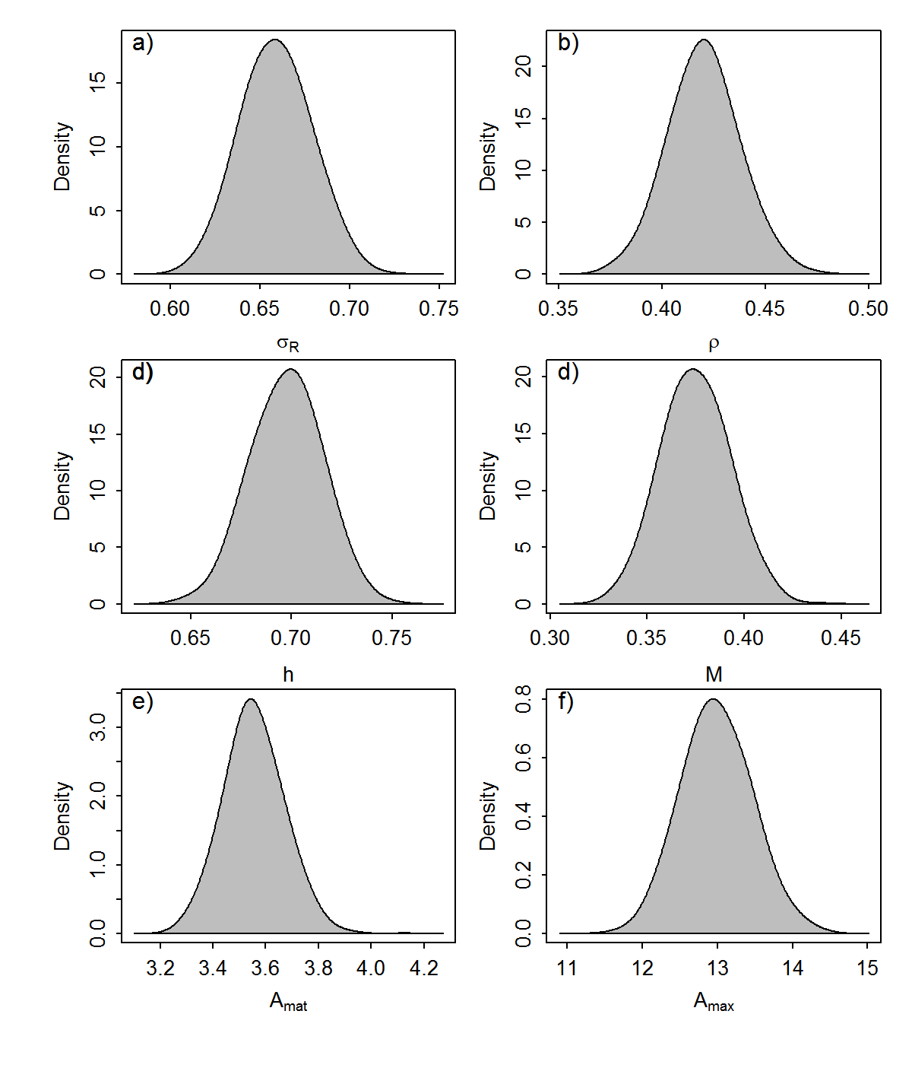
Fig. A2. Predicted distributions of six stock parameters for pilchard (Sardinops sagas) from FishLife2.0 (Thorson, in press)

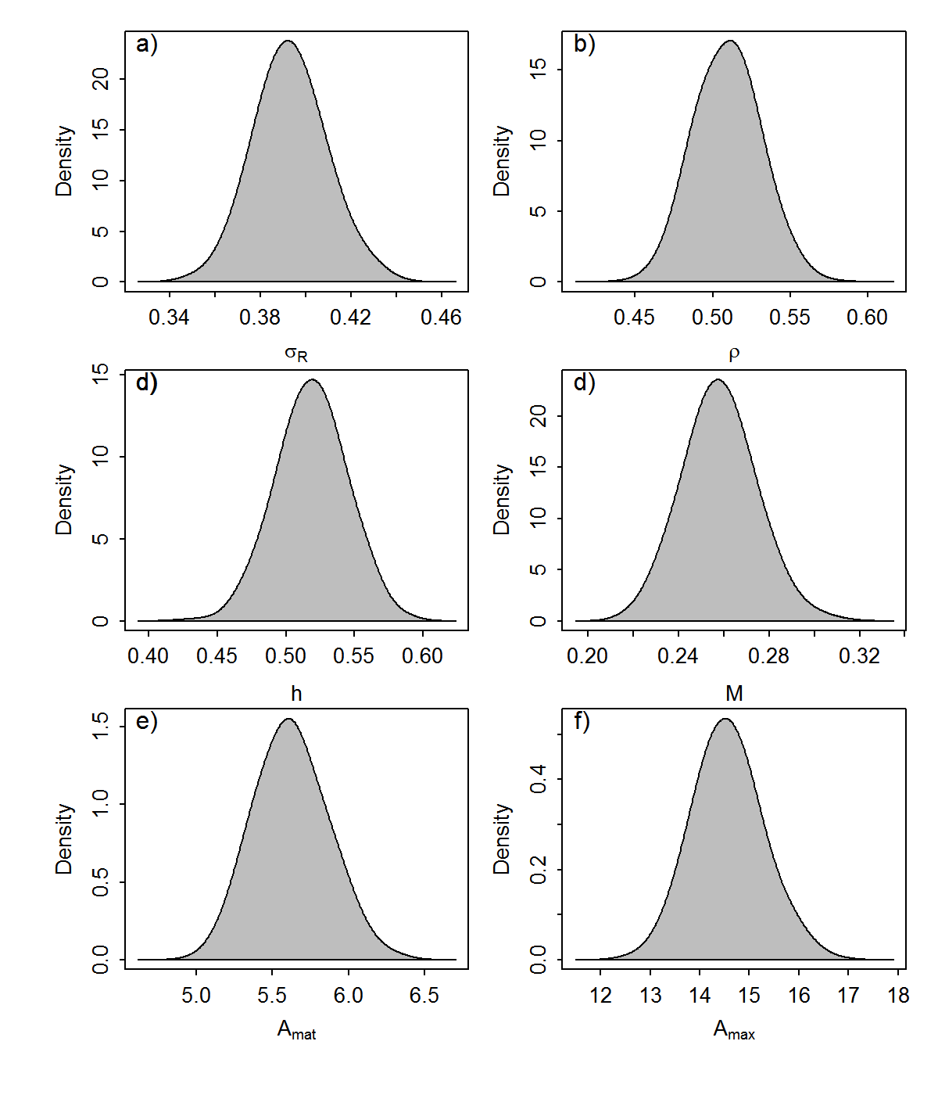
Fig. A3. Predicted distributions of six stock parameters for albacore tuna (Thunnus alalunga) from FishLife2.0 (Thorson, in press)

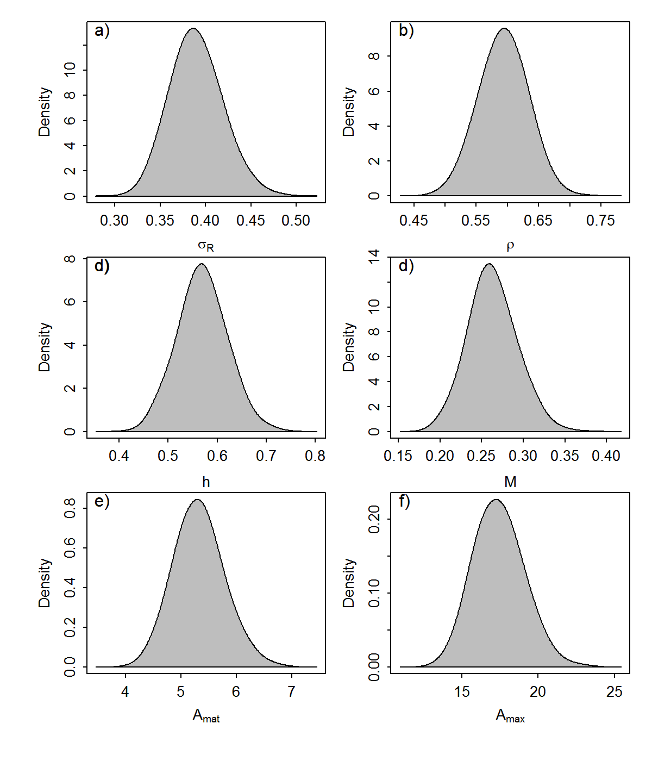
Fig. A4. Predicted distributions of six stock parameters for deep-water cape-hake (Merluccius paradoxus) from FishLife2.0 (Thorson, in press)

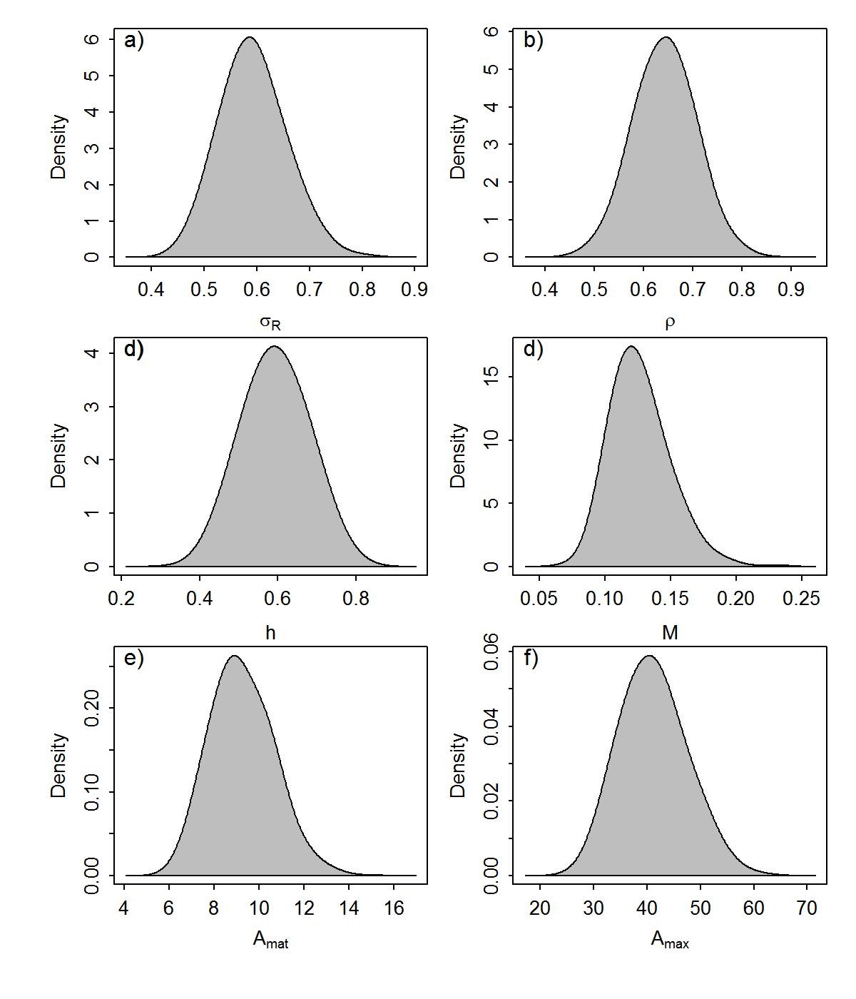
Fig. A5. Predicted distributions of six stock parameters for the rockfish Bocaccio (Sebastes paucispinis) from FishLife2.0 (Thorson, in press)
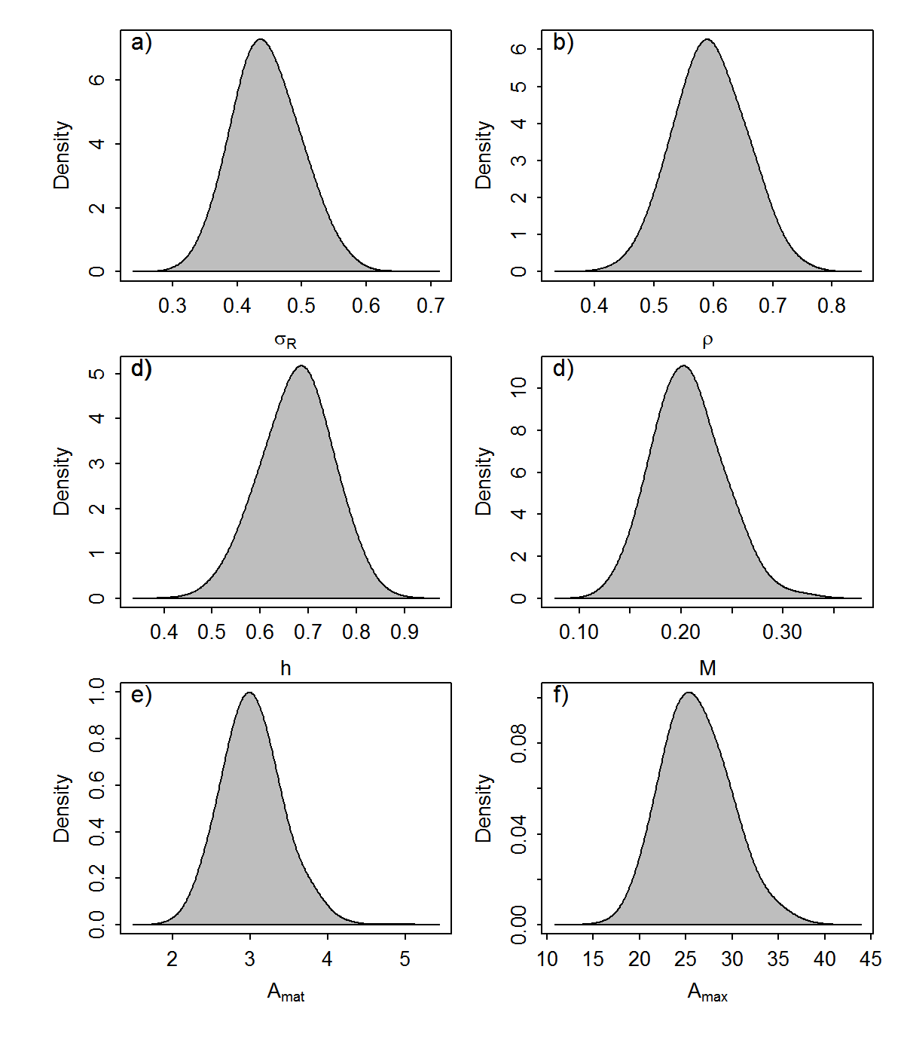
Fig. A6. Predicted distributions of six stock parameters for the silver kob (Argyrosomus inodorus) from FishLife2.0 (Thorson, in press)

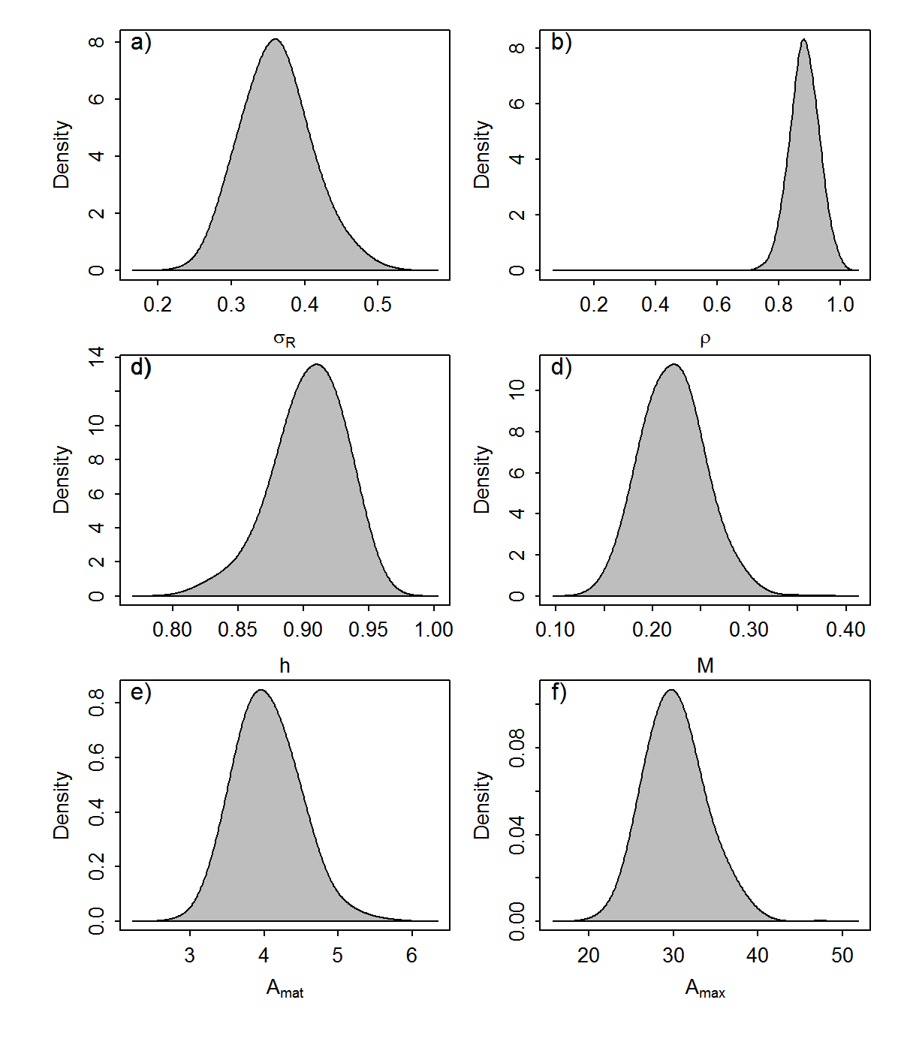
Fig. A7. Predicted distributions of six stock parameters for the carpenter seabream (Argyrozona argyrozona) from FishLife2.0 (Thorson, in press)

