**JABBA-Select: an alternative surplus production model to account for changes in selectivity and relative mortality from multiple fisheries**

Henning Winker1, Felipe Carvalho2, James T. Thorson3, Denham Parker1, Sven E. Kerwath1,4, Anthony J. Booth5, Laurie Kell6

*1 DAFF - Department of Agriculture, Forestry and Fisheries, Private Bag X2, Rogge Bay 8012, South Africa.*

2*NOAA Pacific Islands Fisheries Science Center, Honolulu, 1845 Wasp Boulevard, Building 176, Honolulu, Hawaii 96818*

*3Habitat and Ecosystem Process Research Program, Alaska Fisheries Science Center, National Marine Fisheries Service, NOAA, Seattle, WA, USA.*

*4Department of Biological Sciences, University of Cape Town, Cape Town, South Africa*

*5Department of Ichthyology and Fisheries Sciences, Rhodes University, Grahamstown, South Africa*

6*Sea++, The Hollies, Hall Farm Lane, Henstead, Suffolk, NR34 7JZ, UK.*

**Summary**

Despite ongoing improvements in Bayesian surplus production models (SPMs), researchers often prefer age-structured production models (ASPMs) even when reliable size- or age data are unavailable. Here, we propose a novel Bayesian state-space framework ‘JABBA-Select’ to account for changes in selectivity and relative fishing mortality from multiple fisheries. JABBA-Select extends the JABBA software (Just Another Bayesian Biomass Assessment; Winker et al., 2018) by: 1) using the “steepness” of the stock-recruitment relationship and the selectivity-at-age dependent mortality rates from an equilibrium age-structured model to generate correlated multivariate normal priors on surplus-production shape and productivity parameters; and 2) distinguishing between exploitable biomass (used to fit indices given fishery selectivity) and spawning biomass (used to predict surplus production). In this study, we introduce the properties of the JABBA-Select model using the stock parameters of South African silver kob (*Argyrosomus inodorus*) as a case study. The South African silver kob is exploited by the boat-based hand-line and recreational fishery (‘linefishery’) and the inshore trawl fleet. It was selected as a data moderate example fishery that features strong contrast in selectivity. For proof-of-concept, we use an age-structured simulation framework to compare the performance of JABBA-Select to: 1) a conventional Bayesian state-space Schaefer model, (2) an ASPM with deterministic recruitment; and 3) an ASPM with stochastic recruitment. The Schaefer model produced highly biased estimates of relative and absolute spawning biomass trajectories and associated reference points, which could be fairly accurately estimated by JABBA-Select. When compared to the deterministic and stochastic ASPMs, JABBA-Select showed overall higher accuracy for most of the performance metrics and captured the uncertainty about the stock status most accurately. The results indicate that JABBA-Select is able to accurately account for moderate changes in selectivity and fleet dynamics over time, and provides a robust tool for data-moderate stock assessments.

**1. Introduction**

For over 50 years Surplus Production Models (SPMs) have been used to analyze catch and effort data to assess the biomass and exploitation level of marine populations in relation to fisheries reference points (FRPs) based on the Maximum Sustainable Yield (*MSY*) (Fox, 1970; Schaefer, 1957). SPMs are age- and size aggregated models that approximate changes in biomass as a function of the biomass of the preceding year, the surplus production in biomass and the removal by the fishery in the form of catch and are, therefore, often referred to as Biomass Dynamics Models (Hilborn and Walters, 1992). Somatic growth, reproduction, natural mortality and associated density-dependent processes are inseparably captured in the estimated surplus production function, and the slope of this function as biomass approaches zero is the termed intrinsic growth rate $r$.

Over the last two decades there has been considerable progress in optimizing the fitting procedures of SPMs (McAllister, 2014; Meyer and Millar, 1999; Pedersen and Berg, 2016; Punt, 2003; Thorson et al., 2014). Most recently the release of the Bayesian state-space SPM platform JABBA (Just Another Bayesian Biomass Assessment; Winker et al., 2018) has prompted a fast uptake for a number of tuna and billfish assessments conducted by tuna RFMOs. JABBA is a user-friendly R (R Development Core Team, 2013) to JAGS (Plummer, 2003) interface for ﬁtting generalized Bayesian State-Space SPMs to generate reproducible stock status estimates and diagnostics for a wide variety of ﬁsheries (Winker et al., 2018).

Earlier studies have suggested that both age-structured and SPMs often produce similar FRPs when the assessment is limited to catch and relative indices of abundance (Hilborn and Walters, 1992; Ludwig and Walters, 1989, 1985; Prager et al., 1996, but see Maunder 2003). Yet, many stock assessment scientists retain strong reservations about SPMs (Maunder, 2003; Punt and Szuwalski, 2012; Wang et al., 2014). A major criticism of SPMs is that by ignoring the stock’s size/age-structure, SPMs fail to account for dynamics in gear selectivity (Wang et al., 2014) and lag effects in the population (Aalto et al., 2015).

In contrast to SPMs, age-structured models define spawning-biomass (*SB*) and exploitable biomass (*EB*), where *SB* is the biomass fraction of mature fish (or females) in the population, and *EB* is the exploitable (vulnerable) biomass fraction of the total biomass that is selected by the fishery. This allows age-structured models to explicitly account for the lag-effect of the biomass response of *EB*, which is related to the observed abundance index. However, this requires a minimum of ten stock parameters to model the population dynamics[1], with density-dependent processes typically limited to a spawner-recruitment relationship (SRR) and natural mortality (*M*) being age- and time invariant (Thorson et al., 2012). Moreover, the form and steepness (*h*) of the SRR and estimates of *M* are highly uncertain and it is often not possible to estimate *h* and *M* from the data. As such, scientists commonly fix values for one, or both parameters in age-structured stock assessments (Lee et al., 2012; Mangel et al., 2013), thereby making strong presumptions about the stock’s resilience and stock status reference points. Recent research has demonstrated the importance of estimating recruitment variation in data-poor (catch only) and data-moderate situations (catch and relative abundance indices) to avoid overestimating the precision while reducing bias in stock status estimates (Thorson et al. in press). However, in absence of reliable size- or age data, it remains common practice that researchers apply age-structured models without accounting for time-varying recruitment or other forms of process-error (Thorson et al. in press). There is also a concern that estimating recruitment without stock structure information can inflate uncertainty estimates such that providing management advice becomes impractical (Minte-Vera et al., 2017).

In such data-moderate situations, the analyst could consider a Bayesian state-space formulation for SPMs to provide an alternative and more parsimonious representation of uncertainty relating to FRPs than age-structured models. State-space SPMs can be used to account for both process and observation error (Ono et al., 2012; Punt, 2003). In addition, the choice of fixing key parameters can be overcome in Bayesian SPMs through the formulations of adequate priors (McAllister et al., 2001). Even when such formulations are considered, SPMs are still likely to introduce bias to the FRPs where introductions of new gears, mesh size restrictions or minimum size limits caused changes in selectivity (Wang et al., 2014).

To address some of these SPM caveats, we introduce JABBA-Select, a novel SPM framework that allows approximating differential impacts of fisheries selectivity into a Bayesian state-space surplus production model. JABBA-Select is an extension of the JABBA open source software for fitting generalized Bayesian State-Space SPMs (Winker et al. 2018). We illustrate the key concepts of JABBA-Select based on stock parameters and catch- and abundance time series for silver kob (*Argyrosomus inodorus*), which is caught by the South African boat-based handline and inshore trawl fisheries. For proof of concept, we use an age-structure simulation framework (Thorson et al., in press.; Thorson and Cope, 2015) to compare the performance of JABBA-Select against a deterministic and stochastic implementation of an age-structured production model (ASPM) and a Schaefer SPM.

**2.1 Materials and methods**

*2.1.1 JABBA-Select model*

We formulate the JABBA-Select model by extending the Bayesian state-space SPM estimation framework JABBA (Winker et al. 2018). With JABBA-Select, we seek to improve stock status estimation properties of Bayesian state-space surplus production models by accounting for selectivity-induced distortion of biomass indices and stock productivity. Central to our approach is the integration of prior information from spawning biomass- and yield-per-recruit models with integrated Beverton-Holt spawner recruitment relationship (BH-SRR) into JABBA-Select, which we subsequently refer to as age-structured equilibrium model (ASEM). This type of model is widely used to derive *MSY*-based FRPs from estimated stock parameters by searching iteratively for the fishing mortality that produces *MSY*, *FMSY*, from the corresponding spawning biomass *SBMSY*at MSY (Punt et al., 2013). The required ASEM inputs are parameters describing length-at-age (*la*), weight-at-age (*w*a), maturity-at-age (*ψ*a) and selectivity-at-length (*sa*) for fisheries operating with selectivity *s*,natural mortality *M* and the steepness parameter *h* of the BH-SSR. For convenience, the acronyms that are commonly referred to in the following sections are summarized in Table 1.

The presented framework has four novel components relative to conventional state-space SPMs:

1. The model uses the expression of harvest rate at MSY (*HMSY*), which we define here as *HMSY* = *MSY /SBMSY,* as a surrogate for the intrinsic rate of population increase *r*, and derives the shape parameter *m* of the surplus production curve as a function of *SBMSY/SB0.* This provides a means to generate prior distributions of likely values of *HMSY* and *m* from the ASEM using life history parameters and fishery-selectivity inputs (Fig. 1a)
2. The parameter $H_{{MSY}_{s}}$ is specific to fishing operations that fish with selectivity *s* and can be adjusted to account for selectivity-induced changes in the overall year-specific stock productivity *HMSY,y* as well as on the abundance indices (Fig. 1b).
3. The model separates between exploitable biomass *EBs* and spawning biomass *SB;* the former is usedto fit indices given selectivity *s*, and the latter to predict surplus production. The parameters used to describe the ratio of *EBs,y* and *SBy,* as a function of spawning biomass depletion relative to average unfished levels are inferred from the ASEM (Fig. 1c)
4. The model accounts for the underlying correlation structure between generated values *HMSY* and *m* through the formulation of a multivariate normal (MVN) prior, which allows for estimating both parameters jointly within the model (Fig. 1d).

For illustration of the JABBA-Select model, we use the stock parameter estimates for South African silver kob (Table 1). This species is exploited by the South African boat-based hand-line fishery (‘linefishery’) and the inshore trawl fleet and was selected due to strong contrast in selectivity regimes and life history parameters. Silver kob is the most abundant sciaenid species in South Africa that is predominantly caught between Cape Point and East London. The species’ legal minimum size limit for the linefishery was increased from 400 mm to 500 mm TL in 2003, which effectively resulted in an instant reduction of *EB* (Winker et al., 2013). Furthermore, an increasing proportion of the total catch has been landed by the inshore trawl, particularly after a drastic reduction in linefishery effort in 2003, which was enforced together with the new minimum size regulations. In contrast to the linefishery, there are no minimum size limits for the inshore trawl fishery. As a result the inshore trawl lands a larger proportion of smaller silver kob (*SL50* = 334 mm TL).

*2.1.1 Estimating surplus production from an Age-Structured Equilibrium Model (ASEM)*

To directly link the generalized three parameter SPM by Pella and Tomlinson (1969) to the ASEM, we assume that surplus production is a function of spawning biomass (Thorson et al., 2012) and then express surplus production as a function of our formulation of *HMSY* instead of the intrinsic rate of population increase, so that:

$\text{SP}=\frac{H_{\text{MSY}}}{(1-m^{-1})}\text{SB}\left(1-{\left(\frac{\text{S}\text{B}}{{\text{S}\text{B}}_{0}}\right)}^{m-1}\right)$ (1)

where *SB0* is the unfished biomass and *m* is a shape parameter that determines at which *SB/SB0* ratio maximum surplus production is attained. The functional links between the ASEM and Pella-Tomlinson SPM are illustrated in Fig. 2, which provides a means to translate typical input parameters of age-structured models into the key SPM parameters *r* and *m* (Maunder, 2003; Thorson et al., 2012; Wang et al., 2014). Accordingly, it is possible to generate *HMSY = MSY*/*SB*MSY and *SB*MSY/*SB0* from the ASEM, where the shape parameter *m* is directly related to the inflection point *SB*MSY/*SB0* of the surplus production curve:

$\frac{{SB}_{MSY}}{{SB}_{0}}=m^{\left(-\frac{1}{m-1}\right)}$ (2)

The ASEM formulation is based on deterministic, age-structured population dynamics. The numbers at age per-recruit (${\tilde{N}}_{a}$) at equilibrium are given by:

${\tilde{N}}_{a}=\left\{\begin{aligned}1 if a=0 \\ {\tilde{N}}_{a-1}\exp\left(-s_{a}F-M\right) if a>0\end{aligned}\right.$ (3)

where $s_{a}$ is the selectivity at age *a* (Eq. A4)*, F* is the instantaneous rate of fishing mortality and *M* is theinstantaneous rate of natural mortality. For ease of presentation, we assumed *M* is constant and omitted the plus group.

The Spawning-biomass-per-recruit ($\tilde{S}$) is obtained as function of *F*, such that:

$\tilde{S}\left(F\right)=\sum_{a}{w_{a}ψ_{a}{\tilde{N}}_{a}}$ (4)

where $w_{a}$ is the weight at age *a* (Eqs. A1-A2), $ψ_{a}$ is the proportion of mature fish in the population at age *a* (Eq. A3) and ${\tilde{N}}_{a}$ is the number survivors-at-age per recruit. The corresponding yield-per-recruit is given by:

$\tilde{Y}\left(F\right)=\sum_{a}{\frac{w_{a}s_{a}F}{s_{a}F+M}}{\tilde{N}}_{a}(1-e^{-s_{a}F-M})$ (5)

Under steady state conditions, the yield (*Y*) can then be expressed as a function of equilibrium recruitment $\tilde{R}$ and yield-per-recruit ($\tilde{Y}$)

$Y\left(F\right)=\tilde{Y}(F)×\tilde{R}(F)$ (6)

The corresponding equilibrium spawner-biomass *SB* is:

$SB\left(F\right)=\tilde{S}(F)×\tilde{R}(F)$ (7)

Assuming a Beverton and Holt SSR, the equilibrium recruitment at *F* is given by:

$\tilde{R}\left(F\right)=R_{0}\frac{4h\tilde{S}-\left(1-h\right){\tilde{S}}_{0}}{\tilde{S}(5h-1)}$ (8)

where the steepness parameter *h* is defined as the ratio of the average unfished recruitment $R_{0}$ when spawner biomass is reduced to 20% of unfished levels, *SB*0(Mace and Doonan, 1988) and ${\tilde{S}}_{0}$ is the unfished spawning-biomass per-recruit (*F* = 0).

The quantity MSY and the corresponding fishing mortality at MSY, *FMSY*, is obtained through iterative maximization of Eq. 6 over a range of plausible *F* values, which then allows the calculation of *SB*MSY by inputting *FMSY* into Eq. 7.

*2.1.2 Accounting for fisheries selectivity effects on stock productivity*

Figure 1a demonstrates that the selectivity-specific yield curves from the ASEM (generated through iterations of fishing mortality *F*) closely approximate the shape of the corresponding selectivity-specific surplus production curve from the SPM (Eq. 1) over a wide range of logistic selectivity curves. This indicates that the same catch, but harvested with various selectivity patterns, will result in different quantities of *HMSY* and *MSY* (Wang et al., 2009), but *SB*MSY and thus the shape parameter *m,* is effected less. Therefore, if there are two or more fisheries that operate with different selectivity patterns and their relative contribution to the total catch varies over time, *HMSY* will inherently become time-varying. This also applies to *r* in conventional SPM formulations.

To account for relative changes in the catch $C_{s,y}$ among multiple fisheries that operate with different selectivity *s* in year *y*, we estimate the year-specific stock productivity $H_{{MSY}_{y}}$ as theweighted product of the relative catch (but ignoring lag effects), such that

$H_{{MSY}_{y}}=\sum_{s}{\left(H_{{MSY}_{s}}C_{s,y}\right)}/\sum_{s}{C_{s,y}}$ (9)

so that estimates of $H_{{MSY}_{y}}$ are conditioned on the relative impacts of a fishery-specific selectivity in year *y* (Fig. 1c).

*2.1.3.* *Distinguishing between exploitable biomass and spawning biomass*

Accounting for selectivity dependence of $H_{{MSY}_{s}}$ alone would not address additional distortions during the fitting process of any age-aggregated model (Maunder, 2003; Wang et al., 2014), which can arise from the non-linear behaviour of the ratio of exploitable- to spawning biomass (*EB*/*SB*)relative to biomass depletion levels (Fig. 1c). The ratio *EB*/*SB* would only be constant if the functions describing age-at-selectivity and age-at-maturity were identical, but becomes increasingly disproportionate towards lower biomass levels as age-at-selectivity generally diverges from age-at-maturity (Fig. 1c). To account for this effect, we seek to integrate information about the probable response of ${\text{EB}}_{P_{s}}/{SB}_{P}$ to changes in biomass depletion levels (*P = SB*/*SB0*) into the observation equation of the JABBA-Select model (Eq. 16), where ${\text{EB}}_{P_{s}}/{SB}_{P}$ is conditioned on selectivity *s* and the stock’s life history parameters. Again, we make use of ASEM to obtain expected values of ${\text{EB}}_{P_{s}}/{SB}_{P}$ for different depletion levels of $P_{F}$ by iteratively changing the fishing mortality, *F*.Initial trials indicated that the functional form of this steady-state relationship can be adequately described by the asymptotic growth function of the form:

$\frac{{\text{EB}}_{P_{s}}}{{\text{S}\text{B}}_{P}}=\left(υ_{1,s}+(υ_{2_{s}}-υ_{1_{s}})\frac{1-e^{-υ_{3_{s}}(P_{H}-P_{1})}}{1-e^{-υ_{3_{s}}(P_{2}-P_{1})}}\right)$, (10)

where *PH* denotes the relative depletion *SB*/*SB0* as a function of *F, $υ_{1_{s}}$* and $υ_{2_{s}}$ are parameters describing the ratio of ${\text{EB}}_{P_{s}}/{SB}_{P}$ for the lowest and highest observed depletion *P1* and *P2,* respectively, and $υ_{3_{s}}$ is the rate of change between $υ_{1_{s}}$ and $υ_{2_{s}}$ expected for selectivity *s*(Fig. 3). The expected values of ${\hat{υ}}_{{1-3}_{s}}$ are estimated separately for each catch and abundance time series that have a unique selectivity *s* by fitting Eq. 3 to vectors of ${\text{EB}}_{P,s}/{SB}_{P}$ and $P_{H,s}$. In the present framework, the non-linear relationship between ${\text{EB}}_{P,s}/{SB}_{P}$ and $P_{F}$ is estimated by fixing the ASEM-values *M* and *h* to their means*,* which relies on the assumption that errors arising from the misspecification of externally derived parameters ${\hat{υ}}_{{1-3}_{s}}$ can be compensated for by the process variance in JABBA-select (Eq.13).

* + 1. *Multivariate normal (MVN) prior formulation for the HMSY* and shape *m*

In terms of Bayesian model formulations, the ASEM lends itself to deriving informative priors for *HMSY* and *m* from Monte-Carlo Simulations to produce a distribution of likely values for *MSY/SBMSY* and *SBMSY/SB0* (Mangel et al., 2013; McAllister et al., 2001). In the following, we focus on incorporating the uncertainty associated with *M* and *h* into an informative MVN prior for $H_{MSY}$ and the shape parameter *m*.

First, we use Monte-Carlo simulations to randomly generate 1000 permutations of $H_{{MSY}_{s,k}}^{'}$ and $m_{s,k}^{'}$ where *k* denotes the Monte-Carlo replicate. The Monte-Carlo approach is implemented based on the following steps: (1) randomly generate permutations of the leading parameters $M_{k}^{'}$ from a lognormal distribution and $h_{k}^{'}$ from a beta distribution (Michielsens et al., 2004), (2) iteratively maximize Equation 6over a wide range of *F* values to obtain ${MSY}_{s,k}^{'}$ given the remainder of life history parameters in Table 3, (3) input the corresponding *FMSY* into Equation 7 to obtain ${SB}_{{MSY}_{s,k}}^{'}$, (4) set *F =* 0 to obtain *SB0,* through Equation 7, (5) calculate $H_{{MSY}_{f,s,k}}^{'}$ and $m_{f,s,k}^{'}$ as a function of the ASEM output ratios $H_{{MSY}_{s,k}}^{'}= {MSY}_{s,k}^{'}/{SB}_{{MSY}_{s,k}}^{'}$ and ${SB}_{{MSY}_{s}}^{'}/{SB}_{0}^{'}$ (Eq. 9), respectively.

The MVN prior is parameterized with the mean values and covariance matrix of $log⁡(H_{{MSY}_{s=1,k}}^{'}$) for selectivity *s* = 1 and $log⁡(m_{\overline{s},k}^{'})$ (Fig. 1d), such that

$\{{log⁡(H}_{{MSY}_{s=1}}),log⁡(m_{\overline{s}})\}\sim MVN\left({\{log⁡(\overline{H}}_{{MSY}_{s=1,k}}^{'} ),log⁡( {\overline{m}}_{\overline{f},\overline{s},k}^{'})\},Cov{\{log⁡(H}_{{MSY}_{s=1,k}}^{'}),log⁡( m_{\overline{f},\overline{s},k}^{'})\}\right)$ (11)

where $m_{\overline{s},k}^{'}$ is taken as the mean selectivity *s* across fisheries for each iteration *k.* The prior expectation for a time-invariant $m_{\overline{f},\overline{s}}$ relies on the assumption that *m,* and thus ${ SB}_{MSY}/{SB}_{0}$, can be treated as approximately constant. This assumption is also common practice in age-structured stock assessments (Punt et al., 2013), and implies independence of ${ SB}_{MSY}/{SB}_{0}$ to selectivity. As illustrated in Figure 1a, this assumption may hold well for logistic type selectivity curves, but can theoretically produce biased results in the presence of strong, steep dome-shaped selectivity curves (Wang et al., 2014). To then account for the selectivity effect on $H_{{MSY}_{s>1,k}}^{'}$ for *s* > 1 (i.e more than one selectivity), we used the ratios of the simulation vectors ${{ΔH}_{{MSY}_{s>1}}^{'}=H_{{MSY}_{s>1}}^{'}/H}_{{MSY}_{s=1}}^{'}$, where ${ΔH}_{{MSY}_{s>0}}^{'}$ was then fitted to a gamma probability density function (Fig. 3). The estimated shape and scale parameters are used to generate informative priors for $H_{{MSY}_{s>1,k}}^{'}$ as input to the JABBA-Select model in conjunction with the log-MVN prior for $H_{{MSY}_{s=1}}$ and $m_{\overline{s}}$ (Fig. 1d; Fig. 3).

*2.5 Model formulation*

The generalized form of the process equation is given by:

${\text{SB}}_{y}={\text{SB}}_{y-1}+{\text{SP}}_{y-1}-\sum_{s}{C_{s,y-1}}$ (12)

where *SPy* is surplus production for year *y* and *Cy* is the catch in year *y* for all fishing operations with a common selectivity *s*. Using Eq. 1 for *SPy* and expressing spawning biomass and total catch as a fraction of *SB*0, with *Py = SBy / SB0* results in the following process equation::

$P_{y}=\left\{\begin{aligned}φ e^{η_{y}-{0.5σ}_{η}^{2}} \\ \left(P_{y-1}+\frac{\sum_{s}{γ_{s,y}H_{{MSY}_{s}}}}{1-m^{-1}}P_{y-1}\left(1-P_{y-1}^{m}\right)-\frac{\sum_{s}{C_{s,y-1}}}{{SB}_{0}}\right)e^{η_{y}-{0.5σ}_{η}^{2}}\end{aligned}\right.$ (13)

where $η_{y}$ is the lognormal process error term, with $η_{y}\text{\sim }Normal(0,σ_{η}^{2})$, $σ_{η}^{2}$ is the process variance, $φ$ is a scaling for initial biomass depletion in the first year *P*1, is thecatch with selectivity *s* in year *y*, *m* is the shape parameter, and ${{γ_{s}=C}_{s,y}}/{\sum_{s}{C_{s,y}}}$ is used as a multiplier to weight $H_{{MSY}_{s}}$ relative to catch taken with selectivity *s* (Eq. 9).

The corresponding spawning biomass for year *y* is:

${\text{SB}}_{y}=P_{y}{\text{SB}}_{0}$ (14)

The exploitable biomass is expressed as the product of *SB* in year *y* and the ratio of *EB*/*SB* as a function of *P* = *SB*/*SB0*, such that:

${\text{EB}}_{s,y}={\text{SB}}_{y}\left({\hat{υ}}_{1_{s}}+({\hat{υ}}_{2_{s}}-{\hat{υ}}_{1_{s}})\frac{1-e^{-{\hat{\hat{υ}}}_{3_{s}}(P_{y}-P_{1_{s}})}}{1-e^{-{\hat{\hat{υ}}}_{3_{s}}(P_{2_{s}}-P_{1_{s}})}}\right)$ (15)

where ${\hat{υ}}_{{1-3}_{f,s}}$ are the externally derived parameters to approximate the ratio ${{\text{EB}}_{s,y}}/{{\text{SB}}_{y}}$ for a fishery (or survey) with selectivity *s* within JABBA-Select. The corresponding observation equation is given by:

${ln⁡(I}_{f,s,y})\sim Normal\left({ln⁡(q}_{i}{\text{EB}}_{s,y}\right),σ_{ε_{,y,f}}^{2})$ (16)

where *qi* is the catchability coefficient for abundance index *i,* and $σ_{ε_{y,i}}^{2}$ is the total observation variance in for year *y* for index *i.* Here,we specifically separate index *i* and selectivity *s* to accommodate abundance indices from fishing operations that may have comparable selectivity or observations variances but require different catchability scaling estimates. JABBA-Select allows the separation of $σ_{ε_{y,i}}^{2}$ into three components: (1) the squared externally estimable observation error $σ_{{SE}_{y,,i}}^{2}$ of the log of the expected values from the abundance index *i* from the standardization model, (2) a fixed (or additional) input variance $σ_{fix}^{2}$ and (3) estimable variance $σ_{{est}_{i}}^{2}$*,* where the default prior option for $σ_{{est}_{i}}^{2}$ assumes an uninformative inverse-gamma distributionwith both gamma scaling parameters set to 0.001 (Winker et al., 2018). All three variance components are additive in their squared form and can be switched on or off in any combination to provide flexible data-weighting options to deal with data conflicts and model misspecifications in stock assessments (Carvalho et al., 2017; Francis, 2011).

In summary, JABBA-Select is formulated to accommodate multiple catch time series, as well as changes in selectivity within each fishery (e.g. due to gear regulations) and can be simultaneously fitted to multiple abundance indices with varying selectivity. Just like JABBA, JABBA-Select is implemented in JAGS (Plummer, 2003), called from R. JABBA-Select retains the core features of the basic JABBA model (Winker et al. 2018), including its modular coding structure, a suite of options to fix or estimate process and observation variance components and inbuilt graphics to illustrate model fit diagnostics and stock status results.

*2.2 Case study application to South African silver kob*

For illustration, we provide a worked example by fitting JABBA-Select to available time series of catch and standardized catch-per-unit-effort (CPUE) data for South African silver kob (Winker et. al. 2017). The catch time series were grouped according three selectivitypattern, where selectivity *s*  = 1 was assigned to the early linefishery catch time series (1987-2003) prior to the increase in minimum the size limit from 2004 onwards, *s = 2* to the recent linefishery catch time series (2004-2015) and *s* = 3 to the inshore trawl catches (1987-2015). The external parameter estimates from available size data for the corresponding logistic selectivity functions are provided in Table 2. We fit JABBA-Select to two abundance indices, which were standardized (Winker et al., 2014b) using commercial catch and effort datasets from the South African south and south-east coast fishing regions (Winker et al., 2013). Corresponding to the catch series, both early CPUE series (1987-2003) were assigned to the same *s* =1 and both recent CPUE series (2004-2015) to *s =* 2, but only specified a single *qi* for each of the regional abundance indices *i*. The standard errors for standardized annual CPUE estimates were typically ${\hat{σ}}_{{SE}_{y,i}}$ < 0.1 and thus considered over-precise (Winker et al., 2013). To address this, we made use of additional variance by setting ${\hat{σ}}_{{fix}_{i}}$ = 0.10, which equates to fixed variance component corresponding to a CV of around 14% (i.e. $\sqrt{{0.1}^{2}+{0.1}^{2} }= 0.14$) . An additional, estimable variance $σ_{{est}_{i}}^{2}$ was assigned to each of the regional CPUE series. In this case, by admitting a minimum realistic of observation variance in the form of ${\hat{σ}}_{{SE}_{y}}^{2}+$ $σ_{{est}_{i}}^{2}$, it was possible to substantially reduce the number of MCMC iterations required to achieve convergence in the JABBA-Select model.

Key input priors approximate those used in previous age-structured and assessments of silver kob (Winker et al., 2014a) and are summarized in Table 3. Uncertainty admitted about *M* and *h* included the ranges of 0.11-0.26 and 0.65-0.91 within the 90% credibility intervals, respectively (Fig. 3). Considering that linefish catch reporting only commenced fully in 1987, at a time when many linefish species were already severely over-exploited (Griffiths, 2000), it is necessary to formulate priors to estimate initial spawning biomass relative to *SB0* (Table 3). The informative beta prior (mean = 0.1, CV = 35%) was based on estimates of historical reference levels from around 1900 and per-recruit spawning biomass depletion estimates, which is representative for the early period of the available time 1987-1993 (Griffiths, 2000). This information indicated an initial biomass depletion level of around 10% SB0.

To determine FRPs for the stock status, we made use of JABBA-Select option to specify the target *SB/SB0* in addition to the *SBMSY* that maximizes MSY. Here, we adopted *SB40* = 0.4× *SB0* as a precautionary reference *SB* for the stock status in accordance with the South African Linefishery management protocol. Apart from plots showing the fits to the observed abundance indices, and predicted trajectories of *Hy/H40s* and *SBy*/*SB40*, the model is evaluated based on a number of diagnostics including: (1) the JABBA residual plot, which is described in Winker et al., (2018) and that displays: (i) colour coded lognormal residuals of observed versus predicted CPUE indices by index, (ii) boxplots indicating the median and quantiles of all residuals available for any given year; the area of each box indicates the strength of the discrepancy between CPUE series (larger box means higher degree of conflicting information), and (iii) a loess smoother through all residuals to assess systematically auto-correlated residual patterns; (2) the process error deviates plot, which were calculated by taking the difference between deterministic expectation of $log⁡({\overline{B}}_{y})$ and stochastic realization of $log⁡(B_{y})$ at each time step; (3) plot of posterior and prior distributions for all estimable parameters, combined with the following two metrics: (i) the posterior to prior mean ratio (PPMR) to assess the direction in which the posteriors are influenced in relation to the prior by the data and (ii) the posterior to prior variance ratio (PPVR) to further assess which parameters are informed by data, where the variances were calculate as CV2 to achieve adequate scaling for PPMR ≠ 1.

*2.3 Simulation experiment*

We conducted an age-structured simulation experiment to compare the performance of JABBA-Select against three alternative estimation models (EMs). The first alternative EM is a ‘naïve’ Bayesian state-space Schaefer model, implemented in JABBA (Winker et al., 2018) to provide contrast between more conventionally parameterized SPMs and JABBA-Select. The other two alternative EMs are a deterministic and a stochastic ASPM that matched the population dynamics of the simulation model (Thorson et al., n.d. in press). The age-structured simulation-estimation framework has been used for comparisons of stock assessment model performances in a number of previous studies (Thorson et al., n.d.; Thorson and Cope, 2015; Thorson and Kristensen, 2016) and forms part of the open-source package CCSRA (Thorson and Cope, 2015) within the R statistical. For the reference case, we ensured that all fixed values and prior means corresponding to the ‘true’ input values for the age-structured simulation model. In addition, we explore the sensitivity of the four EMs to model mis-specifications by increasing ‘true’ *M* from 0.18 to 0.23 and decreasing ‘true’ *h* from 0.8 to 0.65 (c.f. Fig. 3) in the simulation model.

*2.3.1 Age-structured simulation*

The basic population dynamic equations corresponding to the ASEM formulation (Section 2.1.1) are provided in Appendix A. Growth, maturation, natural mortality and the BH-SSR function were described by the stock parameters for silver kob (see Table 2). Stochastic variation in recruitment was introduced by treating recruitment as lognormally distributed variable with the expected annual means derived from the BH-SSR function and a log-recruitment standard deviation of $σ_{R}$ = 0.6. The unfished mean recruitment *R0* was set to 1.5 so as to attain *SB0* that was similar to our worked example. Compared to the real-world dynamics of the South African silver kob fishery, the simulation experiment is idealized and simplified to: (1) facilitate adequate convergence of the ASPMs; (2) comparability with previous performance evaluations using this framework (Thorson et al., n.d.; Thorson and Cope, 2015; Thorson and Kristensen, 2016); and (3) to preclude other confounding factors that may not necessarily be attributed to structural differences among the EMs. A simulation horizon of 40 years was adopted (Fig. A1) under the assumption that both catch and abundance indices for a single fishery over this time period were available as input into the EMs (c.f. Thorson et al., in press). A sharp change in length-at-50%-selectivity from 300 mm FL to 500 mm FL was introduced after 25 years to recreate the change in minimum size regulations and provide contrast between the unobservable, latent *SBy* and *EBy*, with the latter being proportional to the observed abundance index. This increases the age-at-50%-selectivity by approximately 2 years and effectively results in a 21% increase of in *MSY*. The observed abundance index was generated as the product of *EBy* and a constant catchability coefficient (*q* = 0.05) with an associated constant lognormal observation error of $σ_{ε}$ = 0.2 (Eq. A9).

We used the effort-dynamics model by (Thorson et al., 2013) to generate unique stochastic realizations of fishing mortality trajectories that determine the population dynamics and resultant catch data. Accordingly, the instantaneous rate of fishing mortality (*Fy*) for year *y* was randomly generated based on a Markovian process:

$\ln\left(F_{y}\right)\sim Normal\left(\ln\left(F_{y-1}{\left(\frac{{SB}_{y-1}}{δ{SB}_{0}}\right)}^{λ}\right)-0.5σ_{F}^{2},σ_{F}^{2}\right)$ (17)

where $F_{1}$ determines the initial fishing mortality at the start of the time series, $λ$ the rate of increase in *Fy,* introduces process noise around the underlying trend and $δ$ determines the spawning biomass depletion level to a ‘bioeconomic’ equilibrium around which that is approached by *Fy* (see Thorson et al. 2013 for further details). We conditioned the simulation model so that stock biomass decreased to low levels ranging between 5% and 20%. At these biomass levels varying strength of recovery signals (flat to increase) were observed following the increase in size-at-selectivity from year 26 onwards (Fig. A1). This was achieved by setting *F1* = 0.01, = 0.14, $δ$ = 0.17 and $σ_{F}=0.15$.

*2.3.2 Surplus production estimation models*

JABBA-Select and the JABBA-Schaefer model were fitted to the simulated abundance index *Iy,* and annual catch *Cy* (in weight) time series, where *Cy* was assumed to be known without error. Both *Iy* and *Cy* were split into *Iy,1* and *Cy,1* for the early years 1-25 and *Iy,2* and *Cy,2* for the recent years 26-40. For JABBA-Select, the early and recent time series were assigned to selectivity *s*  = 1 (*ls* = 300 mm) and *s*  = 2 (*ls =* 500 mm), respectively. As in our case study, a common *q* and $σ_{est}^{2}$ was estimated for the combined time series 1-40. The fixed observation error was set to $σ_{fix}$ = 0.1 to mimic a constant ${\hat{σ}}_{{SE}_{i}}$ = 0.1 for the input time series. The priors were those used in our case study (Table 3), except that the CV on of for *SB0* prior was doubled (CV = 200%). For the Schaefer model, we introduced a so called “change-point” in catchability (Carvalho et al., 2014) by estimating a new *qi,s* for the recent years (2003-2015) of each abundance index. This approach is considered to account for events that are likely to cause changes in catchability, including changes in selectivity (Winker et al., 2018). Process and observation variance were treated the same as for JABBA-Select. A key difference to JABBA-Select relates to the prior formulation for the Schaefer production function of the form:

$SP=rB\left(1-\frac{B}{K}\right)$ (18)

where *r* is the intrinsic rate of population increase, *B* is the inseparably stock biomass (equivalent to *SB*)and *K* the unfished biomass at equilibrium (equivalent to *SB0*). The Schaefer production function produces MSY at *K/2*, which corresponds to the equivalent of *SB0*/2 for *m*  = 2 in the JABBA-Select model. To develop an informative prior for *r*, we applied the widely used Leslie matrix Monte-Carlo simulation approach by McAllister et al. (2001), using the same input parameters and uncertainties about *M* and *h* as for ASEM, but ignoring selectivity (Appendix B).

*2.3.3 ASPM estimation models*

The two ASPMs were structurally identical to the simulation model, except that the deterministic ASPM predicts recruitment as the expected mean from the Beverton and Holt SSR function. The ASPMs were fitted to the simulated abundance index *Iy,* and annual catch *Cy* (in weight) time series, were *Cy* was assumed to be approximately known without error. For the reference case, we assumed perfect knowledge of parameters, except for the four estimable parameters *q, M, R0* and an estimable variance component $σ_{est}^{2}$, given a fixed input of ${\hat{σ}}_{{SE}_{y}}$ = 0.1*.* To improve comparability, we imposed the same gamma distributionon *M* as for the ASEM Monte-Carlo simulation (Fig. 3). Similarly, we imposed the same vaguely informative prior that we used for two JABBA models (Table 3). However, we resolved to fix steepness *h* to its ‘true’ value in the ASPMs after initially attempts to estimate both *h* and *M* simultaneously had caused convergence issues.ASPM parameters were estimated with Template Model Builder (TMB; Thorson and Kristensen, 2016) in the R package CCSRA (Thorson and Cope, 2015). The recruitment variation was estimated as random effect using the epsilon bias-correction estimator (Thorson et al., in press; Thorson and Kristensen, 2016).

*2.3.4 Performance metrics*

For the JABBA-Select and the JABBA-Schaefer models, convergence of the posterior distribution was monitored by recording if all estimable parameters had past the Heidelberger and Welch diagnostic test (Heidelberger and Welch, 1992) and the Geweke convergence test (Geweke, 1992). Convergence was consistently achieved by running three parallel Markov chains, each with 10,000 iterations, of which every second was saved, and a burn-in period of 4000 iterations per chain. . For the ASPMs, we recorded models as converged if the hessian matrix was positive definite and the gradient of the marginal likelihood was within ± 0.0001 for each estimated fixed effect (Thorson et al., in press). For the performance evaluation, only simulation runs where all models achieved convergence were included until 100 successfully converged runs were achieved.

For each converged simulation run, we recorded the errors in estimates relative to the ‘true’ value for *SBy*, *SBy/SB0* and the reference points $H_{{MSY}_{s}}$ and ${MSY}_{s}$ for selectivity *s* = 1 and *s =* 2 (early and recent periods). The error $E_{j,k}$ on the absolute estimates of ${\hat{SB}}_{m,y,k}$ for EM *j* and replicate *k* was recorded as:

$E_{j,y,k}=\log\left({\hat{SB}}_{m,y,k}\right)-log⁡({SB}_{m,y,k})$ (19)

whereas all other were recorded as relative errors, such that:

$E_{j,k}=\frac{{(\hat{X}}_{j,k}-X_{j,k})}{X_{j,k}}$ (20)

where ${\hat{X}}_{j,k}$ is the estimated quantity of interest and $X_{j,k}$ is the corresponding ‘true’ value. The accuracy of the estimates compared to the ‘true’ values was evaluated using root-mean-squared error (RMSE).

To assess if the models accurately capture uncertainty, we also computed the ‘confidence interval coverage’, by calculating the proportion of iterations out of 100 where the true value of a population parameter in the terminal year is within the 50%, 80% and 95% confidence intervals (Rudd and Thorson, 2017).

**3. Results**

*3.1 Case study*

For the case study, the model provided a fairly good fit to both abundance indices (Fig. 4c). Noticeable conflicts between the two abundance indices can be seen during the years 2000-2003, and during 2010-2015. Similarly, the estimated process error deviates were relatively stationary until 2003, when they started showing a systematic negative trend, which further strengthened from 2010 through 2015 (Fig 4d). This trend coincided with a simultaneous decrease in both total landings (4a) and the abundance index (4b) over this period. Deterministically, biomass is expected increase as a result of the substantial decrease in catches. However, the information in abundance indices show no evidence for a positive response to the decrease the continuous decrease in catch and harvest rates relative to *HMSY* (Fig. 4e), which appears to be partially compensated for by the observation variance (Fig. 4c), but mostly by the process error (Fig. 4d). As a result, the silver kob stock is predicted to have remained in collapsed state (*SB/SB40<* 0.5).

A comparison of prior and marginal posterior distributions showed notable updates of the posteriors for ${SB}_{0}$, $H_{{MSY}_{s1}}$, $m_{\overline{s}}$ and the initial depletion scaling parameter $φ$ (Fig. 5). The small posterior to prior variance ration (PPVR) for ${SB}_{0}$ suggests that the estimated ${SB}_{0}$ posterior is largely informed by the data. By contrast, the data holds relative low information about $H_{{MSY}_{s1}}$ and $m_{\overline{s}}$ as judged by the high PPVR (>0.9), suggesting that prior is informative about stock’s productivity. The shift in central tendency towards lower productivity (low $H_{{MSY}_{s1}}$ and high $m_{\overline{s}}$) is therefore likely a result of the interaction of the priors and history catch history in relation to the fitted abundance indices. We suspect the inference about the stock status particularly relies on the correctly specified prior on $φ$ for the initial spawning biomass depletion level at the start of the catch time series.

*3.2. Simulation-estimation experiment*

A total of simulation 115 simulation runs were conducted to achieve 100 replicates for which all four EMs converged. The limiting models in this regards were the two ASPMs, with convergence rates of 95% for deterministic ASPM and 90% for the stochastic ASPM. In all cases both models failed to converge for different replicates. For the sensitivity analysis with the mis-specified *M* and *h* in age-structured simulations model, convergence of the stochastic ASPM decreased to < 80% of runs, whereas the deterministic maintained a convergence rate of 95%.

The predicted spawning biomass trajectories and associated confidence intervals differed notably among models (Fig. 6). The Schaefer model performed poorly in predicting *SBy*/*SB0* and *SBy* of the age-structured stock. This is confirmed by the strong systematic pattern observed in annual errors between predicted biomass and ‘true’ *SBy* values (Fig. 7). The increasing trend in errors up to simulation year 25 indicated that re-estimating *q* for the recent period was insufficient to compensate for the selectivity induced bias. By comparison, it was possible to recover *SBy*/*SB0* and *SBy* relatively accurately with JABBA-Select (Fig. 7). Based on the RMSE values, the correctly specified deterministic ASPM was the most accurate in predicting *SBy*/*SB0,* however itperformed notably poorer when compared to JABBA-Select and stochastic ASPM when estimating the absolute quantities of *SBy*. The stochastic ASPM indicated a positive bias on both *SBy*/*SB0* and *SBy*, which were less accurately estimated than those in JABBA-Select (Fig. 7). For all models, annual RMSE of *SBy*/*SB0* increased noticeably during the simulation years 18-26, coinciding with the induced selectivity change after year 25 (Fig. 8). The predictions of *SBy*/*SB0* for the terminal assessment year were equally accurate with JABBA-Select and the deterministic ASPM, whereas the Schaefer model produced an RMSE value almost five times higher for the terminal year.

Annual RMSE of *SBy* estimates from JABBA-Select showed no systematic pattern and were mostly the lowest of all models, except for overlaps at the start and end of the time series with the stochastic ASPM (Fig. 8). The stochastic ASPM produced the most accurate selectivity-specific estimates of $H_{{MSY}_{s}}$ and ${MSY}_{s}$. The deterministic ASPM estimated $H_{{MSY}_{s}}$ less accurately but performed similarly well for ${MSY}_{s}$. JABBA-Select estimates of $H_{{MSY}_{s}}$ were more accurate than for the deterministic ASPM, but the ${MSY}_{s}$ estimates showed a small, but noticeable negative bias. The estimates of ${ H}_{{MSY}_{s}}$ and ${MSY}_{s}$ from the Schaefer model showed a strong positive bias and were associated with the highest RMSE values of all EMs.

The sensitivity analysis results for *SBy* and *SBy*/*SB0* were similar in terms of model performance when compared to the correctly specified simulation experiment (Fig. A2). The only notable differences were the relatively improved accuracy of *SBy* and *SBy*/*SB0* for the Schaefer and a positive bias on *SBy* for the deterministic ASPM (Fig. A2). By comparison, mis-specifying *M* and *h* revealed stronger contrasts for $H_{{MSY}_{s}}$ and ${MSY}_{s}$. JABBA-Select was the only EM that produced unbiased estimates of $H_{{MSY}_{s}}$, while the estimates from the two ASPMs were negatively biased. The two ASPMs also showed notable decrease in the accuracy of ${MSY}_{s}$ compared to correctly specified simulation experiment (Fig. A3).

The confidence interval coverage (CIC) of the *SB*y=40 and *SB*y=40/SB0 for the final assessment year were generally higher for JABBA-Select (Table 4). The stochastic ASPM and the Schaefer model performed reasonable well in comparison to the poor confidence interval coverage of the deterministic ASPM. The CIC of the deterministic worsened further when *M* and *h* were mis-specified in the sensitivity analysis (Table 4b).

**4. Discussion**

We have introduced JABBA-Select as a novel Bayesian modelling approach to account for changes in selectivity and relative mortality from multiple fisheries in surplus production models. By way of simulation testing, we have demonstrated that JABBA-Select performs well in predicting spawning biomass and the stock’s productivity in situations where a conventional Schaefer model failed. When compared to the deterministic and stochastic ASPMs, JABBA-Select captured the uncertainty for the stock status estimates most accurately and was less sensitivity to mis-specifications of key input parameters in our data-moderate simulation experiments.

The real-world application to the South African silver kob data highlighted a number challenges that are commonly encountered in often disparate data-moderate assessment applications. Among those were incomplete historical catch time series and conflicts among trends in catches, observed abundance indices and the model-predicted population dynamics. The absence of historical catch data requires the strong assumptions of the initial biomass levels at the start of the time series, which can strongly influence the assessment outcome. Systematic misfit to data or conflict between data within an assessment model should be considered as a diagnostic of model misspecification (Carvalho et al., 2017). The model fits and the JABBA residual plot indicated that the model fit the silver kob abundance indices reasonably well, but the systematic trend in the process error deviates indicates a conflict between data and model assumptions. Possible reasons for this are systematic trends in under reporting of catches, unreliable abundance, mis-specified model parameters or natural stochasticity. These results also emphasizes that goodness of fit alone may provide little inference about the prediction ability of the assessment model, which would be a prerequisite for robust projections under alternative quota or effort limits. Evaluating this further would require additional diagnostic approaches. For example, recent stock assessments conducted with JABBA routinely applied retrospective analysis (Cadigan and Farrell, 2005) to evaluate the reliability of parameter and reference point estimates (ICCAT, 2018a; Winker et al., 2018). To compare the predictive ability of alternative model specification the hindcasting casting cross-validation by Kell et al. (2016) was applied in the recent JABBA assessment of Atlantic bigeye tuna (*Thunnus obesus*) (ICCAT, 2018b). Due to the similarity in the modular coding structure between JABBA and JABBA-Select, we suggest that these can be readily implemented with JABBA-Select.

As a novel feature, JABBA-Select summarizes the common input parameters for age-structured models via the ASEM into the productivity parameter *HMSY* and the shape parameter *m*. We have shown that the so derived three-parameter surplus production function closely approximates its equivalent in an age-structured model, which requires a minimum of ten input parameters. In its essence, our approach reduces several correlated stock parameters into two dimensions (though not uncorrelated), where the first component is *HMSY* and the second is *m*. In JABBA-Select, the underlying correlation structure between *HMSY* and *m* is accounted by the formulation of multivariate normal (MVN) prior, which allows estimating both parameters jointly within the model. The idea of developing a joint prior to estimate productivity and shape of the surplus production function is not new (McAllister et al., 2000). As part of a Bayesian surplus production model application to North Atlantic swordfish (*Xaphias gladius*), McAllister et al. (2000) proposed a Monte-Carlo simulation approach for developing a joint MVN prior for *r* and *m*, which involves generating random deviates of *r* and generation times *T* from a Leslie matrix model (Appendix B), and then predicting *m* from an empirical relationship between log(*rT*) and *B/K* (Fowler, 1998). There are two key differences between our ASEM approach and that proposed by McAllister et al. (2000): (i) our ASEM incorporates the effect of selectivity on surplus production curve, and (ii) the parameter *m* is directly derived from the ASEM output of *SBMSY/SB0*, which omits the need of an empirical relationship.

Like most age-structured stock assessments, JABBA-Select relies on externally estimated parameters describing growth, maturity, natural mortality and the spawning- recruitment relationship of the stock. In age-structured models, misspecification of one or several parameters can introduce severe bias in the stock status estimates or cause data conflict between abundance indices and size data (Henrıiquez et al., 2016; Mangel et al., 2013; Minte-Vera et al., 2017). In this study, we have exclusively focused on incorporating the uncertainty of *M* and *h* into informative joint prior of JABBA-Select parameters *HMSY* and *m.* However, this simplification should not preclude extending ASEM to incorporate uncertainty about growth, maturation and longevity. For example, integrated analysis of all life history parameters from *FishBase* ([www.fishbase.org](http://www.fishbase.org)) and spawning-recruitment data series from the RAM Legacy Database (Ricard et al., 2012) has produced a promising predictive modelling tool for objectively generating joint MVN prior distributions of all key input parameters for the ASEM, using the R package *FishLife* 2.0 (Thorson, in press). Such approach could enable JABBA-Select to further relax common ASPM assumptions that most of the (if not all) input parameters describing growth, maturity, natural mortality and the spawning- recruitment relationship are known without error.

An advantage of JABBA-Select compared to conventional SPMs is that the separation of exploitable biomass and spawning biomass, which also enables direct comparisons to the biomass estimates from age-structured models. The simulation results indicate that approximating the relationship between exploitable biomass and spawning biomass can accommodate moderate changes in selectivity, which can be caused, for example, by changes in fisheries target species, gear modifications (e.g. mesh sizes), and the introduction of new fishing methods. Conventional SPM formulations imply that the modelled biomass *By* represents the exploitable part of biomass, which can be conceptually calculated as catch/harvest rates (Pedersen and Berg, 2017). Absolute estimates of *SBy* are therefore only comparable when the fishery selectivity curve is similar maturity to the maturity ogive, so that *EBy* ~ *SBy*. A common thought is that differences between *EBy* and *SBy* are less problematic when comparing relative biomass estimates such as *B*y*/B*0 or *B*MSY*/B*0. However, our simulation results suggest that changes in fisheries selectivity can cause severe bias in relative biomass estimates, which could not be accounted for by introducing a change-point in catchability to re-scale the abundance index to *By.* Pederson and Berg (2017) also pointed out the implications of fitting indices from scientific surveys, when fishery and survey selectivity differ. In such case, they recommend including fish that are also targeted by the fishery in the survey index calculations. In JABBA-Select this can be achieved by simply assign different selectivity functions to the surveys and catch indices, while setting the corresponding survey catch to zero. One caveat is that, in JABBA-Select, the relationship between *EBy* and *SBy*, which is estimated externally, is not updated by the data.

Apart from incorrect assumptions about the selectivity, we initially anticipated that our external approximation approach would be sensitive to mis-specifications of *M*, which appears to be causing the increasing divergence between *EBy* and *SBy* at lower biomass levels. Yet, the accuracy of the *SBy* and *SBy/SB0* estimates appeared to be hardly affected by the mis-specified *M* value in sensitivity experiment. The recent development of length-based per-recruit models, such as LBB (Froese et al., 2018) and LBSPR (Hordyk et al., 2015, 2016), could be used to improve reliability of estimated selectivity parameters from available length data. However, estimation of selection curves remains a major challenge, which also applies to fitting integrated stock assessment models, where selectivity confounded with recruitment, natural mortality and growth and can be affected by changes in availability and non-random sampling, which can all lead to biased assessment results (Carruthers et al., 2017; Minte-Vera et al., 2017) . In particular, the presence of dome-shape selectivity patterns can have strong implication for the stock’s productivity and the shape of the surplus production curve (Wang et al., 2014).

The number of age-structured stock assessments for data-moderate situations has been continuous increasing over the last three decades (Thorson et al., in press), with stock synthesis having taken a leading in this development in recent years (Dichmont et al., 2016; Methot and Wetzel, 2013). On the other hand, SPMs persist as an assessment tool for more data disparate coastal fisheries and within their traditional realm of large pelagic tuna and billfishes and shark assessments (Carvalho et al., 2014; Punt et al., 2015; Winker et al., 2018) As a result of these developments, both models are increasingly run in parallel during stock assessments, in particular, in those conducted by tuna Regional Management Organizations. However,the choice of parameterization for the two different model types may not always be compatible, which can violate the validity model comparison and consequently inference about the stock status. Maunder (2003) highlighted issue by pointing out that the Schaefer model, in predicting MSY at 50% unfished biomass, rarely matches the typical range of steepness values of h = 0.6 – 0.95 considered in age-structured assessments for most tuna and billfishes, which would imply MSY at biomass depletion levels that are notably below 50%. In unifying the parameterization between age-structured and surplus production models, we suggest that JABBA-Select not only provides a robust tool for data-moderate stock assessments, but also an important link to facilitate adequate comparisons between results from age-structured and surplus production models.

**References**

Aalto, E.A., Dick, E.J., Maccall, A.D., 2015. Separating recruitment and mortality time lags for a delay-difference production model. Can. J. Fish. Aquat. Sci. 165, 161–165.

Cadigan, N.G., Farrell, P.J., 2005. Local influence diagnostics for the retrospective problem in sequential population analysis. ICES J. Mar. Sci. 62, 256–265. doi:10.1016/j.icesjms.2004.11.015

Carruthers, T., Kell, L., Palma, C., 2017. Accounting for uncertainty due to data processing in virtual population analysis using Bayesian multiple imputation. Can. J. Fish. Aquat. Sci. 75, 883–896. doi:10.1139/cjfas-2017-0165

Carvalho, F., Ahrens, R., Murie, D., Ponciano, J.M., Aires-da-silva, A., Maunder, M.N., Hazin, F., 2014. Incorporating specific change points in catchability in fisheries stock assessment models : An alternative approach applied to the blue shark ( Prionace glauca ) stock in the south Atlantic Ocean. Fish. Res. 154, 135–146. doi:10.1016/j.fishres.2014.01.022

Carvalho, F., Punt, A.E., Chang, Y.J., Maunder, M.N., Piner, K.R., 2017. Can diagnostic tests help identify model misspecification in integrated stock assessments? Fish. Res. 192, 28–40. doi:10.1016/j.fishres.2016.09.018

Dichmont, C.M., Deng, R.A., Punt, A.E., Brodziak, J., Chang, Y.J., Cope, J.M., Ianelli, J.N., Legault, C.M., Methot, R.D., Porch, C.E., Prager, M.H., Shertzer, K.W., 2016. A review of stock assessment packages in the United States. Fish. Res. 183, 447–460. doi:10.1016/j.fishres.2016.07.001

Fox, W.W., 1970. An Exponential Surplus-Yield Model for Optimizing Exploited Fish Populations. Trans. Am. Fish. Soc. 99, 80–88. doi:10.1577/1548-8659(1970)99<80:AESMFO>2.0.CO;2

Francis, R.I.C.C., 2011. Data weighting in statistical fisheries stock assessment models. Can. J. Fish. Aquat. Sci. 68, 1124–1138. doi:10.1139/f2011-025

Froese, R., Winker, H., Coro, G., Demirel, N., Tsikliras, A.C., Dimarchopoulou, D., Scarcella, G., Probst, W.N., Dureuil, M., Pauly, D., 2018. A new approach for estimating stock status from length frequency data. ICES J. Mar. Sci. fsy078. doi:10.1093/icesjms/fsy078

Geweke, J., 1992. Evaluating the accuracy of sampling-based approaches to the calculation of posterior moments., in: Berger, J.O., Bernardo, J.M., Dawid, A.P., Smith, A.F.M. (Eds.), Bayesian Statistics 4: Proceedings of the Fourth Valencia International Meeting. Clarendon Press, Oxford, pp. 169–193.

Griffiths, M.H., 2000. Long-term trends in catch and effort of commercial linefish off South Africa’s Cape Province: snapshots of the 20th century . South African J. Mar. Sci. 22, 81–110.

Heidelberger, P., Welch, P.D., 1992. Simulation run length control in the presence of an initial transient. Oper. Res. 31, 1109–1144. doi:10.1287/opre.31.6.1109

Henrıiquez, V., Licandeo, R., Cubillos, L.A., Cox, S.P., 2016. Interactions between ageing error and selectivity in statistical catch-at-age models: simulations and implications for assessment of the Chilean Patagonian toothfish fishery. ICES J. Mar. Sci. 73, 1074–1090.

Hilborn, R., Walters, C.J., 1992. Quantitative fisheries stock assessment: choice, dynamics and uncertainty. Chapman and Hall, New York.

Hordyk, A., Ono, K., Valencia, S., Loneragan, N., Prince, J., 2015. A novel length-based empirical estimation method of spawning potential ratio (SPR), and tests of its performance, for small-scale, data-poor fisherie. ICES J. Mar. Sci. 72, 217–231.

Hordyk, A.R., Ono, K., Prince, J.D., Walters, C.J., 2016. ARTICLE A simple length-structured model based on life history ratios and incorporating size-dependent selectivity : application to spawning potential ratios for data-poor stocks 1799, 1787–1799.

ICCAT, 2018a. Report of the 2018 ICCAT blue marlin stock assessment meeting. ICCAT-SCRS 18–22.

ICCAT, 2018b. REPORT OF THE 2018 ICCAT BIGEYE TUNA STOCK ASSESSMENT MEETING, ICCAT-SCRS. Pasaia, Spain.

Kell, L.T., Kimoto, A., Kitakado, T., 2016. Evaluation of the prediction skill of stock assessment using hindcasting. Fish. Res. 183, 119–127. doi:https://doi.org/10.1016/j.fishres.2016.05.017

Lee, H.H., Maunder, M.N., Piner, K.R., Methot, R.D., 2012. Can steepness of the stock-recruitment relationship be estimated in fishery stock assessment models? Fish. Res. 125–126, 254–261. doi:10.1016/j.fishres.2012.03.001

Ludwig, D., Walters, C.J., 1989. A Robust Method for Parameter Estimation from Catch and Effort Data. Can. J. Fish. Aquat. Sci. 46, 137–144. doi:10.1139/f89-018

Ludwig, D., Walters, C.J., 1985. Are Age-Structured Models Appropriate for Catch-Effort Data? Can. J. Fish. Aquat. Sci. 42, 1066–1072. doi:10.1139/f85-132

Mangel, M., MacCall, A.D., Brodziak, J., Dick, E., Forrest, R.E., Pourzard, R., Ralston, S., Chang, Y., Lee, H., Mangel, M., MacCall, A.D., Brodziak, J., Dick, E., Forrest, R.E., Pourzard, R., Ralston, S., 2013. A Perspective on Steepness, Reference Points, and Stock Assessment. Can. J. Fish. Aquat. Sci. 940, 930–940. doi:10.1139/cjfas-2012-0372

Maunder, M.N., 2003. Is it time to discard the Schaefer model from the stock assessment scientist’s toolbox? Fish. Res. 61, 145–149. doi:10.1016/S0165-7836(02)00273-4

McAllister, M.K., 2014. A generalized Bayesian surplus production stock assessment software (BSP2). Collect. Vol. Sci. Pap. -ICCAT 70, 1725–1757.

McAllister, M.K., Babcock, E.A., Pikitch, E.K., Prager, M.H., 2000. Application of a non-equilibrium generalized production model to South and North Atlantic swordfish: combining Bayesian and demographic methods for parameter estimation. Collect. Vol. Sci. Pap. ICCAT 51, 1523–1550.

McAllister, M.K., Pikitch, E.K., Babcock, E.A., 2001. Using demographic methods to construct Bayesian priors for the intrinsic rate of increase in the Schaefer model and implications for stock rebuilding. Can. J. Fish. Aquat. Sci. 58, 1871–1890. doi:10.1139/cjfas-58-9-1871

Methot, R.D., Wetzel, C.R., 2013. Stock synthesis: A biological and statistical framework for fish stock assessment and fishery management. Fish. Res. 142, 86–99. doi:http://dx.doi.org/10.1016/j.fishres.2012.10.012

Meyer, R., Millar, R.B., 1999. BUGS in Bayesian stock assessments. Can. J. Fish. Aquat. Sci. 56, 1078–1086. doi:10.1139/cjfas-56-6-1078

Michielsens, C.G.J., Mcallister, M.K., Catherine, G.M., Murdoch, K.M., 2004. A Bayesian hierarchical analysis of stock-recruit data: quantifying structural and parameter uncertainties. Can. J. Fish. Aquat. Sci. 61, 1032–1047. doi:10.1139/F04-048

Minte-Vera, C. V., Maunder, M.N., Aires-da-Silva, A.M., Satoh, K., Uosaki, K., 2017. Get the biology right, or use size-composition data at your own risk. Fish. Res. 192, 114–125. doi:10.1016/j.fishres.2017.01.014

Myers, R. a, Bowen, K.G., Barrowman, N.J., 1999. Maximum reproductive rate of fish at low population sizes. Can. J. Fish. Aquat. Sci. 56, 2404–2419. doi:10.1139/f99-201

Ono, K., Punt, A.E., Hilborn, R., Rivot, E., 2012. Model performance analysis for Bayesian biomass dynamics models using bias, precision and reliability metrics. Fish. Res. 125, 173–183. doi:10.1016/j.fishres.2012.02.022

Pedersen, M.W., Berg, C.W., 2017. A stochastic surplus production model in continuous time. Fish Fish. 18, 226–243. doi:10.1111/faf.12174

Pedersen, M.W., Berg, C.W., 2016. A stochastic surplus production model in continuous time. Fish Fish. doi:10.1111/faf.12174

Pella, J.J., Tomlinson, P.K., 1969. A generalized stock production model. Inter-American Trop. Tuna Comm. Bull. 13, 421–458.

Plummer, M., 2003. JAGS: A Program for Analysis of Bayesian Graphical Models using Gibbs Sampling, 3rd International Workshop on Distributed Statistical Computing (DSC 2003); Vienna, Austria.

Prager, M.H., Goodyear, G.P., Scott, C.P., Goodyear, C.P., Scott, G.P., 1996. Application of a surplus production model to a swordfish-like simulated stock with time-changing gear-selectivity. Trans. Am. Fish. Soc. 125, 729–740.

Punt, A.E., 2003. Extending production models to include process error in the population dynamics. Can. J. Fish. Aquat. Sci. 60, 1217–1228. doi:10.1139/f03-105

Punt, A.E., Smith, A.D.M., Smith, D.C., Tuck, G.N., Klaer, N.L., 2013. Selecting relative abundance proxies for BMSY and BMEY. ICES J. Mar. Sci. 71, 469–483. doi:10.1093/icesjms/fst162

Punt, A.E., Su, N.-J., Sun, C.-L., 2015. Assessing billfish stocks: A review of current methods and some future directions. Fish. Res. 166, 103–118. doi:10.1016/j.fishres.2014.07.016

Punt, A.E., Szuwalski, C., 2012. How well can FMSY and BMSY be estimated using empirical measures of surplus production? Fish. Res. 134–136, 113–124. doi:10.1016/j.fishres.2012.08.014

Ricard, D., Minto, C., Jensen, O.P., Baum, J.K., 2012. Examining the knowledge base and status of commercially exploited marine species with the RAM Legacy Stock Assessment Database. Fish Fish. 13, 380–398. doi:10.1111/j.1467-2979.2011.00435.x

Rudd, M.B., Thorson, J.T., 2017. Accounting for variable recruitment and fishing mortality in length-based stock assessments for data-limited fisheries. Can. J. Fish. Aquat. Sci. 17, 1–17. doi:10.1139/cjfas-2017-0143

Schaefer, M.B., 1957. A study of the dynamics of the fishery for yellowfin tuna in the eastern tropical Pacific Ocean.No Title. Inter-American Trop. Tuna Comm. Bulliten 2, 247–285.

Thorson, J.T., n.d. Predicting recruitment density dependence and intrinsic growth rate for all fishes worldwide using a data-integrated life-history model. Fish Fish. in press.

Thorson, J.T., Cope, J.M., 2015. Catch curve stock-reduction analysis : An alternative solution to the catch equations. Fish. Res. 171, 33–41. doi:10.1016/j.fishres.2014.03.024

Thorson, J.T., Cope, J.M., Branch, T.A., Jensen, O.P., Walters, C.J., 2012. Spawning biomass reference points for exploited marine fishes, incorporating taxonomic and body size information. Can. J. Fish. Aquat. Sci. 69, 1556–1568. doi:10.1139/f2012-077

Thorson, J.T., Kristensen, K., 2016. Implementing a generic method for bias correction in statistical models using random effects , with spatial and population dynamics examples. Fish. Res. 175, 66–74.

Thorson, J.T., Minto, C., Minte-Vera, C. V., Kleisner, K.M., Longo, C., 2013. A new role for effort dynamics in the theory of harvested populations and data-poor stock assessment. Can. J. Fish. Aquat. Sci. 70, 1829–1844. doi:10.1139/cjfas-2013-0280

Thorson, J.T., Ono, K., Munch, S.B., 2014. A Bayesian approach to identifying and compensating for model misspecification in population models. Ecology 95, 329–341.

Thorson, J.T., Rudd, M.B., Winker, H., n.d. The case for estimating recruitment variation in data-moderate and data-poor age-structured models (in press). Fish. Res. https://doi.org/10.1016/j.fishres.2018.07.007.

Wang, S.-P., Maunder, M.N., Aires-da-Silva, A., 2014. Selectivity’s distortion of the production function and its influence on management advice from surplus production models. Fish. Res. 158, 181–193. doi:10.1016/j.fishres.2014.01.017

Wang, S.-P., Maunder, M.N., Aires-da-Silva, A., Bayliff, W.H., 2009. Evaluating fishery impacts: Application to bigeye tuna (Thunnus obesus) in the eastern Pacific Ocean. Fish. Res. 99, 106–111. doi:10.1016/j.fishres.2009.05.010

Winker, H., Carvalho, F., Kapur, M., 2018. JABBA: Just Another Bayesian Biomass Assessment. Fish. Res. 204, 275–288.

Winker, H., Kerwath, S.E., Attwood, C.G., 2014a. Report on age-structured stock assessments and the simulation of the impact of various fisheries management options for the South African linefishery . Report of the Linefish Scientific Working Group, LSWG No. 1, 2014. Department of Agriculture, Forestry. Cape Town.

Winker, H., Kerwath, S.E., Attwood, C.G., 2013. Comparison of two approaches to standardize catch-per-unit-effort for targeting behaviour in a multispecies hand-line fishery. Fish. Res. 139, 118–131. doi:http://dx.doi.org/10.1016/j.fishres.2012.10.014

Winker, H., Kerwath, S.E., Attwood, C.G.C.G., 2014b. Proof of concept for a novel procedure to standardize multispecies catch and effort data. Fish. Res. 155, 149–159. doi:http://dx.doi.org/10.1016/j.fishres.2014.02.016

**Table 1**. List and description of symbols used throughout the main text body of this study

|  |  |
| --- | --- |
| Symbols | Description |
| *y* | subscript for year |
| *a* | subscript for age |
| *s* | subscript for fishing selectivity |
| *i* | subscript for abundance indices |
| *k* | subscript of simulation permutations |
| *SB0* | unfishing spawning biomass |
| *SBy* | spawning biomas |
| *Py* | ratio of *SBy* / *SB*0 |
| *EB*y,*s* | Exploitable biomass |
| *C*y,s | Catch |
| $$F_{y,s}$$ | Instantaneous rate of fishing mortality |
| $H_{y,s}$*,* | Harvest rate, here: *Hy,s* = *C*y,s / *SB*y |
| *MSY*s | Maximum Yield Yield |
| ${SB}_{MSY}$ | Spawning biomas that produces MSY |
| $H_{{MSY}_{s}}$ | Harvest rate at MSY ${{MSY}_{s}/SB}_{MSY}$ |
| $${SB}_{MSY}/{SB}_{0}$$ | Inflection point of the JABBA-Select surplus production function |
| *m* | shape parameter of the surplus production function |
| *r* | Intrinsic rate of population increase |
| *φ* | Initial depletion of *SB*1/*SB*0 |
| *M* | Natural mortality |
| *h* | steepness of the Beverton and Holt Spawner recruitment relationship |
| *q*i | Catchabilitiy coefficient |
| *F* | instantaneous rate of fishing mortality |
| *Ii,s* | Abundance index |
| $σ_{η}^{2}$ | process variance |
| $$σ_{ε_{i}}^{2}$$ | observation variance |
| $Y_{{40}_{s}}$ | Yield at 0.4 *SB/SB*0 |
|  | Spawning biomass at 0.4 *SB/SB*0 |
|  | Harvest rate at MSYat 0.4 *SB/SB*0 |
| *υ*1-5s | Parameter describing the *EB*P/*SB*P at equilibrium |
| *L*a | Length-at-age |
| *L*∞, **, *t*0 | Parameters of the Von Bertalanffy Growth Function (VBGF) |
| *sa,s* | Selectivity-at-age |
| *sL*50,s | Length-at-50%-selectivity |
| *δSL*50,s | Steepness of the length-at-selectivity function |
| *, * | weight-length parameters |
| *w*a | weight-at-age |
| *a*mat | age-at-maturity (assumed knife-edge) |
| *ψ*a | maturity-at-age |
| *a*min | minimum age considered in assessment |
| *a*max | maximum age or Plus group (optional) |

**Table 2.** Summary of life history parameters for silver kob and carpenter used as input for the ASEM to generate priors for JABBA The following subscripts denotes the three different logistic selectivity function: s1 = linefishery (1987-2002) and s2 = linfishery (2003 -2015) and s3 = inshore trawl fishery (1987-2015)

|  |  |  |
| --- | --- | --- |
| Parameter | Silver kob | Sources |
| *L*∞ | 1372 | Griffiths (1997) |
| *κ* | 0.115 | Griffiths (1997) |
| *a0* | -0.815 | Griffiths (1997) |
| *a* | 0.000006 | Griffiths (1997) |
| *b* | 3.07 | Griffiths (1997) |
| *amat* | 3 | Griffiths (1997) |
| *a*max | 25 | Griffiths (1997) |
| *M* | 0.18 | Winker et al. (2014b) |
| *h* | 0.8 | Winker et al. (2014b) |
| *a*min | 0 | minimum age |
| *a*max | 20 | assumed maximum age |
| *sL,s=1* | 400 | Winker et al. (2014b) |
| *s=1* | 5 | Winker et al. (2014b) |
| *sL,S=2* | 500 | Winker et al. (2014b) |
| *S=2* | 5 | Winker et al. (2014b) |
| *sL,s=3* | 334 | Winker et al. (2014b) |
| *s=3* | 11 | Winker et al. (2014b) |

**Table 3.** Prior specifications used for worked example of silver kob, summarized by their means (**) and coefficients of variation (CV in %).

|  |  |  |  |  |
| --- | --- | --- | --- | --- |
| Parameter | Distribution | ** | CV | Input |
| *SB*0 | log-normal | 35000 | 100% | Prior |
| *q* | Uniform |  | | Prior |
| *φ = SBy=1/SB0* | Beta | 0.1 | 35% | Prior |
| $$σ_{η}^{2}$$ | inverse-gamma | *1/gamma*(0.001,0.001) | | Prior |
| $$σ_{est}^{2}$$ | inverse-gamma | *1/gamma*(0.001,0.001) | | Prior |
| *h* | Beta | 0.8 | 10% | ASEM input |
| *M* | log-normal | 0.18 | 25% | ASEM input |

**Table 5.** Confidence interval coverage (CIC) denoting the proportion of iterations where the ‘true’ values *SBy=40* and *SBy=40/SB0* for the final assessment year (*y* = 40) fell within the predicted 50%, 80% and 95% confidence interval (CI) showing the results from a Schaefer model, JABBA-Select, a deterministic age-structured surplus production model (ASPM-det) and stochastic age-structured model (ASPM-stoch) for (a) the correctly specified reference case and (b) the sensitivity analysis with mis-specified values of natural mortality *M* and steepness *h.*

|  |  |  |  |  |  |  |
| --- | --- | --- | --- | --- | --- | --- |
|  | *SBy=40* | | | *SBy=40/SB0* | | |
| **(a)** | 50% | 80% | 95% | 50% | 80% | 95% |
| Schaefer | 0.5 | 0.73 | 0.91 | 0.2 | 0.48 | 0.73 |
| JABBA-Select | 0.42 | 0.71 | 0.92 | 0.54 | 0.77 | 0.94 |
| ASPM-det | 0.09 | 0.17 | 0.25 | 0.12 | 0.25 | 0.37 |
| ASPM-stoch | 0.35 | 0.63 | 0.84 | 0.39 | 0.73 | 0.86 |
| **(b)** | 50% | 80% | 95% | 50% | 80% | 95% |
| Schaefer | 0.25 | 0.53 | 0.76 | 0.53 | 0.81 | 0.9 |
| JABBA-Select | 0.4 | 0.71 | 0.9 | 0.41 | 0.67 | 0.88 |
| ASPM-det | 0.05 | 0.16 | 0.29 | 0.03 | 0.09 | 0.19 |
| ASPM-stoch | 0.35 | 0.62 | 0.82 | 0.3 | 0.54 | 0.69 |

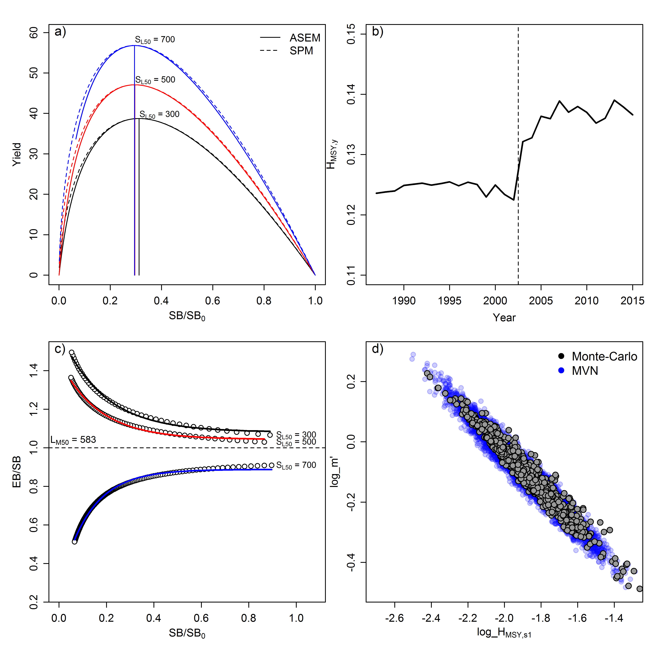

**Fig. 1.** Illustration of the four novel elements of JABBA-Select based on the stock parameters for silver kob: (a) Comparison of the functional forms of the yield curves produced from the Age-Structured Equilibrium Model (ASEM) with the approximation by the JABBA-Select surplus production function (Eq. 1) as function spawning biomass depletion *SB / SB0*,using the life history parameter input values and a range of length-at-50%-selectivity values; (b) JABBA-Select model estimates of time-varying productivity parameters of $H_{MSY,y}$ (Eq. 9), (c) ASEM-derived selectivity-dependent distortion in the exploitable biomass (*EB*) relative to the spawning biomass (*SB*) over a wide a range of *SB / SB0* iterations, which were fitted by Eq. 10, , with the dashed line denoting the increase in minimum size limit for line-caught silver kob and the remainder of variations attributed to variations in the relative catch contribution the of inshore trawl; and (d) Multivariate normal (MVN) approximation of $log⁡(H_{{MSY}_{f,s,k}}^{'})$ and log( $m_{f,s,k}^{'})$ random deviates generated from the ASEM via Monte-Carlo simulations (Eq. 11).



**Fig. 2.** Schematic of functional relationships between the productivity parameter *r* and the shape parameter of the surplus production function and the Age-Structured Equilibrium Model (ASEM; i.e. yield- and spawning biomass-per-recruit models with integrated spawner recruitment relationship). Numbers in boxes denote the sequence of deriving deviates of *r* and *m* from life history and selectivity parameter inputs into the ASEM.

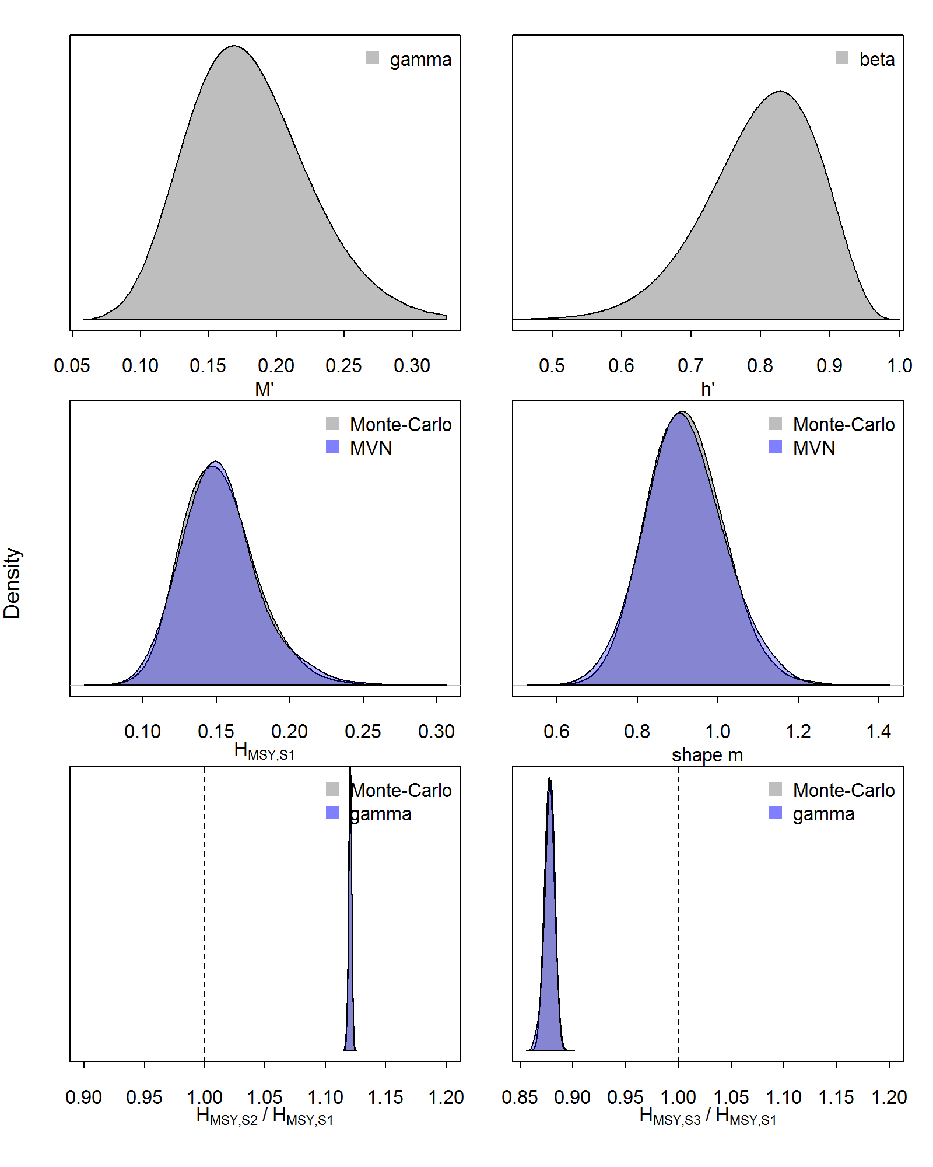

**Fig. 3.** Showing the assumed distributions for natural mortality *M* (gamma) and steepness *h* (beta)deviates used as input for the ASEM to derive an informative Multivariate normal (MVN) priors for silver kob (top panel), resulting distributions of simulated deviates of $H_{{MSY}_{1,1,k}}^{'}$ for fishery *f*  = 1 and selectivity *s* = 1 and $m_{\overline{f},\overline{s},k}^{'}$ and corresponding MVN approximations (middle panel) and ASEM-generated distributions of *HMSY* ratios for recent linefishery selectivity *s =2* (2004-2015) and inshore trawl selectivity *s =* 3 to reference selectivity *s* = 1 for early linefishery (1987-2003), which are approximated by a gamma prior.

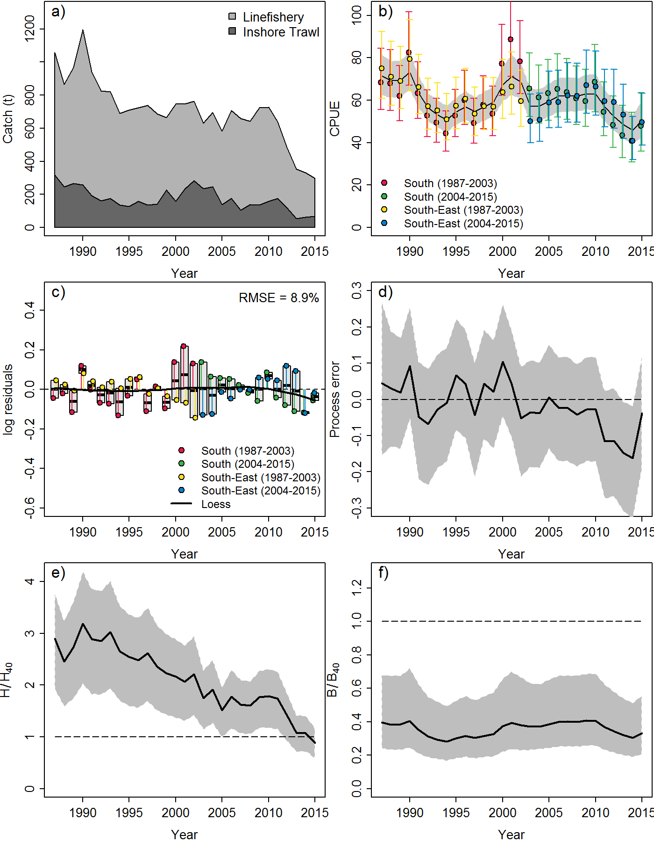

**Fig. 4.** JABBA-Select results for silver kob case-study, showing (a) Cumulative catch time series of the inshore and handline fishery (1987-2015), (b) fits to two standardized abundance indices split into two periods with different selectivity, (c) JABBA residual plot boxplots of combined color-coded residual and a loess smoother fitted through all residual (black line), (d) process error deviates on log-scale; and predicted trajectories of (e) $H_{y}/H_{{40}_{y}}$ and (f) ${SB}_{y}/{SB}_{{40}_{y}}$.

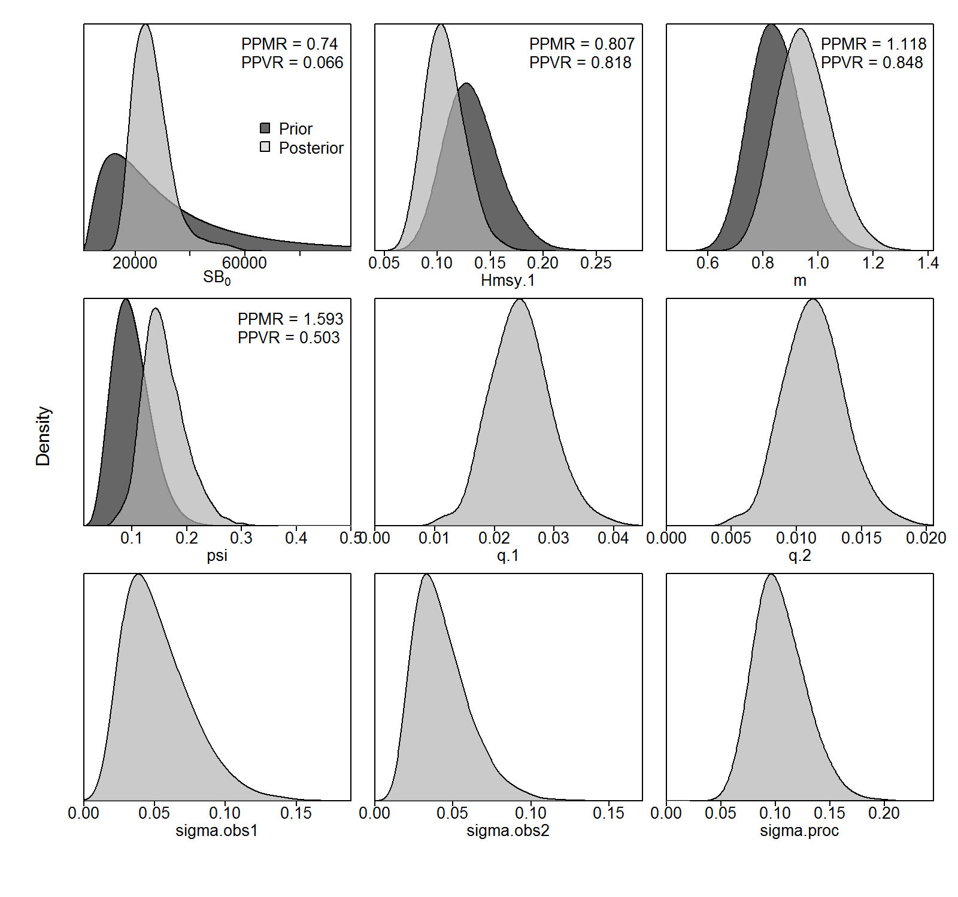

**Fig. 5.** Posterior and prior distributions for all parameters estimated by JABBA-Select model fitted to catch and abundance data for silver kob. PPRM: Posterior to Prior Ratio of Means; PPRV: Posterior to Prior Ratio of Variances (CV2).

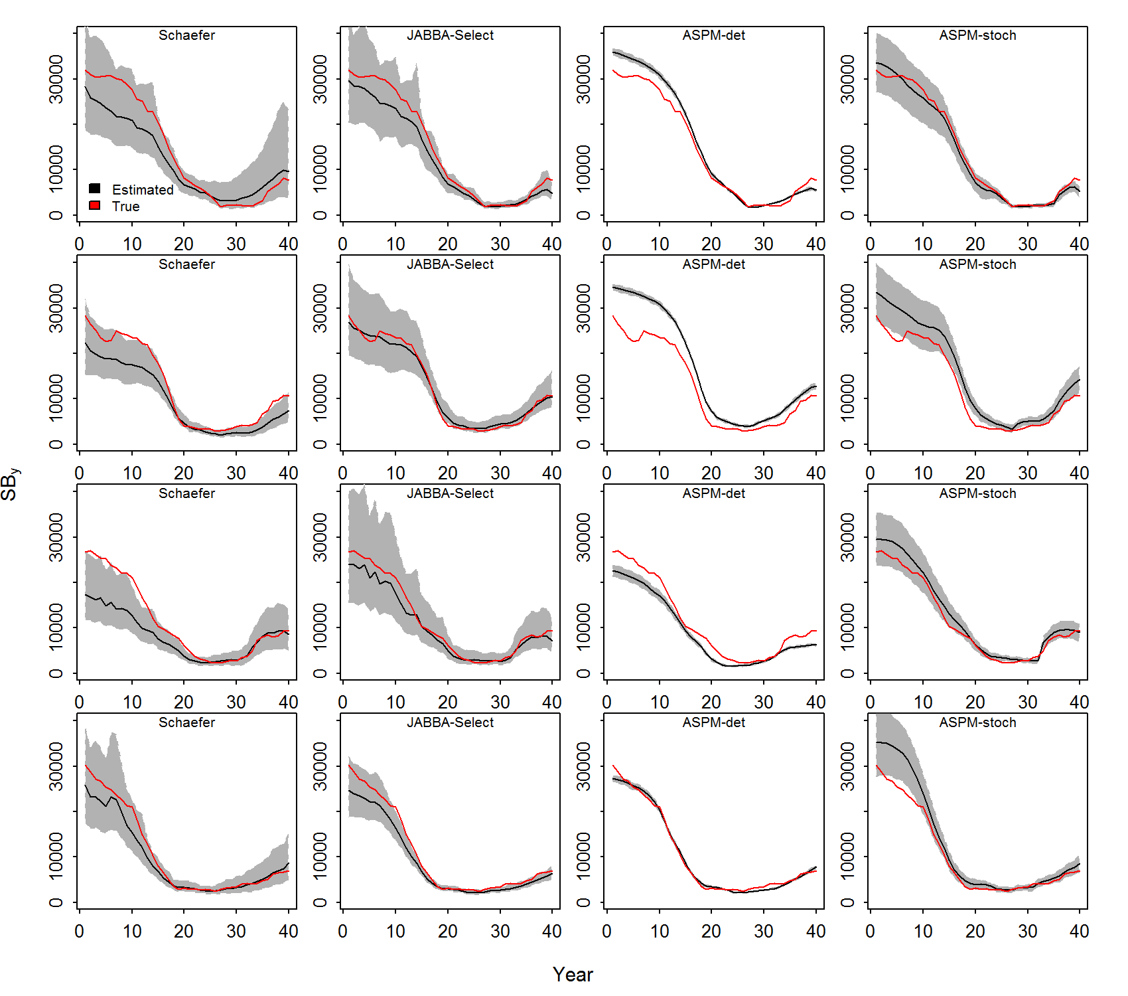

**Fig. 6.** Simulated ‘true’ trajectories of spawning biomass and estimated spawning biomass (*SB*y) and associated 95% Confindence Intervals from four alternative estimations models for the first 4 of 100 simulation replicates, where “-det” and “-stoch” denote the determinsitc and stochastic version of the age-structured production model (ASPMs), respectively.

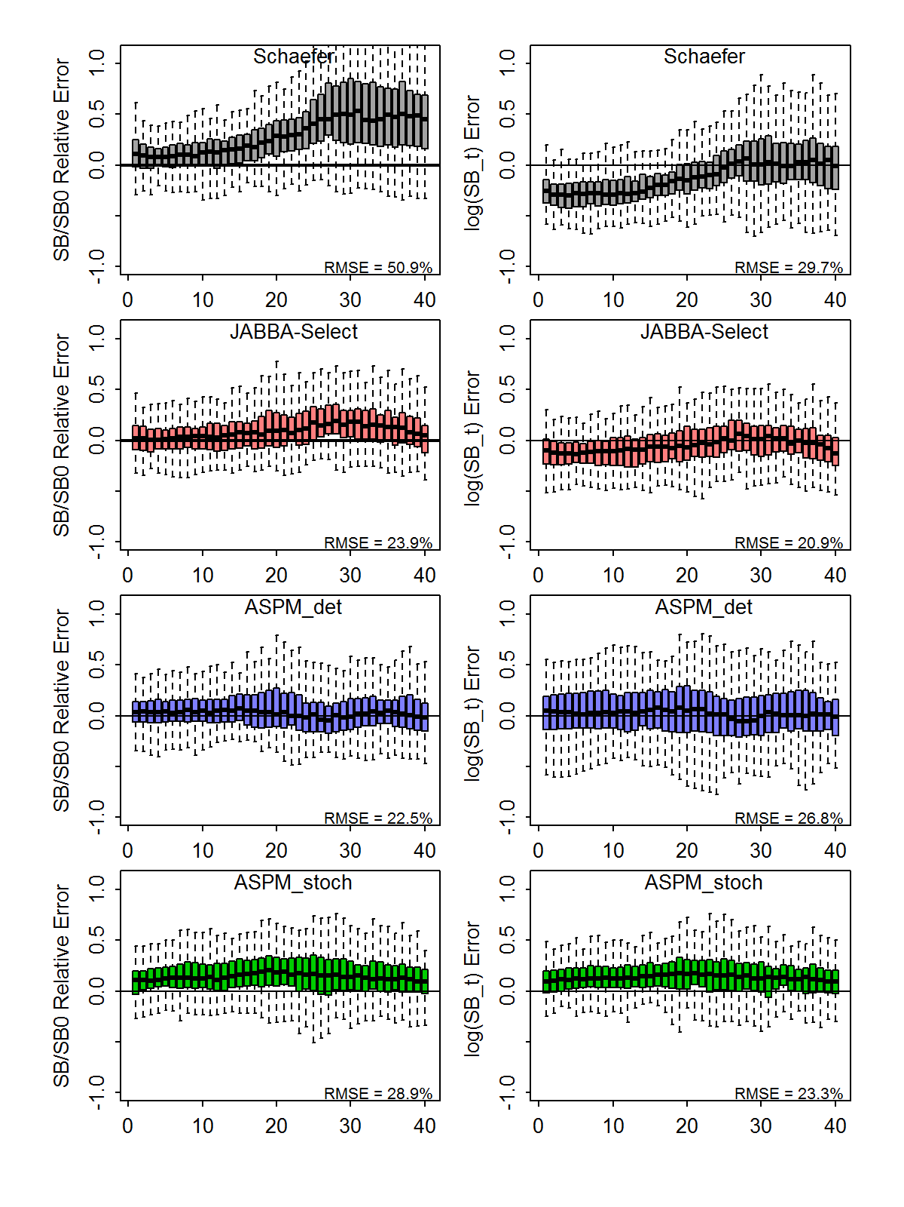

**Fig. 7.** Boxplots showing errors in estimated ratios of spawninig biomass (SB) to unfished spawining biomass (SB0) and absolute quantaties of SB with respect the ‘true’ values for a Schaefer surplus production model (Schaefer), JABBA-Select, a determinitic age-structured production model (ASPM_det) and a stochastic age-structured production model (ASPM_stoch) based on 100 simulation replicates. Root-Mean-Squared-Error (RMSE), representative of the 40 years simulation period, are displayed in the bottom right corner of each plot.

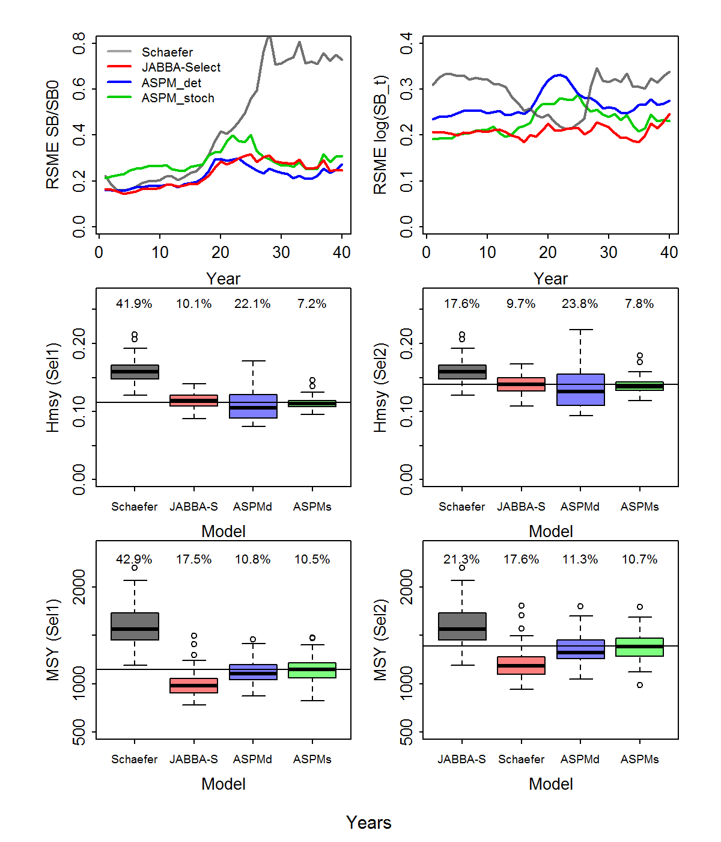

**Fig. 7.** Trends in annual Root-Squared-Mean-Error (Top Panel) and boxplots showing the estimated stock reference points $H_{{MSY}_{s}}$ (middle panel) and (bottom panel) for selectivity *s=*1 (*sL*50 =300 mm) and *s =* 2 (*sL*50 = 500 mm) in comparison to the ‘true’ values (solid horizontal lines) for a Schaefer surplus production model (Schaefer), JABBA-Select (JABBA-S), a determinitic age-structured production model (ASPMd) and a stochastic age-structured production model (ASPMs) based on 100 simulation replicates. Root-Mean-Squared-Error (RMSE) are displayed in on each box for $H_{{MSY}_{s}}$ and ${MSY}_{s_{ }}$.

**Appendix A:**

*Input parameter functions for length-, weight-, maturity- and selectivity-at-age*

Weight-at-age is described as function of the weight to length conversion parameters *ω* and *δ* and length-at-age, *La*, such that

*wa* = *ωLa δ* (A1)

The corresponding *La* was calculated based on the Bertalanffy growth function parameters as:

$L_{a}=L_{∞}(1-e^{-κ\left(a-a_{0}\right)})$ (A2)

where *L∞* is the asymptotic length, $κ$ is the growth coefficient and *a*0 is the theoretical age at zero length.

The fraction of mature females at age *a* was calculated as:

$ψ_{a}=\left\{\begin{aligned}0 for a<a_{mat} \\ 1 for a ≥a_{mat} \end{aligned}\right.$ (A3)

where $a_{mat}$ is the age-at-maturity assumed to be knife-edge.

.

Selectivity-at-age for the fisheries operating with selectivity *s, $s_{a,s},$*  was calculated as a function of length-at-age, *L*a, using a two parameter logistic model of the form:

$s_{a,s}=\frac{1}{1+e^{-(L_{a}-L_{c_{s}})/δ_{s}}}$ (A4)

$L_{c_{s}}$ is the length at which 50% of the catch is retained with selectivity *s* and *δs* is the inverse slope of the logistic ogive.

*Age-structured dynamics*

The age-structured simulation and estimation models were formulated building on the age-structured simulation-estimation framework employed in previous studies (Thorson and Cope, 2015). Numbers-at-age *a* and year *y, Na,y*,are governed by:

$N_{a,y}=\left\{\begin{aligned}R_{y} for a=0 \\ N_{a-1,y-1}e^{-s_{a,s}-F_{y-1}M} for a>0\end{aligned}\right.$ (A5)

where *Ry* is recruitment in year *y*, *sa,s* is fishery selectivity at age under selectivity regime *s*, *M* is the instantaneous rate of natural mortality, and *Fy* in year *y*.

Spawning biomass *SBy* is expressed as:

${SB}_{y}=\sum_{a}{w_{a}ψ_{a}N_{a,y}}$ (A6)

where $w_{a}$ is the weight at age, $ψ_{a}$ is the proportion of mature fish in the population.

Stochastic recruitment is introduced as a lognormally distributed random variable with the expected mean derived from the Beverton-Holt SSR function:

$\ln\left(R_{t}\right)\sim Normal\left(ln\left(\frac{4hR_{0}SB_{y}}{{SB}_{0}\left(1-h\right)+SB_{y}(5h-1)}\right)-0.5σ_{R}^{2}, σ_{R}^{2}\right)$ (A7)

where *R0* is the unfished average recruitment and $σ_{R}^{2}$ is the variance is recruitment.

To initiate the age structure in the first year of the available catch time series, it is assumed that the stock is in an unfished stated, so that *Na,y=*1 can be approximated by a stochastic age-structured as result of recruitment variation in previous years:

$\ln\left(N_{a,y=1}\right)\sim Normal\left(ln⁡(R_{0}e^{-aM})-0.5σ_{R}^{2}, σ_{R}^{2}\right)$ (A8)

Catch-at-age *ca,t* (in numbers) was calculated from the Baranov catch equation:

$c_{a,y}=N_{a,y}\frac{s_{a,s}F_{y}}{s_{a}F_{a}+M}\left(1-e^{-s_{a,S}F_{y-}M}\right)$ (A9)

and total yield $C_{y}$ (in weight) in year *y* the summed product of catch at age and weight at age, such that:

$C_{y}=\sum_{a}{c_{a,y}w_{a}}$ (A10)

The abundance index *Iy* (CPUE) for year *y* was assumed to be proportional to the exploitable portion of the biomass (*EBy*) and associated with a lognormally distributed observation error $ε_{y}$:

$\log\left(I_{y}\right)\sim Normal\left(\ln\left(q{EB}_{y}\right),σ_{ε}^{2}\right)$ (A11)

where *q* is the catchability coefficient and *EBy* is a function of selectivity-at-age, such that:

${EB}_{y}=\sum_{a}{N_{a,y}w_{a}s_{a,s}}$. (A12)

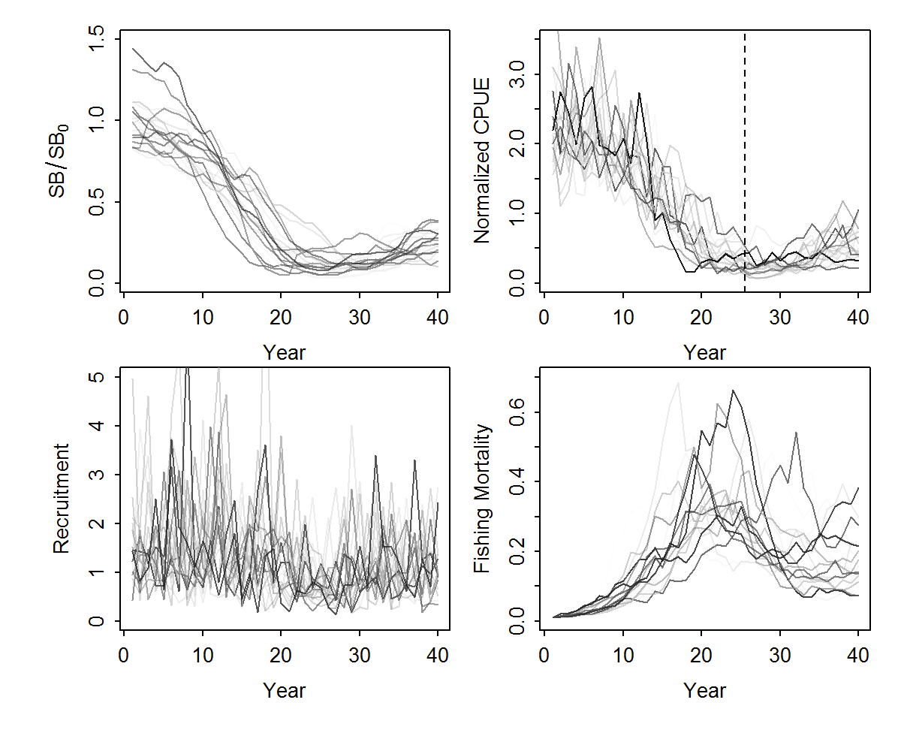

**Fig. A1. S**imulated trajectories of *SBy*/*SB0*, normalized relative abundance indices (CPUE), recruitment deviates and fishing mortality *F* for the first 20 simulation replicates of reference case simulation experiment.

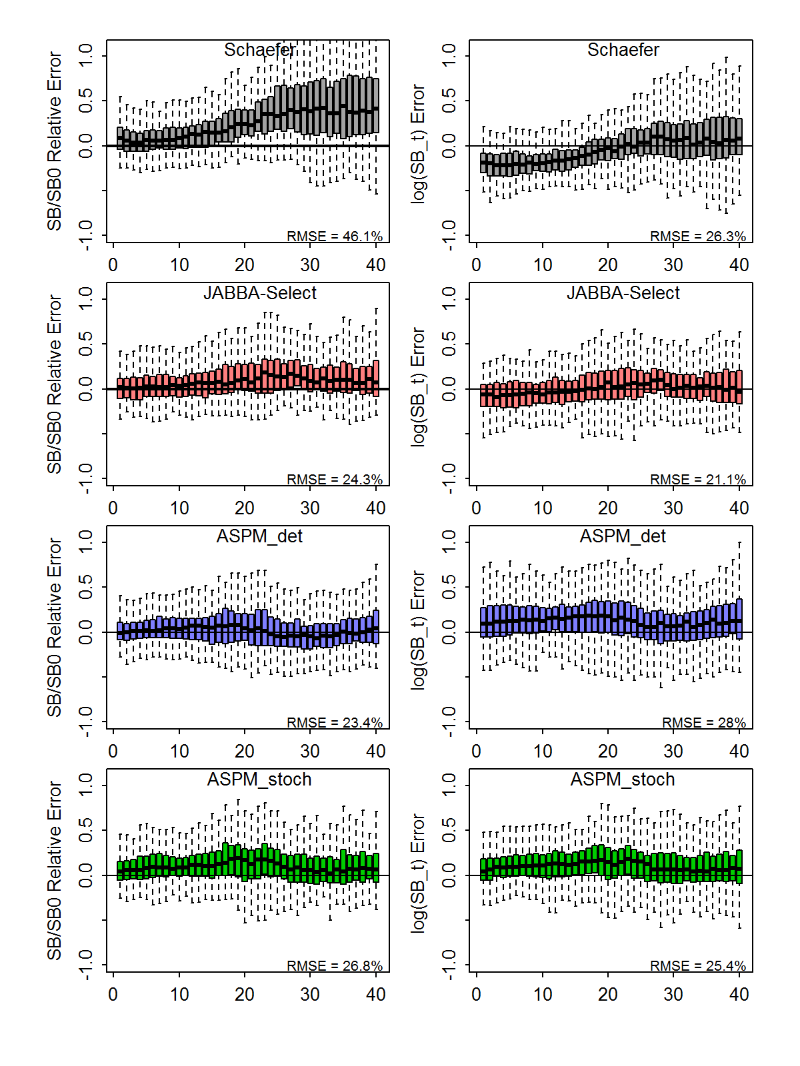

**Fig. A2** Sensitivity analysis results showing boxplots of errors in estimated ratios of spawninig biomass (SB) to unfished spawining biomass (SB0) and absolute quantaties of SB with respect the ‘true’ values for a Schaefer surplus production model (Schaefer), JABBA-Select, a determinitic age-structured production model (ASPM_det) and a stochastic age-structured production model (ASPM_stoch) based on 100 simulation replicates. Root-Mean-Squared-Error (RMSE), representative of the 40 years simulation period, are displayed in the bottom right corner of each plot.

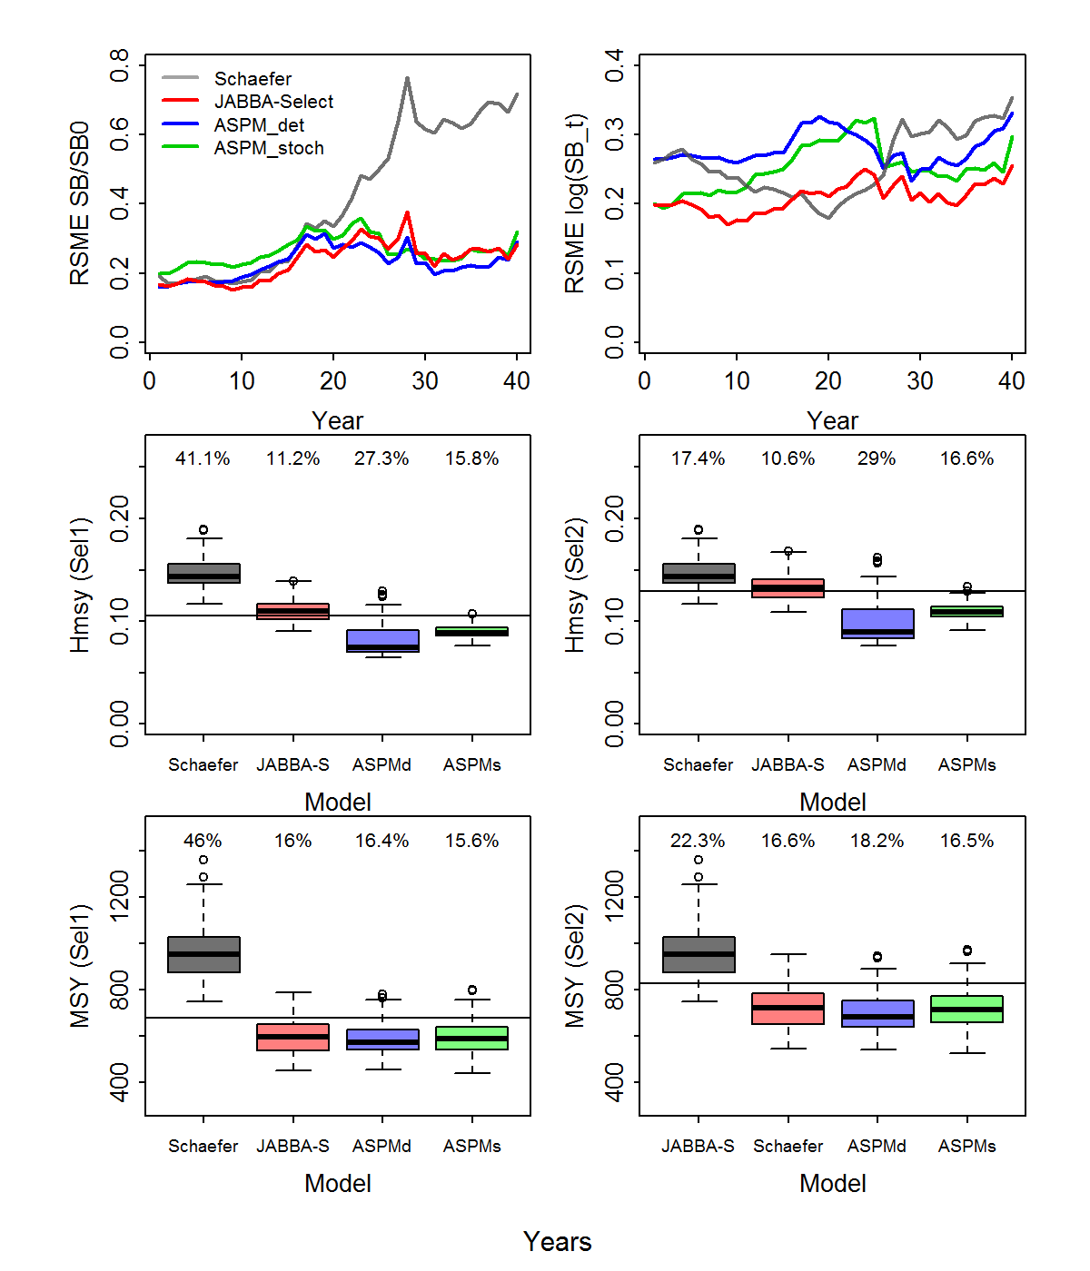

**Fig. A2** Sensitivity analysis results showing trends in annual Root-Squared-Mean-Error (Top Panel) and boxplots showing the estimated stock reference points $H_{{MSY}_{s}}$ (middle panel) and (bottom panel) for selectivity *s=*1 (*sL*50 =300 mm) and *s =* 2 (*sL*50 = 500 mm) in comparison to the ‘true’ values (solid horizontal lines) for a Schaefer surplus production model (Schaefer), JABBA-Select (JABBA-S), a determinitic age-structured production model (ASPMd) and a stochastic age-structured production model (ASPMs) based on 100 simulation replicates. Root-Mean-Squared-Error (RMSE) are displayed in on each box for $H_{{MSY}_{s}}$ and ${MSY}_{s_{ }}$.

**Appendix B**

*Informative r prior generation for the JABBA-Schaefer estimation model*

To specify a prior distribution for the intrinsic rate of increase parameter *r*, we adapted the Leslie matrix method by McAllister et al. (2001). Based on this approach, demographic information was used to construct an age-structured Leslie matrix of the form (Caswell, 2001):

$A=\left(\begin{aligned}{ϕ_{1 }}^{ } \\ θ_{1} \\ 0 \\ 0 \\ 0\end{aligned}\begin{aligned}{ϕ_{2 }}^{ } \\ 0 \\ θ_{2} \\ 0 \\ 0\end{aligned}\begin{aligned}{ϕ_{3 }}^{ } \\ 0 \\ 0 \\ ⋱ \\ 0\end{aligned}\begin{aligned}⋯^{ } \\ 0 \\ 0 \\ 0 \\ θ_{A-1}\end{aligned}\begin{aligned}{ϕ_{A }}^{ } \\ 0 \\ 0 \\ 0 \\ 0\end{aligned}\right)$ (B1)

where $ϕ_{a }$ is the average number of recruits expected to be produced by an adult female at age *a* and $θ_{a}$ is the fraction of survivors at age, with *A* donating the maximum age *amax*. The value of *r* is obtained from ** = exp(*r*), where ** is the dominant eigenvalue of (Quinn and Deriso, 1999; Caswell, 2001).

Age-dependent survival calculated as *Sa* = exp(-*M*), where *M* is the instantaneous rate of natural mortality. The average number of recruits expected to be produced by an adult female at age *t* is expressed as:

$ϕ_{t}=αw_{a}ψ_{a}$ (B2)

where $α$ denotes the slope of the origin of the spawner-recruitment relationship (i.e. the ratio of recruits to spawner biomass at very low abundance) (Hilborn and Walters, 1992; Myers et al., 1999; Forrest et al., 2012), $w_{a}$ is the weight at age *a*, $ψ_{a}$ is the fraction of females that are mature at age *a* (see Eqs. A1-A3 in Appendix A). For the calculation of the annual reproductive rate *a* first consider the BH-SSR of the form:

$R=\frac{αSB}{1+βSB}$ (B3)

where *R* is the number of recruits, *S* is the spawner biomass and  is the scaling parameter (Hilborn and Walters, 1992). In contrast to alternative formulations of the BH-SSR, the parameter  can be directly interpreted as the slope in the origin of the S-R curve (Hilborn and Walters, 1992). We re-parameterized as function of unfished spawner-biomass per recruit ${\tilde{S}}_{0}$ (Eq. 4) and the steepness parameter *h* of the spawner-recruitment relationship (Myers et al., 1999), such that:

$α=\frac{4h}{(1-h)}{\tilde{S}}_{0}^{-1}$ (B4)

We used Monte-Carlo simulations to randomly generate 1000 permutations of randomly generate deviates *k* of $M_{k}^{'}$ from a lognormal distribution and $h_{k}^{'}$ from a beta distribution and used those as input into the Leslie-matrix model, together with the other life history parameters in Table 3. The informative lognormal prior for *r* for the JABBA-Schaefer model was then obtained by taken the mean (log(0.284)) and sd (0.281) of the simulated log(*rk*) deviates (Fig. 1b).

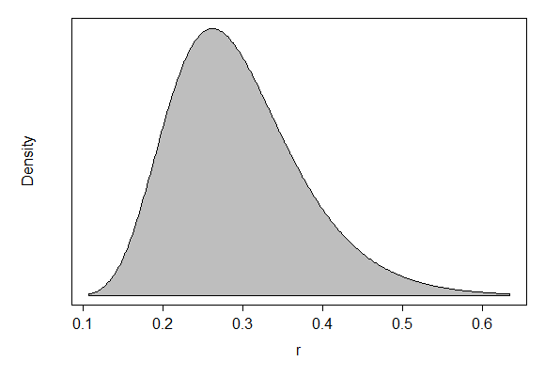

**Fig. B1.** Generated lognormal prior for *r* (mean = log(0.284), sd = 0.281), assumed for the Schaefer estimation model implemented with JABBA.

1. Effective length at birth ($t_{0}$), maximum length ($L_{∞}$), relative growth rate ($κ$), mortality rate ($M$), weight-at-length parameters ($ϖ$, $δ$), spawner-recruit parameters ($R_{0}$, $h$), age-at-maturity ($a_{mat}$) and selectivity-at-age (*Sa*)