**Various requested model outputs for west coast rock lobster**

S.J. Johnston

Table 1: The $σ$ estimates for various data sources for the 2018 west coast rock lobster assessments.

|  |  |  |  |  |  |
| --- | --- | --- | --- | --- | --- |
|  | **A1+2** | **A3+4** | **A5+6** | **A7** | **A8+** |
| CPUE trap $σ$ | - | 0.490 | - | 0.516 | 0.180 |
| CPUE hoop $σ$ | 0.207 | 0.540 | 0.258 | - | 0.177 |
| CPUE FIMS $σ$ | - | 1.521 | 1.103 | 0.753 | 0.341 |
|  |  |  |  |  |  |
| F% trap $σ$ | 0.150* | 0.150* | 0.150* | 0.150* | 0.150* |
| F% hoop $σ$ | 0.150* | 0.150* | 0.150* | 0.150* | 0.150* |
| F% FIMS $σ$ | 0.150* | 0.150* | 0.150* | 0.150* | 0.150* |
|  |  |  |  |  |  |
| CAL male trap $σ$ | - | 0.204 | - | 0.249 | 0.228 |
| CAL female trap hoop $σ$ | - | 0.219 | - | 0.215 | 0.429 |
| CAL hoop male $σ$ | 0.361 | 0.270 | 0.207 | - | 0.153 |
| CAL female hoop $σ$ | 0.340 | 0.235 | 0.238 | - | 0.473 |
| CAL FIMS male $σ$ | - | 0.358 | 0.251 | 0.304 | 0.150* |
| CAL FIMS female $σ$ | - | 0.894 | 0.302 | 0.512 | 0.150* |

*lower bound

Figure 1: Male somatic growth rates for each super-area.

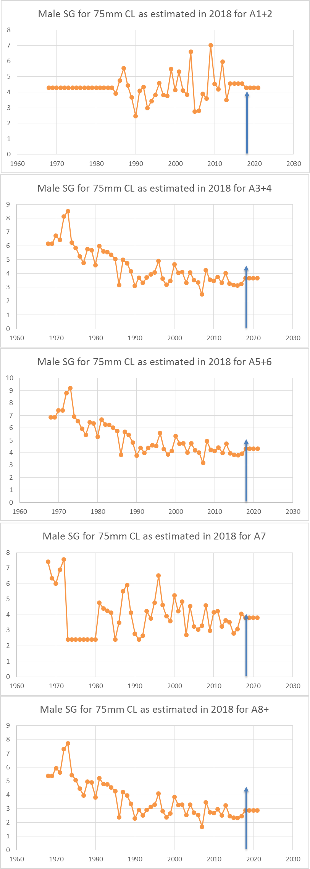

Figure 2: Estimated recruitment trends for each super-area.

