Likelihood profile for h and a fit of the RC model excluding the early CPUE data
A. Ross-Gillespie
Email: mlland028@myuct.ac.za
In order to set up a likelihood profile for the h parameter, runs were conducted fixing the h values for both species at a range of values. Likelihood components are reported for four different values of h. Additionally, a run was conducted where the GLM CPUE data up to 1988 were excluded to see the impact this had on the stock-recruitment relationship.
Table 1: Likelihood components are listed for the RC and for runs with four different h values, as well as a run where the GLM CPUE data are excluded up to 1988. Values are given in absolute terms and relative to the RC values.
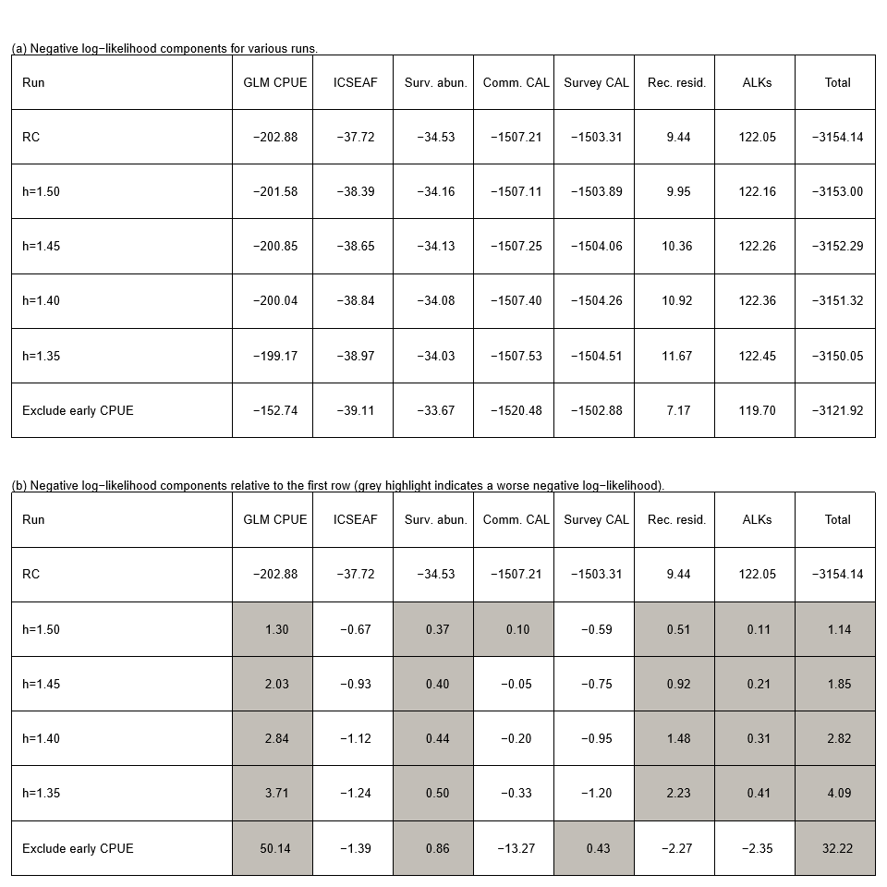

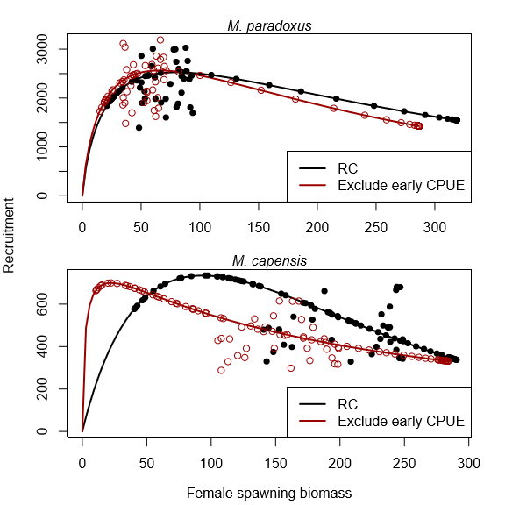
Figure 1: Recruitment against spawning biomass for the RC and a run where the GLM CPUE data up to 1988 are excluded.

Marine Resource Assessment and Management Group, Department of Mathematics and Applied Mathematics, University of Cape Town, Rondebosch.

