Investigation into the small female spawning biomass estimated for M. paradoxus
A. Ross-Gillespie
Email: mlland028@myuct.ac.za
The panel queried how it could be possible that some of the B-H OMs estimate spawning biomass that is much smaller than the survey abundance estimates. Investigation into the matter has revealed that it is most likely the estimates of the growth curve parameters for these models that are responsible for this – the females are estimated to grow at a much slower rate, affecting the age-length conversion matrices and therefore (amongst other things) the maturity-at-age and weight-at-age vectors (which are converted from maturity-at-length and weight-at-length vectors using these age-length matrices). Thus the female component of the spawning biomass is substantially smaller than the male component. Additionally, estimates of spawning biomass are much smaller than estimates of survey exploitable biomass owing to the lower maturity-at-age values used in the spawning biomass calculations. Survey exploitable biomass is also gender-combined, which should be born in mind when comparing the survey abundance estimates with the values of female spawning biomass reported in Hake/P3.

Table 1: Estimates of the growth curve parameters for the nine RS OMs.
 |  | (1) RS01 | (2) RS02 | (3) RS03 | (4) RS04a | (5) RS05a | (6) RS06a | (7) RS04b | (8) RS05b | (9) RS06b
L5 | par, males | 52.30 | 52.30 | 51.95 | 47.19 | 47.24 | 46.89 | 48.64 | 47.87 | 45.68
L5 | par, females | 50.06 | 50.06 | 50.13 | 50.38 | 50.65 | 50.90 | 33.66 | 33.94 | 33.96
L5 | cap, males | 53.61 | 53.61 | 53.74 | 52.76 | 53.88 | 53.89 | 53.34 | 53.88 | 53.19
L5 | cap, females | 54.11 | 54.11 | 54.21 | 52.66 | 54.36 | 54.39 | 53.80 | 54.38 | 53.57
ln(kappa) | par, males | -19.50 | -19.50 | -19.99 | -2.95 | -2.64 | -2.37 | -18.45 | -19.74 | -3.08
ln(kappa) | par, females | -19.42 | -19.42 | -19.50 | -19.15 | -19.41 | -16.61 | -1.27 | -1.25 | -1.19
ln(kappa) | cap, males | -18.88 | -18.88 | -17.17 | -11.40 | -19.24 | -19.69 | -17.72 | -19.56 | -19.31
ln(kappa) | cap, females | -19.60 | -19.60 | -19.79 | -19.99 | -15.80 | -18.22 | -19.84 | -19.72 | -18.63
t0 | par, males | -0.39 | -0.39 | -0.44 | -1.31 | -1.13 | -1.06 | -1.47 | -1.57 | -1.52
t0 | par, females | -0.01 | -0.01 | -0.01 | -0.86 | -0.79 | -0.80 | -0.80 | -0.79 | -0.78
t0 | cap, males | -1.12 | -1.12 | -1.12 | -1.13 | -1.12 | -1.12 | -1.14 | -1.12 | -1.13
t0 | cap, females | -0.77 | -0.77 | -0.77 | -0.80 | -0.77 | -0.77 | -0.77 | -0.77 | -0.77

Table 2: Print-out of the length-at-age values estimated for M. paradoxus males and females for the nine RS OMs
 | M. paradoxus males
Age | (1) RS01 | (2) RS02 | (3) RS03 | (4) RS04a | (5) RS05a | (6) RS06a | (7) RS04b | (8) RS05b | (9) RS06b
0 | 3.77 | 3.77 | 4.23 | 11.09 | 10.36 | 10.26 | 11.03 | 11.46 | 11.90
1 | 13.48 | 13.48 | 13.78 | 19.09 | 18.82 | 19.01 | 18.56 | 18.74 | 19.29
2 | 23.18 | 23.18 | 23.32 | 26.67 | 26.70 | 26.98 | 26.08 | 26.03 | 26.35
3 | 32.89 | 32.89 | 32.87 | 33.87 | 34.04 | 34.25 | 33.60 | 33.31 | 33.09
4 | 42.60 | 42.60 | 42.41 | 40.70 | 40.88 | 40.86 | 41.12 | 40.59 | 39.53
5 | 52.30 | 52.30 | 51.95 | 47.19 | 47.24 | 46.89 | 48.64 | 47.87 | 45.68
6 | 62.01 | 62.01 | 61.50 | 53.34 | 53.17 | 52.38 | 56.16 | 55.16 | 51.55
7 | 71.72 | 71.72 | 71.04 | 59.18 | 58.68 | 57.38 | 63.68 | 62.44 | 57.17
8 | 81.42 | 81.42 | 80.58 | 64.72 | 63.82 | 61.94 | 71.20 | 69.72 | 62.52
9 | 91.13 | 91.13 | 90.13 | 69.98 | 68.61 | 66.09 | 78.72 | 77.01 | 67.64
10 | 100.84 | 100.84 | 99.67 | 74.97 | 73.07 | 69.87 | 86.24 | 84.29 | 72.53
11 | 110.54 | 110.54 | 109.22 | 79.70 | 77.22 | 73.32 | 93.76 | 91.57 | 77.20
12 | 120.25 | 120.25 | 118.76 | 84.20 | 81.08 | 76.46 | 101.28 | 98.85 | 81.66
13 | 129.96 | 129.96 | 128.30 | 88.46 | 84.68 | 79.32 | 108.80 | 106.14 | 85.92
14 | 139.67 | 139.67 | 137.85 | 92.51 | 88.03 | 81.92 | 116.32 | 113.42 | 89.99
15 | 149.37 | 149.37 | 147.39 | 96.35 | 91.15 | 84.29 | 123.84 | 120.70 | 93.88
 | M. paradoxus females
Age | (1) RS01 | (2) RS02 | (3) RS03 | (4) RS04a | (5) RS05a | (6) RS06a | (7) RS04b | (8) RS05b | (9) RS06b
0 | 0.09 | 0.09 | 0.11 | 7.42 | 6.95 | 7.02 | 8.45 | 8.49 | 8.61
1 | 10.09 | 10.09 | 10.11 | 16.01 | 15.69 | 15.79 | 16.65 | 16.81 | 17.11
2 | 20.08 | 20.08 | 20.12 | 24.60 | 24.43 | 24.57 | 22.83 | 23.06 | 23.39
3 | 30.08 | 30.08 | 30.12 | 33.19 | 33.17 | 33.35 | 27.49 | 27.75 | 28.02
4 | 40.07 | 40.07 | 40.13 | 41.79 | 41.91 | 42.12 | 31.01 | 31.29 | 31.44
5 | 50.06 | 50.06 | 50.13 | 50.38 | 50.65 | 50.90 | 33.66 | 33.94 | 33.96
6 | 60.06 | 60.06 | 60.14 | 58.97 | 59.39 | 59.68 | 35.66 | 35.93 | 35.83
7 | 70.05 | 70.05 | 70.15 | 67.56 | 68.13 | 68.45 | 37.17 | 37.43 | 37.20
8 | 80.05 | 80.05 | 80.15 | 76.15 | 76.87 | 77.23 | 38.31 | 38.56 | 38.22
9 | 90.04 | 90.04 | 90.16 | 84.75 | 85.61 | 86.01 | 39.17 | 39.40 | 38.97
10 | 100.04 | 100.04 | 100.16 | 93.34 | 94.35 | 94.78 | 39.82 | 40.04 | 39.52
11 | 110.03 | 110.03 | 110.17 | 101.93 | 103.10 | 103.56 | 40.30 | 40.52 | 39.93
12 | 120.02 | 120.02 | 120.17 | 110.52 | 111.84 | 112.34 | 40.67 | 40.88 | 40.23
13 | 130.02 | 130.02 | 130.18 | 119.11 | 120.58 | 121.11 | 40.95 | 41.15 | 40.46
14 | 140.01 | 140.01 | 140.18 | 127.70 | 129.32 | 129.89 | 41.16 | 41.35 | 40.62
15 | 150.01 | 150.01 | 150.19 | 136.30 | 138.06 | 138.67 | 41.32 | 41.50 | 40.74

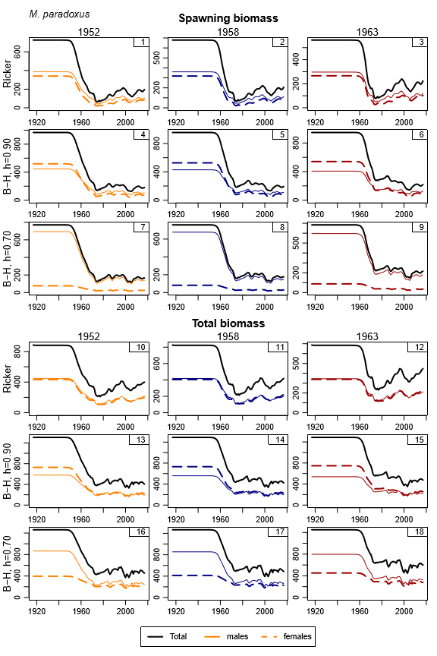
Figure 1: Spawning biomass and total biomass trajectories are shown for M. paradoxus.

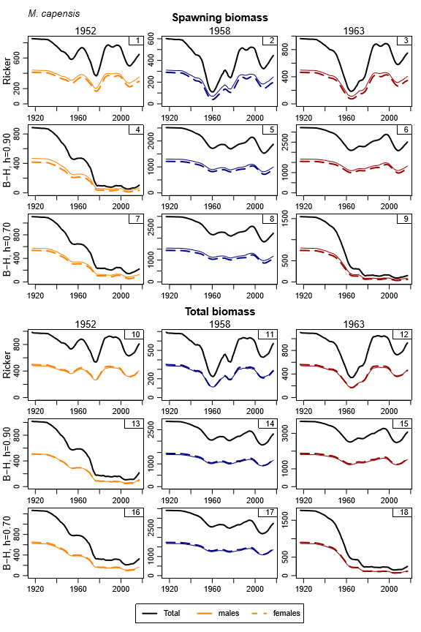
Figure 1: Spawning biomass and total biomass trajectories are shown for M. capensis.

Marine Resource Assessment and Management Group, Department of Mathematics and Applied Mathematics, University of Cape Town, Rondebosch.

