Various additional hake output as requested by the Panel
A. Ross-Gillespie
Email: mlland028@myuct.ac.za

This working paper is a collection of various hake assessment outputs as requested by the Panel. These correspond to the items accorded highest priority, with more information to follow in further working papers.
- One of two major corrections that OLRAC made to the hake model in 2017 was a correction to the MSY calculation:
$C\left(F^{*}\right)=\sum_{g}{\sum_{a}{{\tilde{w}}_{a+1/2}^{g}S_{a}^{g}F^{*}N_{a}^{g}\left(F^{*}\right)}e^{-\frac{\left(M_{a}^{g}+S_{a}^{g}F^{*}\right)}{2}}}$ (pre-OLRAC original)
$C\left(F^{*}\right)=\sum_{g}{\sum_{a}{{\tilde{w}}_{a+1/2}^{g}S_{a}^{g}F^{*}N_{a}^{g}\left(F^{*}\right)}e^{-\frac{\left(M_{a}^{g}\right)}{2}} }$(post-OLRAC correction)
More information on the second major OLRAC correction is provided in MARAM/IWS/2018/Hake/WP4, but in order to ascertain the difference that the MSY calculation correction made, the 2018 RC OM (RS02) was re-run with the MSY calculation error reintroduced. Table 1 provides key assessment results for this run along with the 2018 RC results. The pre- and post-OLRAC correction model results from Hake/P2 have been repeated in Table 1 for reference purposes.
- Figure 1a shows the recruitment vs spawning biomass plots for the nine RS OMs. These figures have been provided for further clarity as the original figures from Hake/P2 are missing some of the points marking model estimates of recruitment fluctuation, and each OM is plotted on a separate plot for clarity purposes.
- The Panel requested plots of the log of recruitment per spawning biomass, which are shown in Figure 1b (plotted against spawning biomass) and in Figure 1c (plotted against time).
- The Panel requested a break-down of the likelihood components for the fits to the GLM CPUE data. Figure 2 shows a detailed break-down of all the likelihood components. Figure 3 lists groupings of likelihood components similar to what has been provided in Hake/P3, but also provides values for the differences in negative log-likelihood components between the RS OMs.

Table 1: Key assessment outputs are provided for four models. The first pair is the 2018 RC (RS02) and the 2018 RC with the MSY calculation error reintroduced (same MLE as the 2018 RC), followed by a column giving the percentage change between the assessment outputs for the two models. The second pair is a repeat of the assessment outputs of the pre- and post-OLRAC correction models from the bridge building document Hake/P2 (models 1b and 2 in that paper), also with the percentage change. The second pair has been included here to compare the change in magnitude in the MSY-related quantities between the pre- and post-OLRAC correction models with the changes when the MSY error is reintroduced to the 2018 RC model. Note that the only difference between the two 2018 models is the MSY calculation correction, but there are additional differences between the two 2017 models, as described in the Appendix of Hake/P2 along with whatever other information OLRAC is able to provide.
 | 2018 RC with MSY calculation error | 2018 RC | Percentage change | 2017 RC pre OLRAC | 2017 RC post OLRAC | Percentage change
lnLtotal | -3154.14 | -3154.14 |  | -3822.70 | -5251.52
Ksp | 318 | 318 | 0.0 | 539 | 515 | -4.5
BspMSY | 63 | 55 | -11.5 | 108 | 115 | 6.6
Bsp2017 | 93 | 93 | 0.0 | 207 | 127 | -38.4
Bsp2017/K | 0.29 | 0.29 | 0.0 | 0.21 | 0.25 | 17.8
Bsp2017/Bspmsy | 1.48 | 1.67 | 13.0 | 0.92 | 1.11 | 20.3
MSY | 122 | 145 | 18.8 | 122 | 137 | 12.7
Ksp | 290 | 290 | 0.0 | 179 | 196 | 9.5
BspMSY | 92 | 86 | -6.7 | 34 | 63 | 86.3
Bsp2017 | 198 | 198 | 0.0 | 112 | 141 | 26.1
Bsp2017/K | 0.68 | 0.68 | 0.0 | 0.62 | 0.72 | 16.2
Bsp2017/Bspmsy | 2.15 | 2.30 | 7.2 | 3.27 | 2.23 | -31.8
MSY | 73 | 84 | 14.3 | 64 | 81 | 26.4

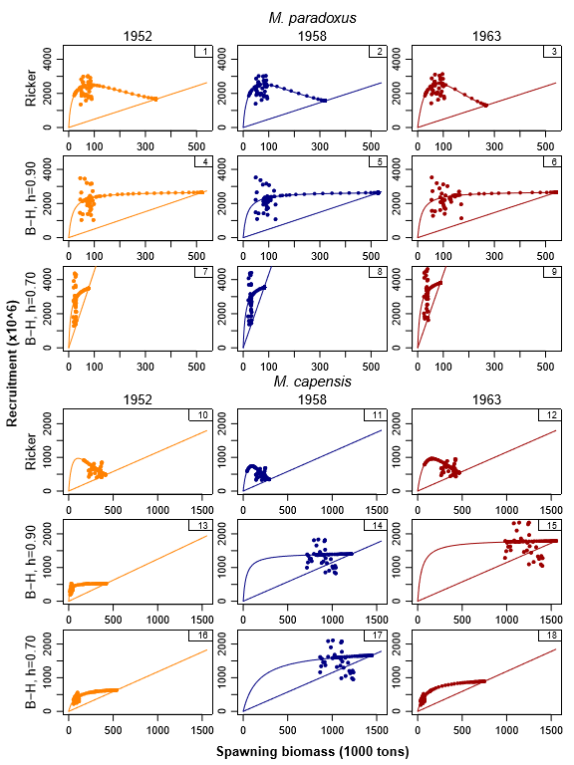
Figure 1a: Recruitment is plotted against female spawning biomass for the nine RS OMs. The individual points show the estimates from the OMs, while the smooth curves show the stock-recruitment relationships and the straight lines the replacement curves.

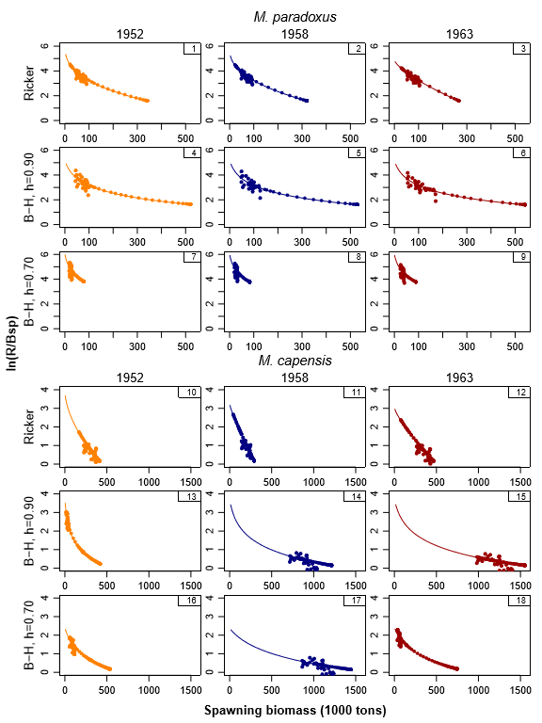
Figure 1b: Log of recruitment per spawning biomass is plotted against spawning biomass for the nine RS OMs. Again, the dots show the assessment output from the OM and the solid line the stock-recruitment relationship.

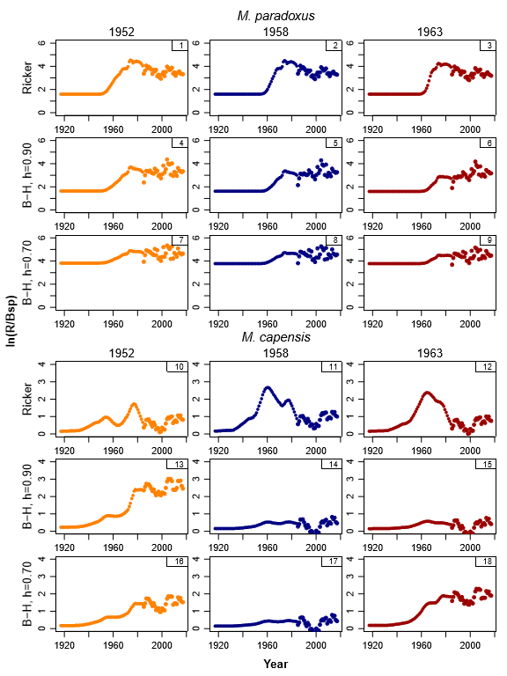
Figure 1c: Log of the recruitment over spawning biomass is plotted against time for the nine RS OMs.

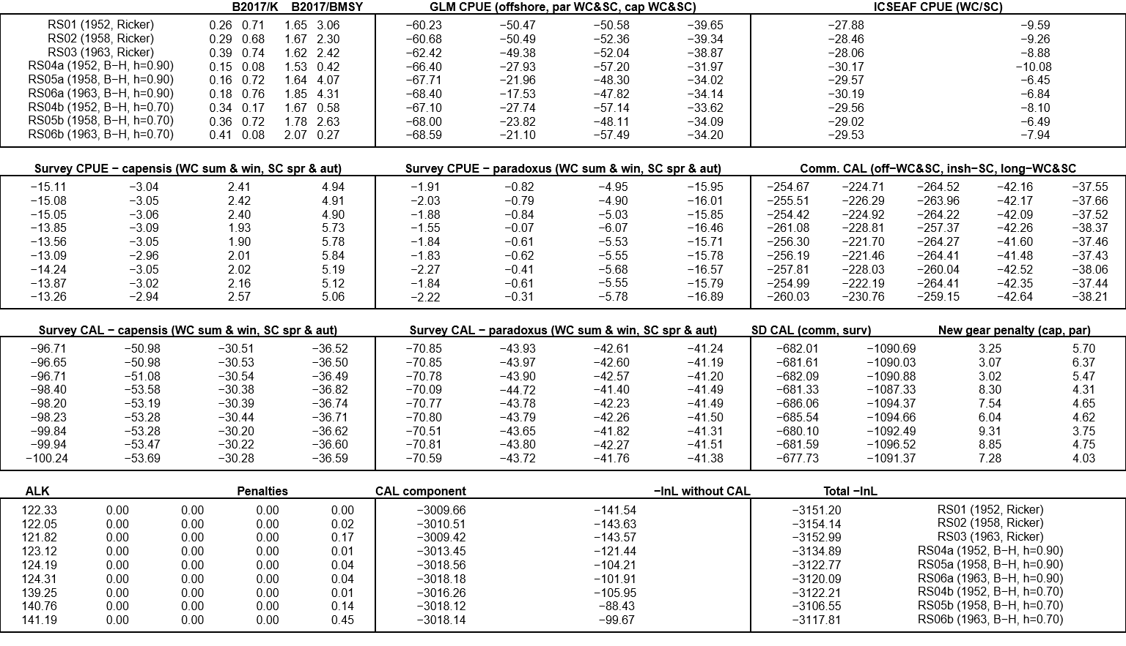
Figure 2: A detailed break-down of the negative log-likelihood components is provided for the nine RS OMs. Each block corresponds to a different data type and the title above that block indicates to which data source each value with that block corresponds to.

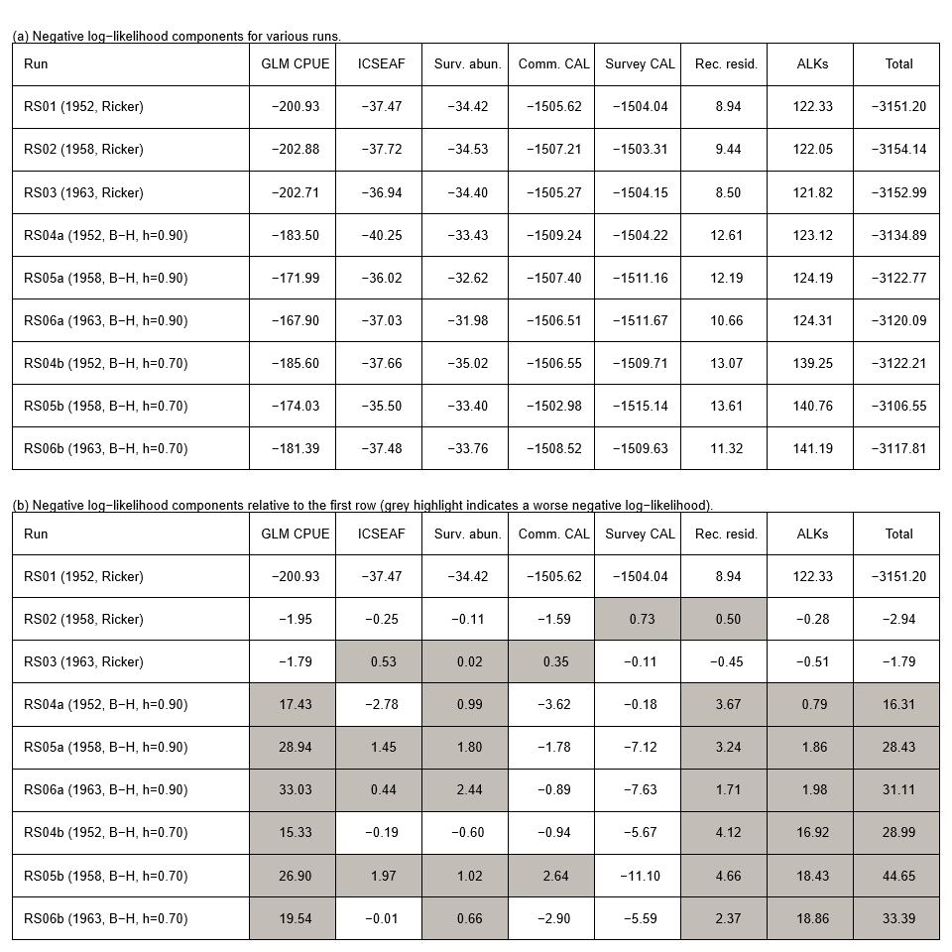
Figure 3: Negative log-likelihoods given by group for (a) absolute terms and (b) relative to the first RS01 OM.

Marine Resource Assessment and Management Group, Department of Mathematics and Applied Mathematics, University of Cape Town, Rondebosch.

