**Corrections applied to the hake assessment ADMB code circa April 2017, and circa January 2018**

**Submitted 27 November 2018**

**Mike Bergh: mike@olsps.com**

Two coding corrections which materially impacted results from stock assessments for hake were not listed in Appendix A of MARAM/IWS/2018/Hake/P2, and are described here. The first was circa April 2017. In April 2017 it was confirmed that the code used to implement equation (9) of ***FISHERIES/2017/FEB/SWG-DEM/07*** involved, for the denominator, the use of the result from equation (8). These two equations appear in the following excerpt from ***FISHERIES/2017/FEB/SWG-DEM/07***:

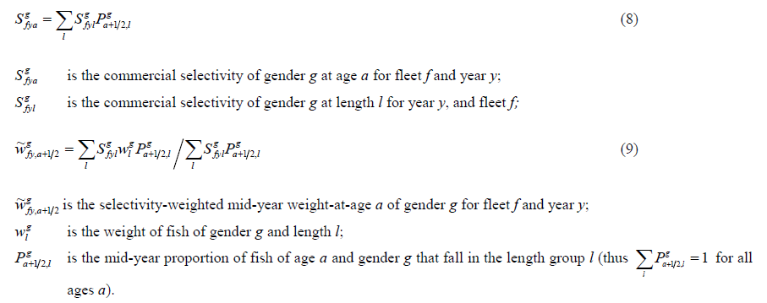

The result of equation (8) is selectivity-**at-age**, which is the denominator of equation (9). It was confirmed in April 2017 that there was an intermediate step in the code which was not documented in ***FISHERIES/2017/FEB/SWG-DEM/07.*** This is that the selectivity-**at-age** was used in the denominator of equation (8) as selectivity-at-age and not in the format shown in equation (9), and that before applying the selectivity-at-age from equation (8) as the denominator in equation (9), this selectivity-at-age is first “normalized” by dividing all the selectivity-at-age values for a given year, fleet and gender by the maximum over all ages.  In the OLSPS Marine calculations equation (9) was applied directly as is, so no intermediate normalization step occurred, and this was the reason that this particular error came to light. As a result, the weights-at-age used by OLSPS Marine for catch calculations all differ from those produced by the code underlying the assessment model described in ***FISHERIES/2017/FEB/SWG-DEM/07***  by the normalization factor used in the intermediate step.  This was confirmed by numerical comparison. These differences can be quite large (~6%) but vary depending on the relationship between selectivity and length.  It seems self-evident that the intermediate step is incorrect, but because the normalisation factors differ by fleet, gender and species, it is difficult to anticipate the resultant impact on the assessment after omitting this intermediate normalisation step.

Figure 1 and Table 1 illustrate what happens to the stock assessment results when the code underlying equation (9) is corrected for the ‘circa April 2017’ error. The impact is slight in most cases, except in one very important respect, the estimate of BMSY. The concern with the updated reference case circa April 2017 prior to this correction had been that ***M. paradoxus*** never reached BMSY, unlike for the preceding assessment, and this had major implications for the coming MSC audit. However the corrected results showed that instead of reaching only 0.89 of BMSY in 2013, ***M. paradoxus*** was estimated as having reached 1.04 of BMSY in 2013. Under these circumstances, the immediate concerns at the time regarding ***M. paradoxus*** were addressed. For the MSC the situation remained unchanged, viz. ***M. paradoxus*** had reached and was now fluctuating around BMSY, rather than having never reached BMSY and perhaps requiring a reversion by the MSC to requiring a revised catch control law (OMP) to effect a “recovery plan”.

A second issue with the code was discovered in January 2018 and was corrected at about the same time. This involved equation (14) of ***FISHERIES/2017/FEB/SWG-DEM/07*** which is shown in the following excerpt:

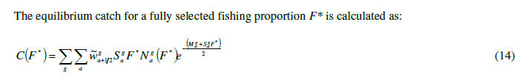

Correction of equation (14) requires omitting the term $S_{a}^{g}F^{*}$ in the exponent. This correction has no impact on the assessment, but it changes the values of MSY (increases it) and it decreases the value of BMSY. These impacts are not documented here.

Table 1. Impact of correction to equation (9) of FISHERIES/2017/FEB/SWG-DEM/07.

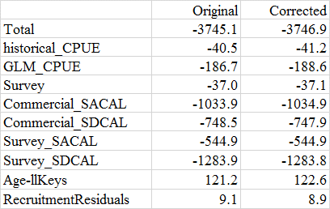

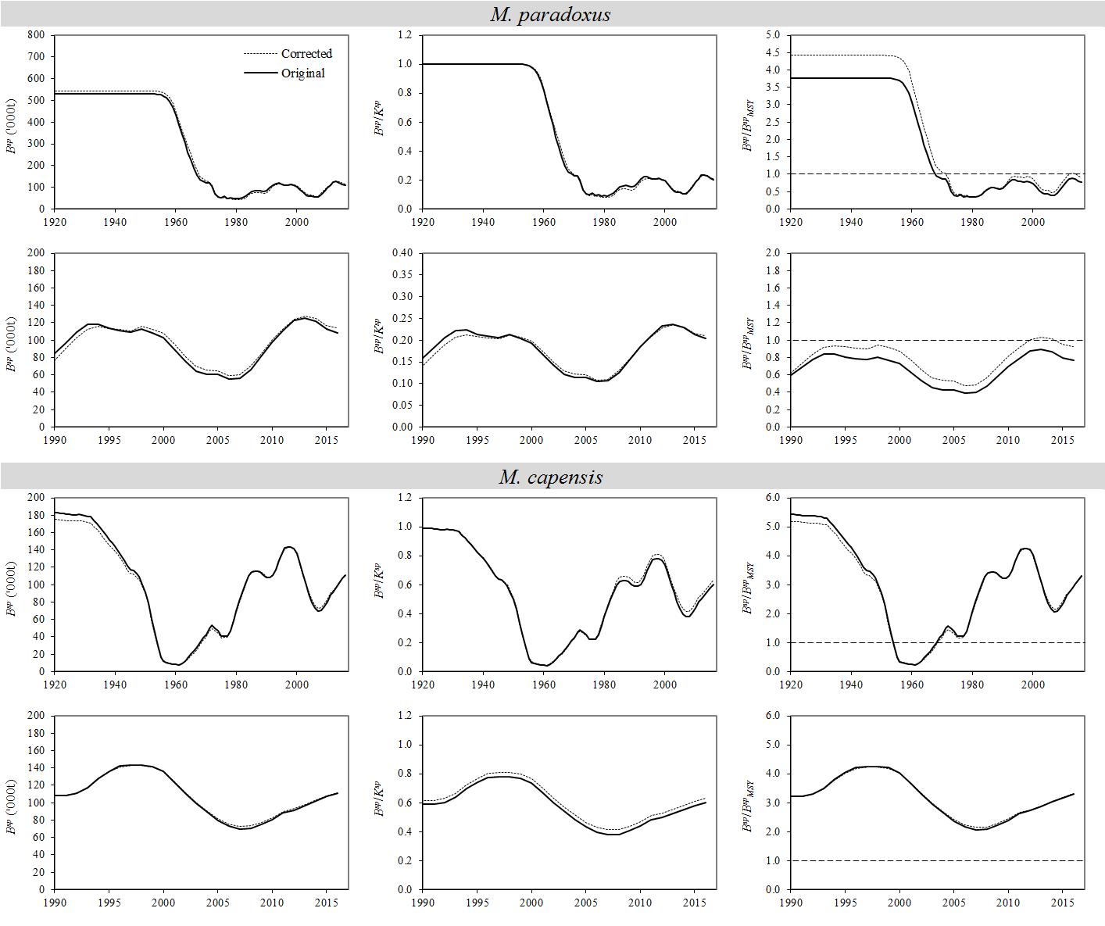

Figure 1. Impact of correction to equation (9) of FISHERIES/2017/FEB/SWG-DEM/07.