Additional robustness tests concerning no future surveys
A. Ross-Gillespie
Email: mlland028@myuct.ac.za
This working paper reports results for three additional robustness tests:
- Decreasing future recruitment
Previously a robustness test was conducted where future carrying capacity was decreased by 30% over the course of five years, and then maintained at the reduced level for the remainder of the projection period. This reducing in K was intended as a proxy for recruitment failure. Here a robustness test is conducted where the recruitment values for 2018-2022 are halved, but are back to normal levels for the remainder of the projection period.
- Decreasing future recruitment plus no surveys
The robustness test above is combined with the no future surveys robustness test
- No future surveys plus undetected increase in catchability of 4%
This is a repeat of RT 5 of Hake/P6a, except that the commercial catchability coefficient is increased by 4% per annum instead of 2%.
Figure 1 plots the performance statistics and Figure 2 the trajectories for the three robustness tests.
Simulations suggest that while a recruitment failure over the next five years would likely result in a severely reduced TAC for almost 20 years, the OMP seems to perform adequately in preserving the hake resource, with the depletion levels after 25 years being very similar to the RC estimates.

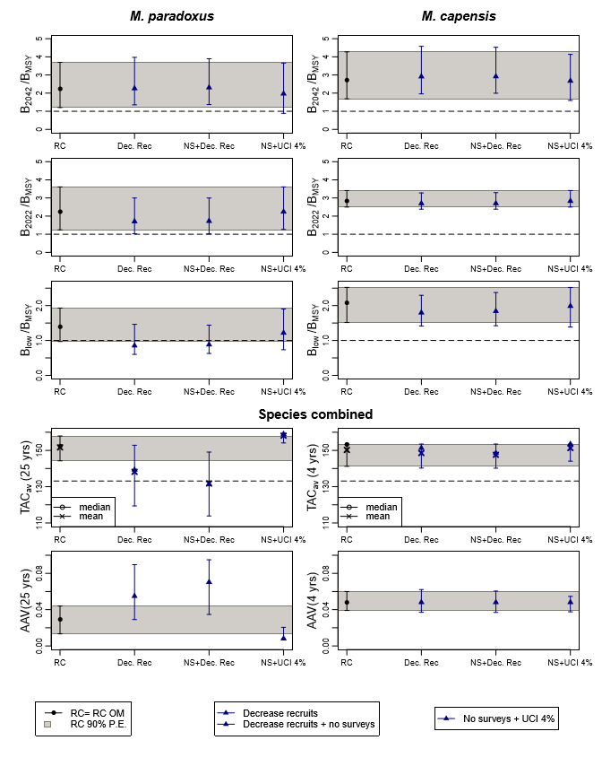
Figure 1: Zeh plots of the performance statistics for the RC and three additional robustness tests.

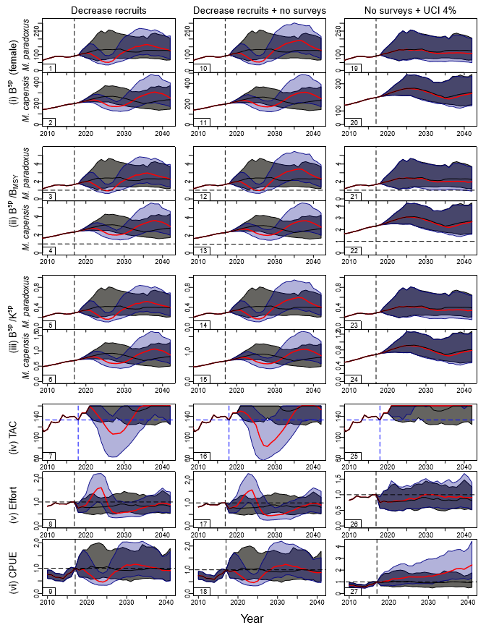
Figure 2: Trajectories for the RC OM (black lines for medians and grey shaded areas for 90% probability envelopes) are contrasted with the three additional robustness tests (red lines for medians and blue shaded area for 90% probability envelopes).

Marine Resource Assessment and Management Group, Department of Mathematics and Applied Mathematics, University of Cape Town, Rondebosch.

