Conditioning results for RT6
A. Ross-Gillespie
Email: mlland028@myuct.ac.za
The key assessment results for the 2017 RC model, the 2018 RC model and robustness test RT6 which uses the original 2017 mortality-at-age vectors are provided in Table 1. Figure 1 plots the recruitment curves for the three models. Figure 2 plots the mortality-at-age vectors for comparison purposes.

Table 1: Key assessment output for the 2017 and 2018 RC models and robustness test RT6.
 |  | 2017 RC | 2018 RC | RT6
M. paradoxus | K | 515 | 318 | 414
 | B_{MSY} | 115 | 55 | 76
 | B₂₀₁₇ | 127 | 93 | 118
 | B₂₀₁₇/K | 0.25 | 0.29 | 0.29
 | B₂₀₁₇/B_{MSY} | 1.11 | 1.67 | 1.55
 | B_{MSY}/K | 0.22 | 0.17 | 0.18
 | MSY | 137 | 145 | 137
M. capensis | K | 196 | 290 | 191
 | BMSY | 63 | 86 | 63
 | B2017 | 141 | 198 | 138
 | B2017/K | 0.72 | 0.68 | 0.72
 | B2017/BMSY | 2.23 | 2.30 | 2.18
 | BMSY/K | 0.32 | 0.30 | 0.33
 | MSY | 81 | 84 | 88

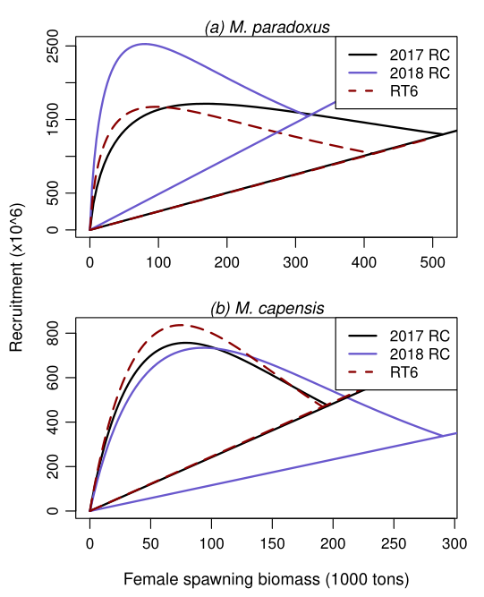
Figure 1: Recruitment is plotted against female spawning biomass for the 2017 and 2018 RC models and robustness test RT6 which uses the original 2017 mortality-at-age vectors.
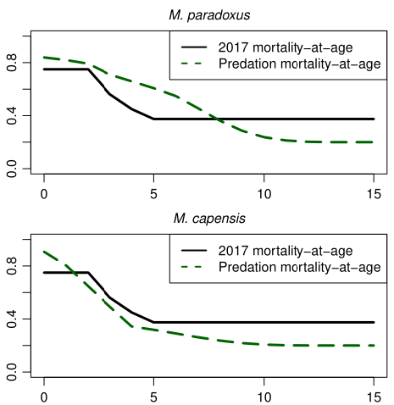
Figure 2: Mortality-at-age vectors used in the 2017 RC model and robustness test RT6 (black lines) and the mortality-at-age vectors from the predation model used in the 2018 RC model.

Marine Resource Assessment and Management Group, Department of Mathematics and Applied Mathematics, University of Cape Town, Rondebosch.

