Comparison of the hake RC OM with the whole RS
A. Ross-Gillespie and D.S. Butterworth
Email: mlland028@myuct.ac.za

Introduction
Owing to time constraints, the robustness tests results for the recommended revised hake OMP reported in MARAM/IWS/Hake/P6a and b were all conducted for the RC OM only. This working paper compares the RC results with the results for the whole RS in order to ascertain whether it is likely that the conclusions drawn from the robustness tests conducted for the RC will hold for the whole RS, or whether the very time-consuming task of reconditioning the RS OMs for the various robustness tests needs to be undertaken.

Results
Figure 1 plots the spawning biomass, TAC, effort and CPUE trajectories for the Base Case (i.e. for the RC assessment model specifications as per MARAM/IWS/2018/Hake/P1) for the single RC OM results and for an equal weighting across the nine RS OMs. Figure 2 repeats these figures, but for the BC as well as two robustness tests, namely increasing and decreasing the offshore trawl fishery F-proportions (i.e. the proportion of the total fishing mortality in the offshore catch on M. paradoxus). These correspond to robustness tests RT 12 a and b of MARAM/IWS/2018/Hake/P6b and were chosen as they had a more substantial impact on the projection results that many of the other robustness tests. Figure 3 plots the performance statistics of the BC and robustness tests for the single RS OM and an equal weighting across the whole RS.

Discussion
Base Case
When an equal weighting across the whole RS is considered, the projections are generally more optimistic, with higher B/B_{MSY} estimates at the end of the projection period, higher predicted TACs with lower effort and higher CPUE (although the RC projections predict higher catches and catch rates in the short term). As can be expected, the probability intervals for the whole RS projections are larger, especially for statistics relating to the M. capensis resource, where the three more “pessimistic” OMs cause a very large spread in results.
Robustness tests
The aim of conducting the robustness tests for the whole RS is to see whether any flags are raised that would have been missed if only the RC OM is considered. On the whole the “relative behaviour” (i.e. how the robustness tests differ from the BC) is similar for the RC OM and the RS and similar conclusions to those in MARAM/IWS/2018/Hake/P6b would have been drawn. The only point of potential concern remains the lower bounds on the M. capensis depletion performances statistics for the whole RS results, which are mostly below one, and drop very low for the robustness test that decreases the F-proportion (i.e. increases the M. capensis offshore trawl catch). But as has been pointed out previously, these low estimates for M. capensis arise almost exclusively from three of the nine RS OMs, all of which are Beverton-Holt models. It has been argued that the three Ricker models in the RS are more credible as their fits have a higher likelihood and that the h values for the B-H models had to be fixed. Figure 3 also plots the performance statistics when only the “optimistic” OMs are taken into account, which show no cause for concern for the status of the M. capensis resource. Perhaps the proposed safeguard rule for the M. capensis resource that is to be included in OMP2018 should be evaluated against the robustness test that decreases the F-proportion to see whether it would perform adequately to preserve the M. capensis population under those circumstances.
Unless there is further concern expressed over the three pessimistic OMs (bearing in mind that all three OMs indicate a recovery of the M. capensis resource under the BC assumptions), it would seem that the trends in the robustness tests would apply fairly well to the whole RS.
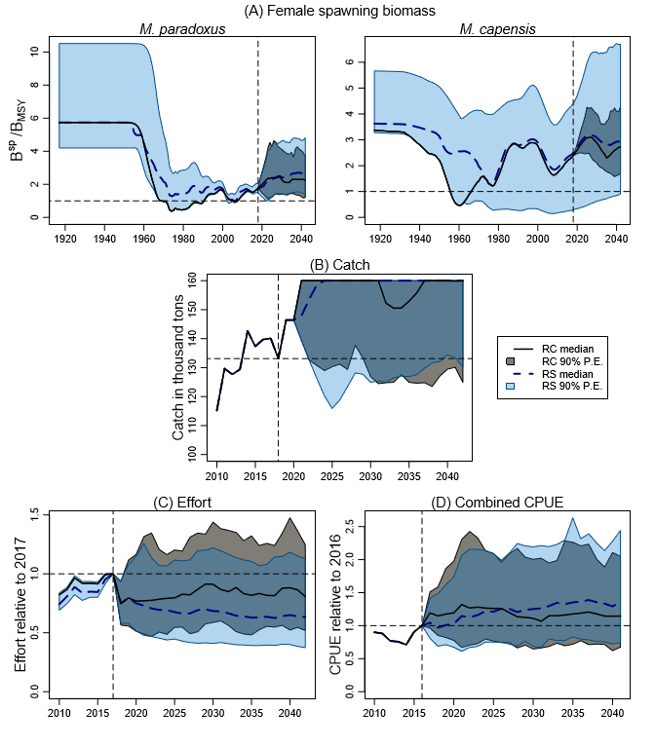
Figure 1: Female spawning biomass, TAC, effort and CPUE trajectories are shown for the RC Base Case OM (black lines for median trajectories and grey shaded areas for 90% P.E.) and for an equal weighting for the BC across the whole RS (blue dashed lines for median trajectories and light blue areas for shading). Projections are as under the revised OMP recommended. Note that the uncertainty about the median trajectory for the RS prior to 2018 is a consequence of the range across the nine RS OMs, which is why there is no such corresponding P.E. prior to 2018 for the single RC OM results.

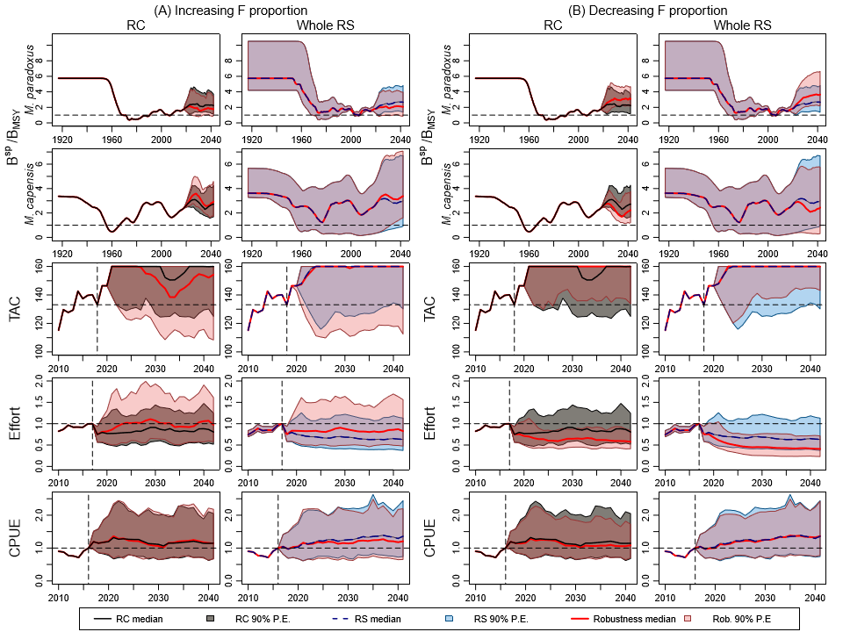
Figure 2: Median estimates and 90% probability envelopes are shown for two robustness tests of the recommended revised hake OMP: (A) increasing the F-proportion and (B) decreasing the F-proportion. For each robustness test, the left column compares the RC OM BC results with the robustness test run for the RC OM, and the right column compares an equal weighting across the whole RS for the BC with the robustness test run for the whole RS.

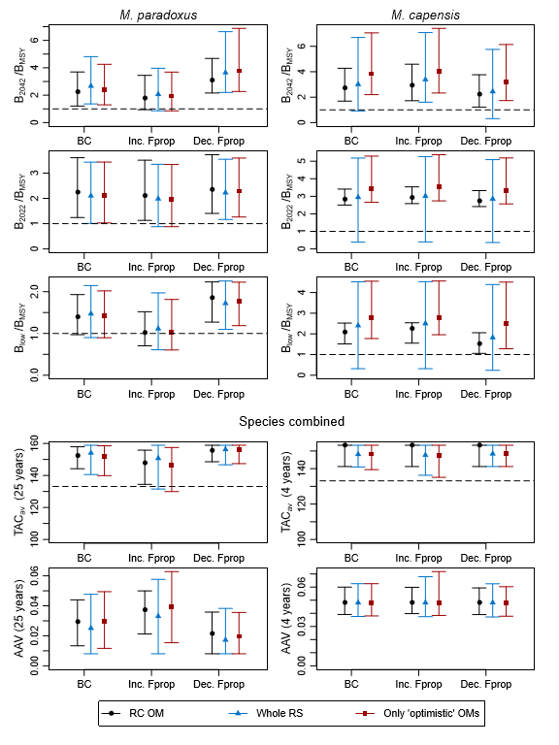
Figure 3: Zeh plots of the performance statistics for the Base Case and the two robustness tests of the recommended revised OMP, each reported for the RC OM and an equal weighting across the whole RS. Results for an equal weighting across the six ‘optimistic’ OMs only have also been included in red.

Marine Resource Assessment and Management Group, Department of Mathematics and Applied Mathematics, University of Cape Town, Rondebosch.

