A state-space approach to approximate changes trawl survey catchability for Merluccius paradoxus and M. capensis

Henning Winker¹
¹DAFF - Department for Agriculture, Forestry & Fisheries, Cape Town, South Africa

This paper presents an initial analysis that aimed to explore potential differences in trawl survey catchability (q) for Merluccius paradoxus and M. capensis between the research vessel RV Africana and the commercial vessels FV Andromeda and FV Compass Challenger. The two commercial vessels were employed during west coast summer surveys in 2013-2016 and south coast autumn surveys 2014-2016 to compensate for non-availability of the RV Africana. Since then, one south coast survey was conducted with the RV Africana in spring 2016 and one west coast survey in summer 2017.

Bayesian State-Space approach
To infer changes in trawl survey catchability, I applied a Bayesian state-space approach for time series analysis. This approach builds on the state-space tool for averaging relative abundance indices, which is implemented in the Bayesian Surplus Production Model ‘JABBA’ software (Winker et al. 2018). A central assumption of the state-space model is that the abundance trend follows a Markovian process, which means that, for example, the current biomass B_{t} at time t is a function of the biomass at the previous time step B_{t-1}. State‐space models are hierarchical models that explicitly decompose an observed time‐series into a process variation and an observation variation, where the biomass is conceptually treated as an unobservable state variable. The process equation is formulated here as a simple log-linear population growth model of the form:

$\log\left(B_{y+1}\right)=\log\left(B_{y}\right)+ρ+η_{y}$ $η_{y}\sim N(0,σ_{proc}^{2})$,

where $ρ$ is some underlying population trend and $η_{y}$ is the lognormal process term that described the year-to-year variation in biomass as deviation from the deterministic expectation of $\log\left(B_{y}\right)+ρ$, given a process variance $σ_{proc}^{2}$. The corresponding observation equation, in log-space, is then given by:

$\log\left(I_{i,y}\right)=log⁡(q_{i})+\log\left(B_{y}\right)+ε_{i,y}$ $ε_{i,y}\sim N(0,σ_{{obs}_{i,y}}^{2})$

where $I_{i,y}$ is the biomass index i for year y, ${ ε}_{i,y}$ is the lognormal observation error term, $σ_{{obs}_{i,y}}^{2}$ is the total observation error variance for year y and index i and is the catchability scaling parameter for index i. The abundance index with the oldest record (in order of occurrence) is taken as a reference index by fixing q₁ = 1 and the others q_{2…n} are scaled to this reference index, respectively. The total observation variance is separated into two components: (1) the externally derived standard error estimates ${\hat{σ}}_{{SE}_{i,y}}^{2}$ for index i and year y and (2) an additional estimable observation variance $σ_{est}^{2}$, which is assumed here to be common to all indices. The two variance components are additive (Francis et al. 2003), so that:

$σ_{{obs}_{i,y}}^{2}={\hat{σ}}_{{SE}_{i,y}}^{2}+σ_{est}^{2}$.

The trend $ρ$ has a uninformative normal prior with a mean of zero and a standard deviation of 1000. The catchability coefficients q_{2…n}, the process variance $σ_{proc}^{2}$and the estimable observation variance $σ_{est}^{2}$ are assumed to follow a non-informative inverse-gamma distribution with both gamma scaling parameters set to 0.001.

The model is run from the R working environment (R Core Team, 2014) and then executed in JAGS (Plummer 2003), using the wrapper function jags() from the R library ‘r2jags’ (Su and Yajima 2012). The Bayesian posterior distributions are estimated by means of a Markov Chains Monte Carlo (MCMC) simulation. Convergence of the MCMC chains is diagnosed using the ‘coda’ package (Plummer et al. 2006), adopting minimal thresholds of p = 0.05 for Geweke’s diagnostic (Geweke 1992) called from R.

Application to hake trawl survey indices
For the purpose of this initial analysis, I used the model-based geostatistical trawl survey biomass indices presented in Winker et al. (2017). For M. capensis, I individually fitted the model to (i) the west coast summer survey index and (ii) south coast autumn and spring survey indices. For M. paradoxis, I only considered the west coast survey, because the south coast surveys for this species appears to be associated with high variation and ambiguous trends. Catchabilities q_{i} were estimated separately for RV Africana surveys with (1) ‘old gear’ and (2) ‘new gear’ and (3) commercial vessel surveys (FV Andromeda or FV Compass Challenger), which were all conducted with the ‘new gear’.

The estimated catchability ratios of old gear to new gear are summarized for reference in Table 1 and provide evidence that the new gear is generally less efficient for hakes. The key results for the estimated catchability ratios of Commercial vessel surveys to the RV Africana are summarized in Table 2. For all cases the estimates suggest reduction in catchability for the commercial vessel surveys (Figs. 1-3). The ratio estimates were particularly precise for the M. capensis south coast survey and the M. paradoxus west coast survey. In both cases, the 95% Credibility Intervals did not overlap with 1, indicating that the effect is of statistical significance. Noting that the first west coast survey conducted with a commercial vessel in 2013 produced a relatively low biomass estimate for M. paradoxus compared the three following years 2014-2016, I also provide results for a sensitivity run, for which excluded the 2013 estimate (Fig. 4), which resulted in a relative increase to about 80% catchability compared to the RV Africana.

References
Francis, R.I.C.C., Hurst, R.J., Renwick, J.A., 2003. Quantifying annual variation in catchability for commercial and research fishing. Fish. Bull. 101, 293–304.
Geweke, J. (1992) Evaluating the accuracy of sampling-based approaches to the calculation of posterior moments. In: Bayesian Statistics 4: Proceedings of the Fourth Valencia International Meeting. (eds J.O. Berger, J.M. Bernardo, A.P. Dawid and A.F.M. Smith). Clarendon Press, Oxford, pp 169–193.
Plummer, M. (2003) JAGS: A Program for Analysis of Bayesian Graphical Models using Gibbs Sampling, (Vol. 124).
Plummer, M., Nicky Best, Cowles, K. and Vines, K. (2006) CODA: Convergence Diagnosis and Output Analysis for MCMC. R News 6, 7–11.
Su, Y.-S. and Yajima, M. (2012) R2jags: A Package for Running jags from R.
Winker H, Fairweather T and Leslie R (2017). Comparison of model-based geostatistical trawl survey biomass indices with the current design-based estimates for the South African hakes. International Fisheries Stock Assessment Review Workshop, Cape Town, South Africa, MARAM/IWS/2017/ Hakes/P7, p. 15, http://www.maram.uct.ac.za/maram/ workshops/2017
Winker, H., Carvalho, F. and Kapur, M. (2018) JABBA: Just Another Bayesian Biomass Assessment. Fisheries Research. 204: 275-288

Table 1. Summary statistics for estimated catchabilities q for M. capensis (HKC) and M. paradoxus (HKP), shown as ratios of ‘Old Gear’ to ‘New Gear’ for west coast (WC) and south coast (SC) survey indices.
Model | Median | se | 95% CI
HKC_SC | 1.558 | 0.181 | 1.231 | - | 1.958
HKC_WC | 1.236 | 0.417 | 0.679 | - | 2.338
HKP_WC | 1.459 | 0.316 | 0.992 | - | 2.203
HKP_WC (Excl. 2013) | 1.419 | 0.263 | 1.016 | - | 2.018

Table 2. Summary statistics for estimated catchabilities q for M. capensis (HKC) and M. paradoxus (HKP), shown as ratios of commercial vessels to the RV Africana to commercial vessels for west coast (WC) and south coast (SC) indices.
Model | Median | SE | 95% CI
HKC_SC | 0.674 | 0.124 | 0.479 | - | 0.968
HKC_WC | 0.828 | 0.295 | 0.412 | - | 1.566
HKP_WC | 0.603 | 0.139 | 0.381 | - | 0.923
HKP_WC (Excl. 2013) | 0.797 | 0.178 | 0.524 | - | 1.218

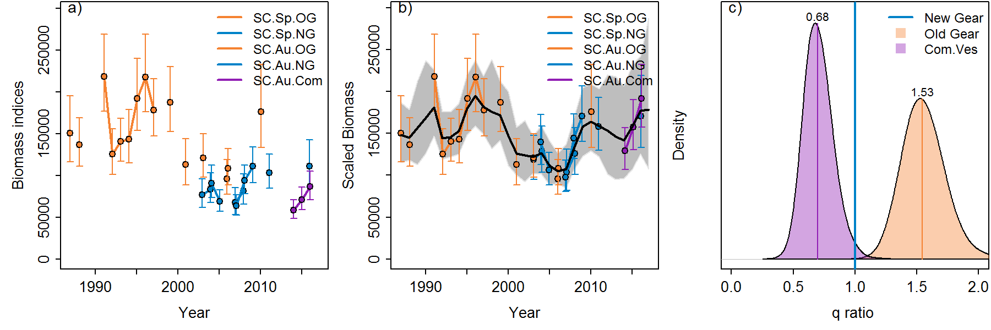
Fig. 1. a) Geostatistical south coast survey biomass indices and standard errors for M. capensis; b) model-predicted abundance trend (solid line) and 95% CIs (shaded area) based on catchability q estimates for RV Africana old gear (OG, q=1), new gear (NG) and commercial vessels (Com); and c) posteriors of ratios of Old Gear to New Gear and Commercial Vessels to New Gear, with numbers denoting the median values.

Fig. 2. a) Geostatistical w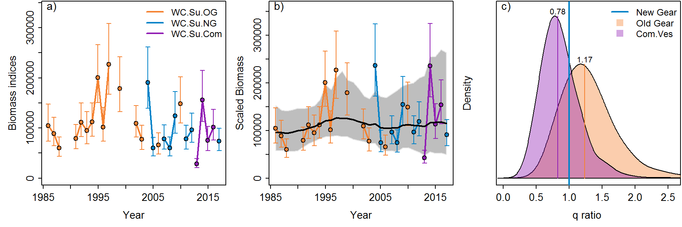est coast survey biomass indices and standard errors for M. capensis; b) model-predicted abundance trend (solid line) and 95% CIs (shaded area) based on catchability q estimates for RV Africana old gear (OG, q=1), new gear (NG) and commercial vessels (Com); and c) posteriors of ratios of Old Gear to New Gear and Commercial Vessels to New Gear, with numbers denoting the median values.

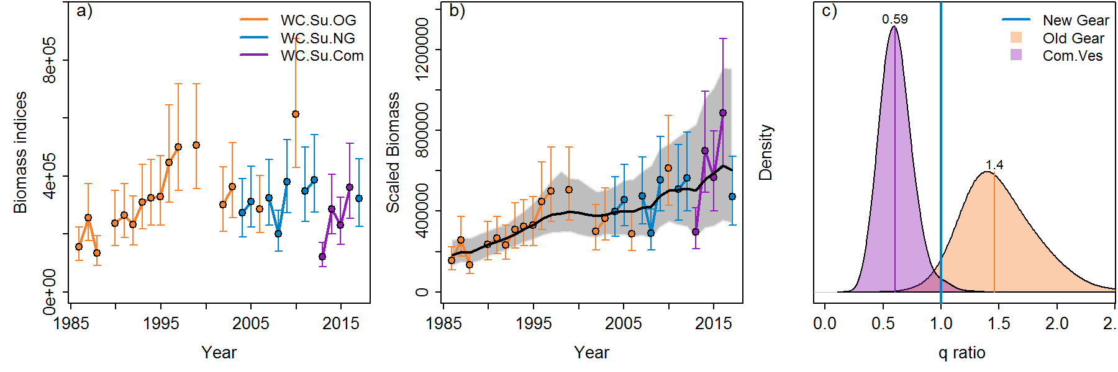
Fig. 3. a) Geostatistical west survey biomass indices and standard errors for M. paradoxus; b) model-predicted abundance trend (solid line) and 95% CIs (shaded area) based on catchability q estimates for RV Africana old gear (OG, q=1), new gear (NG) and commercial vessels (Com); and c) posteriors of ratios of Old Gear to New Gear and Commercial Vessels to New Gear, with numbers denoting the median values.

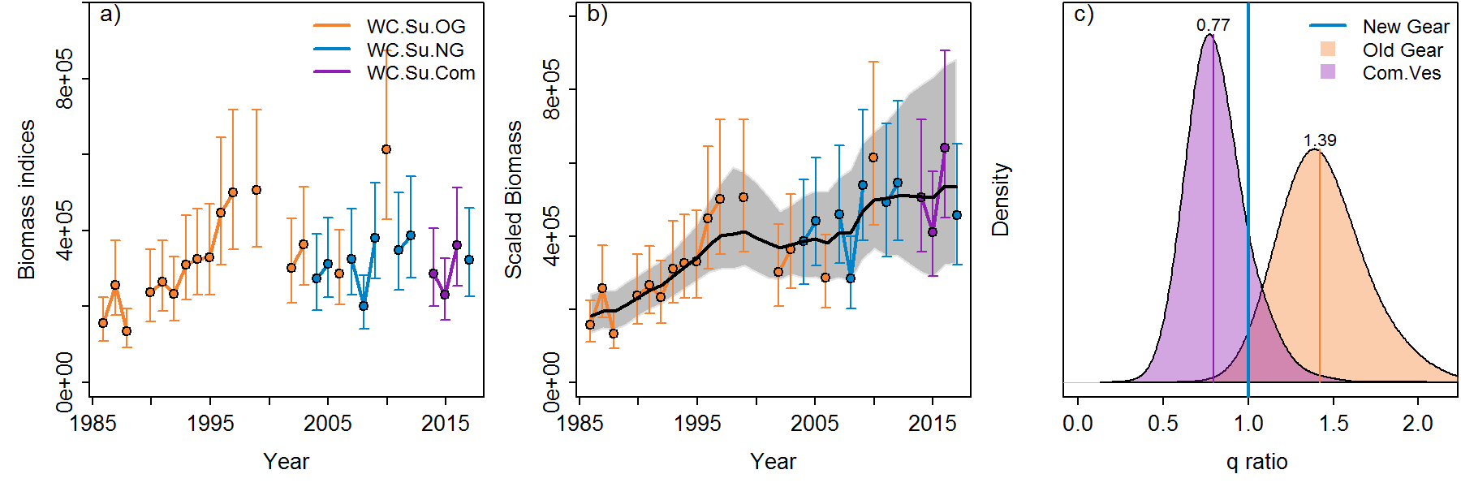
Fig. 4. a) Geostatistical west survey biomass indices and standard errors for M. paradoxus, but excluding the first commercial vessel survey year 2013; b) model-predicted abundance trend (solid line) and 95% CIs (shaded area) based on catchability q estimates for RV Africana old gear (OG, q=1), new gear (NG) and commercial vessels (Com); and c) posteriors of ratios of Old Gear to New Gear and Commercial Vessels to New Gear, with numbers denoting the median values.

