An overview of the SA hake fishery
M.D. Durholtz

Background
The South African hake resource comprises two species, the shallow-water Cape hake Merluccius capensis and the deep-water hake M. paradoxus. Merluccius capensis is found from southern Angola to northern KwaZulu–Natal on the east coast of South Africa. Merluccius paradoxus, on the other hand, is distributed from northern Namibia to southern Moçambique (see Figure 1). As the common names imply, the two species differ in terms of distribution by depth. Off South Africa, the shallow-water species has been recorded at depths of between 30 and 500 m, with most of the population between 100 and 300 m. Deep-water hake are found between 110 and about 1000 m, with most of the population located between 200 and 800 m. Both species display a pattern of increasing size with increasing depth and distance offshore. The distributions of both species are virtually continuous around the South African coast and they are currently treated as single stocks of each species within South African waters. Recent genetic analyses have suggested that there is one stock of shallow-water hake in South African waters, another stock in central/northern Namibia, and a third stock that extends from southern Namibia into the northern areas of the SA West Coast (although the extent of the southward extension is currently unknown). These analyses have also suggested that M. paradoxus is probably a single stock that extends into Namibia.
The resources are currently targeted by four fishing sectors:
- Deep-sea trawl: Operates around the entire SA coast in waters deeper than 110 m. Currently restricted to the “trawl footprint” (Figure 2)
- Inshore trawl: Restricted to the SA South Coast east of the 20°E line of longitude. Currently restricted to the “trawl footprint” (Figure 2).
- Hake longline: Operates around the entire SA coast.
- Hake handline: Restricted to the SA South Coast east of the 20°E line of longitude
Hake are also caught as incidental by-catch in the traditional linefish and horse mackerel-directed midwater trawl fisheries.

Historical development of the fishery
The demersal trawl fishery dates back to the late 1890s, when small side trawlers targeted primarily Agulhas sole (Austroglossus pectoralis) and West Coast sole (A. microlepis) on soft grounds in bays and close to the coast, with hake (likely to be almost entirely M. capensis) being caught as an incidental by-catch. Directed fishing for hake only began towards the end of the First World War and escalated rapidly after the Second World War with about 40 local trawlers operating in South African waters by 1948. Knowledge of the large southern African hake resource spread, leading to the incursion of foreign fleets into the Southeast Atlantic in 1962. Vessels (mostly large factory trawlers) from Japan, Spain and several Eastern European countries began fishing in South African and then in Namibian waters, leading to a dramatic increase in fishing effort and catches of hake. Simultaneously new local entrants were introduced into the domestic fleet. In 1972, the annual hake catch in South African waters peaked at almost 300 000 t and >1.1 million t of hake was taken from Southeast Atlantic waters in that year alone. Decreases in catch rates showed that the resource could not sustain that level of exploitation, and in 1972, the International Commission for the Southeast Atlantic Fisheries (ICSEAF) was established in an attempt to control what had then become an international fishery. By 1977, the number of local trawlers operating in South African waters had expanded to about 85 and the smaller vessels based along the south coast had increased in numbers to 49. At least 20 (with reports of as many as 50) foreign vessels operated in South African waters between 1962 and 1978. South Africa’s declaration of a 200 mile Exclusive Fishing Zone (EFZ) in 1977 marked the onset of direct management of the South African hake resource by the national government. Foreign vessels were largely excluded from South African waters, resulting in a reduction in the total catch of hake to about 50% of that recorded in 1972.

A major source of uncertainty in the development of the hake fishery is the period over which exploitation shifted from almost entirely M. capensis (when the fishery commenced in inshore waters) to catches being dominated by M. paradoxus (which has been the case since about 1978).

Current assessment and management
Assessment of the South African hake resource is complicated by the fact that the two hake species are morphologically similar, so the commercially landed (processed) product cannot be identified easily to species. Catch-and-effort statistics collected from the fishery are therefore not species-disaggregated, and splitting of the catches to species level has required the use of various algorithms (described below). The South African hake resource is currently assessed using a suite of gender-disaggregated Statistical Catch-at-Length models (termed the “Reference Set”), which are fitted directly to age-length keys and length frequencies, as well as to abundance indices provided by both commercial trawl CPUE information (Figure 4) and fishery-independent trawl surveys (Figure 5) . The models assess the two hake species as two independent stocks and are fitted to species-disaggregated data as well as species-combined data.

Exploitation of the SA hake resources is managed primarily with a species-combined Total Allowable Catch (TAC) regulation, the magnitude of which has been computed since 1991 using an Operational Management Procedure (OMP). An OMP is essentially a combination of pre-specified methods of data collection and analysis, coupled with a set of simulation-tested decision rules (effectively a Management Strategy Evaluation approach) that specify exactly how the regulatory mechanism is to be computed each year. In the case of South African hake, the regulatory mechanism is a species-aggregated TAC, the value of which is calculated from stock-specific monitoring data (commercial CPUE indices and indices of abundance derived from demersal research surveys); the ratio of the two species in the catch is monitored to check that it remains within the range evident in the OMP simulation trials. Implicit in this OMP approach is a schedule for OMP revision (every 4 years) to account for updated data sets and possible changes in resource and/or fishery dynamics (or their understanding) and management objectives. The development and revision of recent OMPs has had to take certification of the SA hake trawl fishery by the Marine Stewardship Council (MSC) into consideration. The fishery was first certified in 2004, and re-certified on two occasions (2010 and 2015). The fishery will undergo assessment towards a third re-certification under the new MSC fishery Standard during 2019.

Once the TAC has been determined, a by-catch allowance for the mid-water trawl fishery is deducted (equivalent to 2% of the horse mackerel TAC), following which the remainder is allocated among the four hake-directed sectors in the following proportions:
- Deep-sea trawl: 0.8393
- Inshore trawl: 0.0618
- Hake longline: 0.0655
- Hake handline: 0.0334
Within each sector, the TAC is then apportioned among Right Holders according to their proportional allocations set during the Fishing Rights Allocation Process.
The demersal trawl components (inshore and deep-sea) of the fishery are restricted to fishing within the “trawl footprint” (see Figure 2). This measure was initially a voluntary measure by the industry to facilitate MSC certification, but was incorporated into permit conditions as a formal management measure in 2015.

Catches of hake over recent decades have typically fluctuated about 150 000 t per annum (Figure 3), with most of the catch being landed by the deep-sea trawl sector, and comprising mainly M. paradoxus.

Data available for assessments (see MARAM/IWS/2017/Hake/P2 for more details)
- Total annual catch (Figure 3) per:
  - Species
  - Gender
  - Coast
  - Sector
Note: catches from 1978 onwards are split into species using the species-splitting algorithm that uses spatially explicit species composition information derived from research surveys. Species splitting of catches prior to 1978 assumes a logistic decrease in the percentage of M. capensis from 100% in 1917 to a level corresponding to the 1978-1982 average by 1977. Three variants of operating models use a “centre year” for the shift from predominantly M. capensis to predominantly M. paradoxus of 1950, 1958 and 1965 respectively.

- Commercial (hake deep-sea trawl) CPUE by species (Figure 4). Estimates are available from 1978, when spatially explicit catch and effort data first became available. There is information for earlier years from ICSEAF.

- Commercial proportions at length per:
  - Species
  - Gender
  - Coast
  - Sector
Estimates are available for:
- Deepsea trawl: 1981 – present (West coast species and sex combined), 1975 – present (South Coast species and sex combined)
- Inshore trawl: 1981 – present (M. capensis, sex combined)
- Longline: 1994 – 1997 (species and sex combined) and 2000 – 2010 (species and sex disaggregated)

- Survey abundance indices (Figure 5) per:
  - Species
  - Coast
Note: Surveys are conducted separately on the West and South Coasts. The West Coast is surveyed in summer (January-February), with six winter (June-July) surveys having been conducted in the late 1980s. The South Coast is generally surveyed in autumn (April-May), although a few spring (September-October) surveys have been conducted in the late 1980s and during the 2000s.
Abundance estimates are available for 1985 - present.

- Survey proportions at length per:
  - Species
  - Gender
  - Coast
Estimates are available from 1985 – present, although sex-disaggregated data are available only for 1993 – present

- Age at length per:
  - Species
  - Gender
  - Coast
Age length keys are available for the period 1988 – 2008.

- Female maturity at length ogives per:
  - Species
  - Coast

- Weight at length per:
  - Species
  - Gender
  - Coast

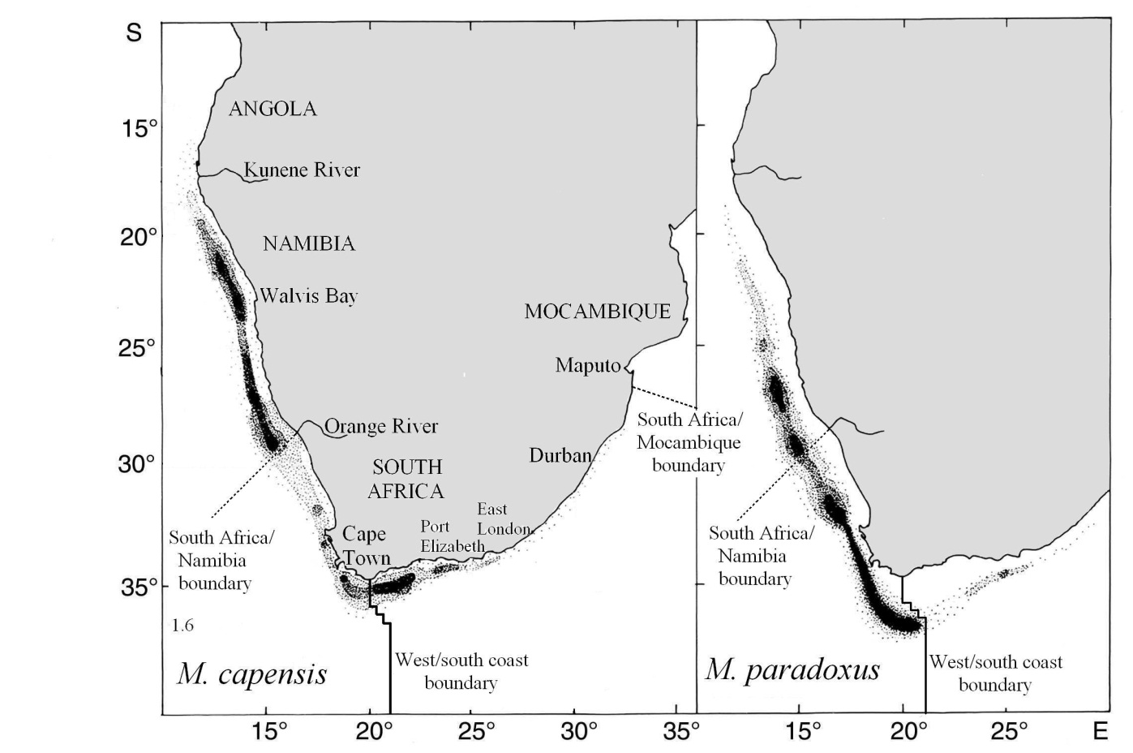
Figure 1: Species distribution for southern African hake (adapted from Payne 1989).

Figure 2: Map illustrating the hake “trawl footprint”, first incorporated into permit conditions for the two trawl sectors in 2015.

Figure 3: (a) Total catches (tons) of Cape hakes split by species over the period 1917 – 2017 and the TAC set each year since the implementation of the OMP approach in 1991. Prior to 1978, where the data required to split the catch by species are not available, the split is calculated using an algorithm that assumes 1958 as the centre year for the shift from a primarily M. capensis to a primarily M. paradoxus offshore trawl catch. (b) Catches of Cape hakes per fishing sector for the period 1960 – 2016. Prior to 1960, all catches are attributed to the deep-sea trawl sector.

Figure 4: GLM-standardised deep-sea trawl CPUE (kg.min⁻¹) indices of hake abundance shown by species and coast

Figure 5: Survey-derived hake abundance estimates (‘000 t ± 1 SE) shown by species and coast. The various vessel – gear combinations are indicated. Note that only surveys that extended to the 500 m isobath are shown.

