**Responses to various panel requests**

**S.J. Johnston**

**Projections assuming a combined S/R function**

1. **Looking at Bsp and recruitment values for 1970+**

Projections assume a S/R relationship which is determined by considering the total (i.e. combined over all five super-areas) recruitment versus total female spawning biomass. Figure 1 plots this relationship. The S/R relationship is shown by the red line and comes into play if the Bsp drops below the lowest level observed in 1998 of 0.0835K. The green line is the average of the **1970**…2010 recruitment values.

Each super-area is projected ahead assuming a future TAC level at the current 2019 TAC level, where future (2011+) recruitment is modelled as a function of female spawning biomass (see Figure 1). Results are compared with the current method of drawing future recruitment at random from the set of estimated recruitment parameters **R1970**…R2010.

Thus, for each super-area:

Step 1: Generate a future recruitment estimate drawn at random with replacement from

**R1970**...R2010 (as for BC method)

Step 2: if Bsp/Bsp(K) >= 0.0835 retain the randomly selected recruitment

If Bsp/Bsp(K) < 0.0835 multiply the randomly selected recruitment estimate by $\frac{Bsp/Bsp(K)}{0.0835}$

***Results***

Figures 2a-e compared the super-area projections for the BC model with those for the model which assumes a stock-recruit function (as shown in Figure 1) for the future.

Figure 3 shows the results combined over all five super-area. Thus for the total resource the following statistics apply:

B75m(20**25**/2006): BC (no S/R relationship in future) = 1.052 [0.831; 1.337]

B75m(20**25**/2006): With a S/R relationship in future = 0.757 [0.716; 0.967]

B75m(20**30**/2006): BC (no S/R relationship in future) = 1.107 [0.675; 1.676]

B75m(20**30**/2006): With a S/R relationship in future = 0.672 [0.387; 0.993]

1. **Looking at Bsp and recruitment values for 1990+**

Projections assume a S/R relationship which is determined by considering the total (i.e. combined over all five super-areas) recruitment versus total female spawning biomass. Figure 1 plots this relationship. The S/R relationship is shown by the red line and comes into play if the Bsp drops below the lowest level observed in 1998 of 0.0835K. The green line is the average of the **1990**…2010 recruitment values.

Each super-area is projected ahead assuming a future TAC level at the current 2019 TAC level, where future (2011+) recruitment is modelled as a function of female spawning biomass (see Figure 4).

Thus, for each super-area:

Step 1: Generate a future recruitment estimate drawn at random with replacement from

**R1990**...R2010 (as for BC method)

Step 2: if Bsp/Bsp(K) >= 0.0835 retain the randomly selected recruitment

If Bsp/Bsp(K) < 0.0835 multiply the randomly selected recruitment estimate by $\frac{Bsp/Bsp(K)}{0.0835}$

***Results***

Figure 5 shows the results combined over all five super-area. Thus for the total resource the following statistics apply:

B75m(20**25**/2006): BC (no S/R relationship in future) = 1.052 [0.831; 1.337]

B75m(20**25**/2006): With a S/R relationship in future = 0.774 [0.694; 866]

B75m(20**30**/2006): BC (no S/R relationship in future) = 1.107 [0.675; 1.676]

B75m(20**30**/2006): With a S/R relationship in future = 0.600 [0.336; 0.937]

**A relationship between somatic growth and CPUE?**

Figure 6 is a plot of both the somatic growth rate and the TRAP CPUE trend for super-area A8+ for the 2000 period. It would appear that there is a relationship between these two indicating that the annual magnitude of growth rate for the male lobsters above legal size impacts the TRAP CPUE trend subsequently observed. This would indicate that the exploitable portion of the stock is highly dependent on the somatic growth rate.

**Plots of biomass trends for different portions of resource (for A8+)**

Figure 7 plots the biomass trends for A8+ showing the following biomass components:

* **Bf > 65mm** (female biomass above 65mm CL)
* **Bm > 65mm** (male biomass above 65mm CL)
* **B > 65mm** (total biomass above 65mm CL)
* **Bf >75mm** (female biomass above 75mm CL)
* **Bm > 75mm** (male biomass above 75mm CL)
* **B > 75mm** (total biomass above 75mm CL)

**Estimated selectivity function and fits to catch-at-length data (for A8+)**

Figure 8 plots the male and female TRAP, HOOP and FIMS selectivity functions for super-area A8+. Figure 9 shows fits to the TRAP, HOOP and FIMS catch-at-length data for super-area A8+ (Note: fits averaged over periods; plus and minus-groups are incorporated).

**Discarded biomass trends**

Figure 10 shows plots of A8+ trends of commercial catch, discarded biomass, ratio of discarded biomass to commercial catch and the biomass lost due to the 10% discard mortality assumed.

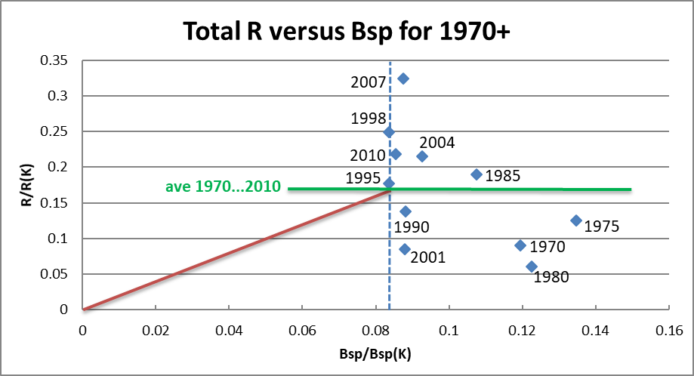

Figure 1: Spawning stock-recruit relationship for all super-areas combined with the proposed S/R relationship (to be applied for years 2011+) shown in **red**. The **green** horizontal line is the average of the R1970…R2010 recruitment parameter estimates.

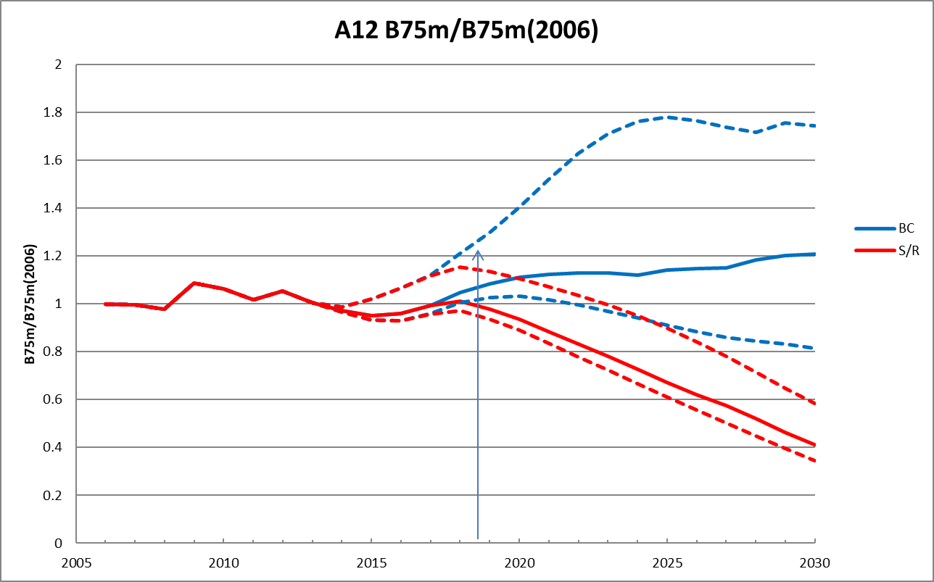

Figure 2a: Super-area A12 B75m/B75m(2006) trajectories for a future CC=26 MT (corresponds to 2019 TAC level). The blue lines (median and 5th and 95th %iles) are for the BC model (which has no S/R function for future recruitment), and the red lines (medians and 5th and 95th %iles) are for the model for which a S/R function is assumed to apply for future recruitment (see Figure 1 above).

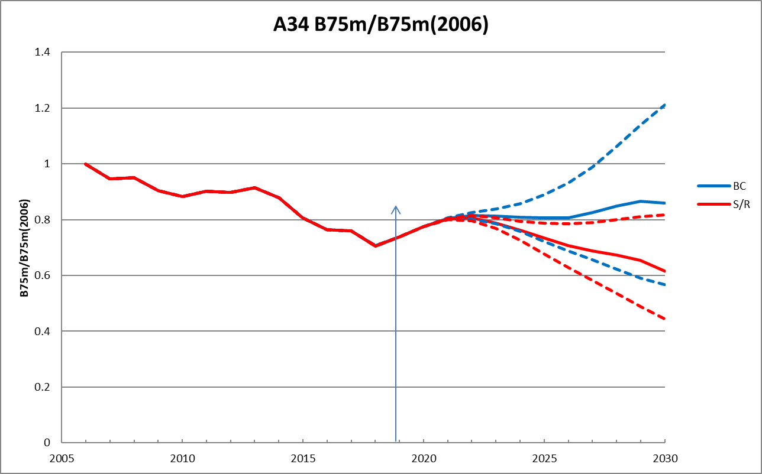

Figure 2b: Super-area A34 B75m/B75m(2006) trajectories for a future CC=128 MT (corresponds to 2019 TAC level). The blue lines (median and 5th and 95th %iles) are for the BC model (which has no S/R function for future recruitment), and the red lines (medians and 5th and 95th %iles) are for the model for which a S/R function is assumed to apply for future recruitment (see Figure 1 above).

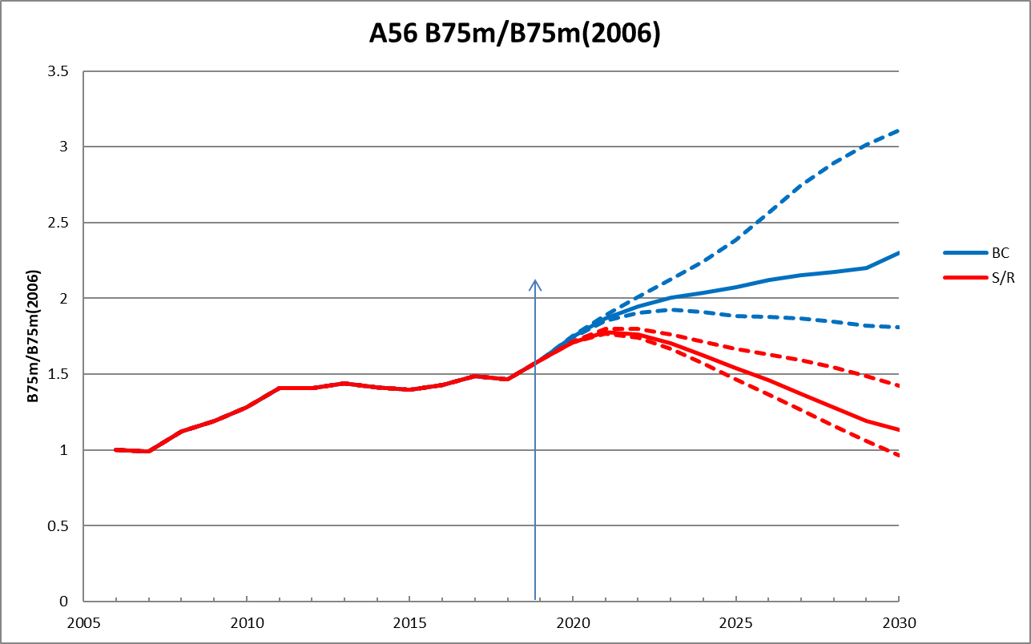

Figure 2c: Super-area A56 B75m/B75m(2006) trajectories for a future CC=86 MT (corresponds to 2019 TAC level). The blue lines (median and 5th and 95th %iles) are for the BC model (which has no S/R function for future recruitment), and the red lines (medians and 5th and 95th %iles) are for the model for which a S/R function is assumed to apply for future recruitment (see Figure 1 above)

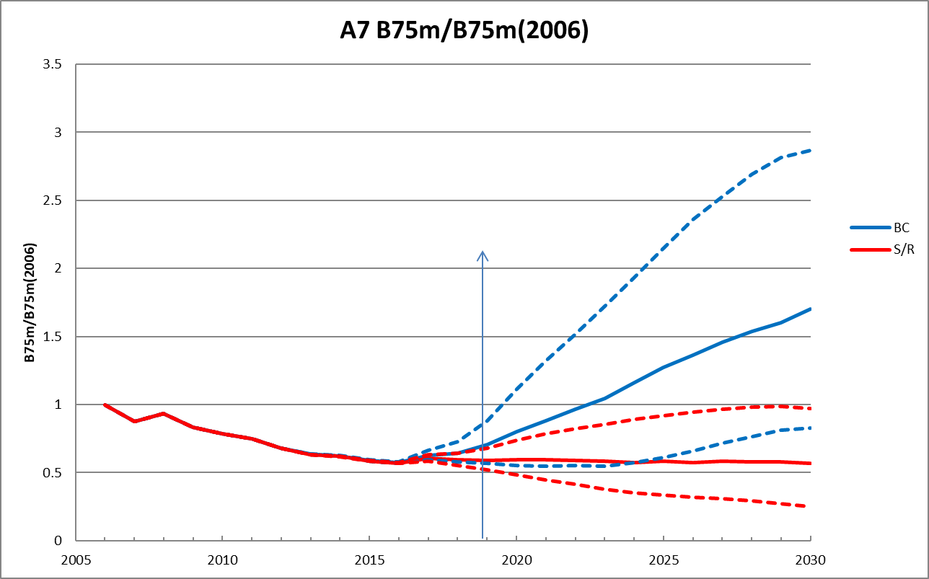

Figure d: Super-area A7 B75m/B75m(2006) trajectories for a future CC=128 MT (corresponds to 2019 TAC level). The blue lines (median and 5th and 95th %iles) are for the BC model (which has no S/R function for future recruitment), and the red lines (medians and 5th and 95th %iles) are for the model for which a S/R function is assumed to apply for future recruitment (see Figure 1 above)

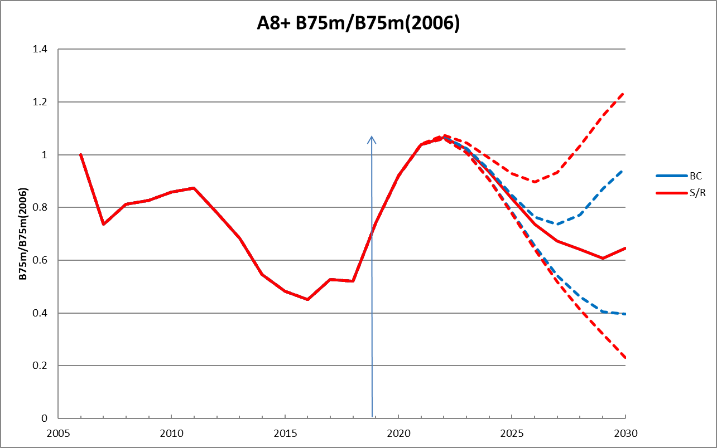

Figure 2e: Super-area A8+ B75m/B75m(2006) trajectories for a future CC=717 MT (corresponds to 2019 TAC level). The blue lines (median and 5th and 95th %iles) are for the BC model (which has no S/R function for future recruitment), and the red lines (medians and 5th and 95th %iles) are for the model for which a S/R function is assumed to apply for future recruitment (see Figure 1 above).

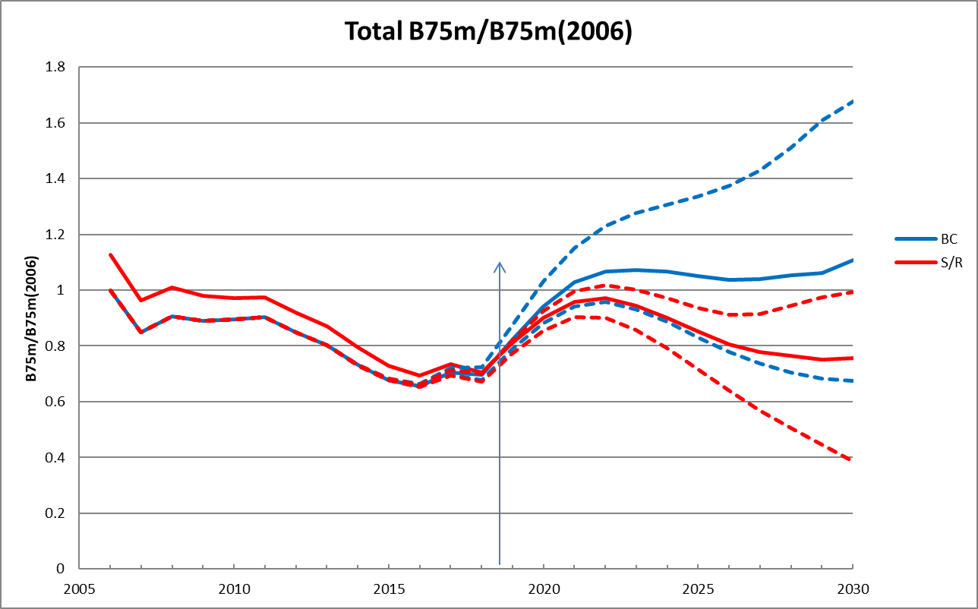

Figure 3: Total (combined super-areas) B75m/B75m(2006) trajectories for a future CC=1084 MT (corresponds to 2019 TAC level). The blue lines (median and 5th and 95th %iles) are for the BC model (which has no S/R function for future recruitment), and the red lines (medians and 5th and 95th %iles) are for the model for which a S/R function is assumed to apply for future recruitment (see Figure 1 above).

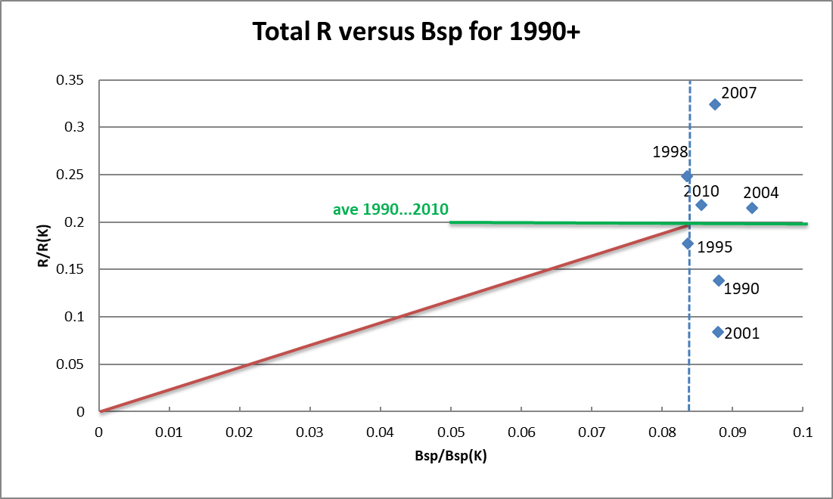

Figure 4: Spawning stock-recruit relationship for all super-areas combined with the proposed S/R relationship (to be applied for years 2011+) shown in **red**. The **green** horizontal line is the average of the R19**90**…R2010 recruitment parameter estimates.

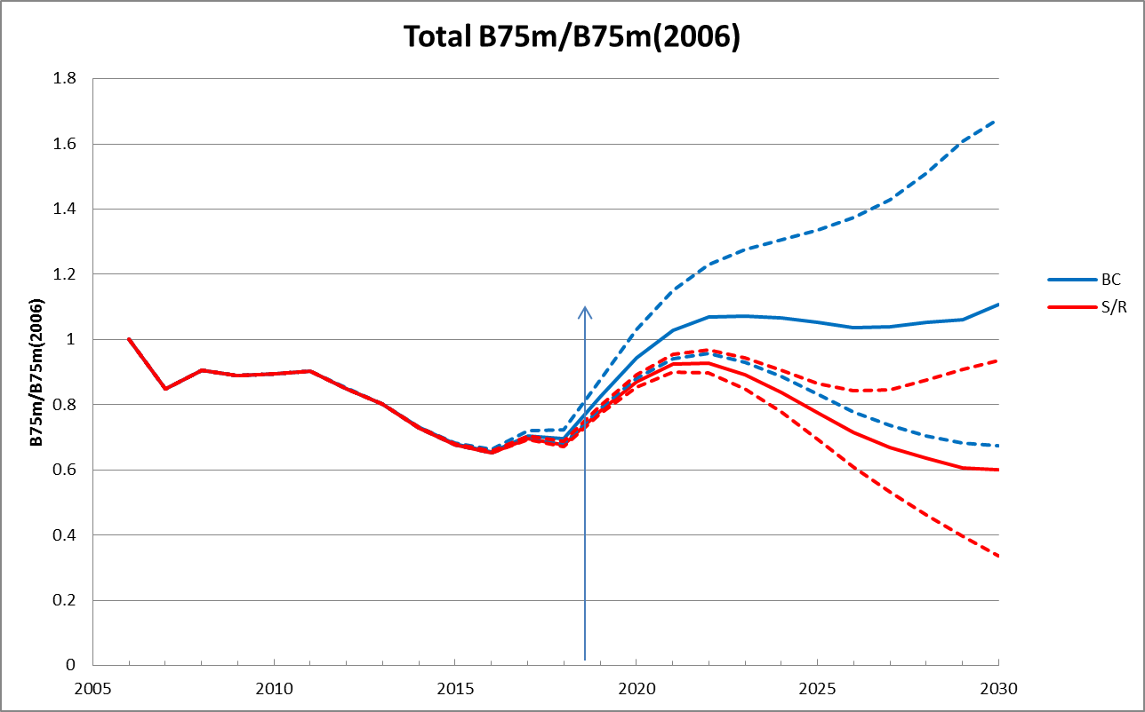

Figure 5: Total (combined super-areas) B75m/B75m(2006) trajectories for a future CC=1084 MT (corresponds to 2019 TAC level). The blue lines (median and 5th and 95th %iles) are for the BC model (which has no S/R function for future recruitment), and the red lines (medians and 5th and 95th %iles) are for the model for which a S/R function is assumed to apply for future recruitment (see Figure 1 above).

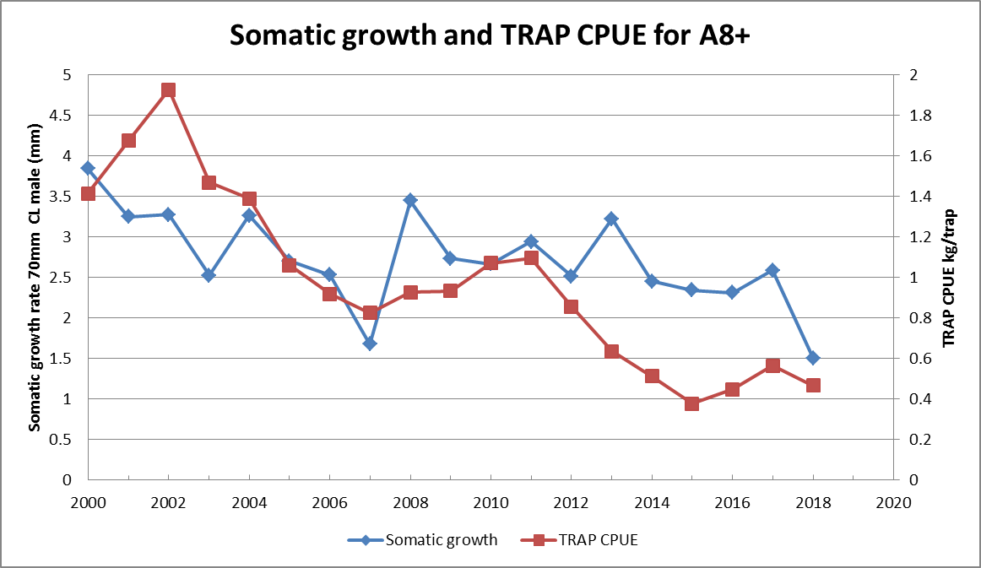

Figure 6: A plot of both the somatic growth rate and the TRAP CPUE trend for super-area A8+ for the 2000 period.

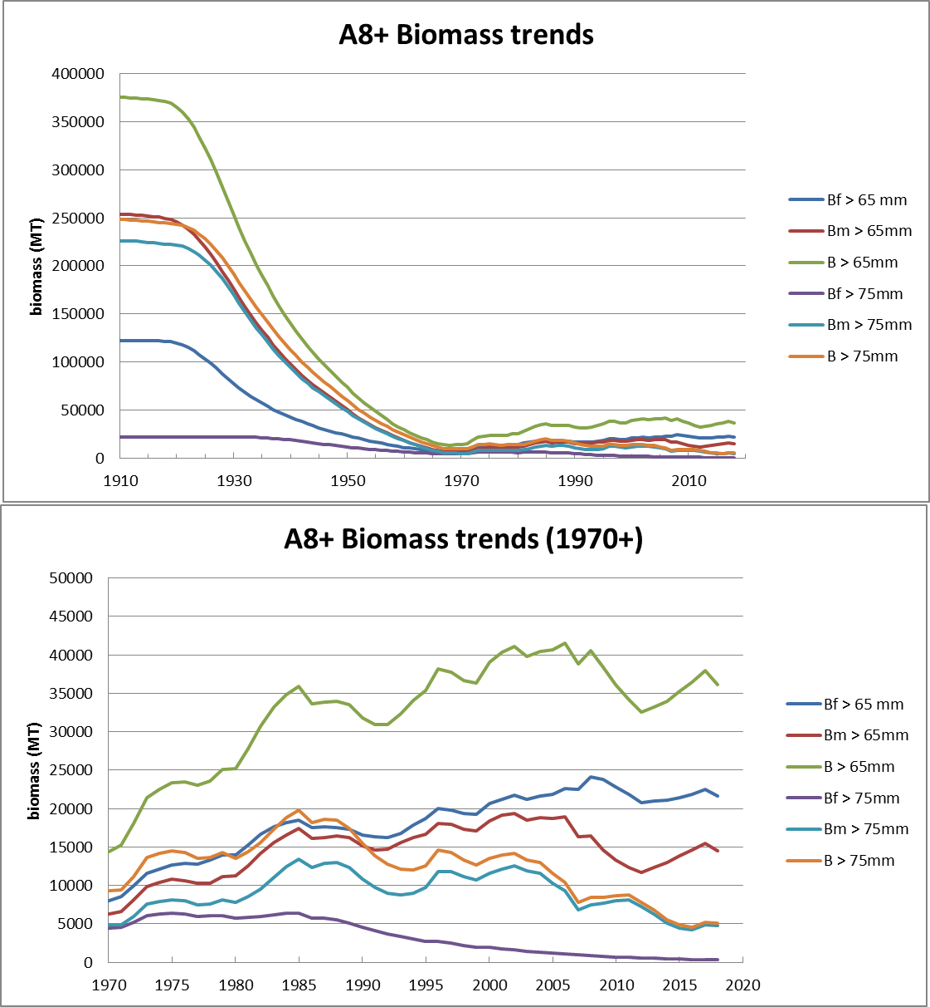

Figure 7: Biomass trends for the BC super-area A8+.

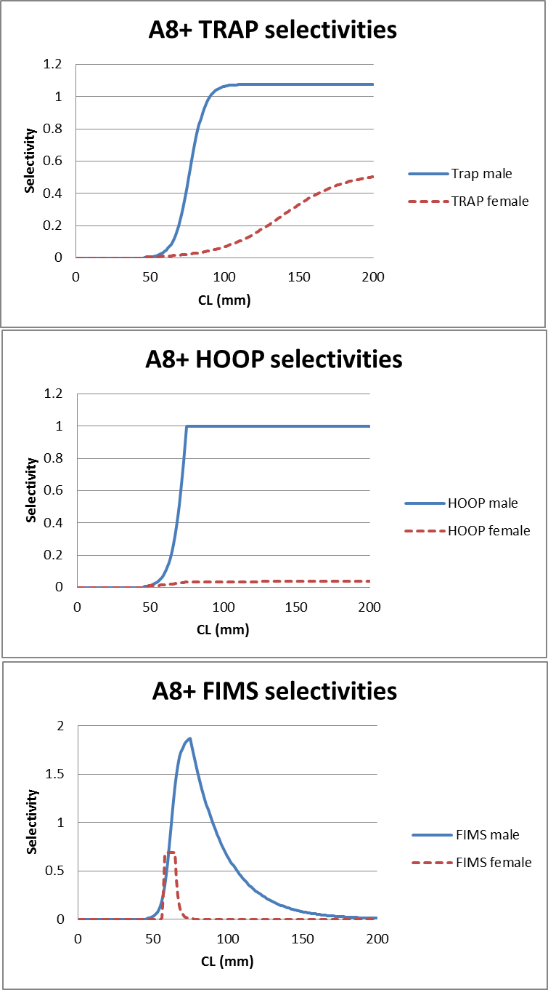

Figure 8: Estimated selectivity functions for super-area A8+.

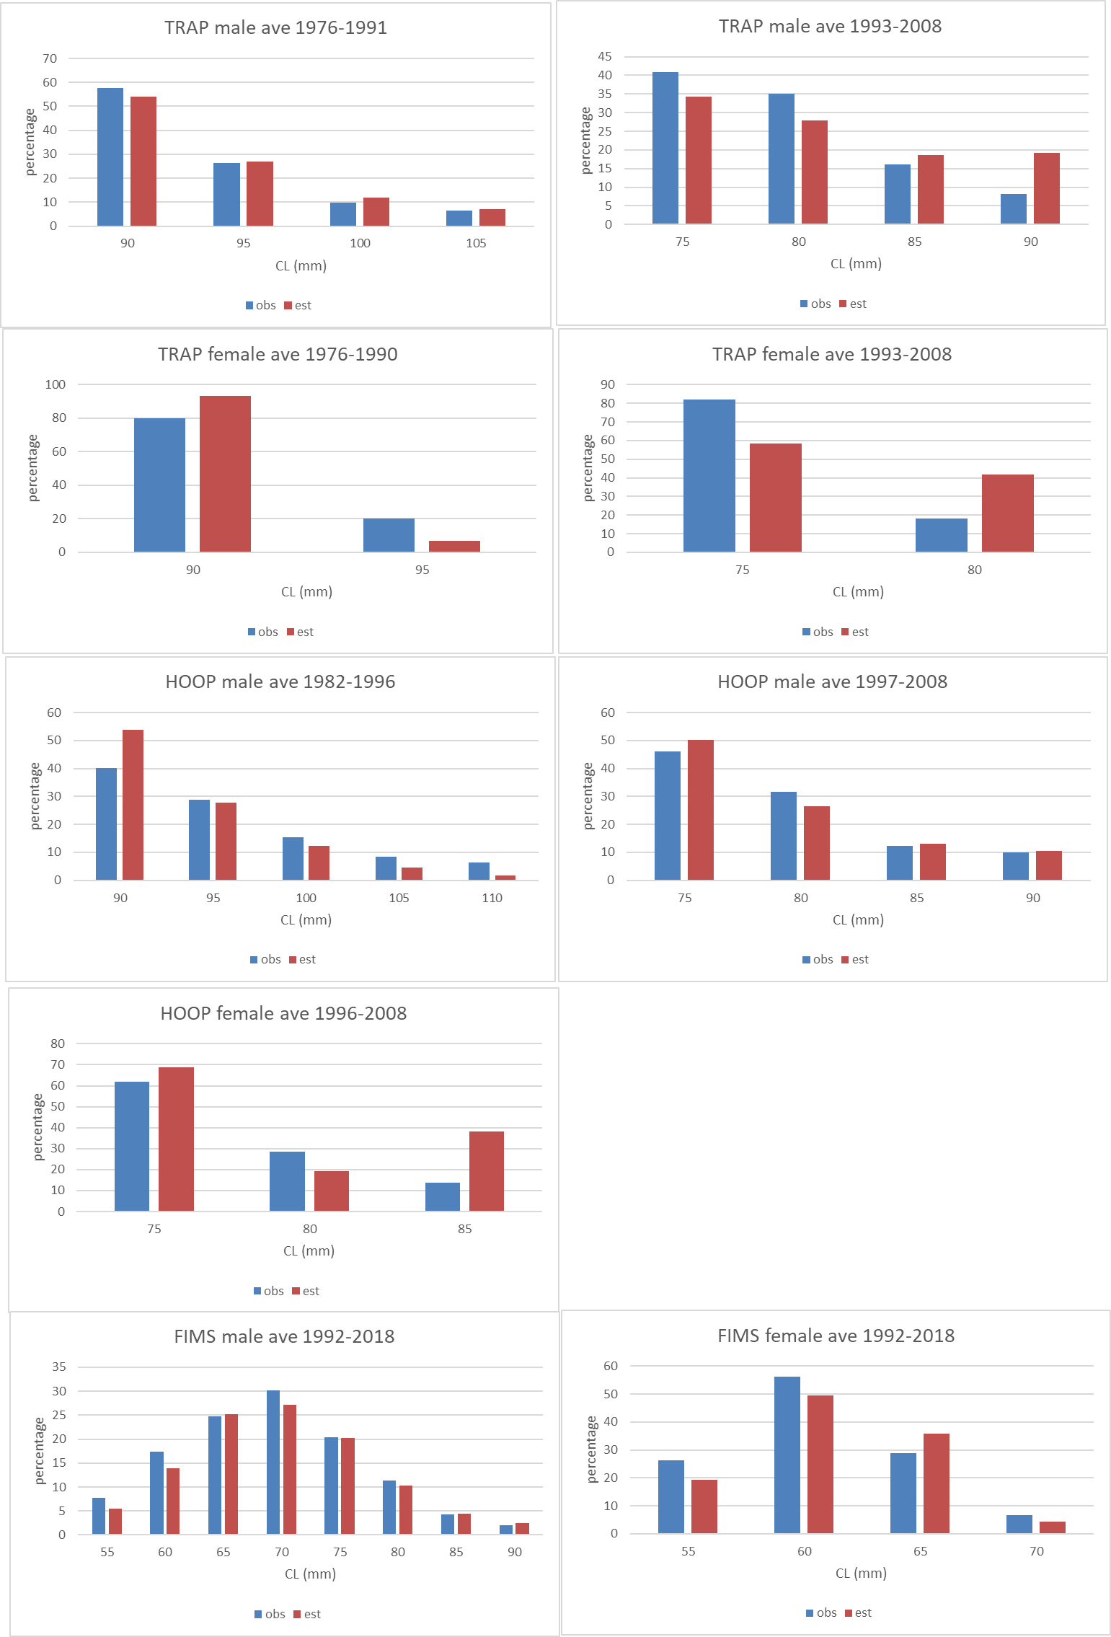

Figure 9: Fits to the TRAP, HOOP and FIMS catch-at-length data for super-area A8+ (Note: fits averaged over periods; plus and minus-groups are incorporated).

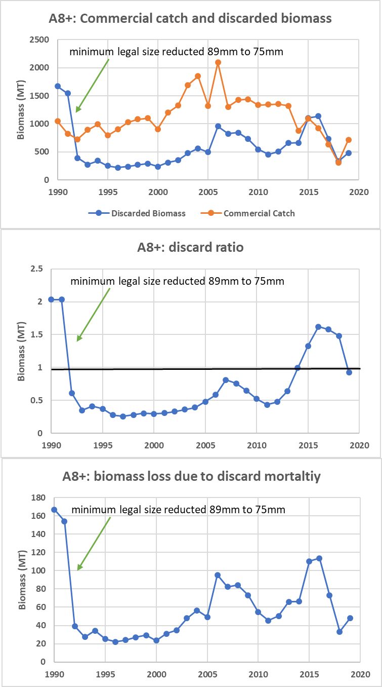

Figure 10: A8+ trends of commercial catch, discarded biomass, ratio of discarded biomass to commercial catch and the biomass lost due to the 10% discard mortality.