**Kingklip Stock Structure**

Information Document prepared for the annual IWS in December 2019 by : Larvika Singh and Deon Durholtz (Dept. of Environment Forestry and Fisheries) and David Japp : Capricorn Marine Environmental (Pty) Ltd

**Problem Statement : Kingklip Stock Hypotheses**

1. Kingklip (*Genypterus capensis)* show clear spatial and temporal distribution patterns, with marked differences in abundance between the West and South Coasts. These observations have led to the suggestion that two stocks of the species are present in SA waters.
2. Although kingklip are widely distributed around the SA coast and are caught at depths from 20m-1000 m, their abundance is generally “patchy” and are associated with habitat preference.

**Kingklip Stocks : Background**

The South African kingklip (*Genypterus capensis*) resource has,since the start of the hake-directed trawl fishery at the beginning of the century, been an important by-catch species for the fishery. What differentiates kingklip from other hake trawl by-catch species (such as Agulhas sole, monkfish and horse mackerel) is their high domestic value and demand.

Kingklip are also caught as by-catch in Namibia’s hake trawl fishery, mainly in the southern parts of Namibia and particularly in the areas fished for deepwater hake, *Merluccius paradoxus.*

Kingklip (also called “ling” or cusk eel), also occur in other southern hemisphere fisheries, including in Chile (*G. chilensis*), Argentina (*G. blacodes*), Brazil (*G. brasilensis*) and in New Zealand and Australian waters (*G. blacodes)*. Differences in morphology have been reported, mostly related to locality associated with depth (darker colours) and to habitat type (e.g. pinkish colours associated with deep sea corals).

In these different areas, kingklip are found widely distributed and their abundance and density highly variable. In South African waters the incidence of kingklip in trawls is relatively low, with very few individuals larger than about 100 cm, being caught (Figure 1).

Kingklip display seasonal aggregating behavior, presumably relating to spawning. The areas in which these aggregations occur are generally not well known, but on the South African east coast, trawlers have exploited aggregations on “hard” or “coral” grounds in appreciable numbers in the past. Similar trawl exploitation patterns targeting these aggregations have also occurred in southern Namibia, with catches of up to 20 - 30 tons being reported.

In 1983, an experimental hake directed longline fishery was initiated in South Africa. However, the target species rapidly shifted to kingklip due to the suitability of the gear for catching this species. Longline catches of kingklip escalated rapidly, particularly in areas not readily accessible to the trawl fishery (hard ground and areas of deep water coral occurrence on the eastern Agulhas Bank).

The longline experiment was terminated in 1989 after marked declines in the catches of kingklip in both the longline and trawl fisheries, suggested that the selective targeting using the longline gear was impacting recruitment.

**Past and Current Research on Stock Structure**

Numerous studies have used different methods in attempting to elucidate the stock structure of kingklip.

1. Payne (1977,1985) suggested three stocks of kingklip; a Namibian stock, a West Coast stock and a South Coast stock. The main criteria for stock discrimination were growth rates, otolith morphology and meristics. Spawning aggregations were also considered to be a strong indicator of different stocks.
2. Japp (1990) South African Journal of Marine Science 9: 223-237. Genetics, distribution of longline catches and otolith and body morphology suggested that kingklip is a single stock in South Africa. However, spatio-temporal patterns in longline catches and markedly different levels of abundance between West and South Coasts led to the recommendation that kingklip should be managed as two units.
3. Sizakele Makgotso Sibanda : *Parasites of* Genypterus capensis *(kingklip) and Assessment of their Potential as Biological Tags* (Marine Biology Honours Thesis 2015) –three parasites were found to discriminate fish from the different locations, namely *Anisakis* sp., *Tentecularia* plerocercoid and *Diphyllobthrium* sp. Recommended to increase sample sizes, and to include parasite data along with morphometric, otolith shape, and vertebral counts in a multi-method approach to disseminate stocks of this species.
4. Mobara et al. 2018. Application of a multiple method approach for stock identification and discrimination of South African kingklip, *Genypterus capensis* (Smith 1874) - Recent genetic analyses of kingklip from South Africa suggest the presence of population sub-structuring with at least two genetic units, one off the west and another off the south coast. Morphological, meristic and parasitological data of kingklip from the west and south coast was applied. Results indicate significant differences between fish from the putative stocks in terms of morphometric characteristics (two otolith shape indices: circularity [p = 0.00007] and form factor [p = 0.00662]) and meristic characteristics (vertebral counts [p < 0.05] and gill raker counts [p = 0.00013]). Parasitological data proved inconclusive. Results support the two-stock hypothesis and identify which phenotypic characteristics may be used to differentiate between them.
5. Van der Lingen (per comm.) – student (Mobara) used otolith shape and otolith micro chemistry (not yet completed) – suggested otolith microchemistry did not show any consistent spatial differences, and the results related to the parasites were not convincing. It seems that there may be two kingklip phenotypes, possibly two genotypes etc but no spatially-linkages.
6. Grant and Leslie (2005) AJMS –Although allozyme markers indicated a single genetic population of kingklip off South Africa, the authors suggested that the best management strategy was to separate allowable catches for kingklip on the “West” and “South” coasts.
7. Henriques et al. 2016 (Fisheries Research) suggested possible population sub-structuring with at least two genetic units (on the West and South coasts). However, low levels of genetic differentiation suggest significant gene flow between populations. “*The absence of temporal stability may result from reproductive sweepstakes, with differential reproductive success between cohorts*“. This suggested that two independent stocks should be considered in the management of the SA kingklip resources.

**Conclusion**

There is still uncertainty regarding the presence (or not) of different stocks off the South African coast. Past research has not considered explicitly the potential for other stocks either in Namibia or further eastwards into Mozambique. With established hake-directed trawl fisheries in the region, there is an ongoing discussion around the most precautionary management of kingklip given the current stock status (still recovering from the heavy exploitation in the 1980’s) and whether or not stock assessments should apply a single or multiple stock scenario.

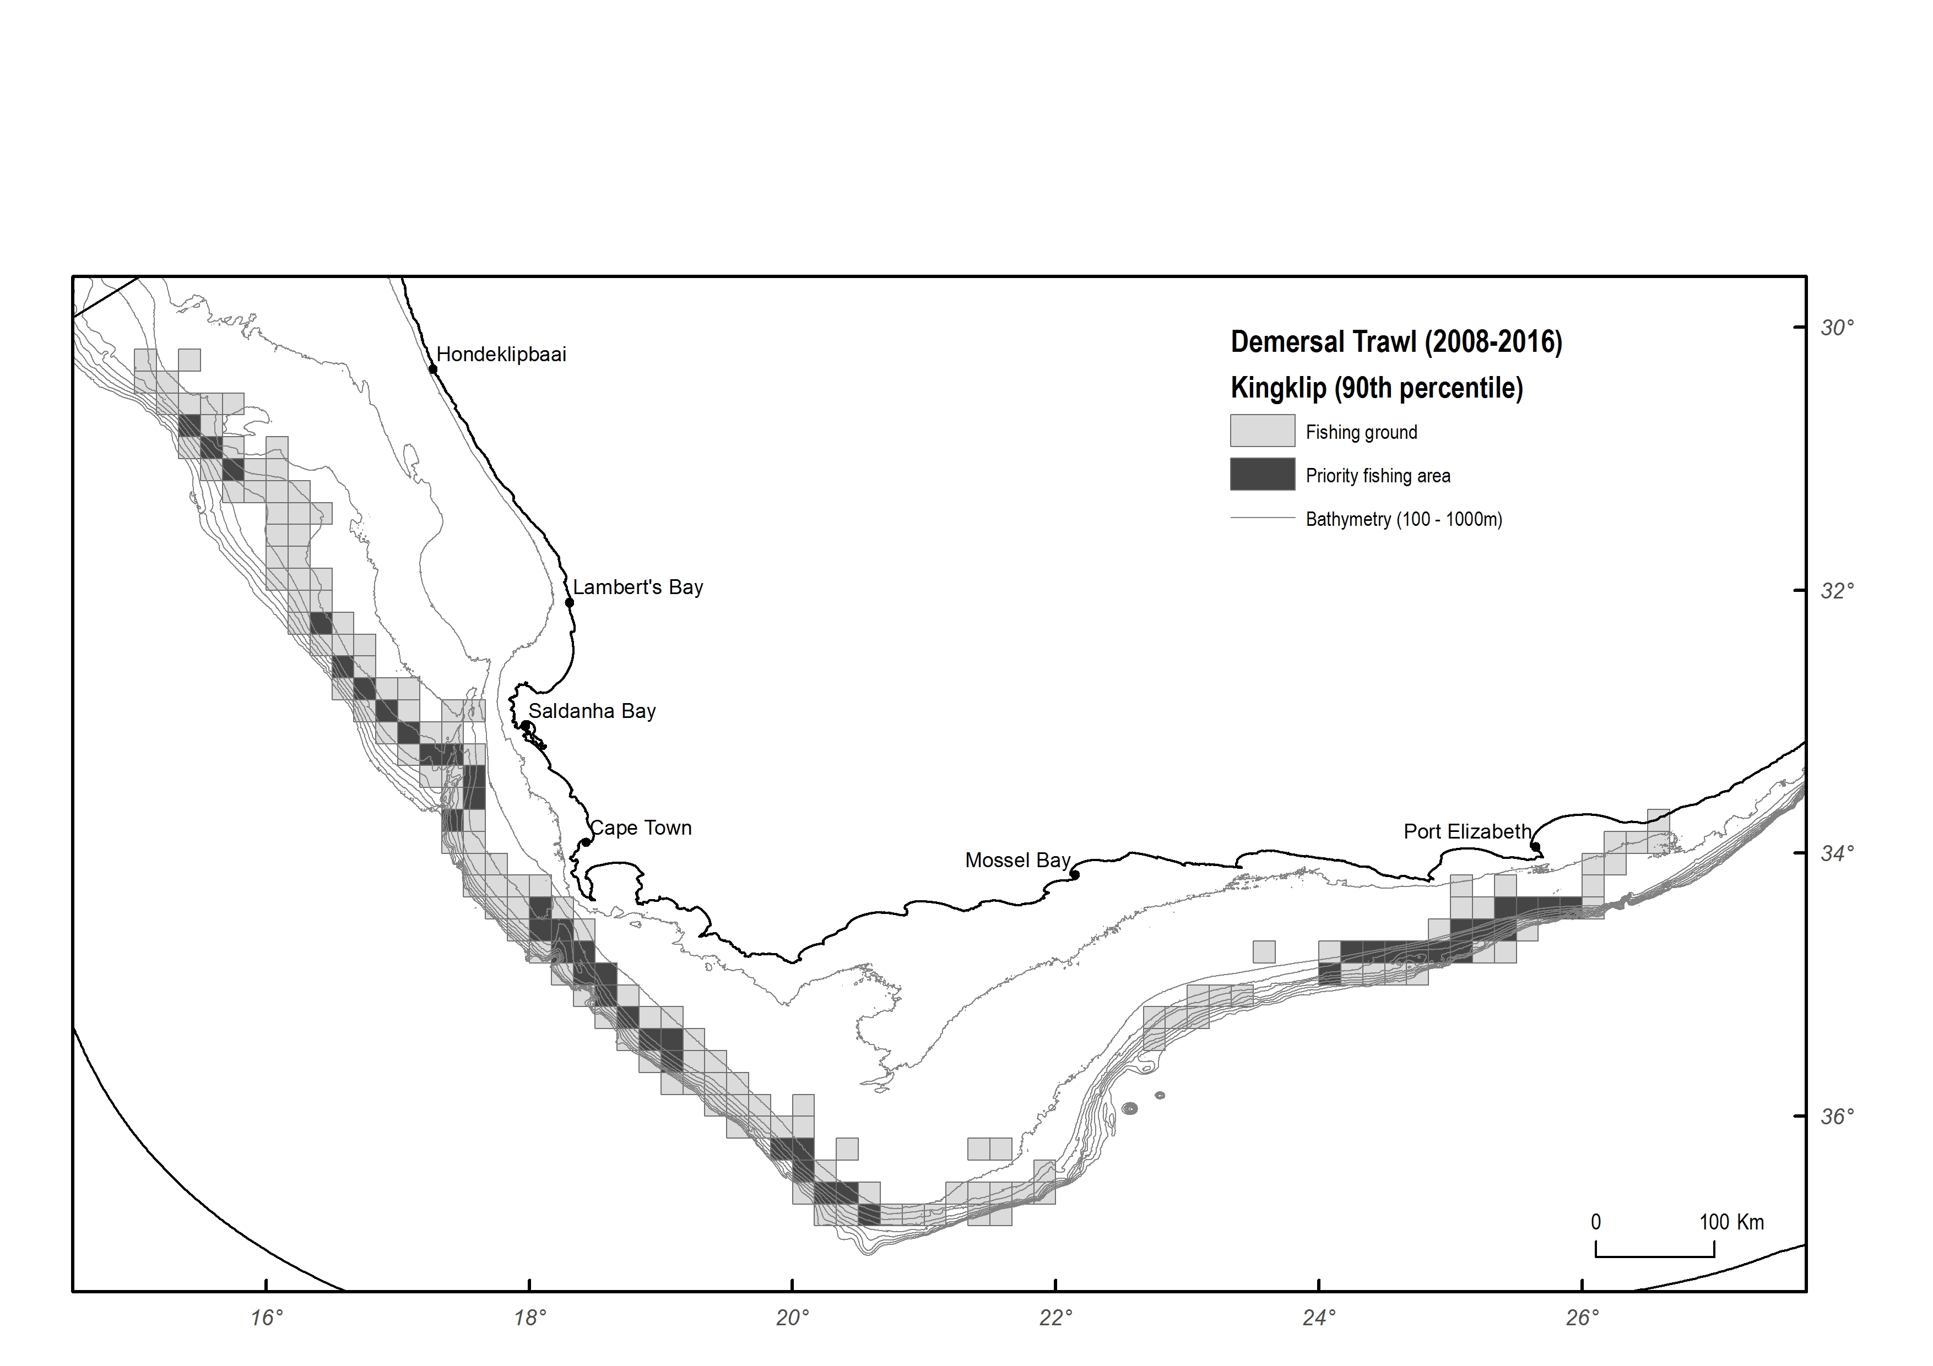

Figure 1. Distribution of kingklip in hake-directed trawls showing the “priority areas” for the species over the period 2008-2016 (after Norman et. al. 2018 : *A Review and Strengthening of the Spatial Management of South Africa’s Offshore Fisheries*). The dark shaded areas show the areas with the highest catches using the 90th percentile.